Catherine Diamond

Silent Cicadas and Noisy Burrowers:

Kafka Inside Out in Thailand

In 2015, the Unfolding Kafka Festival was initiated by Thai dancer/choreographer Jitti Chompee, exploring the writings of Franz Kafka as a source of creativity for performers in Thailand and the Southeast Asian region. Three of the presented artworks focus on the concept of metamorphosis, and the body’s interaction with the environments it both creates and inhabits. Inspired by Isabelle Schad’s dance Der Bau (The Burrow), Chompee and visual artist/scenographer Yoko Seyama created Silence of the Insects, which adopted the cicada as a model of bodily transformation. Together, the two dances and the installation form an assemblage that can be considered under the rubric of Una Chaudhuri’s concept of a ‘theatre of species’. Catherine Diamond is Professor of Theatre and Environmental Literature at Soochow University in Taiwan, and is the director/playwright of the Kinnari Ecological Theatre Project, creating new plays addressing environmental issues in Southeast Asia.

Keywords: Thai dance, theatre of species, performance assemblage, The Metamorphosis, The Burrow, Bangkok Unfolding Festival, Jitti Chompee

AT BANGKOK’S first Unfolding Kafka Festival in 2015, rather than an intercultural collabora-tion, three interrelated presentations formed a ‘performance assemblage’. Assemblage in art usually refers to a three-dimensional collage, but here I use it to describe a tripartite per-formance experience: two dances and an installation, all text-based, by which to create an overarching concept under which a set of mutually informing new contexts could be provided. They created a realm of Kafkaesque surrealism that allowed for Thai cultural inter-pretation, and opened up doors beyond liter-ary metaphor into the mysteries of nature. One of the pieces, The Silence of Insects, had two parts. Created by Berlin-based Japanese artist/scenographer Yoko Seyama and Thai dancer/choreographer Jitti Chompee, it com-prised Seyama’s mobile installation, which was both displayed alone and also served as a 3-D backdrop for Chompee’s dance. Inspir-ing the two of them, however, were two other artists – Czech-born German-Jewish writer Franz Kafka and German dancer/choreogra-pher Isabelle Schad, who performed a solo based on Kafka’s novella Der Bau (The Burrow, 1931) at the festival.

Schad’s The Burrow and Seyama’s The Silence of Insects – based on Metamorphosis (1915) – utilized two of Kafka’s animalistic

narrators who uniquely bridge the worlds of humanity and animality. Kafka’s animal voices – from Gregor Samsa as an insect in Metamorphosis, and Red Peter, the chimpanzee in A Report to an Academy, to the anonymous mole-like burrower and assorted mice, birds, horses, jackals, and dogs that appear in his letters, diaries, and stories, plunge the reader into animal consciousness, taking him or her out of the anthropocentric world with an empathy and perception rare in early twentieth-century fiction. The third piece, Chompee’s dance, incorporated the more directly autobiographical Letters to His Father (1919). From the posthumously published personal address that Kafka wrote to his father, with whom he had a fraught relation-ship, Chompee selected excerpts about the father’s moments of silence and the author’s own sense of being a small animal, namely a mole and a beetle. Chompee’s dancers recited these passages and created a visual, auditory, and textual connection with Seyama’s mobile dangling above them, while their dance style referenced Schad’s The Burrow. Thus the three works refer to each other, and together – their concepts, visual patterns, and inter-pretations of Kafka’s texts – ramified their intertextual looping, creating a performance assemblage.

**Downloaded from** [**https://www.cambridge.org/core**](https://www.cambridge.org/core)**. UNSW Library, on 14 Sep 2020 at 03:16:56, subject to the Cambridge Core terms of use, available at**

[ntq 36:2 (may 2020)](https://www.cambridge.org/core/terms) © [cambridge university press doi:10.1017/S0266464X20000214](https://doi.org/10.1017/S0266464X20000214) 149 [**https://www.cambridge.org/core/terms**](https://www.cambridge.org/core/terms)**.** [**https://doi.org/10.1017/S0266464X20000214**](https://doi.org/10.1017/S0266464X20000214)

Kafka’s Animalized Narrators

Kafka’s animalized narrators oscillate between a dissolution of self into both a hostile and comforting environment, and the penetration of the environment into the self. The constant shifting between animal and human con-sciousness creates a realm in which such fluid transformations are not only accepted by the reader but create a unique perception of the world. Kafka’s hybrid creatures not only blur the distinction between the ‘zoomorphic’ (the presentation of humans in animal form) and the ‘anthropomorphic’ (the attribution of human qualities to animals), but they also attempt to explore deeply into the psychology of the animal. The inversions are not unidirec-tional – that is, they are not merely traditional forms of therianthropy (the transformation of a human being into an animal) in which the human consciousness operates within an animal body – but their consciousness is dis-sected to reveal the animal within human nature despite the human voice needed to express it. Kafka’s animalized narrators are post-human avant la lettre as ‘they demand that we recognize that there are other modes of perception of the world as well as the human, and that these can be sophisticated forms of consciousness’.1

Kafka’s animals provide an illuminating comparison with the traditional animals and hybrids in Southeast Asian literature and per-forming arts, and suggest a potential for their re-emergence in contemporary life during this, the Anthropocene, era. The introduction of Kafka into the Bangkok cultural scene has already suggested to Jitti Chompee a fruitful interrelation between Thai mythology and contemporary views of animality. In their work on Kafka, Gilles Deleuze and Félix Guattari remark that ‘Kafka’s animals never refer to a mythology or to archetypes but correspond solely to new levels, zones of liberated intensities where contents free themselves from their forms as well as from their expressions – from the signifier that formalized them. There is no longer anything but movements, vibrations, thresholds in a deserted matter: animals, mice, dogs, apes,

cockroaches are distinguished only by this or that threshold, this or that vibration, by the particular underground tunnel in the rhizome or the burrow.’2 Alex Goodbody extrapolates this focus on Kafka’s creatures to consider new modes of perception: ‘less a transformation of humans into animals than an erasure of the boundaries of human identity through recognition of species’ irre-ducible interdependence, an emancipatory movement from being to becoming in which the subject no longer occupies a realm of rigid stability but is deterritorialized, liber-ated and released into a “nomadic” mode of existence’.3 Goodbody contends that Kafka’s animals

resist reduction to any single coherent interpreta-tion . . . They have reverberated over the last three-quarters of a century, nourishing voices destabiliz-ing common conceptions of human distinctiveness from non-human animals and hegemonic under-standings of our relationship with non-human ani-mals and nature.4

Kafka’s bestiary is highly personal, and although several of his creatures have accrued near-mythical dimensions, they are not merely religiously or psychologically symbolic, and can achieve their power through being under-stood literally as animals. A committed vege-tarian who resisted his father’s injunction to eat meat, Kafka is one of the few twentieth-century writers who seemed to exist and express much of his life in that uncanny space of animal sensibility, so that virtually all of his writing elides both speciesist and self-in-environment binaries. Writing about the ani-malized narrators, Margot Norris regards Kafka as one of a small group of biocentric thinkers, writers, and artists who ‘create as the animal – not like the animal, in imitation of the animal – but with their animality speaking’.5 The three artists explore animality in both abstract and concrete forms: Schad explores the burrowing mole-like creature’s relation to its environment; Seyama creates a mobile of origami cicadas inspired by Gregor Samsa as a beetle; and Chompee’s dancers roam and clamber blindly like larvae until they emerge from paper carapaces.

**Downloaded from** [**https://www.cambridge.org/core**](https://www.cambridge.org/core)**. UNSW Library, on 14 Sep 2020 at 03:16:56, subject to the Cambridge Core terms of use, available at**

[150](https://www.cambridge.org/core/terms)

[**https://www.cambridge.org/core/terms**](https://www.cambridge.org/core/terms)**.** [**https://doi.org/10.1017/S0266464X20000214**](https://doi.org/10.1017/S0266464X20000214)

Kafka in Thailand

Born in Bangkok in 1974, Jitti Chompee trained in classical ballet in Thailand and Hong Kong and in the modern dance studio of Alvin Ailey in New York. In 2010, he founded 18 Monkeys Dance Theatre.6 Unlike other Thai dancers such as Pichet Klunchun and Pradit Prasart-thong, who have earned international repu-tations, Chompee was not originally trained in khon (the traditional court dance based on the Ramakien), but from the beginning was involved in European and American dance forms, though several members of 18 Mon-keys are trained in khon.

In 2014, Chompee attended the Tanzplatt-form Germany, a biennial showcase for new dance, where he was especially impressed by Isabelle Schad’s The Burrow that explored dance as conceptual living sculpture and also introduced him to Kafka as a source of inspi-ration.7 The same year, he encountered Picas-so’s cubist paintings in Paris, which influenced him to re-evaluate bodies in Thai murals:

When I got back to Bangkok, I was still mulling over the concept of mismatched body and facial parts. From there, I looked up traditional Thai paintings of mythical creatures in the Himmapan Forest and also found their mismatched body parts from different animal and human forms exquisite.8

Thai classical and popular culture teems with human-animal transformations and hybrids, such as the Thai kinnari (half bird, half woman) whose image appears on temple walls and in statuary, or the well-known story Pla Boo Thong (The Golden Fish), in which a mother turns into a golden carp, that was broadcast as a long-running drama serial (2009–10). While Chompee was noting the similarities and considering how they might interact on stage, he attended the Goethe Institute’s literary festival commemorating the ninetieth anniversary of Kafka’s death in Bangkok, at which Thanomnuan O’charoen, Thailand’s pre-eminent Kafka scholar, spoke about the author’s reception in the country. Surprised by the large attendance, the orga-nizer of the festival, Marla Stukenberg, agreed to Chompee’s proposal to represent Kafka through the performing and visual arts in a festival format the following year.9

Kafka’s creatures tend to be interpreted somewhat conventionally in Thailand, where they assume a metaphorical function, sym-bolizing either personal angst or social ills. Thanomnuan O’charoen commented that her university students did not find Kafka’s Meta-morphosis particularly uncanny, and ignored its unique dilemma in favour of more concrete personal and social interpretations:

Social alienation has been felt by Thais too but they have not realized it, nor have they analyzed or pondered it and presented it in a systematic way as Kafka did. As one student writes, ‘The subject matter of Kafka’s literary works is not anything strange for Thai readers. We sometimes, or even throughout our lives, have conflicts with our par-ents. These conflicts are, for example, when our parents are not satisfied with our friends. The Meta-morphosis, which is the story of a human being turning into a gigantic insect, is not a strange story. Many times we want to transform ourselves into something else when we do not like our surround-ings. What happens in this story is universal.10

In addition to universalizing the experience of youth alienation, Thai theatre has also polit-icized the devolution of the human to insect by adapting the same story to express the helpless indignation of a young person living in a polarized society in which education and politics have failed rural residents. Pansak Sukhee’s Kafka and I (and the Agony of Being in a Seemingly Democratic Country Where Soci-ety is Doomed to Collapse) (2011), performed in a Brechtian non-realistic style, tells the story of Muan, a poor student from rural Northeastern Thailand (Issan). When he goes to university in Bangkok, he experiences prejudice from his Bangkok classmates. Alone and alienated, Muan transforms into an insect after hearing a lecture about The Metamorphosis. The name ‘Muan’ refers to the assassin bugs that exist in Northeastern Thailand, and thus both the boy and the bug symbolize isolation from urban society, and the Bangkok middle class’s disdainful attitude toward the Issan farmers.11

Evident from the Thai students’ responses and their stage performances, Kafka’s story is integrated into the Thai social and aesthetic experience. Although Chompee’s dance relates neither to Thai dance or politics, his decision to perform it in an unconventional Bangkok site

|  |  |  |
| --- | --- | --- |
| **Downloaded from** [**https://www.cambridge.org/core**](https://www.cambridge.org/core)**. UNSW Library, on 14 Sep 2020 at 03:16:56, subject to the Cambridge Core terms of use, available at** | |  |
| [**https://www.cambridge.org/core/terms**](https://www.cambridge.org/core/terms)**.** [**https://doi.org/10.1017/S0266464X20000214**](https://doi.org/10.1017/S0266464X20000214) | 151 |  |
|  |  |

situates it in a specifically Thai social and his-torical context. The Silence of the Insects was performed in the narrow, vertical lobby of the Rose Hotel, located near the infamous Patpong district. The seven-storey rectangular space does not seem to have any functional utility for the old hotel, though it provided an unusual and memorable space to hang Seyama’s mobile installation and allow Chompee’s three dancers to explore it both horizontally and vertically. The audience could ascend stairs to various floors so as to observe the dance and the mobile from the perimeter.

The Burrow12

Chompee, however, invited Schad to present The Burrow at the Sodsai Pantoomkomol Cen-tre for Dramatic Arts on the Chulalongkorn campus instead, and this was to have some repercussions on its presentation. The Burrow is Kafka’s strange tale of a creature living underground that has mole-like characteris-tics but whose specific identity is left vague. As Goodbody notes, ‘This imprecision was a matter of conscious writing strategy, rather than accident: when writing The Burrow, Kafka incorporated information on both the badger and the mole from entries in the popular illustrated work of natural history, Brehms Tierleben.’13

The creature is both proud of his vast lab-yrinth of subterranean tunnels and trapped by it. He feels protected by his own thorough

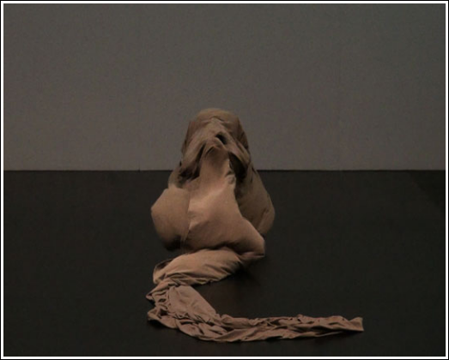

Isabelle Schad’s Der Bau (The Burrow) at Bangkok’s Unfolding Kafka Festival (2015). Photo: Laurent Goldring.

knowledge of the pathways but is also terri-fied of an enemy incursion. The burrow is both an externalization of the creature’s psyche and it is also an extension of his body; the creature and his environment are inextricably inter-twined, not only mentally but physically, even beyond death: ‘I know that here . . . is so essentially mine that I can calmly accept in it even my enemy’s mortal stroke at the final hour, for my blood will ebb away here in my own soil and not be lost.’14 As the earth itself is composed of plant and animal bodies, the burrower reminds himself that he will even-tually be merged even more completely. Despite his confidence and sense of security, the burrower begins to be haunted by sounds, acousmatic noises that he cannot source, and which might even emanate from his own head.

I suspect that many in the audience at the Sodsai theatre were as unfamiliar as I was with the Kafka story, and therefore watched the performance without fully appreciating what it was doing. Schad, conceiving the piece in 2008 with French visual artist Laurent Goldring, dances with four ten-metre-long panels of cloth in ‘earth’ colours of brown, grey, and black that she wields to form shapes in the air around them as prolongations of the body. The length of cloth makes the strips difficult to manipulate and the dance effects the transitions of the cloth into surreal poses of inverting exterior and interior, capturing the burrower’s relationship with the burrow.

Schad presents a topological relationship of the body to the constructions of cloth that both surround her and emanate from her – topology being the mathematical study of continuity through deformation and twistings, such as the Möbius strip in which two sides become a contiguous single surface. It also demonstrates how the interior can become the exterior without any rupture. Topological thinking is particularly apt for Isabelle Schad’s visual rendering in a dance that is also a movement installation, for, as she says, since ‘the burrow is described as a space deriving from the body itself, yet still belonging to it – bearing the form, traces, odours, wastes and reserves, hope and despair – [Kafka’s story] seemed a good basis for further explorations

**Downloaded from** [**https://www.cambridge.org/core**](https://www.cambridge.org/core)**. UNSW Library, on 14 Sep 2020 at 03:16:56, subject to the Cambridge Core terms of use, available at**

[152](https://www.cambridge.org/core/terms)

[**https://www.cambridge.org/core/terms**](https://www.cambridge.org/core/terms)**.** [**https://doi.org/10.1017/S0266464X20000214**](https://doi.org/10.1017/S0266464X20000214)

of conceiving this new relationship between body and space’.15

She performs in the nude to suggest the shapes of cloth as internal organs revealed externally, as the self-created environment enveloping the body, as well as reflecting its inner surfaces, graphically expressing Kaf-ka’s mole-ish burrower in an earth space of his own making – one that is perpetually alive. She says:

The sphere of the intimate is the first space around the body; it is the space needed by the body to feel its integrity free of any threat. It is a transitional space . . . both part of the body and part of the world. The entire surrounding space is of the same order, namely a fully humanized space in which a person is confronted only with oneself.16

Schad twists the cloth about her body, a clumpy mass, as her feet and hands poke out, anthropomorphizing the shapes into another body. She rolls on the ground, wrap-ping and twisting the cloth, concealing and revealing parts of her body while accruing layers of skin and mass: ‘These external tissues are dealt with like internal tissues, and they respond with a surprisingly alive manner, at the same time as part of the body, as a shell, and as a partner.’17 Schad’s interplay between

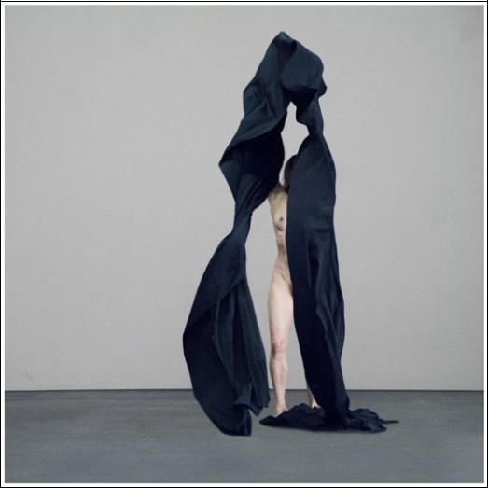

Der Bau (The Burrow) at Bangkok’s Unfolding Kafka Festival (2015). Photo: Laurent Goldring.

external and internal space not only mani-fested Kafka’s burrower, hiding, exposing, revelling, fleeing, but also presented Kafka’s metaphysical interflow between the creator and his creation.

The naked body on display, while com-monplace in Berlin, is still unusual on the Southeast Asian performing arts stage, and there is a sharp economic and cultural divide between the entertainment offered in Bang-kok as one of the world’s sex tourism capitals, and the university-based art scene in which Der Bau was presented. In deference to the sensibilities of the university audience, Chom-pee requested Schad to cover up her private parts with skin-coloured patches. During the Q&A after the performance, however, this decision was queried. An awkward discus-sion ensued between the artist, the moderator, and the audience about cultural difference and how much was (falsely?) assumed or catered to. Her nudity was certainly justified, given that the piece was centred on the exten-sion and permeation of the body with its environment.

The Thai stage had encountered the issue before with Belgian dancer Jérôme Bel and khon dancer Pichet Klunchun in Pichet Klunchun and Myself (Bangkok Fringe Festival, 2004, and again in 2018). Their dance-conversation included Bel, who is known for having his dancers perform in the nude, demonstrating this to Klunchun, and when he bent to take off his trousers, the Thai artist, citing his culture’s tradition of modesty, objected. Bel asked about Bangkok’s infamous sex clubs, where the Thai dancers are ‘very naked’. Klunchun replied that ‘They’re performing for tourists’, which ended their discussion – but not the question of hypocrisy and socio-economic divides. Several people in the audience con-curred that Schad’s performance transcended the gendered body, acknowledging that her female body had succeeded in becoming a universal body in its exploration of space in relation to the cloth. However, in her attempt to thwart Klunchun’s critique of offending cultural modesty, her act of self-censorship somewhat riled the audience’s sense of its own cosmopolitan sophistication.18

|  |  |  |
| --- | --- | --- |
| **Downloaded from** [**https://www.cambridge.org/core**](https://www.cambridge.org/core)**. UNSW Library, on 14 Sep 2020 at 03:16:56, subject to the Cambridge Core terms of use, available at** | |  |
| [**https://www.cambridge.org/core/terms**](https://www.cambridge.org/core/terms)**.** [**https://doi.org/10.1017/S0266464X20000214**](https://doi.org/10.1017/S0266464X20000214) | 153 |  |
|  |  |

Silence and Sounds

Kafka’s creature says he takes particular plea-sure in the burrow’s quiet. The soundscape of Schad’s dance emphasized silence, except for the sounds of the dancer’s breathing and her feet on the floor; the soft cloth made very little sound. Some minimalist sporadic noises were created by Peter Böhm to suggest the burrower’s world – scratching, whooshing, knocking, twittering – which were somewhat irritating and non-specific, but there was no overt representation of Kafka’s creature becoming increasingly terrified by a non-localized sound. Brian Kane’s sonic analysis of Kafka’s story applies an auditory dimen-sion to the deterritorialization between the burrow and the burrower by employing the concept ‘acousmatic’, to refer to a sound that one hears without seeing the causes behind it. Kane observes that ‘as the mole investi-gates, positing unverifiable hypotheses, it becomes impossible to determine if the sound comes from one or many places; who or what could be causing it; if it comes from near or far; or if it is not simply imagined’.19 As the noise is heard everywhere equally throughout the burrow, day and night, Kane concludes that ‘If the sonic effect underdetermines attribu-tions of its source or cause, then the location of that source as definitively located inside or outside the listener’s own body also becomes uncertain’.20 In the dance, Schad’s undis-guised panting breaths emphasize them as outward emanations of her internal organs. However, Kane’s supposition raises the pos-sibility that Schad’s cloth sculpting the air around her body could be the visual mani-festation of a blind mole-like creature that understands its physical milieu solely through auditory perception.

Responding to Kane’s acousmatic analysis, musicologist Elaine Fine suggests that what the burrower hears are the cicada nymphs that spend most of their lives underground, emerging only for a few weeks to sing their deafening song before mating and dying. She notes that when the millions of nymphs emerge to shed their casings, the moles rapa-ciously devour them. She surmises that, in turn, Kafka’s creature has to endure the

cicadas’ shrill noise, which, reverberating through the earth, utterly surrounds him.21 The concepts of inner and outer move from Schad’s visual presentation to one of imagined auditory sensation, thus providing a context for Yoko Seyama’s silent cicadas.

Yoko Seyama: Cicadas and Kafka’s Insect

While Schad’s dance visualizes topological construction, Seyama’s mobile installation in the Rose Hotel evokes an all-encompassing surround sound . . . via silence. Spectators whispered as they moved around the perim-eter of the dark rectangular space on several floors. Yet Seyama’s cicadas also move in space suspended from three mobile bars, their free-floating appearance and shadows shape the space around them, and their silence reverberates with imagined sound. It was her memory of their sound that led Seyama to embark on their folded metamorphosis from sheets of washi paper to full-fledged flying cicada imagos. Instead of being immersed in the auditory cloaking of the cicadas’ song, the spectator is wrapped in their ghostly silence, but as they hover, the insects emanate both their potential for noise and their unsettling quiet.

Having previously collaborated with Yoko Seyama, Chompee invited her to participate, but the project was her first time working with the Japanese art of paper folding, which she said was suggested by the festival’s title, ‘Unfolding Kafka’. Seyama finds origami fascinating as, after unfolding the figure, it returns to its full sheet with only the traces of the folds remaining. Thus its folding and unfolding is also an exercise in topology, and it enacts Der Bau’s literal meaning of ‘building’ or ‘construction’. While the paper cicada can return to its original state because nothing is cut or disfigured, the real insect transformations are unidirectional, for cica-das, like butterflies, experience ‘holometa-boly’: a complete metamorphosis.

Seyama took her inspiration from both Kafka’s Metamorphosis, in which the protago-nist Gregor Samsa suddenly becomes a giant insect, and her own nostalgia for the noisy

**Downloaded from** [**https://www.cambridge.org/core**](https://www.cambridge.org/core)**. UNSW Library, on 14 Sep 2020 at 03:16:56, subject to the Cambridge Core terms of use, available at**

[154](https://www.cambridge.org/core/terms)

[**https://www.cambridge.org/core/terms**](https://www.cambridge.org/core/terms)**.** [**https://doi.org/10.1017/S0266464X20000214**](https://doi.org/10.1017/S0266464X20000214)

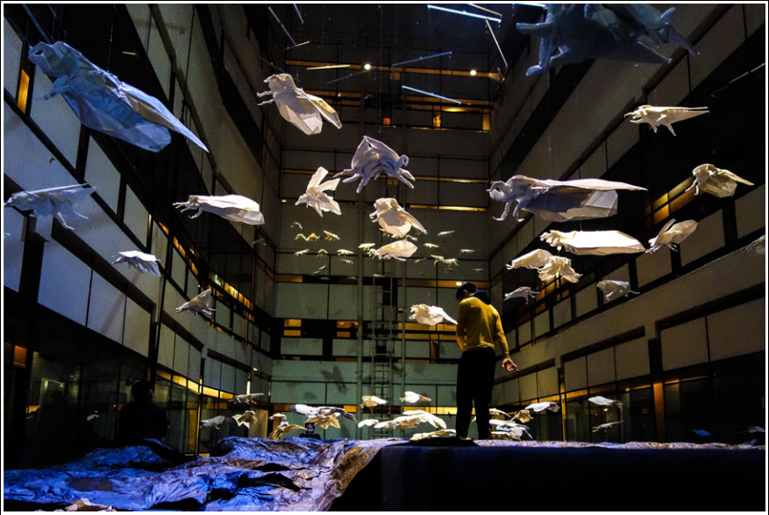

Jitti Chompee and Yoko Seyama’s The Silence of Insects at Bangkok’s Unfolding Kafka Festival (2015). Photo: Yoko Seyama.

cicadas in Japan.22 The cicada provided both an archetypal insect form, and one that reso-nates in Japanese and Thai cultures. Kafka, however, never mentioned the possibility of a cicada, and expressly forbade any illustra-tion of the creature that Gregor Samsa trans-forms into, as his description of it in the story intentionally defies specific categorization.23 As translator Susan Bernofsky explains,

both the adjective ungeheuer (meaning ‘monstrous’ or ‘huge’) and the noun Ungeziefer are negations – virtual nonentities – prefixed by ‘un’. Ungeziefer, a term from Middle High German, describes some-thing like ‘an unclean animal unfit for sacrifice’, belonging to ‘the class of nasty creepy-crawly things’. It suggests many types of vermin – insects, yes, but also rodents. Kafka wanted us to see Gre-gor’s new body and condition with the same hazy focus with which Gregor himself discovers them.’24

In English, the insect is typically imagined as a sort of beetle, but is sometimes referred to as a cockroach, for such is implied in the Ger-man ‘monstrous vermin’, but the Thai trans-lation does not produce the same distasteful

connotations. As O’charoen contends, ‘The Thai translators used “big insect” (แมลงยักษ์-

-Malang Jak) after the German words zu einem ungeheueren Ungeziefer or like the English words a gigantic insect. The Thai readers should imagine what kind of insect.’25 In Sukhee’s

Kafka and I, however, the association of ‘Muan’, the assassin bug, is clearly derogatory. By choosing the cicada, Seyama draws a parallel between Samsa’s transformation and one of the most miraculous metamorphoses in nature.

About thirty different species of cicadas exist in both Thailand and Japan. In parts of Thailand, they are among the insects that, stripped of its wings, are fried and eaten, and may also be made into amulets to be worn for good luck.26 In Japan they are the heralds of summer, with reference to them appearing in Japanese classical literature. Cicada-hunting for Japanese children is still a popular pastime, even in towns, and thus their absence in Berlin was noted by Seyama. The males make their deafening noise, which can reach 120 decibels, from their tymbals: a pair of ribbed membranes that their muscles flex in and out. In Thailand, it is primarily the females that are eaten because the males’ abdomen is hollow – where the two tymbals are located to make the sound rever-berate. Spending most of their lives under-ground, cicadas ingest xylem, a tree sap that they sip through straw-like probosces. In Thailand’s Chinese community, cicadas are symbols of rebirth, and their shed casings are used for treating skin ailments.

Although cicadas exist in southern Europe, Kafka makes no mention of them in any of his

|  |  |  |
| --- | --- | --- |
| **Downloaded from** [**https://www.cambridge.org/core**](https://www.cambridge.org/core)**. UNSW Library, on 14 Sep 2020 at 03:16:56, subject to the Cambridge Core terms of use, available at** | |  |
| [**https://www.cambridge.org/core/terms**](https://www.cambridge.org/core/terms)**.** [**https://doi.org/10.1017/S0266464X20000214**](https://doi.org/10.1017/S0266464X20000214) | 155 |  |
|  |  |

writings, but even if he had, his determination to preserve the indeterminacy of his hybrid creatures would have obscured any direct influ-ence. Given the juxtaposition of The Burrow and The Metamorphosis at the festival, however, the cicada provides a fascinating link, and one whose strange underground life and final acoustic mating song would perhaps have appealed to the writer. Pattramon Sukprasert writes that Seyama, ‘instead of decoding the text or presenting her work as an extension of Kafka’s story . . . found [the cicada] similar to Kafka’s creature’, quoting her as saying:

Cicadas live underground for years and years and one day they come up and cry out loud. They live on the ground for only a short period of time before they die. . . . I somehow feel that this has some relationship with how Kafka’s creature had some kind of difficulty with his father and one day was transformed. . . . Insects can probably be human. One of the insects hanging in my piece can be you. If their size is as big as a human being, such as is the

case in Kafka’s story, they could occupy and embed us.27

In order to make the ninety-six separate ori-gami cicadas, which were based on six differ-ent models, Seyama consulted engineers in origami clubs.28 As each insect required about 200 folds, Seyama employed assistants from the local origami club to help with the time-consuming task. Formed from handmade washi paper (comprising mulberry, hemp, and gampi fibres), the sheets of one square metre were folded into insects 30 40 cm in length, and then lightly coated with ultraviolet paint. Dangling in the vertical space, the result was magical, but also eerie and creepy, for while Bangkok residents might encounter cicadas on a visit to the countryside, the insects resembled the more familiar city beast, the giant flying cockroach. The floating cicadas were intensely silent, and being made from white paper, shift-ing to deep blue from the black lighting, they were nonetheless bizarrely albino, frightening in their size but beautiful in their collective repose. When asked about her title, The Silence of Insects, for a creature so famous for its noise, Seyama said the audience had to imagine how loud such large insects would be.

While it is presumed that Kafka’s burrower is a mole-like creature, Seyama’s choice of the

cicada not only resonates with The Metamor-phosis, but also sheds new light both on Kaf-ka’s story and Schad’s dance. Cicadas exist within the bodily formed shells while the organs inside literally dissolve to become a wholly new creature that cracks the carapace to emerge. Nothing exemplifies the exchange of inner and outer organs more than the mir-acle of insect metamorphosis. Considering Schad’s The Burrow in conjunction with The Silence of Insects, her creature resembles the sightless cicada nymph exploring its burrow, and the movements of the cloth perform an act of metamorphosis.

Jitti Chompee’s Dance

Seyama’s cicadas were viewed both as an independent installation and as an integrated extension of Chompee’s dance. The Thai cho-reographer connected with The Metamorphosis and the cicadas by presenting three dancers as squirming larvae, and referenced Schad’s technique by wrapping and exposing their bodies under paper coverings while reciting excerpts from Kafka’s Letter to His Father. Con-cealed under large pieces of brown paper, the dancers wriggled on the floor and clambered over each other, occasionally exposing a limb. The paper was less flowing than Schad’s cloth, and thus there was less variety of movement between the covering and the body, and more interaction between the three bodies as they crawled over each other. The wrinkled paper resembled the thin pliable shells – called ‘instars’ – that the cicada moults five times while underground. The paper was used not as an elongation of the movement from the bodies inside, but was instead manipulated to cover and uncover. The Silence of Insects evinced no khon or discernibly Thai move-ments, and the dancers, when shedding their paper skins, revealed bodies in modern shorts.

The three dancers wriggle inside their cas-ings while reciting from Kafka’s long indict-ment of his father’s tyranny and indifference. Chompee picked a few sections in which Kafka makes a generous interpretation of his father’s silences: ‘Mostly when you suffered in silence, and affection and kindliness by their own strength overcame all obstacles, and moved

**Downloaded from** [**https://www.cambridge.org/core**](https://www.cambridge.org/core)**. UNSW Library, on 14 Sep 2020 at 03:16:56, subject to the Cambridge Core terms of use, available at**

[156](https://www.cambridge.org/core/terms)

[**https://www.cambridge.org/core/terms**](https://www.cambridge.org/core/terms)**.** [**https://doi.org/10.1017/S0266464X20000214**](https://doi.org/10.1017/S0266464X20000214)

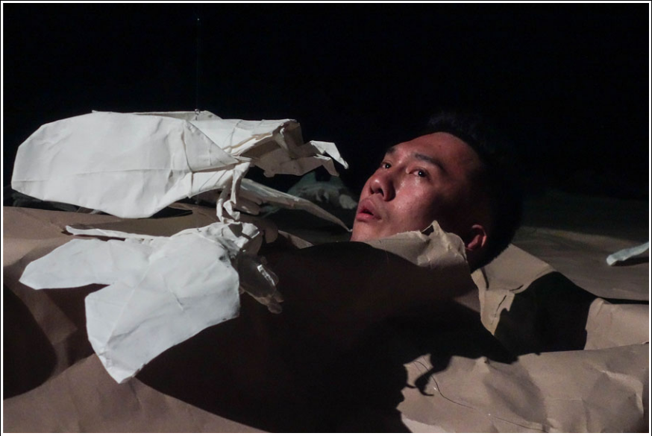

The Silence of Insects at Bangkok’s Unfolding Kafka Festival (2015). Photo: Yoko Seyama.

me immediately. Rare as it was, it was won-derful’.29 A second dancer recites another rare occasion when his father attempted not to dis-turb the writer; the words hang in the air like the floating insects, disembodied from the dancers: ‘Or when, during my last illness, you came tiptoeing to Ottla’s room to see me, stopping in the doorway, craning your neck to see me, and out of consideration only waved to me with your hand. At such times one would lie back and weep for happiness, and one weeps again now, writing it down.’30 Kafka seems to grab at whatever sensitivity he can fathom from his father, who was not otherwise portrayed as being either sensitive or gracious. The man could respond to his son’s physical illness, though he could not tolerate Franz’s morbid psychological sufferings.

In another textual fragment, silence takes on different meanings. In lieu of speech, writ-ing becomes Kafka’s necessary substitute: ‘My writing was all about you . . . there is nothing bad to fear; once you have crossed that thresh-old, all is well. Another world, you do not have to speak.’31 What pains Kafka is both how different they are and how inextricably they are tied. However, in the end, Kafka evokes a self-effacing insect sensibility: ‘it is, after all, not necessary to fly right into the middle of the sun, but it is necessary to crawl

to a clean little spot on Earth where the sun sometimes shines and one can warm oneself

1. little.’32 While one dancer recites, another crawls over to one side of the space and begins scaling a ladder up the wall. Gravity elongates the paper covering, and the worm inside seems to grow as it climbs. It stops midway and returns back to the floor – perhaps an attempt, and failure, to transcend.

The voices of the three Thai dancers are disorienting, speaking the German text in English and emanating from the partially con-cealed Thai bodies, thus raising Kane’s obser-vation about the acousmatic quality of the voice: ‘The voice is neither body nor language, but a phantom effect in excess of both fields.’33 Kafka’s voice emerges through the ventrilo-quism of the Thai dancers and passes through the ghostly silence of Seyama’s cicadas dan-gling above them. The dancers hiding under their paper carapaces resemble Kafka as he exposes his intimacy with his father while hiding behind the written word. From inside a larva-like protective anonymity – under paper like that upon which Kafka’s letter was written – they gradually expose their bodies from within it. The two dance pieces and the installation puncture the borders between body and environment, human and animal, visual and aural perception.

|  |  |  |
| --- | --- | --- |
| **Downloaded from** [**https://www.cambridge.org/core**](https://www.cambridge.org/core)**. UNSW Library, on 14 Sep 2020 at 03:16:56, subject to the Cambridge Core terms of use, available at** | |  |
| [**https://www.cambridge.org/core/terms**](https://www.cambridge.org/core/terms)**.** [**https://doi.org/10.1017/S0266464X20000214**](https://doi.org/10.1017/S0266464X20000214) | 157 |  |
|  |  |

The Unconsoling Silence

The Silence of Insects takes us into a tripartite assemblage of Kafka’s phantasmagoric world – Seyama’s cicadas serene as they float in the blue-black light and haunting in their silence; Schad’s cloth panels whirling in sculpted designs and then layering upon the frightened body inside, evoking both the horror and wonder of real insect metamorphosis and allowing us to imagine, through Kafka’s tale, the sensorial life of the animal in its self-created environment; and Chompee’s clam-bering larvae, seemingly caught in a limbo of immaturity as they voice Kafka’s struggle to free himself from his father’s oppression. At the time of writing in 2019, however, the title The Silence of Insects takes on the more sinister connotation of Rachel Carson’s Silent Spring, as forests fall silent without the insects’ hum.

The worldwide drop of insect populations affects the survival of birds, reptiles, and amphibians as well as that of flowering plants. Estimates of widespread decline have been made from anecdotal evidence, but the 2016 study by the Krefeld Entomological Associa-tion brought to the world’s attention that the overall abundance of flying insects in Ger-man nature reserves had decreased by 75 per cent in just 27 years.34 While studies all over in Europe and North America show declines, the lack of studies in Asia make it impossible to know the degree of a similar silencing occurring in Asian forests. Cicadas face threats from pesticides and habitat destruction, primarily from human felling, and invasive insects’ decimation of the spe-cies of trees that the cicadas depend upon. At my hillside abode, the cicadas have begun chirp in late May, but when I hear them now

1. am reminded of Matsuo Basho’s haiku: ‘Nothing in the cry of cicadas suggests they are about to die.’

Notes and References

1. Alex Goodbody, ‘Animal Studies: Kafka’s Animal Stories’, Handbook of Ecocriticism and Cultural Ecology, ed. Hubert Zapf (Berlin: De Gruyter, 2016), p. 249–72, <[https://researchportal.bath.ac.uk/en/publications/](https://researchportal.bath.ac.uk/en/publications/animal-studies-kafkas-animal-stories) [animal-studies-kafkas-animal-stories](https://researchportal.bath.ac.uk/en/publications/animal-studies-kafkas-animal-stories)> (at p. 7).

2. Gilles Deleuze and Félix Guattari, Kafka: Toward a Minor Literature, trans. Dana Polan, Theory and History of

Literature 30 (Minneapolis: University of Minnesota Press,

1986), p. 13.

3. Goodbody, op. cit., p. 6.

4. Goodbody, op. cit., p. 3.

5. Margot Norris, Beasts of the Modern Imagination: Darwin, Nietzsche, Kafka, Ernst, and Lawrence (Baltimore: Johns Hopkins University Press, 1985), p. 1.

6. In 2011, the Goethe Institute supported Chompee to choreograph Lieber Adzio, a dance based on the Thomas Mann novella Death in Venice, which was his first collab-oration with Yoko Seyama and her composer husband Dirk P. Haubrich.

7. Pawit Mahasarinand, ‘The Costume as a Transitional Object,’ The Nation, 5 November 2015 <[http://www.nation](http://www.nationmultimedia.com/life/The-costume-as-a-transitional-object-) [multimedia.com/life/The-costume-as-a-transitional-object-](http://www.nationmultimedia.com/life/The-costume-as-a-transitional-object-)30272269.html>.

8. Jasmine Moir, ‘Interview with Jitti Chompee’, Hanoi, Vietnam (17 May 2016) <[http://www.goethe.](http://www.goethe.de/ins/id/lp/prj/tco/por/bel/enindex.htm) [de/ins/id/lp/prj/tco/por/bel/enindex.htm](http://www.goethe.de/ins/id/lp/prj/tco/por/bel/enindex.htm)>.

9. In the second Unfolding Kafka Festival in 2017, Chompee further explored one of Kafka’s animalized narrators by presenting Red Peter, based on ‘A Report to an Academy’, in which he used his 18 Monkeys khon-trained dancers. For the third festival in November 2019, subtitled ‘Kafka’s Zoo’, Chompee proposed even greater emphasis on Kafka’s animals: ‘The grotesque uni-verse of Kafka blurs the line between human and non-human by allowing us to reflect on the otherness through humanized creatures . . . Furthermore, since the environ-ment affects our perception, the festival encourages you . . .

to question the relationship between the subject’s gaze and the object in the same way humans look at animals in

1. zoo differs from observing them in the wild’ <[http://](http://www.unfoldingkafkafestival.com/) [www.unfoldingkafkafestival.com/](http://www.unfoldingkafkafestival.com/)>. However, none of the performances dealt directly with any of Kafka’s animalized characters, nor did any Thai performers participate.

10. Thanomnuan O’charoen, ‘Response to Kafka’s Works in Thailand’, address given at the Kafka Literary Festival, Bangkok, 2014. O’charoen gives several other responses of Thai Kafka readers, including those who come to the German-language writer through Japanese writer Haruki Murakami, whose works honour Kafka, and are very popular in Thai translation.

11. Wankwan Polachan, ‘Theatre as a Communica-tion Medium for Sustainable Social Change’, Proceedings of the 7th International Forum on Public Relations and Adver-tising, Mahidol University, Bangkok, Thailand (13– 15 August 2012).

12. ‘Der Bau’ can also literally mean ‘building’ or ‘construction’, and these were used as the title in many English language reviews of Der Bau.

13. Goodbody, op. cit., p.12.

14. Franz Kafka, ‘The Burrow’, in The Great Wall of China, trans. Willa and Edwin Muir (New York: Schocken,

1970), p. 61.

15. Isabelle Schad and Laurent Goldring, ‘Der Bau: Overview’, 8 June 2012 <[https://isabelle-schad.net/](https://isabelle-schad.net/spip.php?article146) [spip.php?article146](https://isabelle-schad.net/spip.php?article146)>.

16. ‘Supernaut’, ‘Der Bau (The Burrow/Le Terrier) by Isabelle Schad, Laurent Goldring’, 25 November 2012 <<https://supernaut.info/2012/11/der-bau-the-burrow-le-terrier-by-isabelle-schad-laurent-goldring>>.

17. Ibid.

18. Schad went on to perform Der Bau in Ho Chi Minh City, Hanoi, and Jakarta, with the Indonesian capital being the only place where she did not concede to

**Downloaded from** [**https://www.cambridge.org/core**](https://www.cambridge.org/core)**. UNSW Library, on 14 Sep 2020 at 03:16:56, subject to the Cambridge Core terms of use, available at**

[158](https://www.cambridge.org/core/terms)

[**https://www.cambridge.org/core/terms**](https://www.cambridge.org/core/terms)**.** [**https://doi.org/10.1017/S0266464X20000214**](https://doi.org/10.1017/S0266464X20000214)

requests to ‘cover up’, being fully supported by her hosts to present the work as it was intended (personal commu-nication, Berlin, 9 September 2019).

19. Brian Kane, Sound Unseen: Acousmatic Sound in Theory and Practice (Oxford: Oxford University Press, 2014), p. 139.

20. Ibid., p. 159.

21. Elaine Fine, ‘Kafka’s Cicada?’, Musical Assump-tions, 25 June 2011 <[https://musicalassumptions.blo](https://musicalassumptions.blogspot.com/2011/06/kafkas-cicada.html) [gspot.com/2011/06/kafkas-cicada.html](https://musicalassumptions.blogspot.com/2011/06/kafkas-cicada.html)>.

22. Personal communication, Berlin, 10 September 2019.

23. In a 1915 letter to his publisher, Kafka stipulated, ‘The insect is not to be drawn. It is not even to be shown from a distance.’ See Franz Kafka, Briefe 1902–1924, ed. Max Brod (Frankfurt am Main: Suhrkamp, 1966), p. 13.

24. Bernofsky further notes that the German word Verwandlung does not suggest a natural change of state associated with the animal kingdom such as the change from caterpillar to butterfly, but is used in fairy tales to describe a supernatural transformation. See Susan Ber-nofsky, ‘On Translating Kafka’s “The Metamorphosis”’, New Yorker, 14 January 2014 <[https://www.newyorker.](https://www.newyorker.com/books/page-turner/on-translating-kafkas-the-metamorphosis) [com/books/page-turner/on-translating-kafkas-the-metamorphosis](https://www.newyorker.com/books/page-turner/on-translating-kafkas-the-metamorphosis)>.

25. O’charoen, op. cit.

26. Polachan (op. cit.) cites a scene in Kafka and I in which the Professor, representing the urban middle class, shows disdain towards the Northeastern rural residents for their custom of insect-eating.

27. Pattramon Sukprasert, ‘Silent Insects Hang Out,’ Bangkok Post. 11 November 2015 <[https://](https://www.bangkokpost.com/topstories/761280/silent-insects-hang-out) [www.bangkokpost.com/topstories/761280/silent-insects-hang-out](https://www.bangkokpost.com/topstories/761280/silent-insects-hang-out)>.

28. Periodical Cicada and Flying Cicada were designed by Robert J. Lang, and Cicada was designed by Hisao Fukui.

29. Franz Kafka, Letter to His Father, trans. Ernst Kai-ser and Eithne Wilkins, revised by Arthur S. Wensinger (2011) <[http://heavysideindustries.com/wp-content/](http://heavysideindustries.com/wp-content/uploads/2011/08/Franz-Kafka-Letter-to-his-father1.pdf) [uploads/2011/08/Franz-Kafka-Letter-to-his-father1.](http://heavysideindustries.com/wp-content/uploads/2011/08/Franz-Kafka-Letter-to-his-father1.pdf) [pdf](http://heavysideindustries.com/wp-content/uploads/2011/08/Franz-Kafka-Letter-to-his-father1.pdf)>.

30. Ibid.

31. Ibid.

32. Ibid.

33. Kane, op. cit, p. 150.

34. Caspar A. Hallmann, et al., ‘More than 75 percent decline over 27 years in total flying insect biomass in protected areas,’ PLOS One (18 October 2017) <[https://](https://journals.plos.org/plosone/article?id=10.1371/journal.pone.0185809) [journals.plos.org/plosone/article?id=10.1371/journal.](https://journals.plos.org/plosone/article?id=10.1371/journal.pone.0185809) [pone.0185809](https://journals.plos.org/plosone/article?id=10.1371/journal.pone.0185809)>.

|  |  |  |
| --- | --- | --- |
| **Downloaded from** [**https://www.cambridge.org/core**](https://www.cambridge.org/core)**. UNSW Library, on 14 Sep 2020 at 03:16:56, subject to the Cambridge Core terms of use, available at** | |  |
| [**https://www.cambridge.org/core/terms**](https://www.cambridge.org/core/terms)**.** [**https://doi.org/10.1017/S0266464X20000214**](https://doi.org/10.1017/S0266464X20000214) | 159 |  |
|  |  |