# Question - 1

**Move to the RIGHT an “X” in an array**

Move to the RIGHT an “X” in an array

## Input

An array of characters, composed of “0” and only 1 “X”

Example : ["0", "X", "0", "0"]

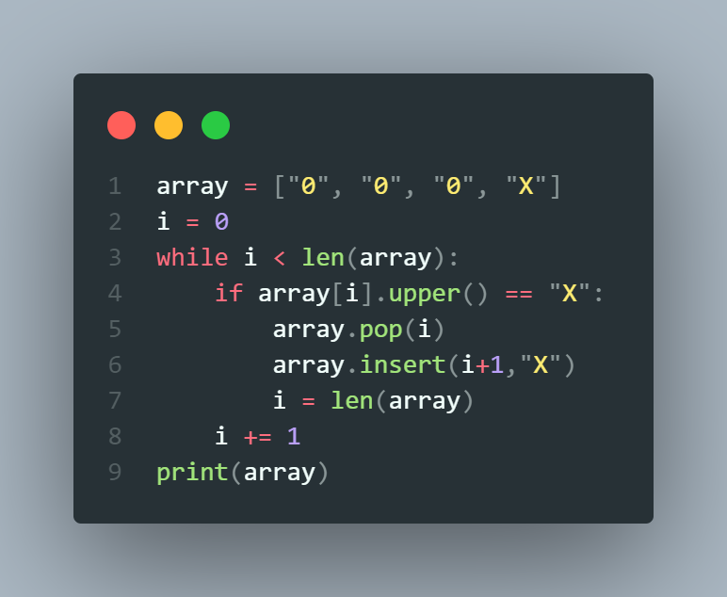

## Output

The same array, but the X has been moved to the RIGHT

Example: ["0", "0", "X", "0"]

Note : if the X is already at the last position, it cannot be moved, so just print the same array

(no change)

Examples



**BATCH-2023-C2-ARRAY-S10**

**…**

10000

minutes

|  |  |  |  |  |
| --- | --- | --- | --- | --- |
| Input | | | Output | |
|  | ["0", "X", "0", "0"] |  |  | ["0", "0", "X", "0"]    Explanation:  We moved the X on the RIGHT |
|  |
|  | ["0", "0", "0","0", "0", "X"] | |  | ["0", "0", "0","0", "0", "X"]    Explanation:  We cannot move more to the right, just print the same |
|  | |

# Question - 2

**Filter value of array that has duplicate value.**

Filter value of array that has duplicate value.

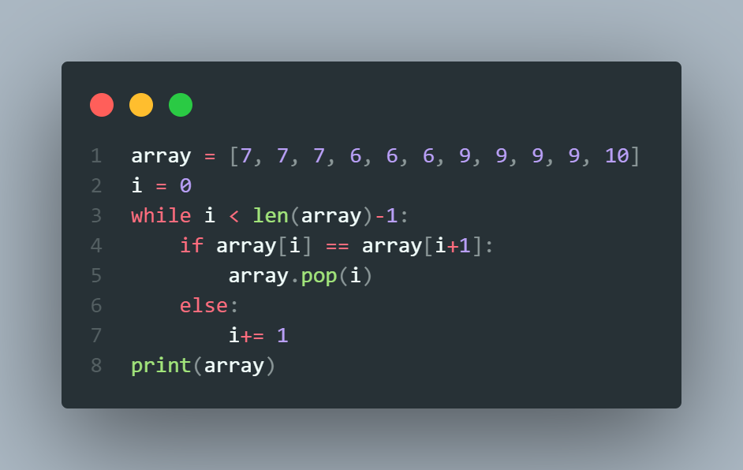

## Input

An Array

## Output

An Array

|  |  |  |  |  |  |
| --- | --- | --- | --- | --- | --- |
| INPUT | | | | OUTPUT | |
|  | [7, 7, 7, 6, 6, 6, 9, 9, 9, 9, 10] | | |  | [7, 6, 9, 10] |
|  | | |
|  | [7, 7, 7, 6, 10] | |  |  | [7, 6, 10] |
|  | |
|  | [7, 6, 10] |  | |  | [7, 6, 10] |
|  |

Question - 3 **Add Value to The End of Array**

**INPUT**:

* A array of strings (list of names) *Example:* [“ronan”, “rady” ]

* A string ( a name)

*Example:* “seiha”

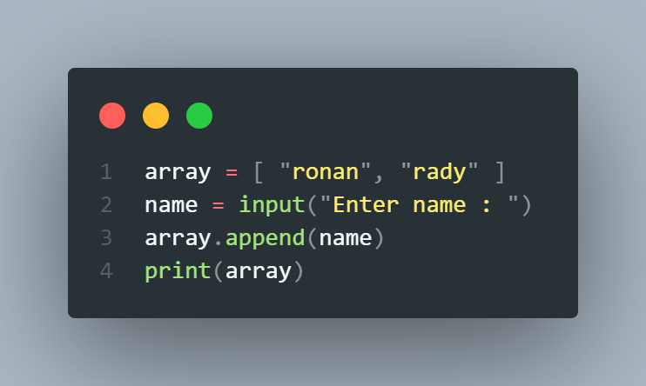

**OUTPUT:**

* A array of string : the intial array with the new nameadded at the end of an array

*Example:* [“ronan”, “rady” , '"seiha"]

Question - 4 **[ARRAY] Remove 7 From Array**

I**NPUT:**

* A array of integers

*Example:* number = [4, 5, 6, 3, 7, 8 ]

*\*\*\*Note: This exercise assumes that 7 exists only once in an array*

**OUTPUT:**

* A array of integers - without the number 7

*Example:* [4, 5, 6, 3, 8 ]

*\*\*\*You must follow these steps:*

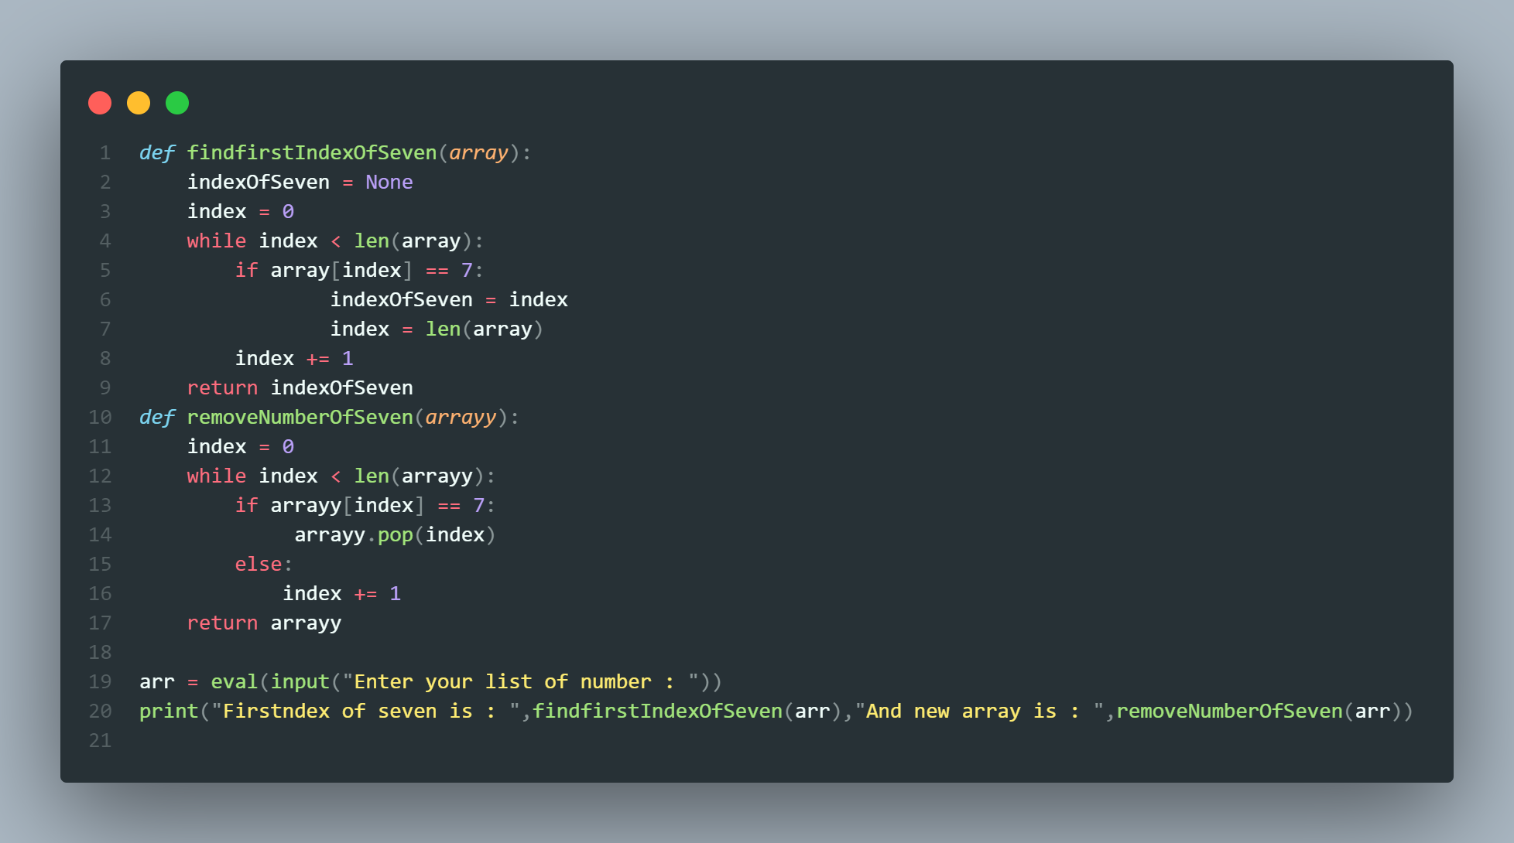

**STEP1**: Write a function to find the index of 7 in an array and your function must return an index (integer)

|  |  |
| --- | --- |
| Function  name | findIndexOfSeven |
| Paramete  rs | array (integer) |
| Return  value | index (integer) |
| Example  s | findIndexOfSeven( [5, 7, 2, 11] ) --> 1 |

**STEP2**: Use the return value of your previous function to remove 7 from an original array

**STEP3**: Print the array after removing 7

# Question - 5

**Find the position of number 7 (row & column)**

Find the position of number 7 (row & column)

* INPUT

Array 2D of numbers

* OUTPUT

the position of number 7 (row and column)

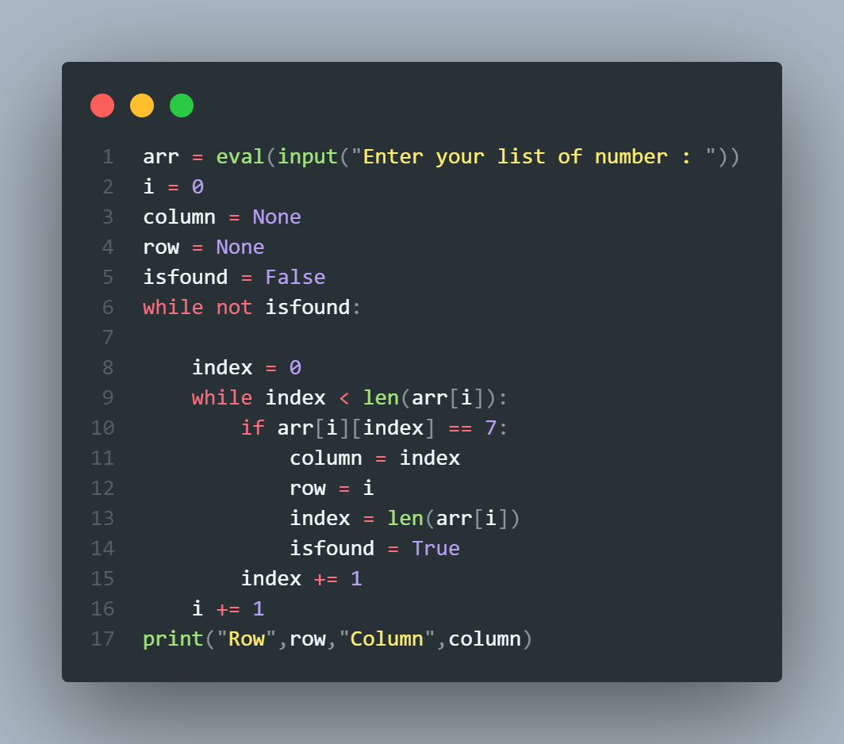

**Example:**

|  |  |
| --- | --- |
| INPUT | OUTPUT |
| [  [1,2,3],  [4,5,6],  [7,8,9]  ] | Row: 2 and Column: 0 |
| [  [1, 7,3],  [4,5,6],  [1,8,9]  ] | Row: 0 and Column: 1 |
| [  [1,3 ,3], [4, 7,6],  [1,8,9]  ] | Row: 1 and Column: 1 |