# Question - 1

**Update values in an array, if less than 10**

Check if in number in list less than 10 update its value to 10

(No need to create new array)

Input

An ARRAY

Output

An STRING, each value sperated by a **space**

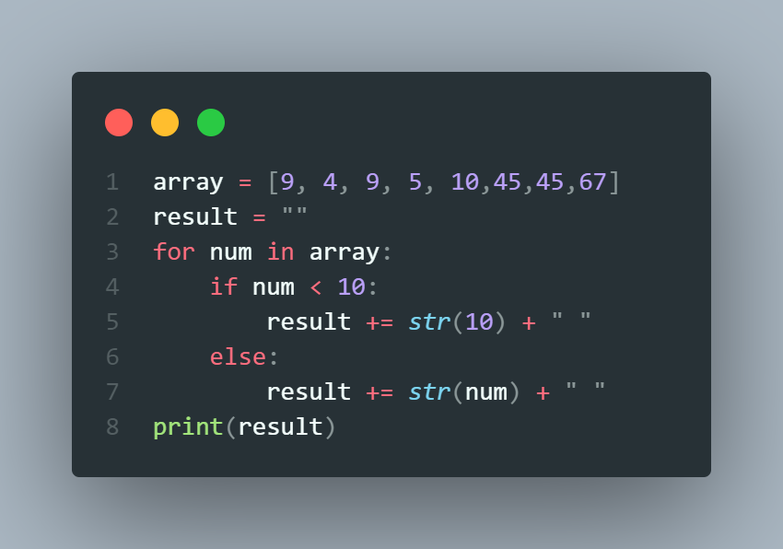

|  |  |  |  |  |  |
| --- | --- | --- | --- | --- | --- |
| INPUT | | | | OUTPUT | |
|  | [9, 4, 9, 5, 10] | |  |  | 10 10 10 10 10 |
|  | |
|  | [9, 7, 2, 17, 46] | | |  | 10 10 10 17 46 |
|  | | |
|  | [10] |  | |  | 10 |
|  |

# Question - 2

**[ARRAY] Transfer Array Values to Another Array**



**BATCH-2023-C2-S13-PRACT**

**…**

10000

minutes

**INPUT:**

* An array of integers (ORIGINAL array)

*Example*

*: originalArray = [3, 4, 2, 5, 3, 2]*

**OUTPUT:**

* NEW array of integers

*\*\*\*The new array must include each of the values from original array + 1*

*Example: newArray = [4, 5, 3, 6, 4, 3] --> Because: originalArray = [3+1,*

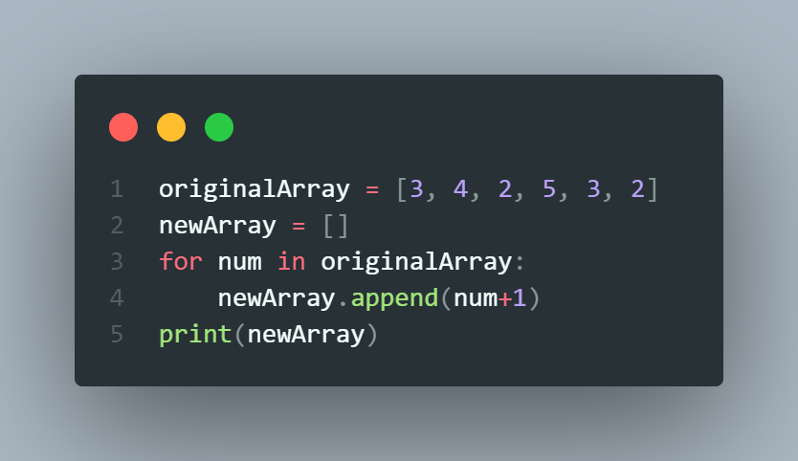

*4+1, 2+1, 5+1, 3+1, 2+1]*

Example1:

Input: [3,4,5,2]

Output: [4,5,6,3]

Example2:

Input: [1,7,5,2,0]

Output: [2,8,6,3,1]

# Question - 3

**[ARRAY] Remove 7 From Array**

I**NPUT:**

* A array of integers

*Example:* number = [4, 5, 6, 3, 7, 8 ]

*\*\*\*Note: This exercise assumes that 7 exists only once in an array*

**OUTPUT:**

* A array of integers - without the number 7

*Example:* [4, 5, 6, 3, 8 ]

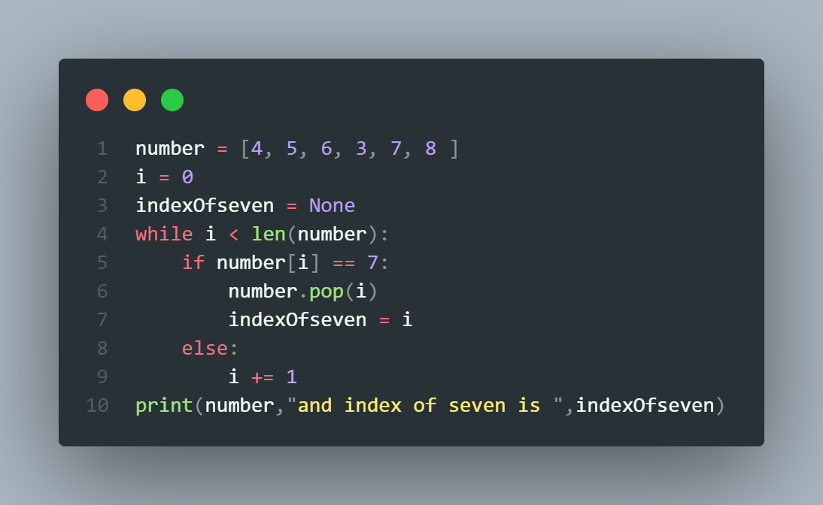

*\*\*\*You must follow these steps:*

**STEP1**: Write a function to find the index of 7 in an array and your function must return an index (integer)

|  |  |
| --- | --- |
| Function  name | findIndexOfSeven |
| Paramete  rs | array (integer) |
| Return  value | index (integer) |
| Example  s | findIndexOfSeven( [5, 7, 2, 11] ) --> 1 |

**STEP2**: Use the return value of your previous function to remove 7 from an original array

**STEP3**: Print the array after removing 7

# Question - 4

**[ARRAY] Replace 1 by 0 in an array**

**INPUT:**

* Enter an array of integers into the console

*\*\*\*array is not given, you have to code it using* ***eval(input())***

**OUTPUT:**

* An array: the same array, but after the replacement of 1 with 0.

*Example 1:*

[4,1,6,5,8]

[4,0,6,5,8] --> 1 is replaced by 0

*Example 2:*

[3,4,3,2]

[3,4,3,2] --> Nothing changed

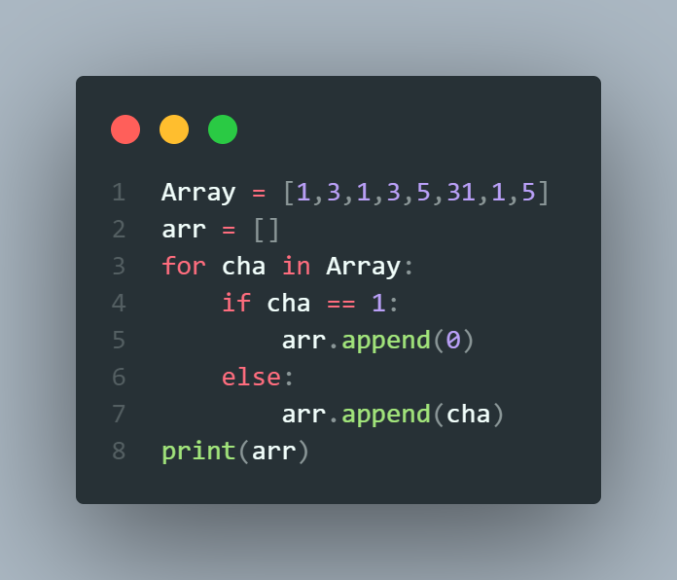

**FUNCTION:**

|  |  |
| --- | --- |
| **Function name** | replaceOne |
| **Parameters** | array (an **array**) |
| **Return value** | array after replacement (an array) |
| **Examples** | numberOfSevens ( [5, 7, 7, 1] ) --> [5,7,7,0] |

# Question - 5

**Find average of odd number in list.**

# Find average of odd number in list (truncate the average to the integer value)

|  |  |
| --- | --- |
|  |  |

Input

An array

Output

A integer

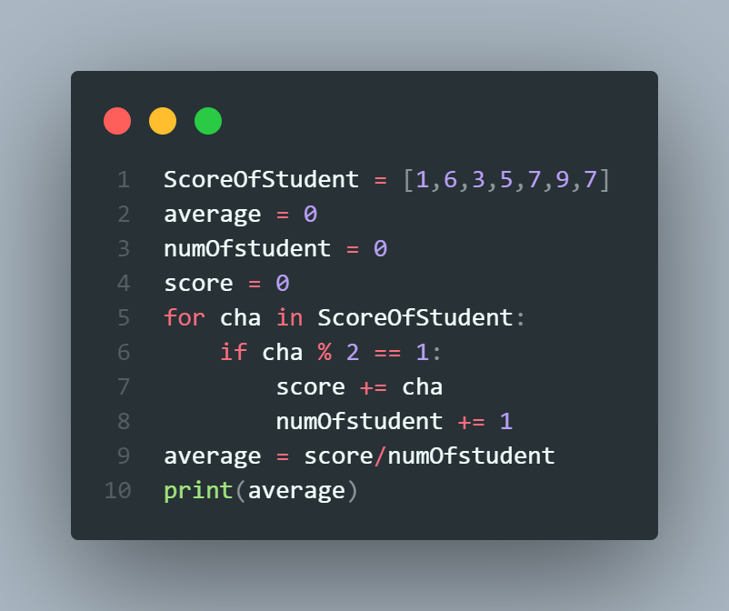

|  |  |
| --- | --- |
| INPUT OUTPUT | |
| [1, 3, 5, 6, 8] | 3 |
| [1, 2, 3, 5, 20, 3] | 3 |
| [4, 5, 8, 7] | 6 |