DaBin App Store Content
  - Version 0 4 41 Build 96 English US 6 October 2026
Use this document to populate DaBin’s Mac App Store listing, prepare the review submission and publish the supporting privacy and support content. The screenshot pages show the current native interface; the accompanying folder contains the original upload images and plain text fields.
This local review draft is not ready for submission while quality, performance or release gates remain open. Complete the owner fields and release checks before submission. Copy only the text under the relevant field into App Store Connect. Reviewer notes are private; listing copy, support details and the privacy policy are public.

App information
Field | Value | Status
Platform | macOS | Prepared
App name | DaBin | Name availability to confirm
Subtitle | Save, organize and focus | 24 of 30 characters
Primary category | Productivity | Proposed
Primary language | English US | Proposed
Bundle ID | com.dabin.mac | Confirm Connect record
Version and build | 0.4.41 / 96 | Confirm build availability
Requirements | Apple Silicon / macOS 14 or later | Current build
SKU | [OWNER APP SKU] | Private app record field
Secondary category | None proposed | Optional

Promotional text
A little robot for the useful bits of your day. Save ideas, links and files, keep projects together, and give one task your attention - all on your Mac.
152 of 170 characters. Public product page field.

Keywords
clipboard,screenshots,notes,files,tasks,projects,focus,reminders,organizer,local,robot
86 of 100 bytes. Paste as one comma-separated line.

Product description
Public Description field | 1723 of 4000 characters
DaBin keeps the useful bits of your day together on your Mac: notes, links, images, files and tasks.

Save and find
Paste content, drop files, or create a note or task. Search your saved content across DaBin and browse results in date columns. Local text recognition helps find words in supported images and documents. Search covers content saved into DaBin, not every file on your Mac.

Organize your projects
Keep related captures and tasks in projects with recognizable colors. Preview saved content, add notes, use priority tags and export selected items as a ZIP to a location you choose.

Focus on a task
Plan your day and choose a focus duration. When a running timer finishes, the little desktop robot shows an alarm with the first three words of your task title. Click the robot to dismiss it; the task stays open until you complete it.

Optional Auto Capture
Auto Capture starts off. After you enable it, DaBin can save later clipboard changes and new images from a screenshot folder you select. It does not record your screen or import existing screenshots. Choose a destination and pause at any time. A red recording symbol in the menu bar shows active monitoring. App exclusions and sensitive-clipboard checks help reduce unwanted captures, but cannot guarantee that all sensitive content is detected.

Local by design
No account, advertising, analytics or cloud sync. Saved captures, notes and recognized text stay on this Mac. Website previews are optional and off by default; enabling them can contact manually saved websites. Automatically captured links never fetch previews. You control exports, local backups, Recently Deleted and permanent deletion.
Made for Apple Silicon Macs with macOS 14 or later.

Whats New for an update
Use this field only for a subsequent App Store version. Apple does not offer it for a first App Store version.
The little DaBin companion peeks out as you approach and opens with one click. Successful automatic saves bring a nod, wiggle or sign raise, with rapid saves sharing an item count. Quiet mode and Reduce Motion use a still expression. Captions, Tasks and Projects have compact controls; project dates can be picked by day or week, and Export Selected saves only the items you check.

App Review notes
Private App Review Information | No sign in required | No demo credentials
DaBin is an Apple Silicon macOS menu-bar/desktop app. It requires macOS 14 or later and has no login, paid unlock, ads or server account.
Start: Open DaBin; use its menu-bar item or click the revealed desktop robot once to open the board. The upper + opens a new task directly. Captions and Tasks use compact single-row controls. Projects places filters, the day/week date picker, view controls and Export Selected together; export requires checked items and includes only those items. Quit through the menu bar or Settings. Closing the board leaves the menu-bar app running; Quit shuts its services down.
Manual capture: Paste text or a link with Cmd-V, or drop a fictional image/file into the app. Create a note/task, assign a project and search for its content. Search accepts typing, context-menu paste and Cmd-V; results are grouped by date. Export and archive backup use native destination pickers. Local OCR/document search is limited to saved supported content.
Auto Capture: OFF on first launch. Enable it through its explicit consent flow, choose clipboard and/or screenshots, and choose a destination. Screenshot monitoring requires selecting a folder in the macOS picker; it monitors only new regular images, not existing files or the live display. The menu-bar icon becomes a red recording symbol while monitoring, even with the board closed or Quiet mode on. Ready, Paused and Off are separate states. Successful saves produce a generic companion acknowledgement; rapid saves can share a count such as Saved 3 items. Clicking the revealed companion opens the board during movement. Quiet mode and Reduce Motion use a static expression without body animation. Pause or turn off to stop monitoring. Automatically captured links never fetch remote previews. Source-app exclusions and sensitive-pasteboard checks are best-effort.
Privacy: Settings → Privacy policy & data controls contains the full bundled policy, local deletion instructions and online policy/support links. Captures are stored on device. The bundled policy is Updated 5 October 2026. Persistent destination labels may reveal the project name locally. Website previews are optional, off by default, and only apply to manually saved links. There is no analytics, advertising or cloud-sync SDK. The app does not request Accessibility, Screen Recording, camera or microphone access. Reminder permission is requested only when a reminder is saved; notifications use generic text. A completed focus timer can show the first three words of the task title locally.
Store build: App Sandbox is enabled. User-selected files and scoped bookmarks support import/export and screenshot-folder access. The direct-download updater and installer are excluded from this binary; updates are managed by the Mac App Store. No automatic launch-at-login or privileged helper is installed.
Suggested review: verify manual save/search/task/project/export; opt into clipboard capture using fictional text; opt into a new screenshot in a chosen temporary folder; pause and confirm monitoring stops; disable capture and quit. No demo credentials are needed.
2531 of 4000 bytes. Enter the real review contact separately on the owner details page. The Quick Guide PDF can be attached as supplemental review material if useful.

Screenshot 1 Captions
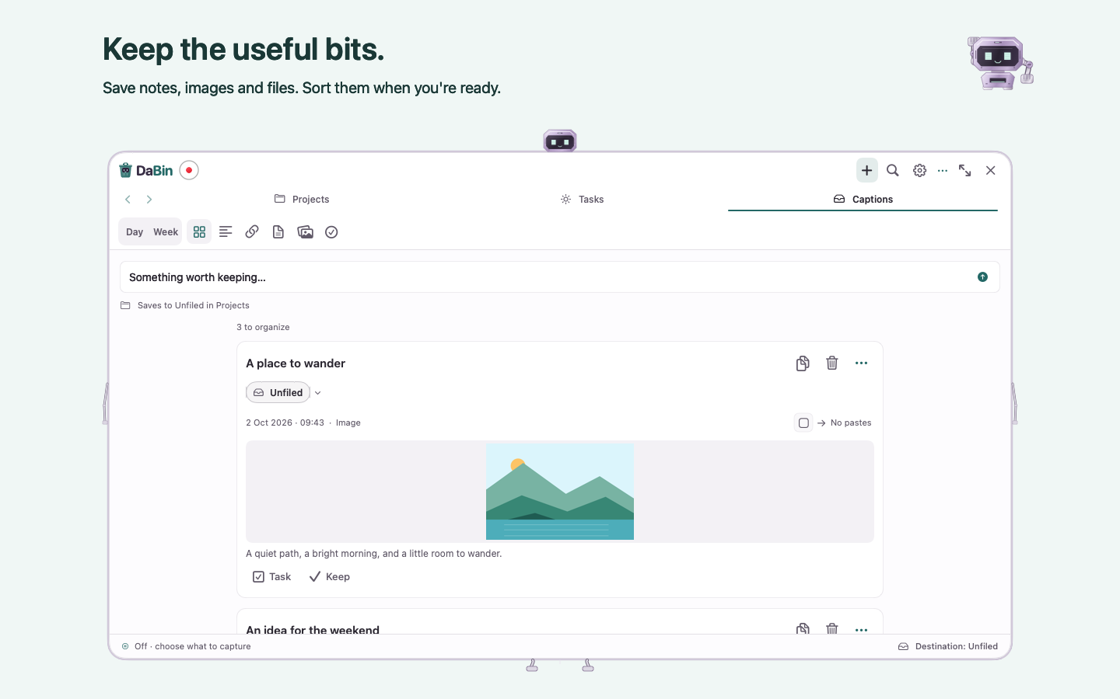
DABIN__APP_STORE__01_INBOX.png | 1440 × 900 | RGB PNG | No transparency
Upload the original PNG from Screenshots in this order. Compare against the final signed app and confirm artwork rights before upload.

Screenshot 2 Projects
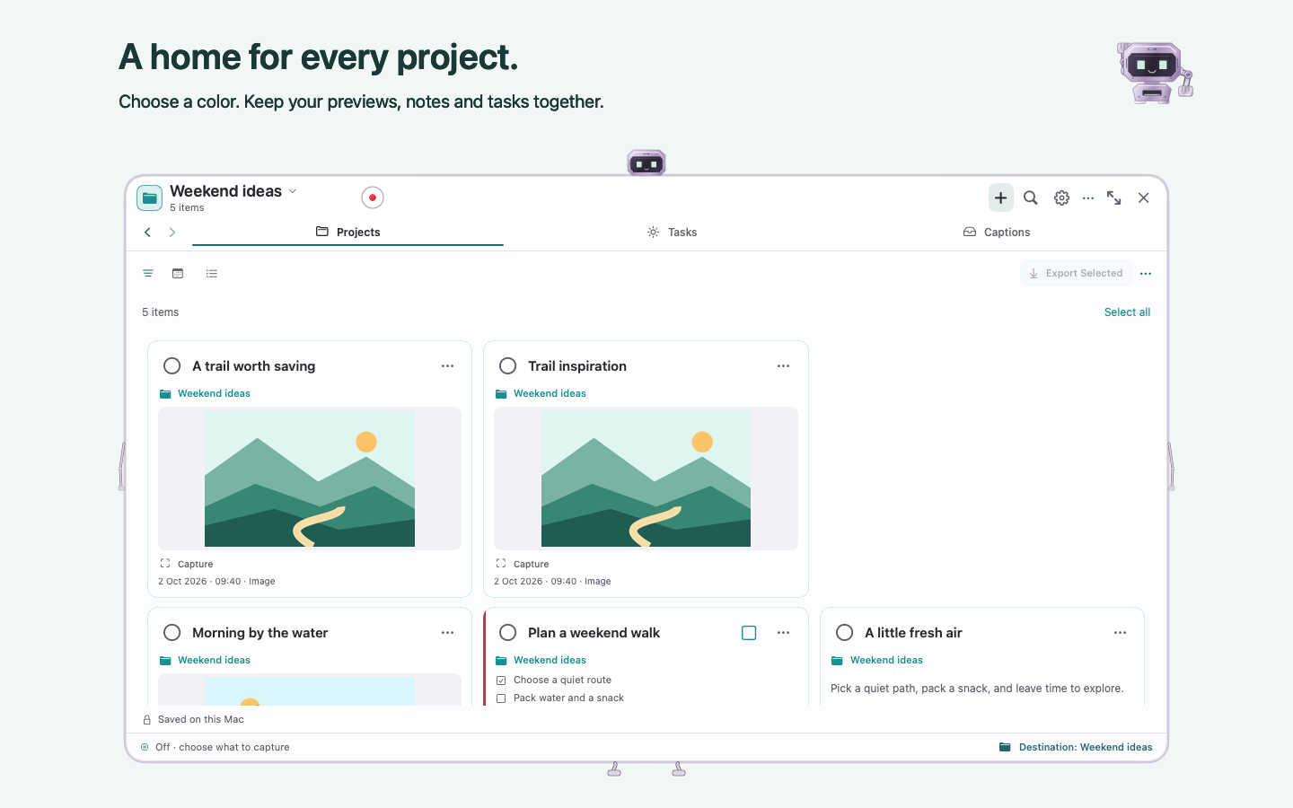
DABIN__APP_STORE__02_PROJECTS.png | 1440 × 900 | RGB PNG | No transparency
Upload the original PNG from Screenshots in this order. Compare against the final signed app and confirm artwork rights before upload.

Screenshot 3 Focus
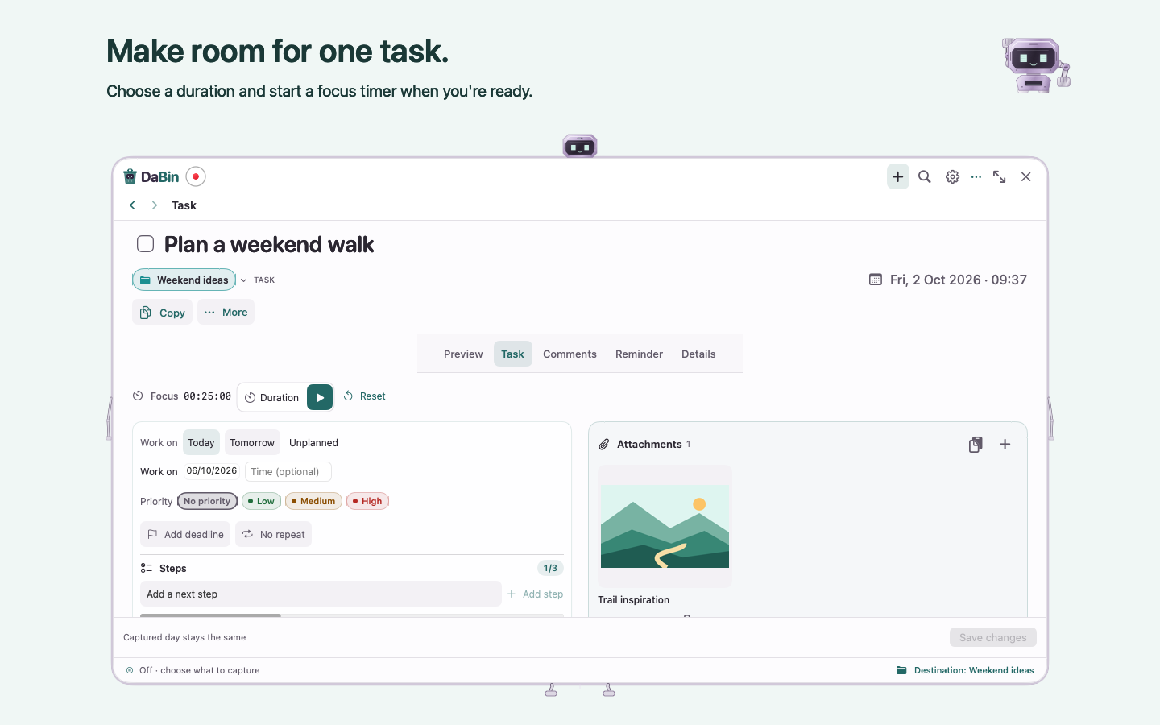
DABIN__APP_STORE__03_FOCUS.png | 1440 × 900 | RGB PNG | No transparency
Upload the original PNG from Screenshots in this order. Compare against the final signed app and confirm artwork rights before upload.

Privacy and declarations
Confirm these answers against the exact distribution-signed build and the current App Store Connect questionnaires. These are proposed answers supported by the current source audit, not completed account declarations.
Declaration | Prepared answer or required decision
App Privacy | Data Not Collected is proposed. Saved captures, notes, recognized text and usage remain on device; the developer receives none of them. Owner confirmation is required.
Tracking | No tracking in the audited source. No advertising or analytics SDK was found.
Optional networking | Website previews are off by default. Enabling them can send URLs and connection data to websites for manually saved links. Automatic links never fetch previews. Review this behavior when completing privacy answers.
Privacy URL | Use the linked policy below after publishing the 5 October 2026 text and verifying that the public and bundled versions match.
Age rating | Complete Apple’s current questionnaire. No numeric rating is assigned in this pack; assess actual features and optional website access.
Export compliance | Uses non-exempt encryption: false is proposed in the current metadata. The audited implementation uses system HTTPS. Owner must confirm the current questionnaire and any regional documentation.
Content rights | Questionnaire: [OWNER ANSWER]. Confirm permission for third-party content displayed or accessed, including optional website previews. Also confirm rights to the app, name, robot, icon and screenshot artwork. Local storage does not determine the rights answer.
Accessibility labels | Optional declarations. Claim only features evaluated against Apple’s criteria in the exact signed app. No label is claimed by this pack.
License agreement | Apple’s standard agreement is a proposed default. Owner must select it or provide a reviewed custom agreement.

Privacy policy destination

Permissions and behavior for review
Auto Capture starts off and uses explicit opt-in. Screenshot monitoring uses a folder chosen in the macOS picker. Reminder notifications are requested when a reminder is saved. DaBin does not request Accessibility, Screen Recording, camera or microphone access. Mac App Store builds use the sandbox and App Store updates; the direct-download updater is excluded.

Owner details and release checks
Fill these fields in a private copy. Review contact details belong in App Store Connect and must not be placed in the public support page or a public repository.
Field | Owner response
Connect record | [APPLE ID] / [DEVELOPER DISPLAY NAME]
Legal rights holder | [LEGAL NAME]
Copyright field | 2026 [LEGAL RIGHTS HOLDER]
Public support email | [PUBLIC SUPPORT EMAIL]
Public support URL | [MAINTAINED PUBLIC SUPPORT URL]
Private review contact | [FIRST NAME] [LAST NAME]
Private review email | [REVIEW EMAIL]
Private review phone | [PHONE WITH COUNTRY CODE]
Price and tax category | [PRICE] / [TAX CATEGORY]
Countries and regions | [AVAILABILITY]
Release method | [MANUAL OR AUTOMATIC RELEASE]
EU trader declaration | [TRADER STATUS AND REQUIRED VERIFIED DETAILS]
Optional public URLs | [MARKETING] / [PRIVACY CHOICES] / [ACCESSIBILITY]

Release status
Native QA: failed. The final source-unchanged Release Store campaign completed with 125 of 126 suites passing; strict zoom performance is the sole native-suite failure. The unsigned Store compile/preflight passed. Completed XCTest readback confirms 2 of 2 tests passed with 0 failures and preserves the unsigned executable hash. A fresh/private/tmp ad-hoc sandbox fixture passed save and reopen/export. The privacy render command and all 4 original-resolution visual inspections passed. The original coordinator report retains the timing failure and the earlier collector/FileProvider failures; separate readback/rerun receipts retain their correction evidence. The local direct Release version was updated to 0.4.41 (96) with the prior app backed up and both archive inventories preserved; the two direct updater suites passed. Normal product launch and the physical external drop matrix remain untested.
Performance: failed. Strict zoom performance remains failed against unchanged 50 ms input-to-layout and 33 ms steady-timer budgets. The 30-second campaign measured p95 input 51.3154 ms and steady timer 61.2394 ms. The original unsampled 600-second workload completed 600.02 measured seconds with 5,399 captures and 5 zoom/navigation cycles; p95 input 53.6320 ms and steady timer 63.0316 ms still exceeded the gates. Completion is not performance acceptance. These synthetic offscreen measurements do not measure physical input-to-display latency or certify absence of leaks.
- Strict zoom timing exceeds the unchanged internal 50 ms input-to-layout and 33 ms steady-timer budgets.
- An unresolved reentrant NSTableView warning remains in the zoom fixture logs.
- Physical input and a second monitor remain untested. An isolated fictional same-app note drop passed; real external app/browser drop acceptance remains untested.
- The public policy serves older 4 October text; exact parity with the bundled 5 October policy awaits authorized publication.
- Owner fields, distribution signing/validation and Apple account/review steps remain pending.
A hash-verified production module proves matching compiled inputs. It does not prove that every runtime suite passed, that performance budgets were met, or that distribution signing and Apple review are complete.

Before submitting
- Confirm the app record, name availability, SKU, developer display name, bundle ID and version/build number. Complete current agreements and applicable banking, tax or regional information. Declare EU trader status even if EU distribution is excluded.
- Publish the supplied privacy policy and a maintained support page with real contact details. The previously checked public policy still contained the older text; publication and parity verification remain open.
- Resolve distribution signing and the Mac Installer Distribution identity. Export and validate the final package, then upload and select the processed build when authorized.
- Finish signed-app acceptance: fresh install and upgrade, folder grants and revocation, save/search/export, cross-app drops, reminders and quit behavior. Verify macOS 14 and the current shipping macOS, VoiceOver/keyboard, energy and IPv6-only networking.
- Compare every screenshot against the signed app, confirm rights, complete privacy/age/encryption declarations and select the release method. Apple review is still required.

Support page copy
Replace the two contact placeholders before publishing. Add the Quick Guide PDF and the privacy policy link to the support page.

Contact support
Email: [PUBLIC SUPPORT EMAIL]
Support page: [PUBLIC SUPPORT URL]
Include your DaBin version, macOS version and the steps that led to the issue. Use fictional examples and remove private material from any screenshots. Do not send your capture archive, passwords or sensitive clipboard contents.

Getting started
Open DaBin from its menu-bar item or click the revealed desktop robot once. Paste text or a link into Captions, or drop in a file. Use the upper + button to create a task directly. Keep related work in a project and use Search to find it again.

What does Search cover
Search finds content saved into DaBin, across projects and dates. You can type, use the context-menu Paste action or press Command-V in the search field. Results appear in date columns. Local text recognition also indexes supported saved images and documents; it does not search every file on your Mac.

Does Auto Capture record my screen
No. Auto Capture is optional and starts off. After you enable it, DaBin can save later clipboard changes and new images added to the screenshot folder you choose. Existing clipboard contents and existing images are not imported when monitoring starts. The red menu-bar symbol indicates active monitoring. Pause or switch it off whenever you need to.

Where is my content stored
On this Mac. DaBin has no account, cloud sync, advertising or analytics. Optional website previews are off by default and can contact websites for manually saved links. Automatic captures never fetch link previews. Exports and backups are stored in the location you choose; a cloud-synced destination may upload them through that service.

How do I move content to another app
Drag a card or caption to a destination that accepts its text, link, image or file representation. The receiving app controls what it can accept. You can also copy and paste or export. DaBin keeps its saved content, and original source files remain in place.

How do I export a project selection
In Projects, check the items you want and choose Export Selected. DaBin creates a ZIP containing those selected items at the destination you choose. The day/week date picker and filters help narrow the workspace; selecting a date or filter alone does not select items for export.

How does the companion respond
With Auto Capture off, approach the chosen corner or camera island to reveal the companion. Click once to open DaBin, including during movement. Successful automatic saves use generic acknowledgements; rapid saves can share an item count. Quiet mode and Reduce Motion keep the expression still. Paused capture remains clearly labeled.

How do I back up or remove content
Use More > Back up archive to create a local backup. Recently Deleted lets you restore removed captures or delete them permanently. Turning Auto Capture off stops new monitoring but keeps earlier captures. See Settings > Privacy policy & data controls for complete deletion instructions.

Which Macs are supported
DaBin 0.4.41 requires an Apple Silicon Mac with macOS 14 or later. The Mac App Store version receives updates through the App Store.
Read the DaBin privacy policy

DaBin privacy and your data
The following is the full policy bundled with DaBin 0.4.41. Publish the matching text at the public Privacy Policy URL before submission. It covers both the direct download and Mac App Store distribution channels.
Updated 5 October 2026

Your daily board stays on your Mac
DaBin saves the content you choose to paste, drop or type: text, links, files, tasks, comments and reminders. If you separately enable Auto Capture, it can also save later clipboard changes and new image files from a folder you authorize as your screenshot location. DaBin keeps capture time, any available source path or URL, best-effort source-application information for automatic captures, and local preview information. These help you find your work again. Original files stay at their source; DaBin keeps its own copies.
DaBin has no account, cloud sync, ads, analytics or external AI service. The developer does not receive your captures, searches or usage. DaBin does not track you across apps or websites.

Local text recognition and search
DaBin uses Apple frameworks on this Mac to recognize text in saved images, screenshots, PDFs and supported text documents. It reads DaBin's own saved copy after the capture succeeds. Recognition does not record the live screen, contact a website, use an external AI service or upload the file or recognized text. It does not require Screen Recording permission.
Recognized text is stored with the capture in the same local archive and is used by Search and text exports. A PDF with an existing text layer is read directly; image-only pages are recognized locally. DaBin limits the amount of very large documents it processes and reports a partial index when that limit applies. You can inspect recognized text in capture details and rebuild the local index from Settings. Moving a capture to Recently Deleted hides its recognized text from search; permanently deleting the capture also removes its recognized text.

Manual capture
With Auto Capture off, the clipboard is read only when you explicitly paste into DaBin. Hovering over the robot does not read it. DaBin reads your pointer position to reveal the robot at a screen corner or, if you select it on a compatible Mac, around the built-in camera island. Camera-island placement uses ordinary macOS screen safe-area geometry; it does not use the camera, record your screen or monitor what you type elsewhere.
Manual file captures are accessed through your paste, drop or Import files selection. Outside the screenshot location you separately authorize for Auto Capture, DaBin does not scan your folders. Theme, window position, robot-home, preview and Auto Capture preferences are stored locally. Optional global shortcuts register only the specific key combinations shown in Settings. The save-clipboard shortcut is an explicit paste action; shortcuts do not monitor general typing and do not require Accessibility permission.

Optional Auto Capture
Auto Capture is off by default. Clipboard and screenshot-folder monitoring have independent switches. Clipboard capture does not require a screenshot-folder grant. Existing installations that enabled the previous combined Auto Capture setting retain both channels during migration. When clipboard monitoring starts, DaBin records the clipboard's current change count as a baseline. It does not import what was already on the clipboard; only changes made after enabling or resuming monitoring are considered. Choosing Pause stops both channels; disabling an individual switch stops that channel. Content already saved remains in your archive until you permanently delete it.
To watch screenshots, DaBin asks you to choose their save folder with the macOS folder picker. It stores a security-scoped bookmark locally so it can regain access to that chosen location while monitoring is enabled. Existing images form a baseline and are not imported when monitoring starts. New regular image files added there are treated as screenshot captures, even if another app created them for a different purpose, so DaBin recommends a dedicated screenshot folder. DaBin does not scan unrelated folders. Revoking the folder grant stops screenshot-folder capture until you choose a folder again; independently enabled clipboard capture can continue.
macOS does not provide apps with a public notification for every system screenshot. Folder monitoring therefore covers screenshots written to the location you chose. A screenshot whose destination is the clipboard can be detected as a later clipboard change. Screenshots saved elsewhere are outside the chosen folder monitor. DaBin reads the resulting file or clipboard representation; it does not record the live screen and does not request Screen Recording access for this feature.
DaBin saves a source application when macOS makes one reasonably identifiable at capture time. This is best-effort information: focus can change, and the app can be unknown or imprecise. It is not proof of where content originated. DaBin itself and common password managers are excluded by default. Because source detection has limits, these exclusions are an additional safeguard rather than a guarantee. Pause or turn off Auto Capture before handling content you do not want it to observe.
For a single image seen through both the screenshot folder and clipboard within a short interval, DaBin compares a normalized image fingerprint and suppresses the second channel's copy. Copying the same image again through one channel remains a new action. Automatic captures use the same local archive as manual captures. Their contents are not uploaded. Automatically captured links never fetch website previews, even if Fetch link previews is enabled for manually saved links.
Successful automatic saves produce a brief robot confirmation after the item has been saved. The confirmation uses the item type or a combined "Saved N items" acknowledgement rather than the saved text, image or file. Clicking the revealed robot opens DaBin, including while it moves. Quiet mode and Reduce Motion keep these confirmations still.
When Auto Capture has a project destination, the persistent robot holds a sign with that project name. Pausing shows "Paused" alongside the destination; a destination without a project is labelled "Unfiled". These local labels can reveal a project name to someone viewing your screen. The menu bar uses a red recording symbol while capture is active, including when the board is closed or Quiet mode is on. The robot panels request exclusion from window capture, but macOS does not guarantee that every screenshot or third-party screen recorder will honor that exclusion.
Four or more successful automatic actions in the same capture hour appear as an expandable hourly group in Inbox's Day view.

Optional website previews
Fetch link previews is off by default. Turning it on contacts websites for eligible manually saved links that need a preview, including earlier manual captures, and for new manual links. Automatically captured links are never eligible for these requests. For an eligible link, the requested URL and your IP address reach the website and any servers it uses for redirects, images or icons. The website may log these requests under its own privacy policy. Only enable previews for links you are comfortable contacting.
DaBin uses Apple's Link Presentation framework for these requests. It does not send your files, notes, comments or tasks to those websites. Preview titles and images are saved locally.
Turn Fetch link previews off in Settings to stop queued requests and cancel active preview requests. This cannot undo requests already sent and does not remove previews already saved. Opening a saved link launches your browser, whose settings and the website's privacy policy apply.

Software updates
The direct GitHub build checks for updates only when you choose Check for Updates. That request contacts GitHub, which receives your IP address and ordinary connection information under GitHub's privacy policy. DaBin does not send captures, searches, comments, reminders, file names or archive contents.
When you choose Download & install, DaBin downloads the published release package from GitHub into its sandbox. It verifies the package's HTTPS origin, exact size and SHA-256 checksum before opening the built-in installer. The installer asks before changing the application, verifies the app, backs up the previous installation and leaves the capture archive in place. DaBin does not check or download updates silently. Mac App Store builds receive updates through the App Store instead.

Reminders
DaBin asks for notification permission when you first save a reminder. Notifications are scheduled locally through macOS with a generic message, without the capture's contents. You can turn off a reminder in its record and save, or change DaBin's notification permission in System Settings.
Task focus timers are separate from system reminders. When a timer you start finishes while DaBin is running, the robot shows a visual alarm clock and a sign with the first three words of the task title. Those words are visible locally to someone viewing your screen; they are not uploaded or placed in the generic reminder notification. Pressing the robot dismisses the alarm without marking the task completed. Quiet mode and Reduce Motion stop its animations but do not hide a waiting timer alarm. Its panel requests exclusion from window capture, but this is not a guarantee against screenshots or third-party screen recording.

Keeping and removing your data
By default, captures and saved previews stay on this Mac until you remove them. There is no cloud copy. If you enable clipboard retention in Settings, eligible inactive automatic clipboard captures move to Recently Deleted after the interval you choose. Pinned items, tasks and their attachments, project resources, reminders, named snippets and shelf items are protected. Editing or restoring an eligible capture restarts its retention interval. Clear unfiled copies uses the same recoverable removal; neither option deletes your original source files or empties Recently Deleted. Pausing or disabling Auto Capture stops new monitoring but does not delete earlier captures. Marking a task Completed keeps its original record. Minimize only collapses a capture on the board; it keeps the saved content.
Choose Move to Recently Deleted on a capture and confirm to hide it from the active archive and cancel its notification. Its original, notes, recognized text, pins, project and saved copies remain available for Undo or Restore. Recently Deleted has no automatic expiry. Choose Delete permanently there and confirm to remove its record and DaBin's saved copies, including previews and recovery copies. Permanent deletion cannot be undone in DaBin. Source files in their original locations are kept. If DaBin cannot finish removing local copies, it shows a warning and retries when you open the app again.
To remove all captures, first turn Auto Capture and Fetch link previews off, then turn off and save any active reminders. Choose Show DaBin data folder below, then quit DaBin. In Finder, move that whole DaBin data folder to Trash. Empty Trash when you are ready to permanently remove it. Do not delete only the database or individual day folders while keeping the rest of the archive.
Removing this data folder removes DaBin's capture index, archive, copied originals, previews and recovery copies together. Original files elsewhere on your Mac, exports and backups are separate and are not removed. Theme, window, robot-home and Auto Capture preferences, including the selected-folder bookmark, are stored separately and may remain. Removing the app alone may leave its local data on the Mac. Removal is ordinary file and database deletion; DaBin does not promise forensic secure erasure.

Backups and security
DaBin uses the macOS app sandbox. Its local data is not separately encrypted by DaBin; your Mac's account access and disk protection apply. Backups you create, including system backups, can contain your captures. You control their retention and removal.
More → Back up archive creates a local .dabinbackup folder at the location you choose. It contains capture metadata, originals, saved previews, recognized text, notes, organization and Recently Deleted items. It does not include application preferences or screenshot-folder grants. Backup files are not separately encrypted. If you choose a folder synchronized by another service, that service may upload the backup under its own settings.
More → Restore archive backup verifies saved checksums and merges the backup into the current archive. Identical records are retained; conflicting existing records or files stop the restore instead of being overwritten. Restored future reminders are reconciled with macOS. To copy the live data folder manually, quit DaBin first. The developer cannot recover data that exists only on your Mac or delete your own backups for you.

Files and reference sources

Package contents
DaBin App Store Content is the editable submission document. DaBin Quick Guide is the updated customer PDF. Screenshots contains the three original PNGs; Assets contains the current 1024-pixel app icon and bundled ICNS for reference. Copy contains individual listing fields, reviewer notes, support copy, metadata JSON and the full policy. The package manifest records file sizes and checksums.
The app icon is delivered in the app build. An App Store preview video is optional and is not included in this pack. The updated PDF is a support and review attachment, not a substitute for product page screenshots.

Verification scope
The selected source and native screenshot fixture are version 0.4.41 build 96. Screenshots use fictional records and production native views. Compare them with the final distribution-signed app. Automated source checks and local preparation evidence do not complete owner declarations or signed-app acceptance.
This document concerns the Mac App Store channel. A separately installed direct-download app has its own update channel. The local direct-update evidence is separate from distribution-signed Store acceptance. This pack does not report an App Store upload, submission or approval.

Apple references
Apple references last checked 5 October 2026. Recheck the live App Store Connect forms before entering or submitting the prepared content.
Product page fields and limits
App information and content rights
Mac screenshot specifications
App Review Guidelines
App Privacy details
Current age rating questionnaire
EU trader requirements
Distribution and release workflow
Current submission requirements

Local sources
Product fields: docs/app-store/metadata-en-US.json. Privacy: the selected release’s bundled PrivacyPolicy.md. Native images: docs/app-store/screenshots/0.4.41-96/manifest.json. Release evidence: native/build/qa/runs/20261005T213352249116Z-app-store/report.json. The package contains separate copies of the public fields for App Store Connect.

