Author-Portfolio Task

Problem Statement  
**Author portfolio website assignment**

Header—

1.Use ootb(which comes by default with AEM) header component and create books about me, contact me and homepage. These pages should come in header with proper styling and make sure books have a drop-down so books should come.

1. Footer sections-  
   about me  
   contact me  
   books-list with hyperlink should be open in new tab  
   social media section-

Note for footer we can use text or list components to author the content.

1. Home page  
   use teaser component to display some award ceremony for author so that it could have image title and some description and one CTA (which will link to that page where user can user the entire new for that award..page will be created and authored on cta)  
   We can use at least 5-6 components including text , image , title or teaser component.
2. Books page-  
   create a book component which will get the books page as parent path (books page should be authored )  
   and that component should fetch all the books which you have created under /contact/books folder and make sure all of the books should be placed under /content/books folder  
   Now create book pages under /content/books hierarchy and author the page with title, image and text component. So that when a book component is authored it fetches these properties from each page to show on the books page as cards and each card should have Title, Description and image and make sure each card should have a unique title, description and image.
3. About me page  
   use Author component component to provide some information about Author only this component should be used on this page.
4. Contact me page-  
   We can use text or teaser components to provide contact details to connect with the author or some social media profile links so anybody can follow him on Social Media platform.  
   Note: Header and footer should be used at template level so every page can use it.  
   And to create the home page we can use the content page(OOTB template) but for the books page we have to use the book page template that was given as part of assignment previously.

Flowchart:

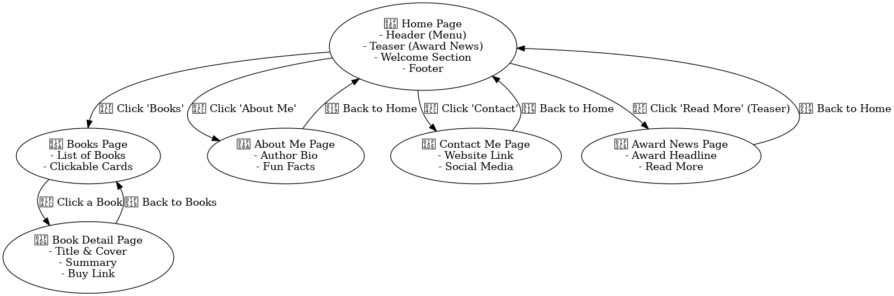

**Walkthrough of the Author Portfolio Project**

This **Author Portfolio Website** is a **Game of Thrones-themed** web project dedicated to **George R.R. Martin** and his works. It follows a structured approach to showcase the author’s biography, books, and achievements.

**📌 Project Structure & Navigation**

1. **Home Page**
   * Welcomes users to the world of Westeros.
   * Highlights key achievements with a teaser component.
   * Provides navigation to different sections (Books, About Me, Contact).
2. **Books Page**
   * Displays a list of books from *A Song of Ice and Fire* series.
   * Uses a **Custom Book Component** to fetch book details dynamically.
   * Each book is a clickable card that leads to its detailed page.
3. **Book Detail Pages**
   * Each book (e.g., *A Game of Thrones*, *A Clash of Kings*) has a dedicated page.
   * Includes title, cover image, synopsis, and key details in a well-structured UI.
4. **About Me Page**
   * Showcases George R.R. Martin’s biography.
   * Features an **Author Component** with his image, career highlights, and fun facts.
5. **Contact Me Page**
   * Provides ways to connect (social media links, official website).
   * Uses a simple **Text Component** for clean formatting.
6. **Award News Page**
   * Highlights notable awards, e.g., *Hugo Award for A Storm of Swords*.
   * Clicking a teaser on the home page leads here for a full news story.

**📌 Technical Approach**

* **OOTB & Custom Components**: Used for structured content management.
* **Dynamic Data Fetching**: Books are loaded dynamically to maintain flexibility.
* **Clean & Professional UI**: Designed for an engaging reading experience.
* **Themed Styling**: Inspired by *Game of Thrones* for an immersive feel.

**Final Result**: A fully responsive and interactive portfolio that captures the essence of George R.R. Martin’s literary universe!