InnovateX

1.HOME PAGE (+ Countdown Feature)

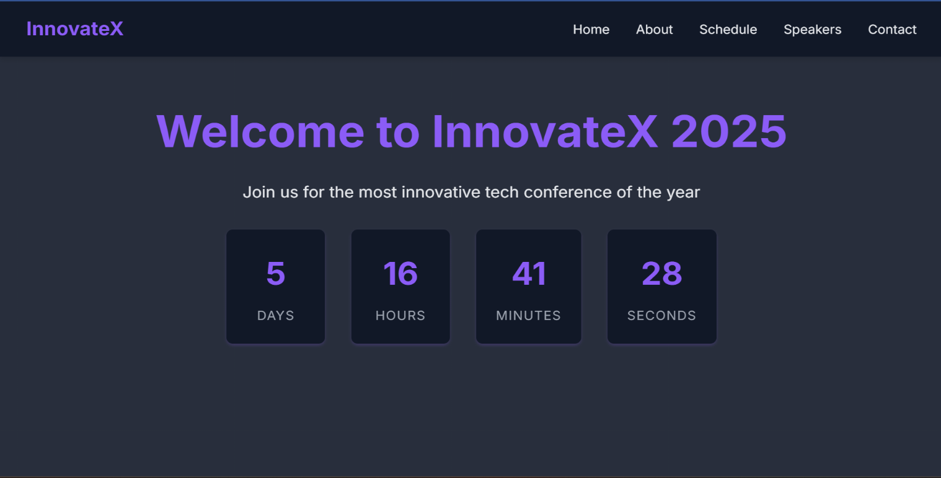

2. ABOUT SECTION

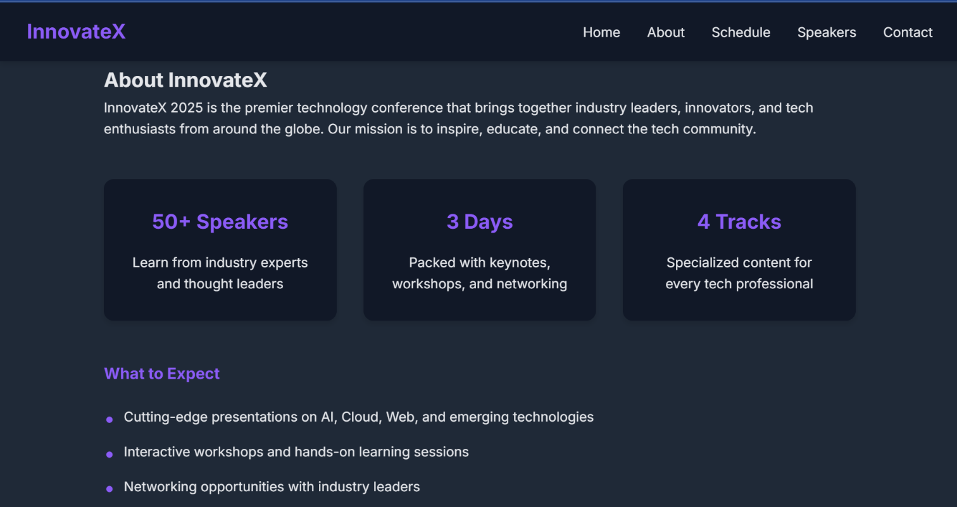

3. SCHEDULE SECTION (+ FILTER FEATURE)

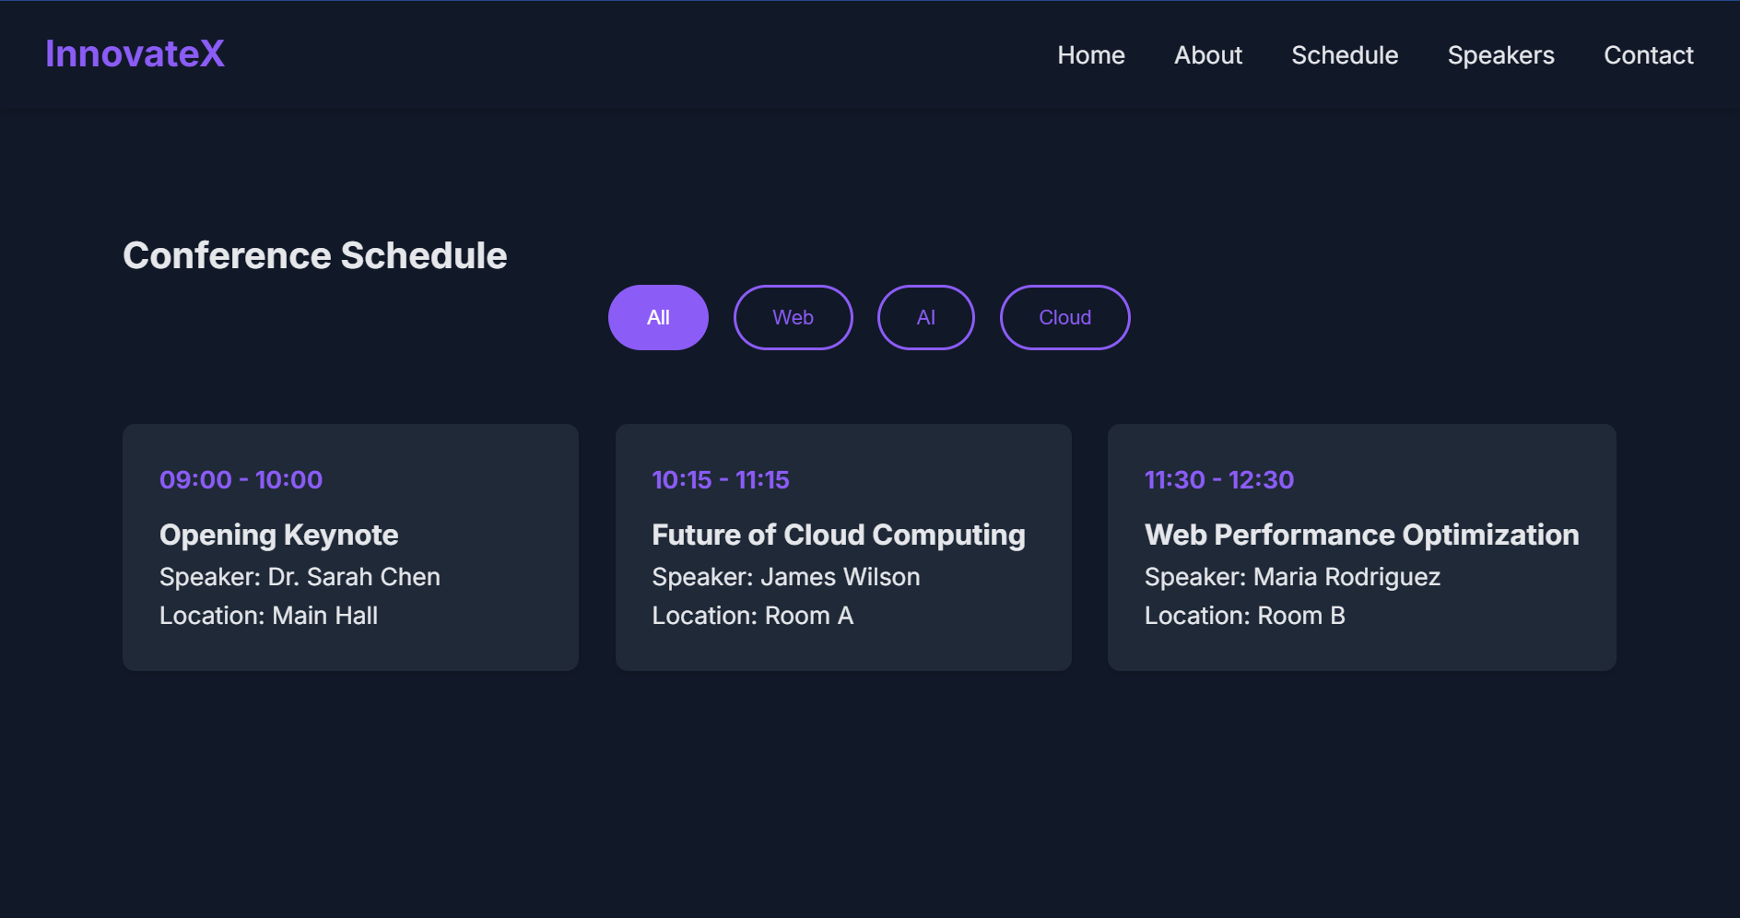4. SPEAKERS SECTIO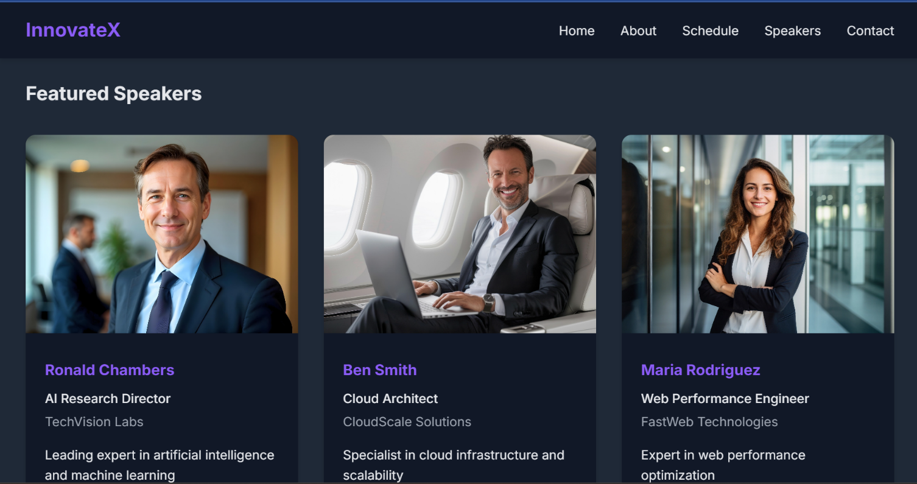N

5. CONTACT SECTION (+ VALIDATION)

SUCCESS

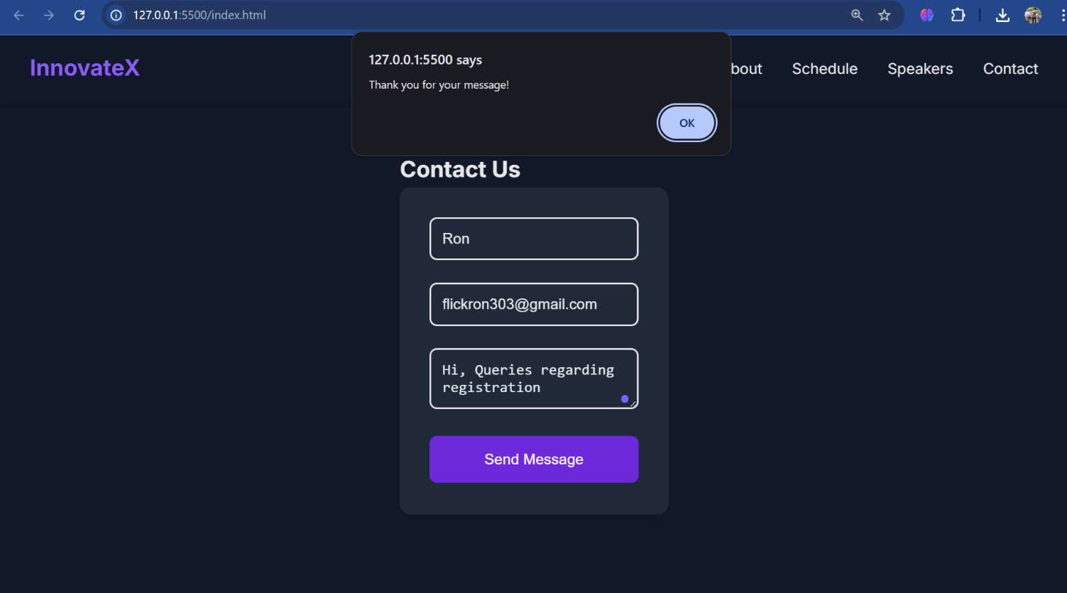FAILED

