**The data I used:**

• Mall Customer Segmentation Data | Kaggle.

**The features I will use in my model are:**

• Annual income And Spending score.

-> I didn't use (Age or Gender) as they not my interest.

I used elbow method to know the **k** value and k = 5, I used Euclidean error function

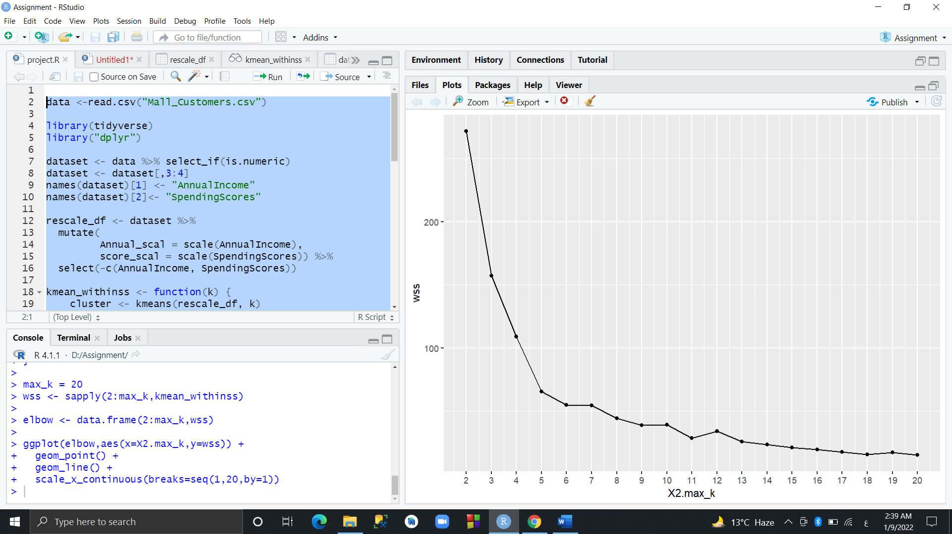

**Error Function (Euclidean) = 19.85091**

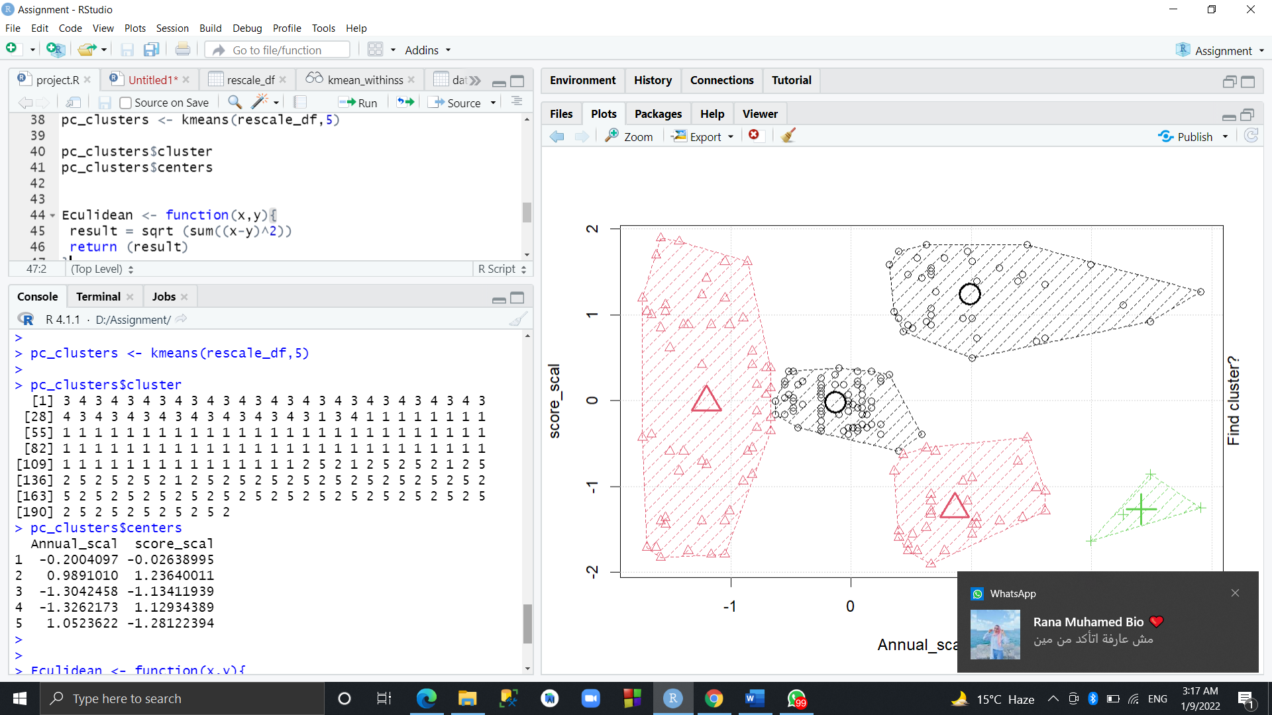

**The graph of clusters**:

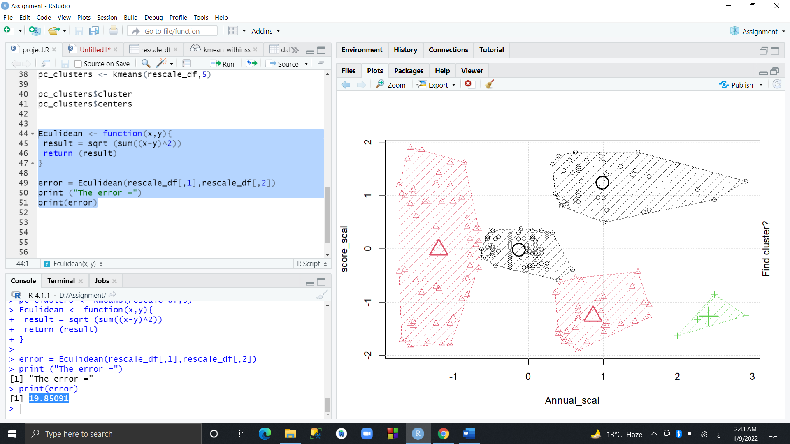

**We have 5 clusters:**

The first on for customers with low Annual incoming and high spending score. (Red)

The second one for customers with average Annual incoming and Average spending score. (Black)

The third one for customer with high Annual income and low spending score. (Red)

The fourth one for customer with high Annual income and high spending score. (Black) -> **TARGET**

The fifth one for customers with Extra high Annual spending and low Spending score. (Green)