# All-pairs shortest path

This is for finding the shortest path from any vertex to any other vertex. A n * n (n = number of vertices) matrix is used to keep track of the paths.

## Transitive closure

Transitive closure shows what vertices are reachable. If they are reachable from a given vertex, the value 1 it put into the reachability matrix.

The Floyd-Marshall DFS can be used for this.

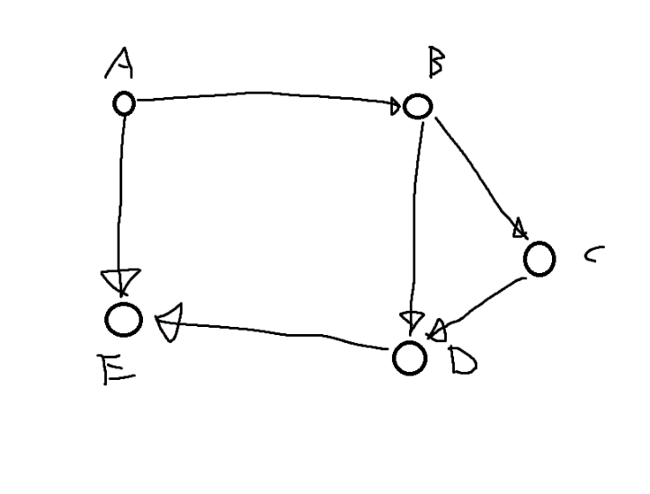 1

|  |  |  |  |  |  |
| --- | --- | --- | --- | --- | --- |
|  | A | B | C | D | E |
| A | 1 | 1 | 1 | 1 | 1 |
| B | 0 | 1 | 0 | 0 | 0 |
| C | 0 | 1 | 1 | 0 | 0 |
| D | 0 | 1 | 1 | 1 | 1 |
| E | 0 | 1 | 1 | 0 | 1 |