Roger Chan

Matthew Hicks

Alec Borman

Dang

TABLE OF CONTENTS

General information 1

LOGIN PAGE 2

STUDENT page 3

professor PAGE 4

Page 1

GENERAL INFO

Our application was an attendance app that allows you to do the basic functions in taking attendance.

Overview of Application

The application starts you out at a login page that looks something like this

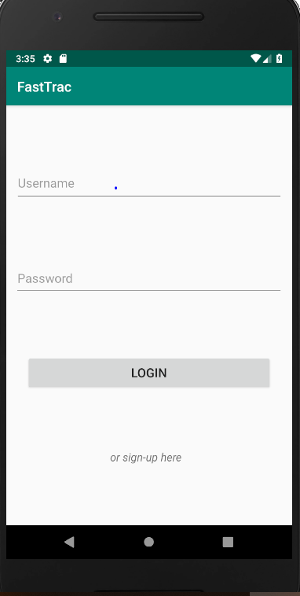

And from here you can mess around with the activity

LOGIN PAGE

The login page has two factor authentication consisting of a username and password. The user enters their credentials and if they are a student they will go to the student page, and if they are a professor, they will go to the professor page. If the user is not registered, they can click the ‘or sign up here’ button and sign up.

Page 2

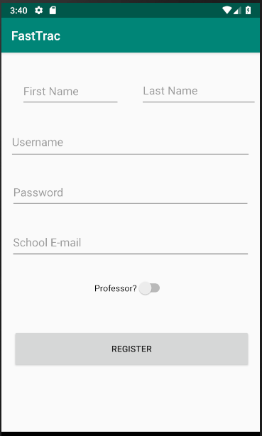

Here the user enters their information and will be able to sign in next time.

STUDENT PAGE

Once a student logs in they will be presented with a page like this

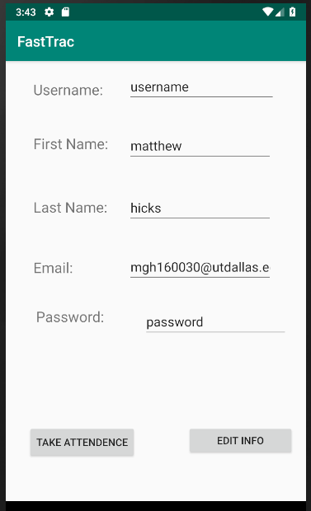

Here all the students information will show up and they can change it however they want by clicking the edit info button. They can then take attendance by clicking the ‘Take attendance button’ which will pull up a screen with all the classes the current student is in.

Page 3

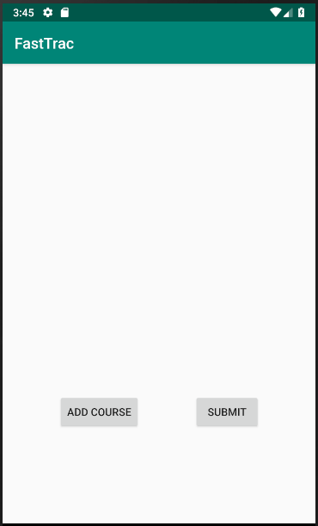

Here the student can click add course and will be prompted to put in the course code. If the course code is invalid, the user will be told so. If you can add the course, it will pop up onto your screen after you click submit. If the course is open, you can take attendance by clicking the course, which will then put up prompt telling you weather or not you were accounted for the course.

PROFESSOR PAGE

If you log in as a professor you will come to a page like that shows all the courses you are currently teaching.

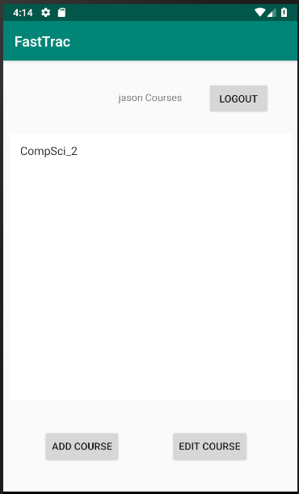

You can make a course by clicking add course and then it will show a page like this

Page 4

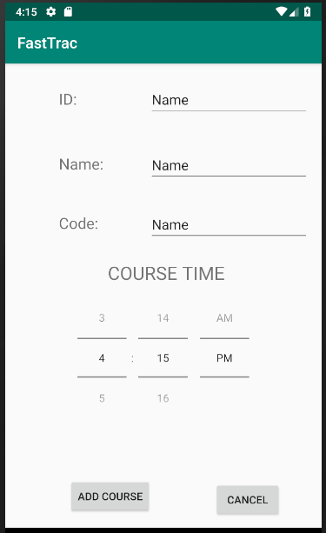

Here you can put in the values of what you want the course id to be, the name of the course, the code and the time. If you put in something besides numbers, you will be told that you cannot do that. You then click add course and it will take you back to the professor page. You can delete a course by clicking edit course and then clicking the ‘X’ button and it will delete the course from the database.