**SetConsoleTextAttribute函数用法**



[花狗Fdog_](https://zxfdog.blog.csdn.net/) 2019-12-30 13:15:17  3218  收藏 50

分类专栏： [杂七杂八](https://blog.csdn.net/fdog_/category_10317747.html) 文章标签： [c语言](https://www.csdn.net/tags/MtTaEg0sMzc0NzktYmxvZwO0O0OO0O0O.html)

版权

写在前面：  
大家好，我是 *花狗Fdog* ，来自内蒙古的一个小城市，目前在泰州读书。  
很感谢能有这样一个平台让我能够在这里分享所学所感。  
我喜欢编程，喜欢代码，喜欢去做一个程序员。  
努力学习，争取多年后，给亲人更好的生活。  
QQ/WX：2506897252 欢迎交流。

**文章目录**

* [1.介绍](https://blog.csdn.net/Fdog_/article/details/103764196?ops_request_misc=%25257B%252522request%25255Fid%252522%25253A%252522160933648216780271152834%252522%25252C%252522scm%252522%25253A%25252220140713.130102334..%252522%25257D&request_id=160933648216780271152834&biz_id=0&utm_medium=distribute.pc_search_result.none-task-blog-2~all~top_click~default-1-103764196.first_rank_v2_pc_rank_v29&utm_term=SetConsoleTextAttribute#1_8)
* [2.头文件](https://blog.csdn.net/Fdog_/article/details/103764196?ops_request_misc=%25257B%252522request%25255Fid%252522%25253A%252522160933648216780271152834%252522%25252C%252522scm%252522%25253A%25252220140713.130102334..%252522%25257D&request_id=160933648216780271152834&biz_id=0&utm_medium=distribute.pc_search_result.none-task-blog-2~all~top_click~default-1-103764196.first_rank_v2_pc_rank_v29&utm_term=SetConsoleTextAttribute#2_11)
* [3.函数原型](https://blog.csdn.net/Fdog_/article/details/103764196?ops_request_misc=%25257B%252522request%25255Fid%252522%25253A%252522160933648216780271152834%252522%25252C%252522scm%252522%25253A%25252220140713.130102334..%252522%25257D&request_id=160933648216780271152834&biz_id=0&utm_medium=distribute.pc_search_result.none-task-blog-2~all~top_click~default-1-103764196.first_rank_v2_pc_rank_v29&utm_term=SetConsoleTextAttribute#3_13)
* [4. 参数](https://blog.csdn.net/Fdog_/article/details/103764196?ops_request_misc=%25257B%252522request%25255Fid%252522%25253A%252522160933648216780271152834%252522%25252C%252522scm%252522%25253A%25252220140713.130102334..%252522%25257D&request_id=160933648216780271152834&biz_id=0&utm_medium=distribute.pc_search_result.none-task-blog-2~all~top_click~default-1-103764196.first_rank_v2_pc_rank_v29&utm_term=SetConsoleTextAttribute#4__15)
* [4.三种写法演示](https://blog.csdn.net/Fdog_/article/details/103764196?ops_request_misc=%25257B%252522request%25255Fid%252522%25253A%252522160933648216780271152834%252522%25252C%252522scm%252522%25253A%25252220140713.130102334..%252522%25257D&request_id=160933648216780271152834&biz_id=0&utm_medium=distribute.pc_search_result.none-task-blog-2~all~top_click~default-1-103764196.first_rank_v2_pc_rank_v29&utm_term=SetConsoleTextAttribute#4_37)
  + [(1)使用十六进制设置参数](https://blog.csdn.net/Fdog_/article/details/103764196?ops_request_misc=%25257B%252522request%25255Fid%252522%25253A%252522160933648216780271152834%252522%25252C%252522scm%252522%25253A%25252220140713.130102334..%252522%25257D&request_id=160933648216780271152834&biz_id=0&utm_medium=distribute.pc_search_result.none-task-blog-2~all~top_click~default-1-103764196.first_rank_v2_pc_rank_v29&utm_term=SetConsoleTextAttribute#1_38)
    - [其他颜色数值：](https://blog.csdn.net/Fdog_/article/details/103764196?ops_request_misc=%25257B%252522request%25255Fid%252522%25253A%252522160933648216780271152834%252522%25252C%252522scm%252522%25253A%25252220140713.130102334..%252522%25257D&request_id=160933648216780271152834&biz_id=0&utm_medium=distribute.pc_search_result.none-task-blog-2~all~top_click~default-1-103764196.first_rank_v2_pc_rank_v29&utm_term=SetConsoleTextAttribute#_49)
  + [（2）使用十进制设置参数](https://blog.csdn.net/Fdog_/article/details/103764196?ops_request_misc=%25257B%252522request%25255Fid%252522%25253A%252522160933648216780271152834%252522%25252C%252522scm%252522%25253A%25252220140713.130102334..%252522%25257D&request_id=160933648216780271152834&biz_id=0&utm_medium=distribute.pc_search_result.none-task-blog-2~all~top_click~default-1-103764196.first_rank_v2_pc_rank_v29&utm_term=SetConsoleTextAttribute#2_51)
    - [其他颜色数据：](https://blog.csdn.net/Fdog_/article/details/103764196?ops_request_misc=%25257B%252522request%25255Fid%252522%25253A%252522160933648216780271152834%252522%25252C%252522scm%252522%25253A%25252220140713.130102334..%252522%25257D&request_id=160933648216780271152834&biz_id=0&utm_medium=distribute.pc_search_result.none-task-blog-2~all~top_click~default-1-103764196.first_rank_v2_pc_rank_v29&utm_term=SetConsoleTextAttribute#_62)
  + [（3）使用函数已定义好的参数](https://blog.csdn.net/Fdog_/article/details/103764196?ops_request_misc=%25257B%252522request%25255Fid%252522%25253A%252522160933648216780271152834%252522%25252C%252522scm%252522%25253A%25252220140713.130102334..%252522%25257D&request_id=160933648216780271152834&biz_id=0&utm_medium=distribute.pc_search_result.none-task-blog-2~all~top_click~default-1-103764196.first_rank_v2_pc_rank_v29&utm_term=SetConsoleTextAttribute#3_64)
    - [其他颜色数值：](https://blog.csdn.net/Fdog_/article/details/103764196?ops_request_misc=%25257B%252522request%25255Fid%252522%25253A%252522160933648216780271152834%252522%25252C%252522scm%252522%25253A%25252220140713.130102334..%252522%25257D&request_id=160933648216780271152834&biz_id=0&utm_medium=distribute.pc_search_result.none-task-blog-2~all~top_click~default-1-103764196.first_rank_v2_pc_rank_v29&utm_term=SetConsoleTextAttribute#_75)

**1.介绍**

很多时候，我们希望编写出能够拥有各种颜色的程序，能够让人眼前一亮，虽然system(color)函数可以设置颜色，但是system(color)函数设置的颜色只能有一种，这显然不是我们想要的结果，我们需要的是一个名为SetConsoleTextAttribute的函数。  
SetConsoleTextAttribute()函数是一个API设置字体颜色和背景色的函数。参数表中使用两个属性（属性之间用，隔开），不同于system(color)，SetConsoleTextAttribute()可以改变界面多种颜色，而system()只能修改为一种！。

**2.头文件**

<windows.h>

**3.函数原型**

BOOL SetConsoleTextAttribute(HANDLE hConsoleOutput, WORD wAttributes);

**4. 参数**

HANDLE hConsoleOutput  
consolehwnd = GetStdHandle(STD_OUTPUT_HANDLE)  
GetStdHandle(nStdHandle)是返回标准的输入、输出或错误的设备的句柄，也就是获得输入、输出/错误的屏幕缓冲区的句柄。

其参数nStdHandle的值为下面几种类型的一种:

| **值** | **含义** |
| --- | --- |
| STD_INPUT_HANDLE | 标准输入的句柄 |
| STD_OUTPUT_HANDLE | 标准输出的句柄 |
| STD_ERROR_HANDLE | 标准错误的句柄 |

这里我们只需要使用STD_OUTPUT_HANDLE即可，

WORD wAttributes是用来设置颜色的参数，有三种写法：

SetConsoleTextAttribute(GetStdHandle(STD_OUTPUT_HANDLE), 0x07);

//第二个参数填十六进制数字。

SetConsoleTextAttribute(GetStdHandle(STD_OUTPUT_HANDLE), 7);

//直接填十进制数字。

SetConsoleTextAttribute(GetStdHandle(STD_OUTPUT_HANDLE), BACKGROUND_BLACK | FOREGROUND_RED);

//BACKGROUND代表背景，FOREGROUND代表前景，

* 1
* 2
* 3
* 4
* 5

**4.三种写法演示**

**(1)使用十六进制设置参数**

SetConsoleTextAttribute(GetStdHandle(STD_OUTPUT_HANDLE), 0x06);

printf("花狗\n");

SetConsoleTextAttribute(GetStdHandle(STD_OUTPUT_HANDLE), 0x07);

printf("花狗\n");

SetConsoleTextAttribute(GetStdHandle(STD_OUTPUT_HANDLE), 0x08);

printf("花狗\n");

* 1
* 2
* 3
* 4
* 5

结果如下：  
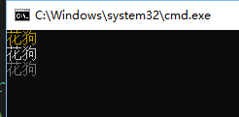

**其他颜色数值：**

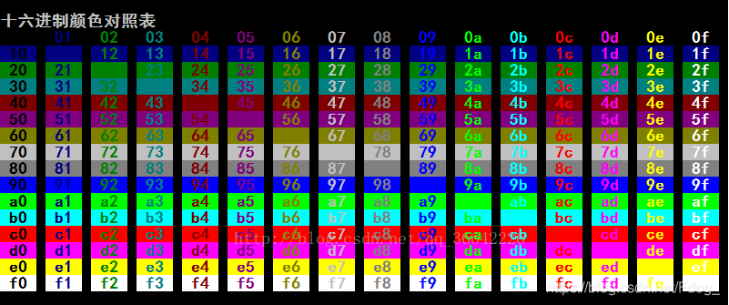

**（2）使用十进制设置参数**

SetConsoleTextAttribute(GetStdHandle(STD_OUTPUT_HANDLE), 10);

printf("花狗\n");

SetConsoleTextAttribute(GetStdHandle(STD_OUTPUT_HANDLE), 12);

printf("花狗\n");

SetConsoleTextAttribute(GetStdHandle(STD_OUTPUT_HANDLE), 14);

printf("花狗\n");

* 1
* 2
* 3
* 4
* 5

结果如下：  
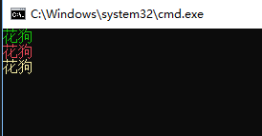

**其他颜色数据：**

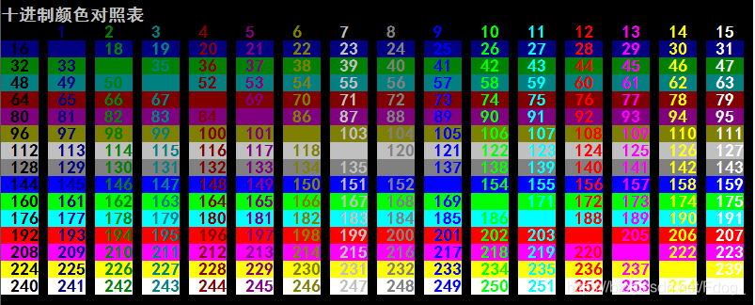

**（3）使用函数已定义好的参数**

SetConsoleTextAttribute(GetStdHandle(STD_OUTPUT_HANDLE), BACKGROUND_GREEN | FOREGROUND_RED);

printf("花狗\n");

SetConsoleTextAttribute(GetStdHandle(STD_OUTPUT_HANDLE), BACKGROUND_GREEN | FOREGROUND_BLUE);

printf("花狗\n");

SetConsoleTextAttribute(GetStdHandle(STD_OUTPUT_HANDLE), BACKGROUND_RED | BACKGROUND_GREEN);

printf("花狗\n");

* 1
* 2
* 3
* 4
* 5

结果如下：  
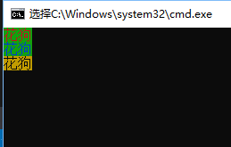

**其他颜色数值：**

| **属性** | **含义** |
| --- | --- |
| FOREGROUND_BLUE | 文字颜色包含蓝色 |
| FOREGROUND_GREEN | 文字颜色包含绿色 |
| FOREGROUND_RED | 文字颜色包含红色 |
| FOREGROUND_INTENSITY | 文字颜色加强 |
| BACKGROUND_BLUE | 背景颜色包含蓝色 |
| BACKGROUND_GREEN | 背景颜色包含绿色 |
| BACKGROUND_RED | 背景颜色包含红色 |
| BACKGROUND_INTENSITY | 背景颜色加剧 |
| COMMON_LVB_LEADING_BYTE | 前导字节 |
| COMMON_LVB_TRAILING_BYTE | 尾随字节 |
| COMMON_LVB_GRID_HORIZONTAL | 顶部水平 |
| COMMON_LVB_GRID_LVERTICAL | 左垂直 |
| COMMON_LVB_GRID_RVERTICAL | 正确的垂直 |
| COMMON_LVB_REVERSE_VIDEO | 反转前景和背景属性 |
| COMMON_LVB_UNDERSCORE | 下划线 |

好了，其他数值各位有兴趣的自行研究。

如有错误，欢迎指出批评，欢迎讨论。  
*每文一句：没有理想，就达不到目的；没有勇敢，就得不到东西。*