Short report on the need of synchronization in the RMI version

Students:
Roger Castellà Cot
Arnau Martín Giol
Alex Gutierrez Canuto

Which Collection(s) did you use. Specify type(s) and purpose

We used the following collections in our implementation:

HashMap<Integer, ClientRep> clients
We used a HashMap to store client information (instances of ClientRep). It uses an integer as the key and a ClientRep object as the value.

ArrayList<Integer> numbersChecked
We used an ArrayList in ClientRep class to store the list of numbers that each client has attempted. This helps in checking for repeated numbers and providing the list of attempts when requested.

Did any of these collections need to be thread-safe (required synchronization). If the answer is yes specify:
(a) which collection(s)
(b) how did you accomplished the synchronization (show snippet of code if necessary)

Yes, some of the collections needed to be thread-safe because the server handles multiple clients concurrently.

(a)

HashMap<Integer, ClientRep>: This collection is shared in multiple threads (one per client), so it needs synchronization to avoid concurrent update problems. We need synchronization when adding, retrieving, or removing elements.

ArrayList<Integer>: This collection is part of the ClientRep class and is accessed when a client sends a number or requests the list of attempts. It needs synchronization to ensure safe concurrent access.

(b)

We used synchronized blocks to ensure thread safety for the shared collections.

For clients (HashMap), we synchronized access when retrieving or modifying the map:

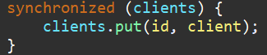

When accessing elements of ClientRep class we used synchronized for the whole HashMap “clients” or only for the “numbersChecked” list or other attributes:

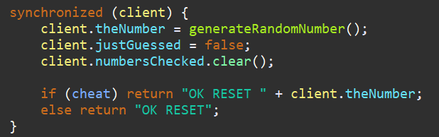

We also used synchronized (this) when generating unique ids for new clients:

