Phishing Alert Analysis

Alert ID: 001
Type: Phishing
Priority: High

Analysis:
The email contains multiple phishing indicators such as urgency, suspicious sender address, and a fake domain name that mimics Microsoft.

The domain micr0soft-account-reset.com was analyzed using VirusTotal. Although no security vendors flagged it as malicious (0/94), the domain appears suspicious due to typosquatting (replacement of "o" with "0") and impersonation of a trusted brand.

New or less-known phishing domains may not be immediately detected by security tools.

Figure 2: VirusTotal analysis of suspicious domain
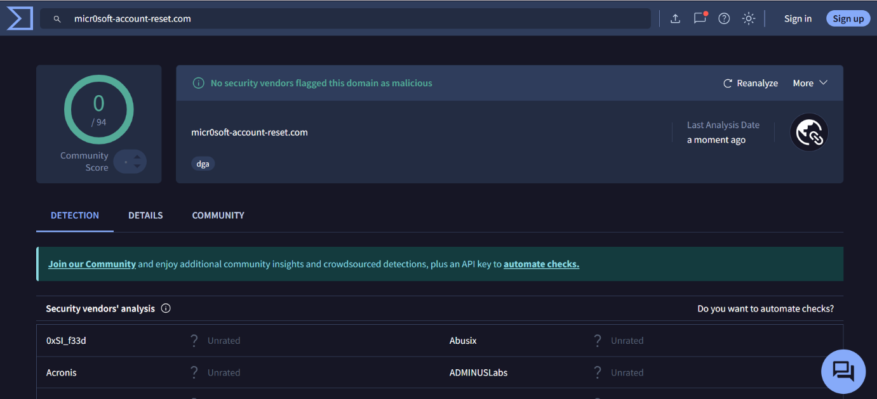

Conclusion:
This alert is classified as High priority because it can lead to credential theft and unauthorized access. Even though VirusTotal shows no detection, the domain is still considered suspicious based on behavioral indicators.

