**Roger Killam**

**Microsoft Data Warehouse Demo**

September 06, 2021

**Independent Book Sellers Admin Manual**

Contents

Introduction 2

SSIS 2

SSIS SQL Server Agent Job 3

SSIS Proxy Account 3

Databases 3

IndependentBookSellers 3

DWIndependentBookSellers DW Tables 4

DWIndependentBookSellers Maintenance Tables 5

DWIndependentBookSellersRestored 5

Stored Procedures 5

ETL 5

Logging 6

Maintenance & Validation 6

Views 7

ETL Logging 9

ETL Reports 9

DWIndependentBookSellersETLReport 9

DimAuthorsETLReport 10

DimStoresETLReport 11

DimTitlesETLReport 12

FactSalesETLReport 13

FactTitleAuthorsETLReport 14

Maintenance 15

Maintenance Logging 16

DWIndependentBookSellersMaintReport 16

ETL Troubleshooting 17

SQL Server Agent Job 17

SSIS Package 21

Summary 25

Supporting Documentation 25

Reference 25

Changelog 25

# Introduction

This document is an overview of the Microsoft SQL Server Database Data Warehouse (DW) DWIndependentBookSellers. The DWIndependentBookSellers database tables are populated through the scheduled execution of a SQL Server Integration Services (SSIS) Package. The SSIS package process is logged and made available for review through custom SQL Server Reports. Also included in this document are some general troubleshooting steps, and an overview of the system’s maintenance tasks.

# SSIS

SSIS is a Microsoft product used for data integration and transformation. This system is used for – “copying or downloading files, loading data warehouses, cleansing & mining data, and managing SQL Server objects and data.(1)”

In the context of Independent Book Sellers, an SSIS Package(2) is used to organize the collection of components that makeup the data warehouse’s **E**xtract, **T**ransform and **L**oad (ETL) process. The SSIS package is stored in the *C:\data_warehouse_demo\data_warehouse_demo_visual_studio_project\****Admin*** folder on the *LOCALHOST* SQL Server. The name of the SSIS package is IndependentBookSellersETLpackage.

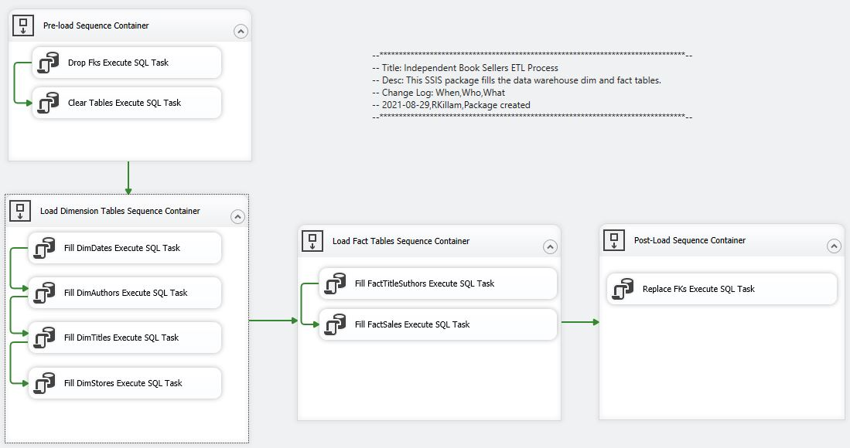

Figure . IndependentBookSellersETLpackage.dtsx

## SSIS SQL Server Agent Job

The SQL Server Agent Job DWIndependentBookSellersETL is scheduled to execute the SSIS package daily at 1 A.M.

## SSIS Proxy Account

**Note: DWIndependentBookSellersETL requires the SSIS Package Execution Proxy Account SSIS_Proxy.**

This proxy account can be created and configure using the PowerShell script:

*C:\data_warehouse_demo\data_warehouse_demo_visual_studio_project*\Scripts\**New-SSISProxyUser.ps1**

# Databases

## IndependentBookSellers

IndependentBookSellers is the DW source database. Data is moved from this database and into DWIndependentBookSellers.

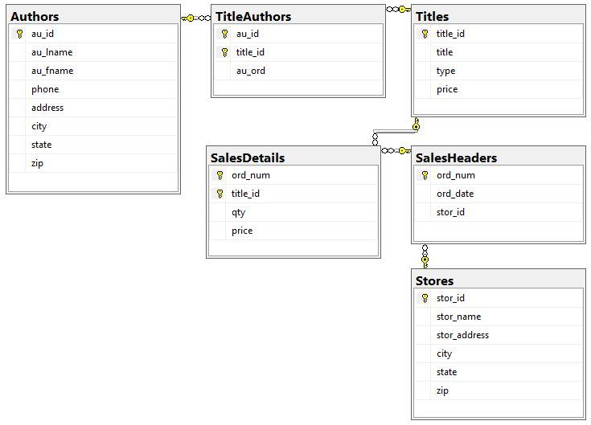

Figure . IndependentBookSellers

## DWIndependentBookSellers DW Tables

The DWIndependentBookSellers database contains the DW. The DW consists of 4 dimension tables, and 2 fact tables.

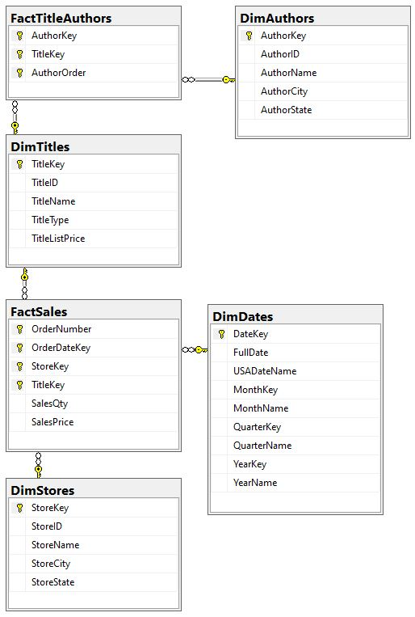

Figure . DWEmployeeProjects

## DWIndependentBookSellers Maintenance Tables

The DWIndependentBookSellers database contains 3 administration logging tables.

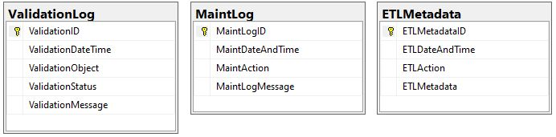

Figure . Process Logging Tables

## DWIndependentBookSellersRestored

The SQL Server Agent Job DWIndependentBookSellersMaint drops and recreates the database DWIndependentBookSellersRestored, see the Maintenance section for further details.

# Stored Procedures

## ETL

There are a total of 6 stored procedure responsile for filling the Dim and Fact tables. **The stored procedure pETLDimDates creates a lookup table that is not fillled by a select from IndependentBookSellers.**

* **pETLDimAuthors**
  + Fills the DimAuthors table
* **pETLDimStores**
  + Fills the DimStores table
* **pETLDimTitles**
  + Fills the DimTitles table
* **pETLFactSales**
  + Fills the FactSales table
* **pETLFactTitleAuthors**
  + Fills the FactTitleAuthors table
* **pETLDimDates**
  + Creates the DimDates lookup table

## Logging

The following stored procedures are used to create administrative logging tables.

* **pInsETLLog**
  + Creates an admin table for logging ETL metadata
* **pInsMaintLog**
  + Creates an admin table for maintenance logging
* **pInsValidationLog**
  + Creates an admin table for data validation logging

## Maintenance & Validation

The following stored procedures are used to complete maintenance tasks. Also included here are procedures for validating database backups. See the Maintenance section for further details.

* **pETLDropFks**
  + Drops the DW foreign keys
* **pETLReplaceFks**
  + Replaces the DW foreign keys
* **pETLTruncateTables**
  + Clears the data from all DW tables
* **pMaintDBBackup**
  + Performs a full database backup
* **pMaintIndexes**
  + Drops and creates FK column indexes
* **pMaintRestore**
  + Restores the database backup
* **pMaintValidateDimAuthorsRestore**
  + Validates DimAuthors in the restore database
* **pMaintValidateDimDatesRestore**
  + Validates DimDates in the restore database
* **pMaintValidateDimStoresRestore**
  + Validates DimStores in the restore database
* **pMaintValidateDimTitlesRestore**
  + Validates DimTitles in the restore database
* **pMaintValidateFactSalesRestore**
  + Validates FactSales in the restore database
* **pMaintValidateFactTitleAuthorsRestore**
  + Validates FactTitleAuthors in the restore database

# Views

* **DWIndependentBookSellersRowCounts**
  + Returns a row count for all of DWIndependentBookSellers’ tables
* **vETLDimAuthor****s**
  + Selects and casts AuthorID, AuthorName, AuthorCity, and AuthorState from **[IndependentBookSellers].**[dbo].[vETLDimAuthors]
* **vDimAuthorsTopTen**
  + Select the top 10 authors from **[DWIndependentBookSellers].**[dbo].[DimAuthors]
* **vETLDimStores**
  + Selects and casts StoreID, StoreName, StoreCity, and StoreState from **[IndependentBookSellers].**[dbo].[Stores]
* **vDimStoresTopTen**
  + Select the top 10 stores from **[DWIndependentBookSellers].**[dbo].[DimStores]
* **vETLDimTitles**
  + Selects TitleID, TitleName, TitleType, and TitleListPrice from **[IndependentBookSellers].**[dbo].[Titles] where the price is not null.
* **vDimTitlesTopTen**
  + Select the top 10 titles from **[DWIndependentBookSellers].**[dbo].[DimTitles]
* **vETLFactSales**
  + Selects and casts OrderNumber, OrderDateKey, StoreKey, TitleKey, SalesQty, and SalesPrice from inner join on:
    - **[IndependentBookSellers].**[dbo].[SalesHeaders]
    - **[IndependentBookSellers].**[dbo].[SalesDetails]
    - **[DWIndependentBookSellers].**[dbo].[DimDates]
    - **[DWIndependentBookSellers].**[dbo].[DimStores]
    - **[DWIndependentBookSellers].**[dbo].[DimTitles]
* **vFactSalesTopTen**
  + Select the top 10 sales from **[DWIndependentBookSellers].**[dbo].[FactSales]
* **vETLFactTitleAuthors**
  + Selects AuthorKey, TitleKey, and AuthorOrder from inner join on:
    - **[IndependentBookSellers].**[dbo].[TitleAuthors]
    - **[DWIndependentBookSellers].**[dbo].[DimAuthors]
    - **[DWIndependentBookSellers].**[dbo].[DimTitles]
* **vFactTitleAuthorsTopTen**
  + Select the top 10 title authors from **[DWIndependentBookSellers].**[dbo].[FactTitleAuthors]
* **vDimDatesTopTen**
  + Select the top 10 dates from **[DWIndependentBookSellers].**[dbo].[DimDates]

***Views continued…***

* **vDWIndependentBookSellersETLJobHistory**
  + Selects JobName, StepName, RunDateTime, and RunDurationSeconds where SQL Server Agent Job name is DWIndependentBookSellersETL and *step_name* is not “(Job outcome)” from inner join on:
    - [msdb].[dbo].[sysjobs]
    - [msdb].[dbo].[sysjobhistory]
* **vDWIndependentBookSellersMaintJobHistory**
  + Selects JobName, StepName, RunDateTime, and RunDurationSeconds where SQL Server Agent Job name is DWIndependentBookSellersMaint and *step_name* is not “(Job outcome)” from inner join on:
    - [msdb].[dbo].[sysjobs]
    - [msdb].[dbo].[sysjobhistory]
* **vETLMetadata**
  + Selects and casts ETLMetadataID, ETLDate, ETLTime, ETLAction, and ETLMetadata from **[DWIndependentBookSellers].**[dbo].[ETLMetadata]
* **vMaintLog**
  + Selects and casts MaintLogID, MaintDate, MaintTime, MaintAction, and MaintLogMessage from **[DWIndependentBookSellers].**[dbo].[MaintLog]
* **vValidationLog**
  + Selects ValidationID, ValidationDateTime, ValidationObject, ValidationStatus, and ValidationMessage from **[DWIndependentBookSellers].** [dbo].[ValidationLog]

# ETL Logging

An ETL transaction log is found in the DWIndependentBookSellers table ETLMetadata. This log includes record ID, date, time, the action performed, and action metadata.

Figure . ETL Log

## ETL Reports

Several SQL Server reports are available for viewing the status of ETL jobs and transactions. These reports can be found in the directory:

*C:\data_warehouse_demo\data_warehouse_demo_visual_studio_project*\**SSRS**

### DWIndependentBookSellersETLReport

Figure . DWIndependentBookSellersETLReport

### DimAuthorsETLReport

Figure . DimAuthorsETLReport

### DimStoresETLReport

Figure . DimStoresETLReport

### DimTitlesETLReport

Figure . DimTitlesETLReport

### FactSalesETLReport

Figure . FactSalesETLReport

### FactTitleAuthorsETLReport

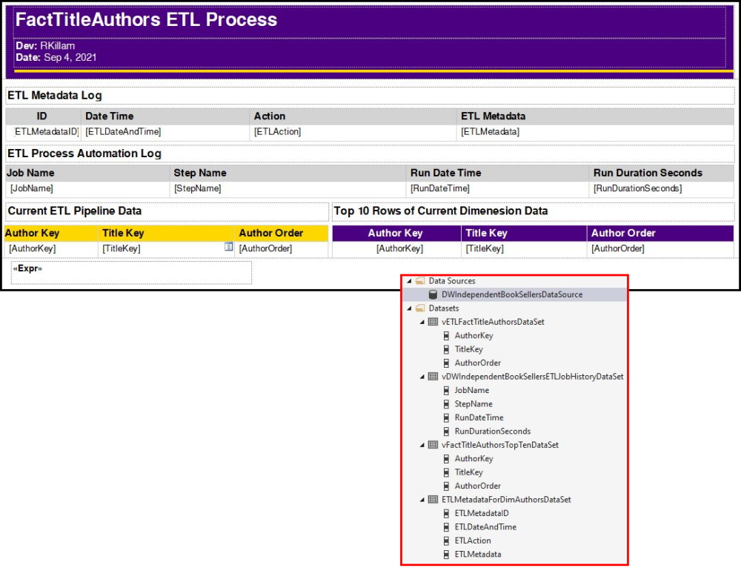

Figure . FactTitleAuthorsETLReport

# Maintenance

Daily at 2 A.M., the SQL Server Agent Job DWIndependentBookSellersMaint executes the following maintenance stored procedures.

* **pMaintIndexes**
  + Drops and creates FK column indexes
* **pMaintDBBackup**
  + Full back up of DWIndependentBookSellers
* **pMaintRestore**
  + Restores the database backup as DWIndependentBookSellersRestored
* **pMaintValidateDimDatesRestore**
  + Validates DimDates in the restore database
* **pMaintValidateDimAuthorsRestore**
  + Validates DimAuthors in the restore database
* **pMaintValidateDimTitlesRestore**
  + Validates DimTitles in the restore database
* **pMaintValidateDimStoresRestore**
  + Validates DimStores in the restore database
* **pMaintValidateFactTitleAuthorsRestore**
  + Validates FactTitleAuthors in the restore database
* **pMaintValidate****FactSalesRestore**
  + Validates FactSales in the restore database

## Maintenance Logging

A maintenance log is found in the DWIndependentBookSellers’ table MaintLog. Also, backup validations are logged to the table ValidationLog.

## DWIndependentBookSellersMaintReport

The following maintenance report can be found in the directory:

*C:\data_warehouse_demo\data_warehouse_demo_visual_studio_project*\**Reports**

Figure . DWIndependentBookSellersMaintReport

# ETL Troubleshooting

## SQL Server Agent Job

**Problem:** The SQL Server Agent is disabled, or an Agent job fails to complete.

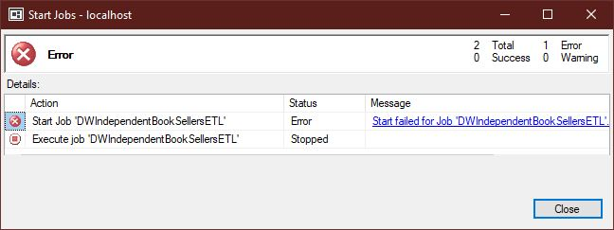

Figure . Example of a SQL Server Agent Job error

**Symptom:** DW database tables are not updating.

**Troubleshooting Steps:**

Check the status of the SQL Server Agent. From [SQL Server Management Studio (SSMS),](https://docs.microsoft.com/en-us/sql/ssms/download-sql-server-management-studio-ssms?view=sql-server-ver15) ensure that the SQL Server Agent is running.

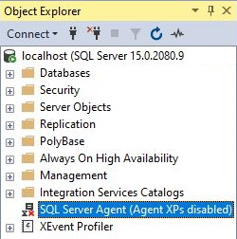

Figure . SQL Server Agent Status Disabled

If the SQL Server Agent is not running, start the Agent by right-clicking on SQL Server Agent and select Start.

Figure . SQL Server Agent

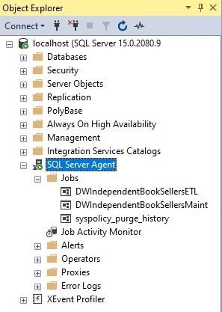

Figure . Start SQL Server Agent

Once the SQL Server Agent’s status has been verified, review DWIndependentBookSellersETL’s SQL Server Agent Job history. This is done by right-clicking on DWIndependentBookSellersETL and selecting View History.

Figure . SQL Server Agent Job View History

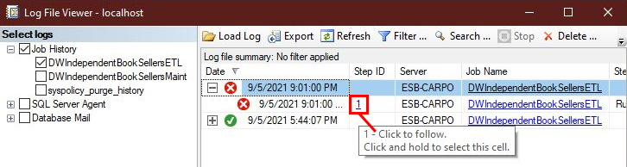

Figure . SQL Server Agent Job History

In this example, the job failed at *Step ID 1.* Click on the Step ID to view the failed step. From the Job Step Properties window, you can begin the process of tracing steps to the point of failure. In this case, the error was caused by a typo in the package filename.

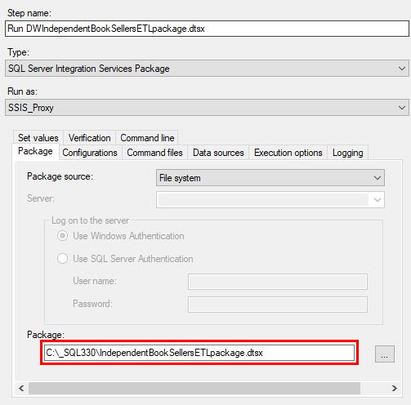

Figure . SQL Server Job Step Properties

For more information on how to troubleshoot the SQL Server Agent, see [Agent Service fails to start on standalone server - SQL Server | Microsoft Docs](https://docs.microsoft.com/en-us/troubleshoot/sql/admin/agent-service-fails-start-stand-alone-server).

## SSIS Package

**Problem:** The SSIS ETL package fails to complete.

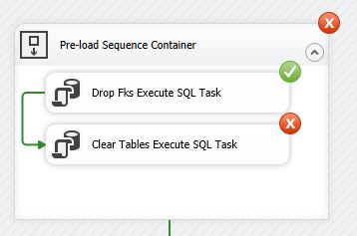

Figure . SSIS Package Error

**Symptom:** DW database tables are not updating.

**Troubleshooting Steps:**

Using [*Microsoft Visual Studio,](https://visualstudio.microsoft.com/vs/enterprise/) open the *data_warehouse_demo_solution* solution. The project solution is in the *C:\data_warehouse_demo\data_warehouse_demo_visual_studio_project* folder on the *LOCALHOST* SQL Server.

**\*Note: Run Microsoft Visual Studio in Administrator mode by right-clicking on its menu item and select More -> Run as administrator.**

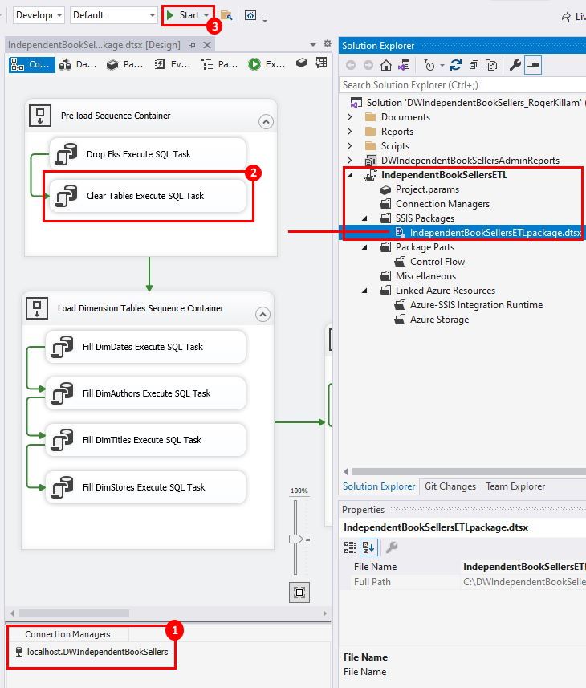

Figure . DWIndependentBookSellers VS Solution

**From the *data_warehouse_demo_solution* Visual Studio solution, open the SSIS package IndependentBookSellersETLpackage and review the following items that have been numbered and highlighted in RED, see *Figure 21 DWIndependentBookSellers VS Solution.***

**(1)** Check that the Connection Managers is set to localhost.DWIndependentBookSellers.

**(2)** Review Sequence Containers.

In the case of example *Figure 20 SSIS Package Error,* the packed failed on the SQL task Clear Tables. Double-click on Clear Tables Execute SQL Task to open the Execute SQL Task Editor.

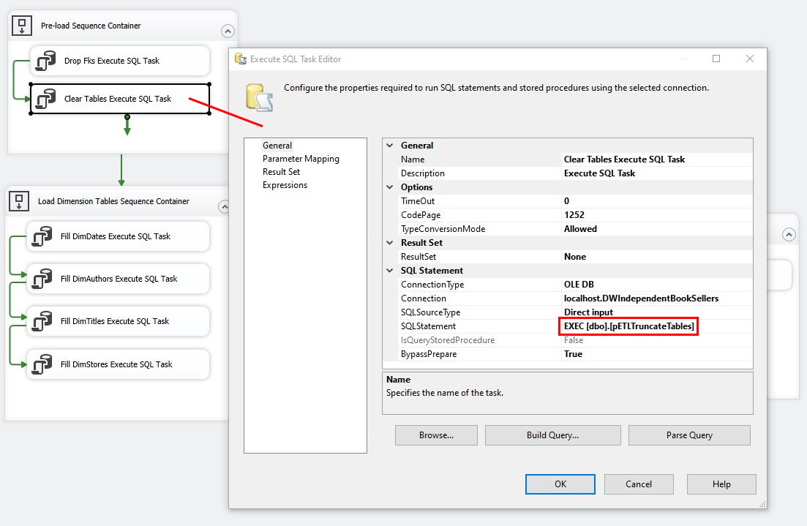

Figure . SSIS SQL Task Editor

From the Execute SQL Task Editor, you can determine the procedure that is being called by this step.

Note: You can run the package from Visual Studio by selecting the Start button, see **(3)** in *Figure 21 DWIndependentBookSellers VS Solution.*

Tracing the SQL stored procedure pETLTruncateTables to localhost. DWIndependentBookSellers reveals that the procedure’s name has been modified.

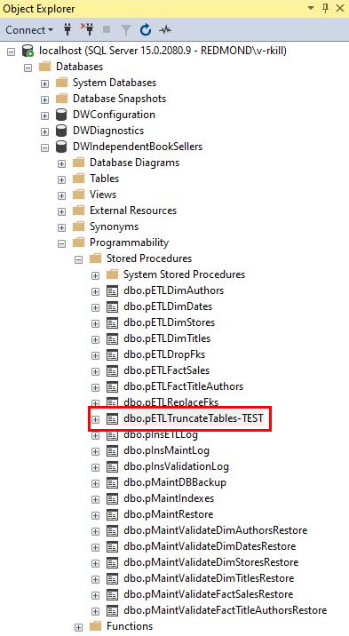

Figure . DWIndependentBookSellers.pETLTruncateTables

**Item (3)** Start

After correcting the SQL stored procedure’s name, the SSIS package can be tested by selecting the Start button. This will open a debugger which provides an overview of the package’s execution.

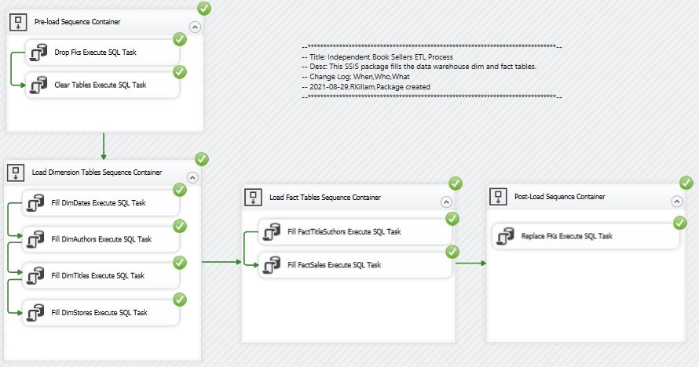

Figure . SSIS Package Debug

To exit out of the debugger and return to the SSIS editor, click on the stop button.

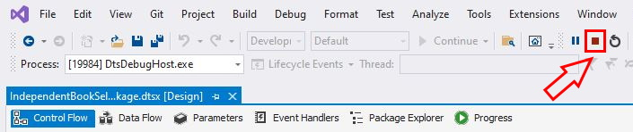

Figure . Stop SSIS Debugging

# Summary

This document has reviewed the database objects found in the Independent Book Sellers Data Wearhouse. An overview of the ETL process was outlined by describing transactions performed by stored procedures, which are executed by a SQL SSIS package agent job. The ETL changelog was described, providing a view of the captured ETL transactions. General troubleshooting steps were also outlined, as well as maintenance routines.

# Supporting Documentation

02_metadata_worksheet.xlsx

# Reference

(1)Microsoft. (2018, July 06). “SQL Server Integration Services.” Microsoft Docs.  
Retrieved from [SQL Server Integration Services - SQL Server Integration Services (SSIS) | Microsoft Docs](https://docs.microsoft.com/en-us/sql/integration-services/sql-server-integration-services?view=sql-server-ver15)

(2)Microsoft. (2016, August 31). “Integration Services (SSIS) Packages.” Microsoft Docs.  
Retrieved from [Integration Services (SSIS) Packages - SQL Server Integration Services (SSIS) | Microsoft Docs](https://docs.microsoft.com/en-us/sql/integration-services/integration-services-ssis-packages?view=sql-server-ver15)

# Changelog

|  |  |  |
| --- | --- | --- |
| **When** | **Who** | **What** |
| 2021-09-06 | RKillam | Document created |