KiCAD Database Library Installation Instructions

This is the instructions to install a database library on KiCad. After downloading “Libraries” from github, do the following steps:

Step 1: Setup the database library path on the kicad_dbl file
On Database_Setup paste, open the Database_Setup.kicad_dbl file and update the path of your database sqlite file.
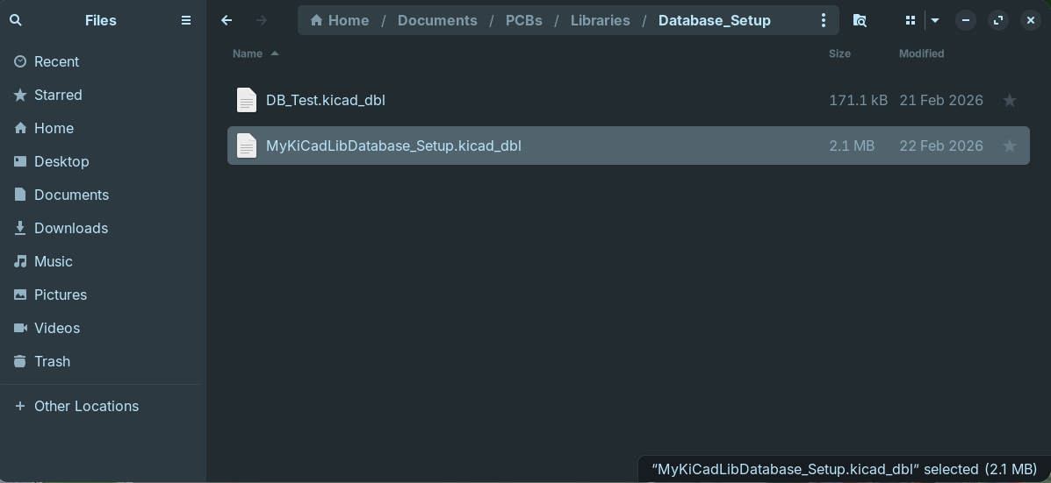

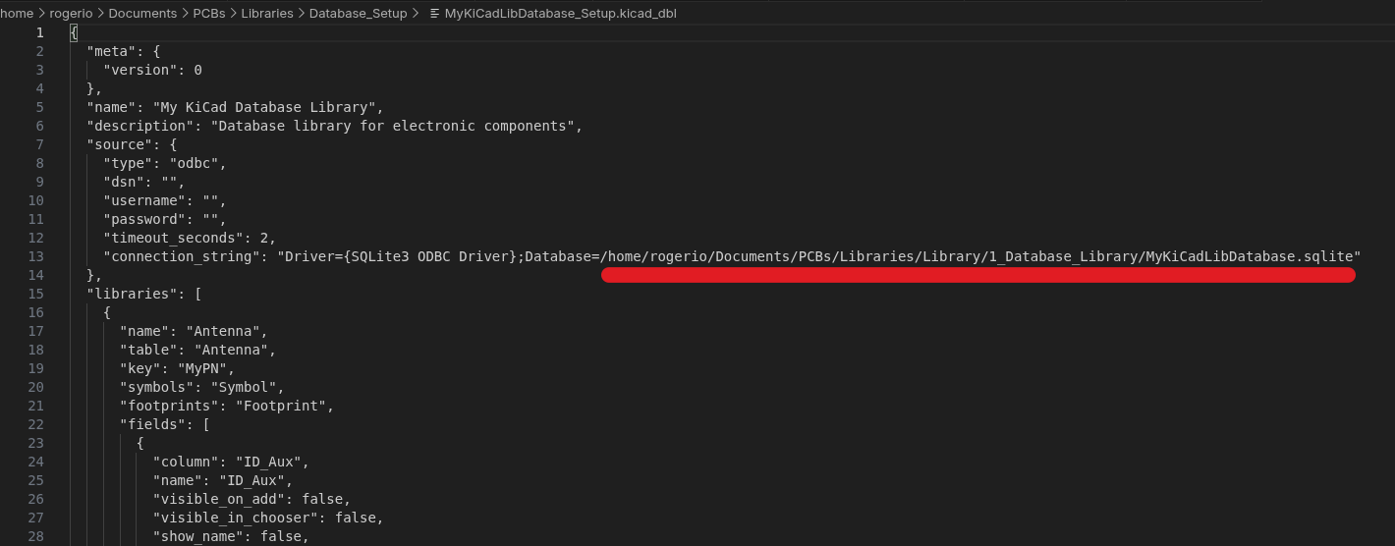
Step 2: Configure Paths
Open KiCad, on Preferences→Configure Paths, add new paths with the directories where your pastes are located.

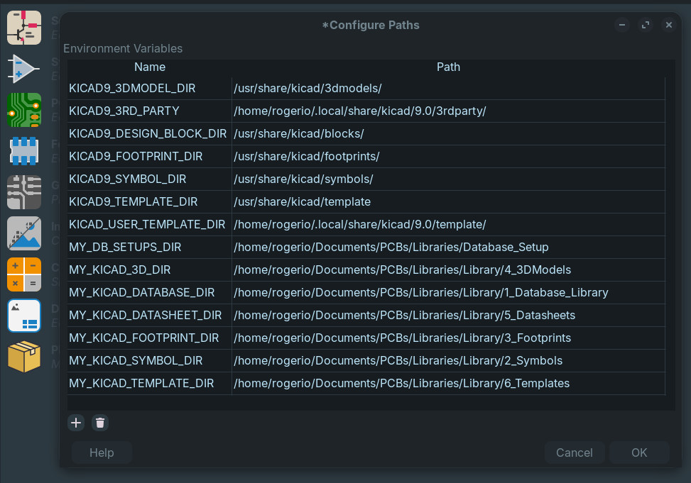

Step 3: Add Footprint Libraries
On KiCad, Preferences→Manage Footprint Libraries.., add the footprints libraries that are located on Library/3_Footprints (the libraries names start with MyLib_ and they are copies of the KiCad libraries).

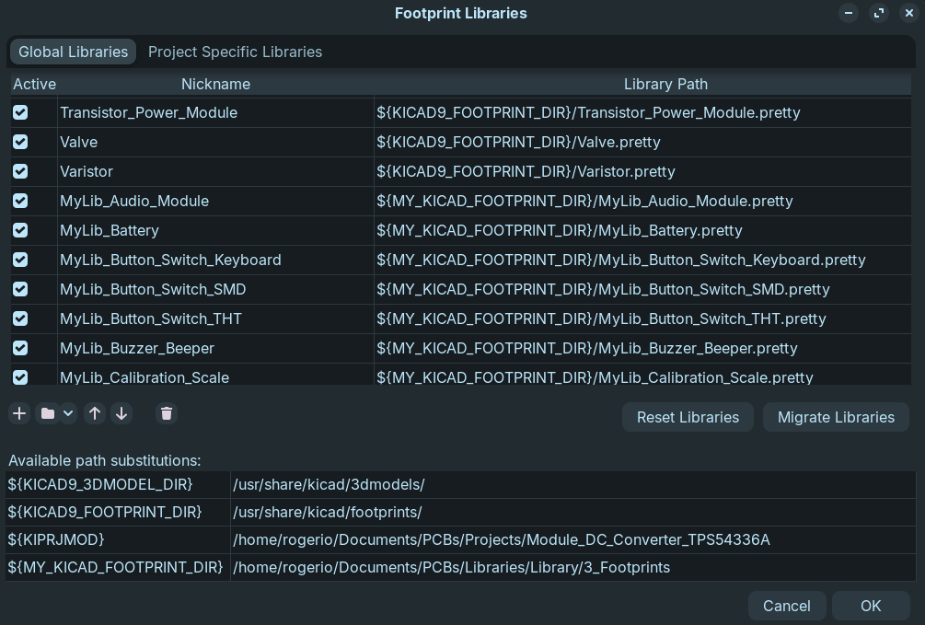
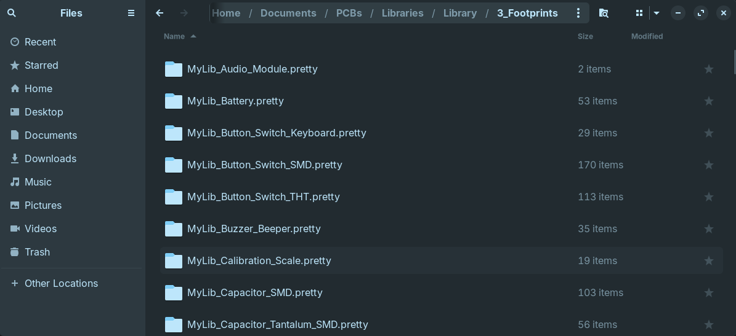
Step 4: Add Symbol Libraries
On KiCad, Preferences→Manage Symbol Libraries.., add symbol libraries that are located on Library/2_Symbols (the libraries names start with MyLib_ and they are different of the KiCads libraries, put the new symbols that you create on these libraries files – create new symbols libraries files if necessary). Deselect the “Visible” option on these libraries. Click OK.

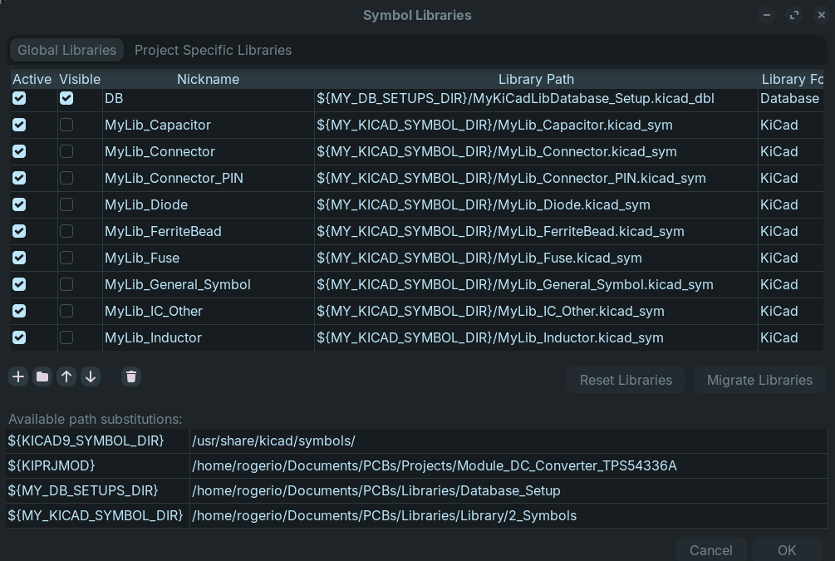
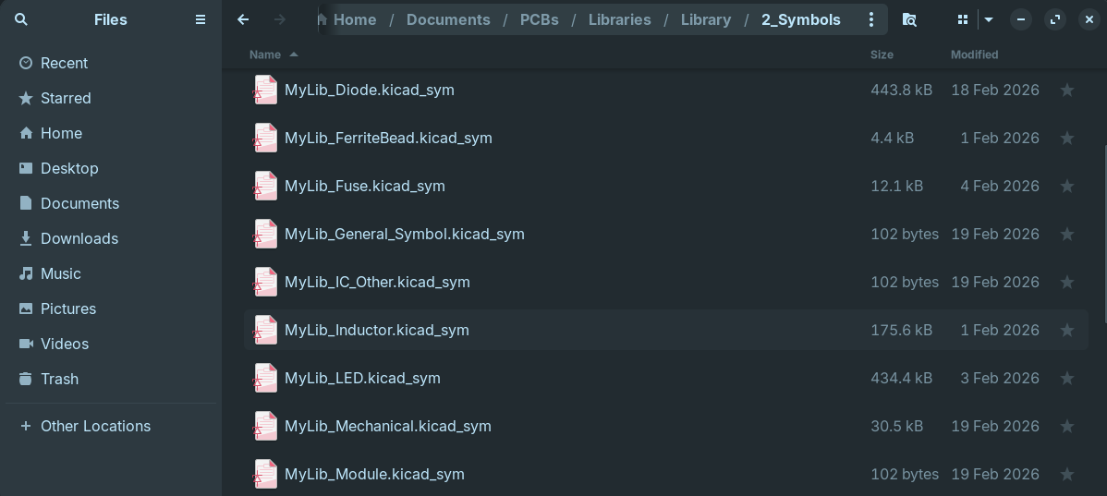
Step 5: Add the Database library
On KiCad, Preferences→Manage Symbol Libraries.., change the library format to “Database”, select the Database_Setup file (.kicad_dbl). Select Visible for this one. Give it a name (in this case, DB) and click OK.

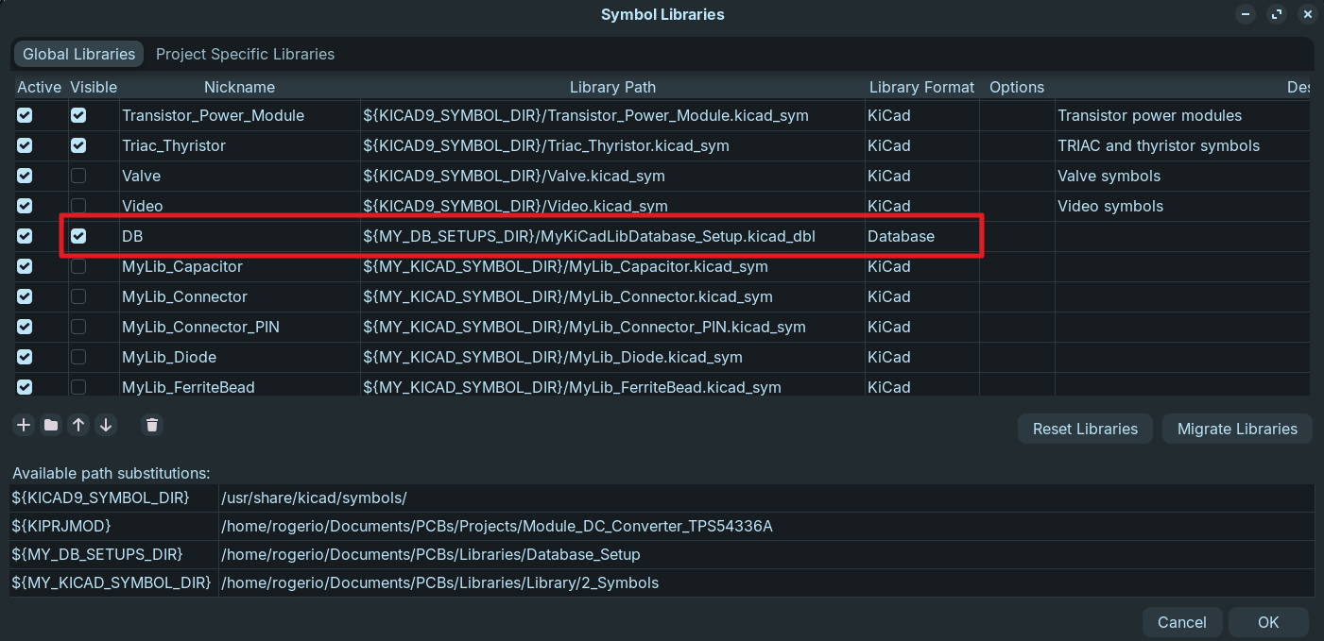
Step 6: Editing the Database Library (update components)
You can use your preferable software to open de the Database.sqlite. I”m using “DB Brownser for SQLite”. Create new Components editing this database file. If you create a new Table, is necessary to update the Database_Setup.kicad_dbl file (There is a Python File on PyGen paste that you can use to recreate de kicad_dbl file that read the tables on the Database.sqlite)

