Analysing the Network of Aged Care Hospital Transfers in Victoria

Student Name: Lesheng Xu

Student ID: 29615550

Email: lxuu0021@student.monash.edu

Supervisors:  
- Dr Michael Lydeamore   
- Prof Di Cook

# Introduction / Background

The transfer of residents from aged care facilities to hospitals is a common and necessary component of eldercare. These transfers occur for a variety of reasons such as urgent medical treatment, regular medical appointments, and preventative health care. They also occur to prevent or manage outbreaks within facilities by removing vulnerable residents to reduce transmission risks. Although medically justified, these transfers may pose significant risks, particularly with respect to the spread of infectious diseases. Older adults are more susceptible to infections, and their frequent transfers between facilities and hospitals potentially create a vector for disease transmission across sites.

Aged care networks form complex systems in which facilities are nodes and patient transfers are links. Epidemiological and network studies have shown that patient movement in such systems can influence the spread of diseases such as influenza and MRSA (Donker et al., 2010; Assab et al., 2017). However, this dynamic has not been rigorously studied in the Australian aged care context, particularly within Victoria. Given the sector's vulnerability during recent infectious outbreaks, including COVID-19, a deep understanding of these inter-facility connections is both timely and necessary.

# Need for the Study / Motivation

The Australian aged care sector, especially in Victoria, was severely impacted during the COVID-19 pandemic. Infections were often introduced and amplified through transfers between aged care facilities and hospitals. This research is motivated by the need to understand how transfer patterns contribute to this problem.

While research has addressed hospital networks and general healthcare systems (Donker et al., 2010), a gap exists in the context-specific analysis of aged care in Victoria. Further, there is a need to move beyond descriptive studies and toward predictive models that can inform practical interventions. Insights from this research can guide policy on managing transfers, preventing outbreaks, and improving aged care outcomes, especially for infection control.

This proposal aims to fill this gap using network science and epidemiological modelling, with the potential to impact public health policy, hospital logistics, and aged care management.

# Research Questions

1. **What are the structural properties of the network formed by patient transfers between aged care facilities and hospitals in Victoria?**
2. **Can the impact of COVID-19 be detected in the network?**
3. **What is the most appropriate model fit for the transfer network?**
4. **Can simulated outbreak scenarios (e.g., COVID-19-like diseases) within the aged care transfer network inform future infection prevention strategies?**

# Review of the Literature

Healthcare network analysis has gained attention as a method to understand and potentially curb the spread of infectious diseases. Donker et al. (2010, 2012) and Assab et al. (2017) demonstrated that patient transfers between healthcare institutions can significantly influence infection dynamics. They used network analysis metrics—such as centrality, clustering, and modularity—to uncover key institutions that act as hubs or bridges for disease propagation.

Although similar methodologies have been applied in the United States and Europe, the literature remains sparse in the Australian context. Moreover, the aged care sector presents unique challenges compared to hospital settings, including higher baseline vulnerability, longer stay durations, and limited infection control resources.

Various modelling approaches, such as agent-based simulations and stochastic processes, have been used to simulate disease spread within healthcare systems (Pei et al., 2018). These techniques help assess different outbreak scenarios and intervention strategies (e.g., reducing specific transfers or vaccinating key nodes). However, their application in Victorian aged care remains underexplored.

This study builds on the existing body of work, and will contextualize findings within the Australian aged care system using data from Ambulance Victoria.

# Research Methodology

This study aims to model and analyse the inter-facility patient transfer network between aged care facilities and hospitals in Victoria using transfer data from Ambulance Victoria. We will explore and evaluate several candidate models for fitting and explaining the observed network, such as the gravity model, spatial interaction models, and network regression frameworks. Model selection will be based on empirical fit, interpretability, and suitability for potential downstream applications such as infectious diseases modeling.

## 1.Data Source:

The study will use anonymized patient transfer data from Ambulance Victoria, detailing origin and destination facilities, timestamps, and patient identifiers (unique ID).

2.Ethical Considerations:  
Patient data will be anonymized and used in compliance with Alfred Health ethics guidelines and health data protection standards. Approval has been sought from the Alfred Health ethics committee.

## 3.Network Construction

We will construct a directed, weighted network, where:

* Nodes represent aged care facilities and hospitals.
* Edges represent the flow of patients, directed from the origin (facility) to the destination (hospital).
* Edge weights reflect transfer frequency over a selected time window (e.g., quarterly or annually).
* Define time period including Covid (Start from 15 March, 2020), Weekdays, Weekends

This structure enables the application of network analysis techniques and the estimation of statistical models of link formation and intensity. Visualization and analysis will be conducted using R (with packages such as igraph, tidygraph, and ggraph).

## **4.**Candidate Modeling

To explain and predict the observed patterns in transfer flows, the following modeling strategies will be considered: 1. Gravity Model. 2. Stochastic Block Models. 3. Exponential Random Graph Models...

## **5.**Model Selection and Evaluation

We will use the following criteria to compare candidate models:

* Goodness-of-fit: Deviance, RMSE, or log-likelihood metrics on holdout data
* Interpretability: Ability to explain key drivers of transfer volume
* Predictive performance: Ability to forecast transfer behaviour under unseen conditions
* Scalability: Computational feasibility for full-state data
* Applicability: Compatibility with potential extensions (e.g., infection spread simulation)

Cross-validation or bootstrapping techniques will be employed to assess model stability. Network diagnostics (e.g., centrality, degree distribution, modularity) will also be used to interpret the structure.

## **6.**Optional Extension: Infection Risk Simulation

As an optional component, contingent on model suitability and time, the transfer network may be used as a substrate for infection spread simulation (e.g., COVID-19 or seasonal influenza). This would involve:

* Assigning transmission probabilities to edges
* Simulating stochastic SIR dynamics
* Identifying high-risk nodes or potential "super-spreader" pathways

However, this will be treated as a secondary objective and is not critical to the project's success.

# Preliminary Results

## Exploratory data analysis

##### Age and gender

The histogram of age has majority of patients are between 80 and 95 years old, reflecting a population from Residential Aged Care Facilities (RACFs). The right-skewed distribution suggests most patients are elderly, with fewer younger individuals. Young age tail (ages 0–50) likely includes data anomalies or misclassified visitors, staff, or newborns, and may be required for analysis focused purely on aged care and filtered out depending on the network presentation.

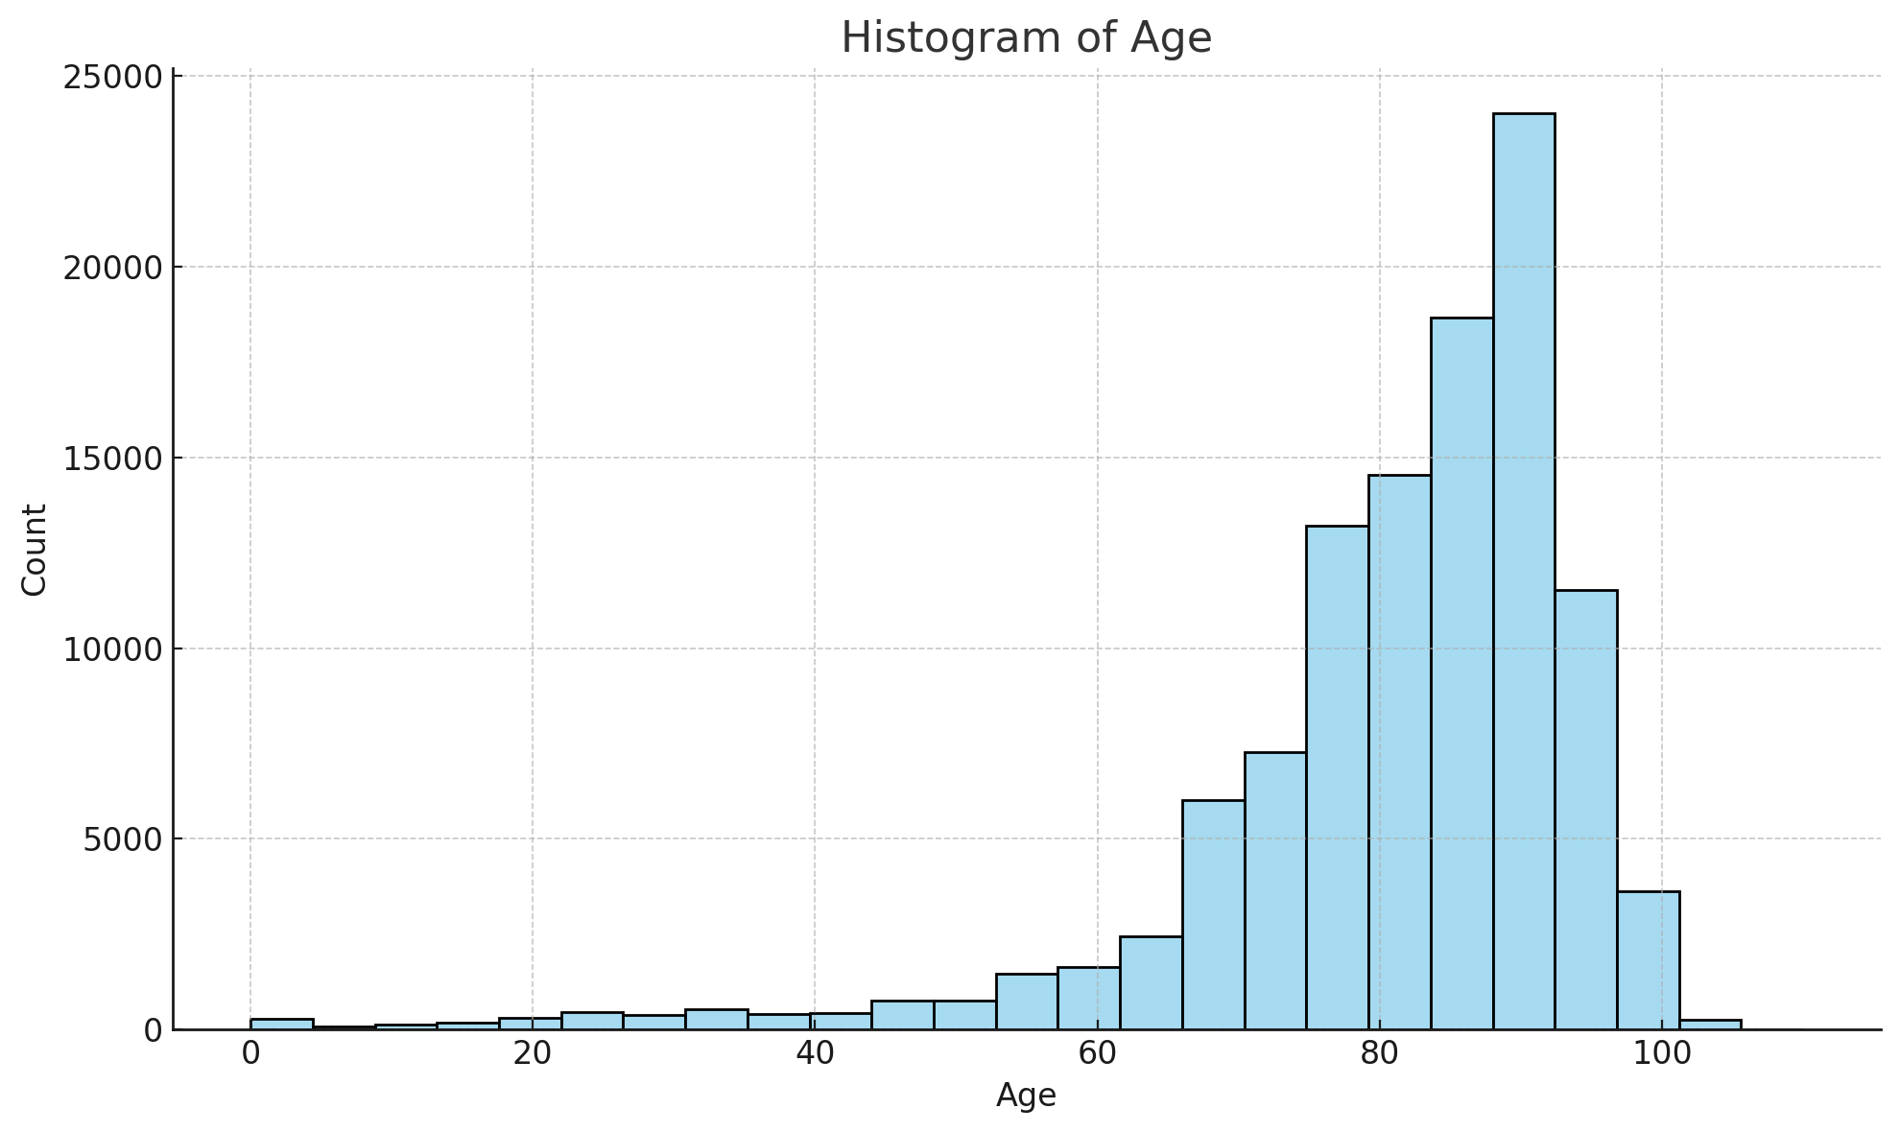

*Figure 1: Histogram of age allocation*

Female Predominance (~57%) is consistent with demographic patterns in aged care populations. Women have higher life expectancy, leading to more elderly females in Residential Aged Care Facilities. Many residents requiring care for chronic, degenerative conditions are female. Male Proportion (~43%) indicates a [substantial](https://www.thesaurus.com/browse/substantial) cohort of older males accessing ambulance services. Male residents may differ slightly in clinical profiles (e.g., more cardiac or trauma-related transfers), though that would require deeper diagnosis comparison. 36 cases entries marked as "Indeterminate" is likely due to data entry errors or edge cases involving gender identity not captured in binary format. Given the tiny proportion, it does not significantly affect analysis, but could be flagged for completeness.

##### Diagnosis and Case Nature

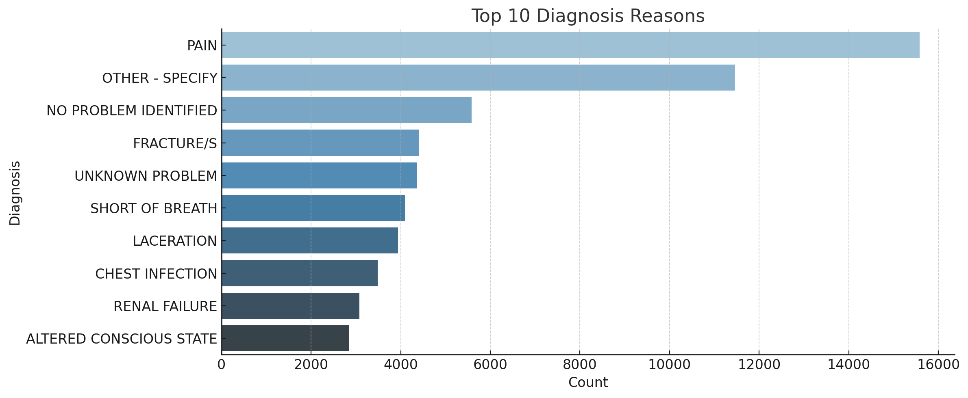

*Figure 2: Top 10 Diagnosis Reasons*

The most common diagnosis - pain , reflects frailty and chronic illness in elderly patients. A significant share of cases involve ambiguous or unspecified issues, suggesting diagnostic complexity in this population. Many are trauma or fall related, like fractures and lacerations, underlining fall risk in aged care settings. Respiratory and renal diagnoses align with known comorbidities in aged care residents.

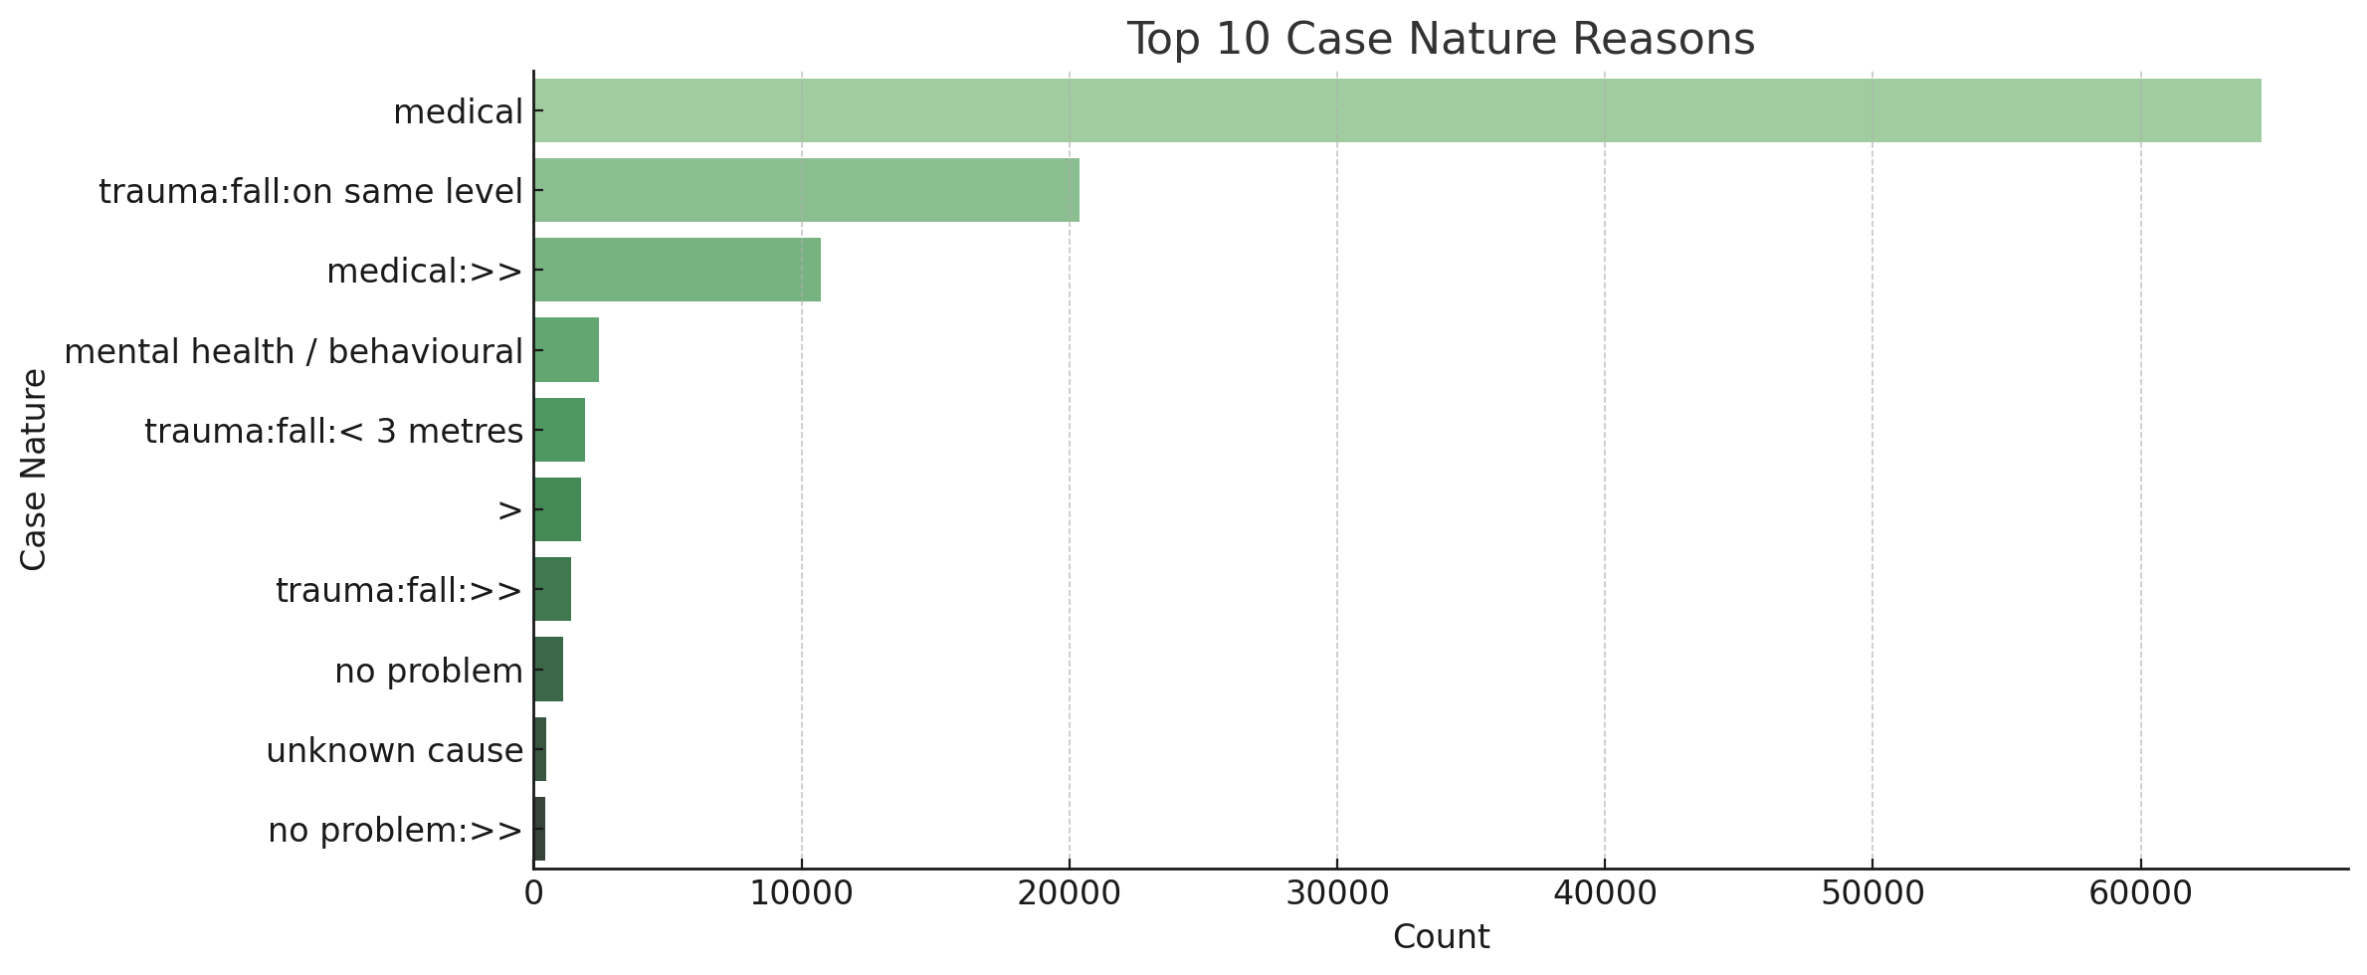*Figure 3: Top 10 Case Nature Reasons*

The overwhelming lead of “medical” nature confirms the dataset's focus on internal, chronic, or age-related conditions. Falls (on the same level or <3 metres) are a major concern, collectively making up ~25,000 records, consistent with the injury/frailty patterns in aged care. Several entries (e.g., “>>” or malformed text) suggest dirty or inconsistent data, which may need cleaning or reclassification for reliable statistical analysis.

Many patients present with vague symptoms, making definitive diagnosis difficult at scene level. Pain, breathing issues, altered consciousness, and fractures dominate diagnosis patterns, which is the key concerns in frail elderly populations. Falls are a huge contributor to emergency response and hospital transfers, both by diagnosis (fractures, lacerations) and case nature. The presence of ambiguous and malformed entries highlights the importance of data cleaning before advanced analysis.

##### 1.3 Transfers

General transfer counts has total records of 109,415. The full set of transfers recorded in the data set, covering multiple years and all types of transfers.

Pre-COVID Transfers (Before March 2020): 52,119

These are transfers that occurred before the pandemic began impacting healthcare systems in Victoria, which represents about 47.6% of the data set.

During-COVID Transfers (March 2020 Onward): 57,296

Despite pandemic disruptions, transfer activity did not decrease dramatically overall. In fact, the number is slightly higher. This increase could be due to changes in hospital admission procedures, discharges from aged care during outbreaks, or system configurations.

| Period | Transfers | % of Total |
| --- | --- | --- |
| Weekdays | 83,175 | ~76% |
| Weekends | 26,240 | ~24% |

*Table 1: Weekdays vs Weekends transfer counts*

Transfers between weekdays and weekends are heavily skewed toward weekdays, which makes sense operationally. More hospital staff and admin are available during weekday and routine and inter-hospital transfers are usually scheduled during business days. Weekend transfers are likely more urgent or emergency-related. However, the number of days are different for the two category, a standardized transformation is necessary for further pattern analysis.

| Day | Count | Remark |
| --- | --- | --- |
| Friday | 17,419 | Highest volume – likely due to clearing patients before the weekend. |
| Wednesday | 16,864 | Mid-week, stable scheduling. |
| Thursday | 16,504 | Similar reasons as Wednesday. |
| Monday | 16,446 | Start-of-week scheduling resumes. |
| Tuesday | 15,942 | Slightly lower, but consistent. |
| Saturday | 13,690 | Weekend begins – reduction in routine transfers. |
| Sunday | 12,550 | Lowest – possibly only emergency or critical transfers. |

*Table 2: Day-of-Week breakdown from highest to lowest*

The decline from Friday to Sunday suggests planned transfers slow down on weekends, which is similar to previous comparison.

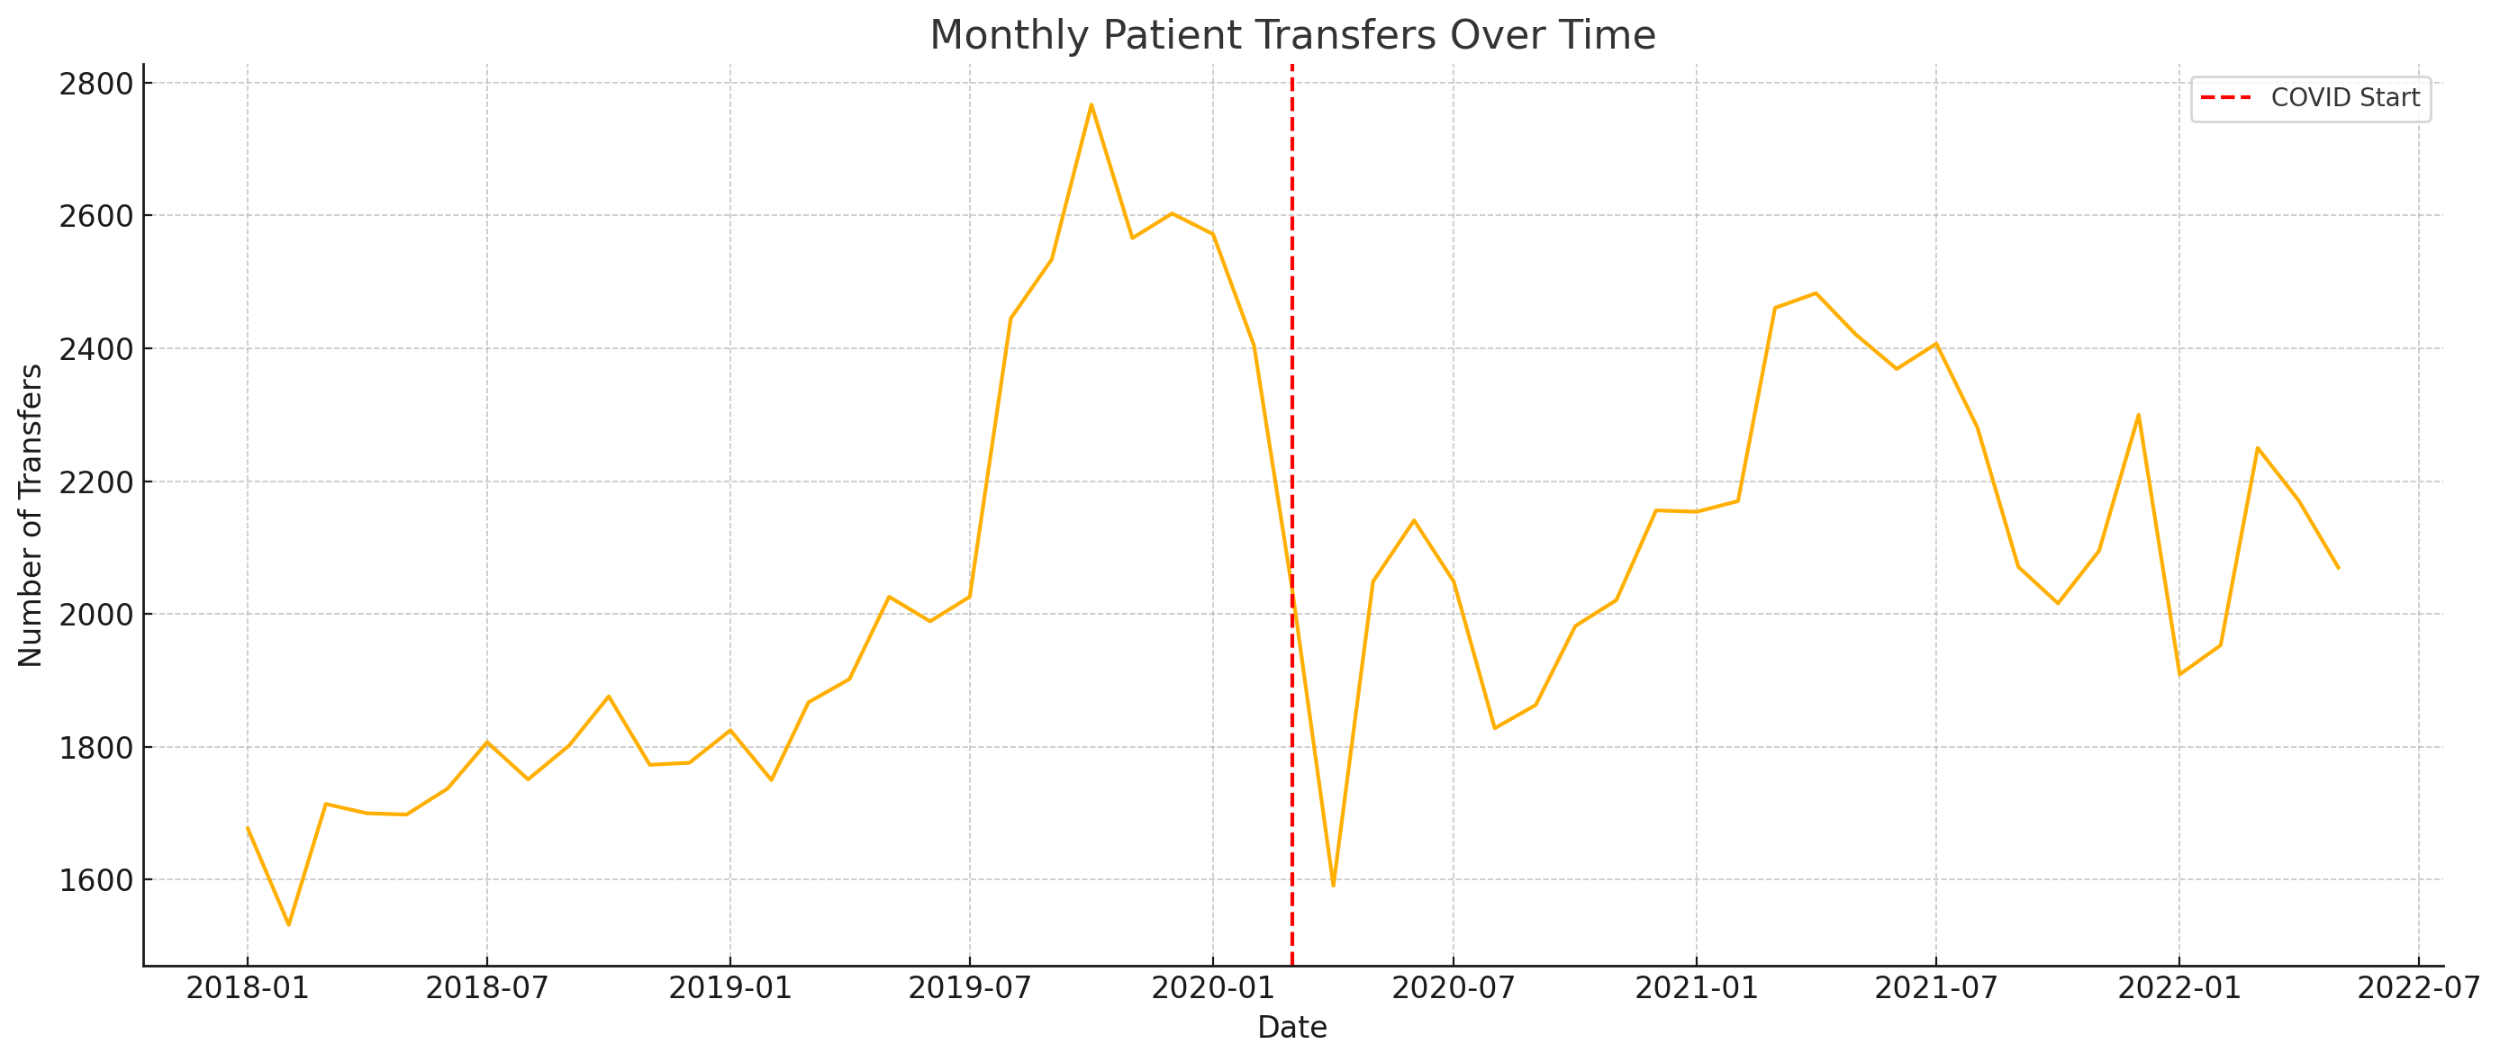*Figure 4: Monthly transfer trend*

The plotted line graph shows a steady number of transfers before March 2020. The visible dip starting March 2020, indicating the immediate impact of the COVID-19 pandemic.

This likely coincides with initial lock-downs, policy shifts restricting movement, or because of hesitation in transferring elderly patients due to infection risk.

Recovery or plateau phases can be seen later in 2020–2022 as systems adjusted (e.g., protocols for safe transfer, vaccinated populations, etc.).

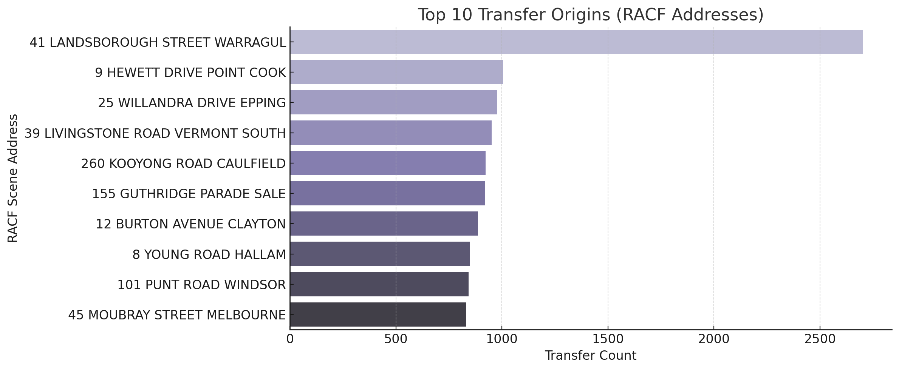

*Figure 5: Top 10 transfer origins*

These addresses represent large and high-needs aged care facilities, with frequent transfers to hospitals.

The very high number at Landsborough Street, Warragul is not a Residential Aged Care Facility (RACF), but rather the address of West Gippsland Hospital, a known public hospital in Victoria. By filtering, 1699 out of 2704 transfers are identified as inter-hospital transfers. Therefore, the address can be treated as hospital. This case illustrates why cross-verifying fields like “sceneaddress”, “category”, and “iht” from the dataset is crucial when identifying RACF-related flows.

Regional sites like Sale and Warragul show significant activity, suggesting strong ambulance dependency in non-metropolitan areas.

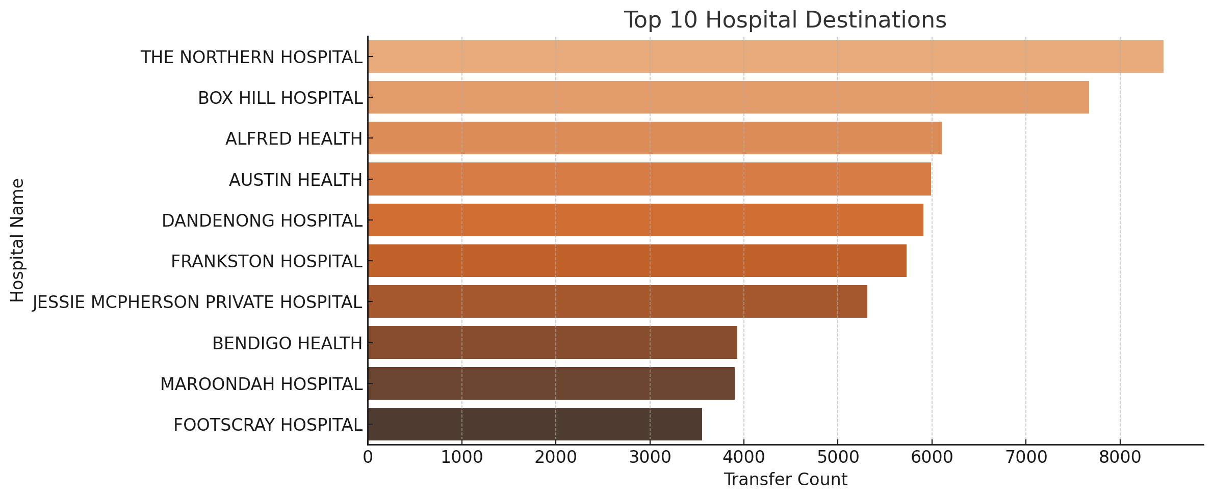

*Figure 6: Top 10 hospital destinations*

These hospitals are all major metropolitan or regional centres, serving large populations and multiple RACFs in their catchment area.The Northern Hospital and Box Hill Hospital top the list, indicating large volumes of aged care in surrounding suburbs (e.g., Epping, Heidelberg, Bundoora) and also well-connected ambulance referral networks

Private facilities like Jessie McPherson also appear, hinting that some RACF residents are privately insured or transferred based on GP/contractual relationships.

## 2.Network

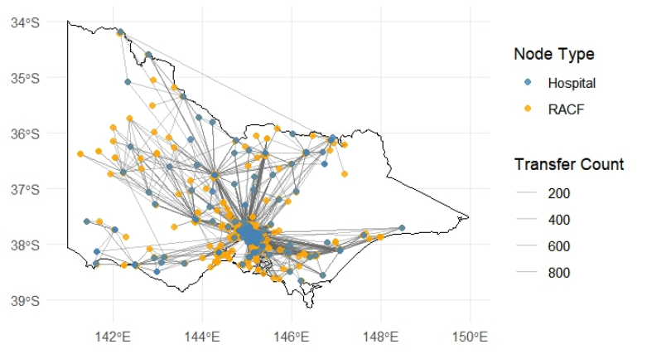

*Figure 7: Network Visualization*

Figure 7 visualizes the directional flow of patient transfers across the state, connecting RACFs (yellow nodes) to hospitals (blue nodes) using geospatial coordinates. Each node’s size represents the volume of transfers, while edge thickness reflects the frequency of movement between each RACF and hospital.The plot demonstrates a strongly centralized structure, with dense connections concentrated around Melbourne's metropolitan area. Numerous RACFs link to major hospitals like the Northern, Alfred, Box Hill, and Austin, marking these as key hubs for aged care admissions. In contrast, rural and regional RACFs appear more isolated, typically connected to single hospitals over greater distances, which highlights rural areas' reliance on limited healthcare facilities.

The map also reveals critical transfer corridors and regional dependencies, with some lines extending far across the state, implying longer transport times and possible challenges in accessing timely care. Ultimately, the network plot clearly visualizes both the urban-centralized nature of aged care transfers and the geographic disparities affecting remote Victorian RACFs.

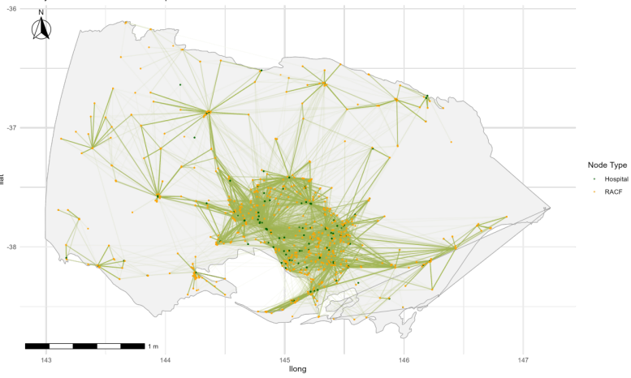

*Figure 8: Fish-eye network of transfers over Victoria*

The fish-eye transformation magnifies Melbourne's metropolitan region, where most RACF-to-hospital transfers are concentrated. Meanwhile, it compresses rural areas to minimize visual clutter, highlighting the network's core activity in Figure 8. This distortion highlights the intricate web of connections among major hospitals and RACFs that would otherwise overlap in a standard geographic plot. This enables clearer identification of transfer hubs, corridors, and high-demand facilities. The fish-eye view sacrifices precise geographic fidelity for enhanced clarity, directing attention to high-traffic transfer hubs. This approach better reveals key patterns—hospital bottlenecks, RACF reliance, and overlapping service zones, which demands analytical focus. This transformation is particularly useful for healthcare network analysis because it balances clarity with spatial context, supporting better recognition of operational bottlenecks and urban transfer dynamics while still retaining the overall structure of the network across Victoria.

##### 2.1 Network comparison

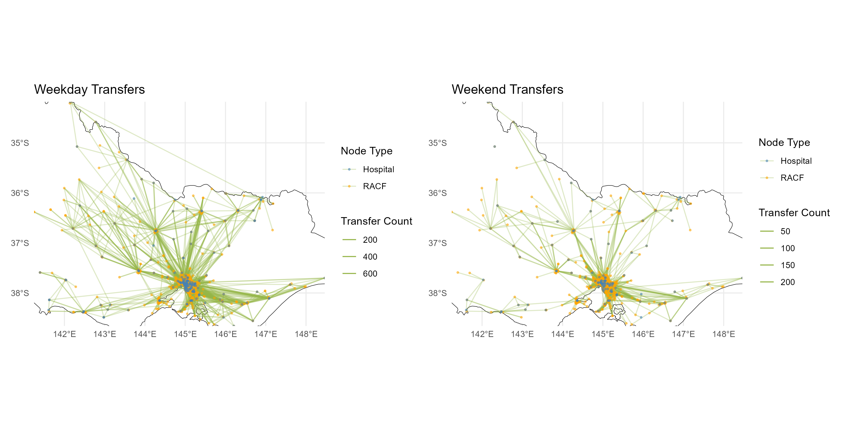

*Figure 9: Comparison of transfer network between weekdays and weekends*

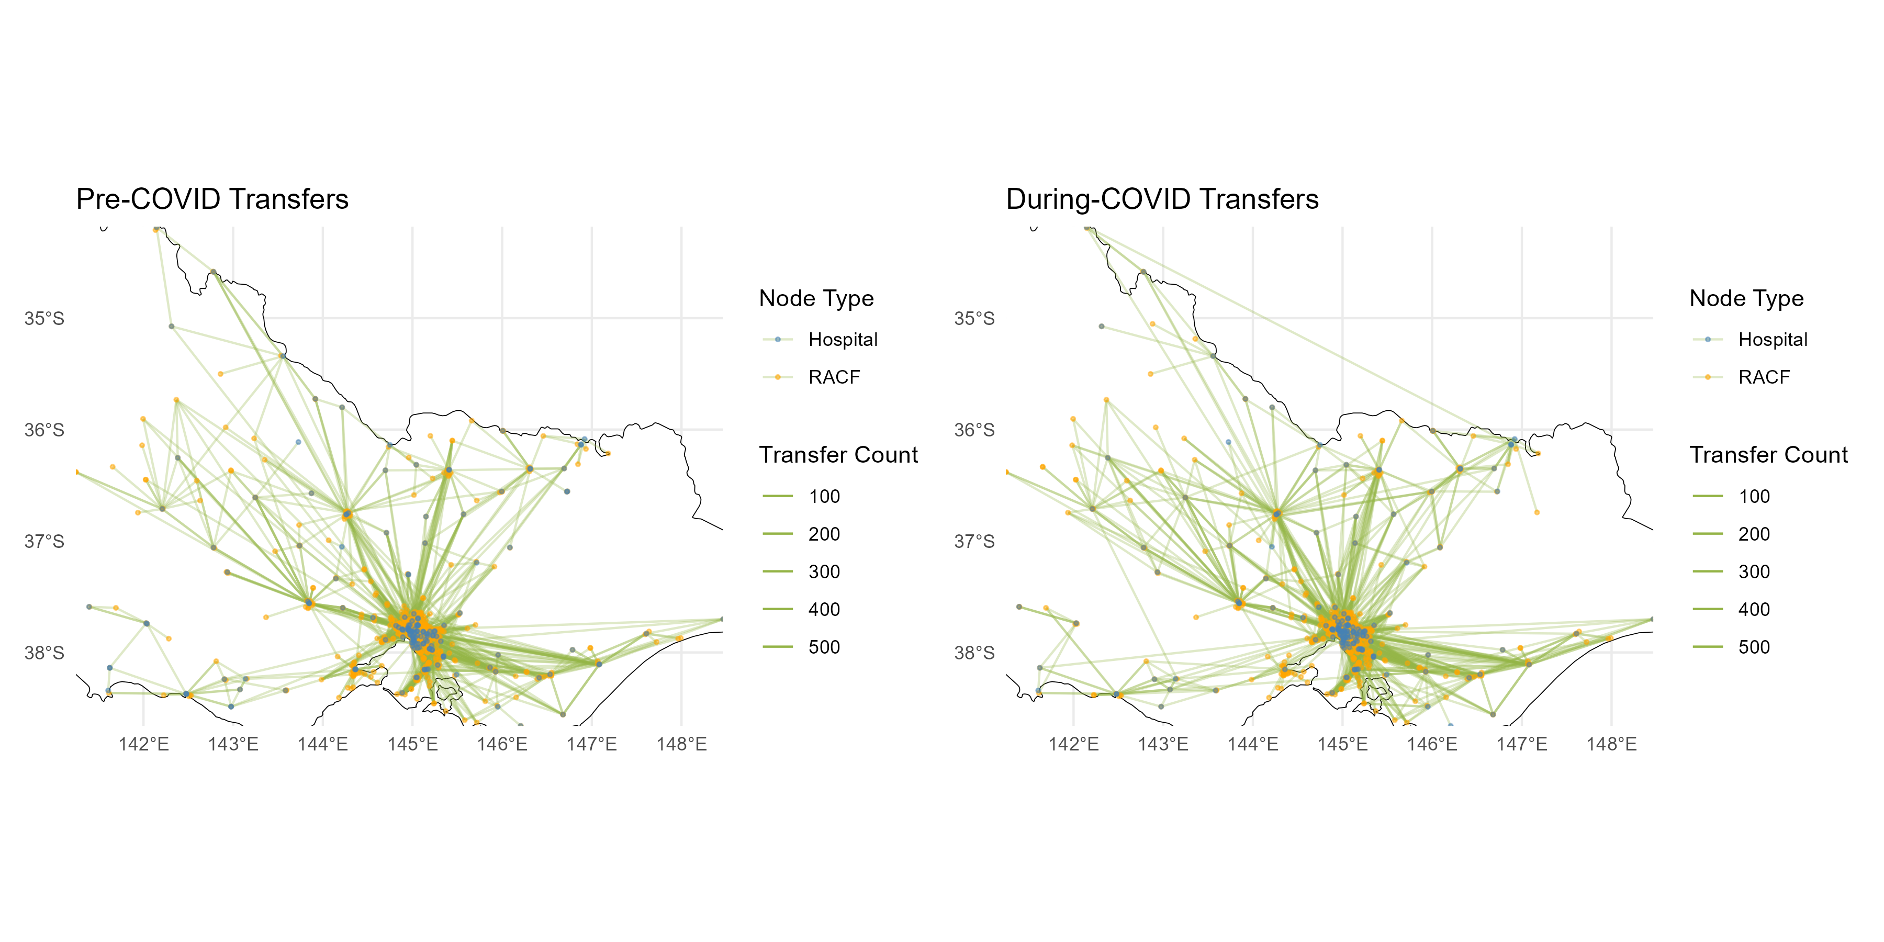

*Figure 10: Comparison of transfer network before and during COVID period*

Figure 9 and 10 show comparative visualization of transfer networks across two dimensions: weekday vs weekend and pre-COVID vs during-COVID. Each plot maps the aged care transfer network in Victoria, with nodes representing hospitals and RACFs, and edges indicating the volume of transfers, scaled by thickness.

Compared with weekday transfers, weekends transfers show a clear reduction in overall activity: the network is sparser, edges are thinner, and fewer RACF-hospital pairs remain active. This supports the earlier EDA finding that transfers drop significantly during weekends, likely due to operational and scheduling limitations.

While both pre-COVID and during-COVID transfer networks appear broadly similar in structure, featuring dense connections between major hospitals and surrounding RACFs, there are minor shifts in the periphery by inspection. During-COVID networks show slight increased concentration engagement from peripheral areas, suggesting a broader geographic spread of transfer activity. This is possibly due to outbreak management, regional hospital pressure, or altered triage protocols

However, by only inspection, the difference of pattern can hardly be captured accurately. Adjacency matrices and heat maps are essential tools for identifying and visualizing changes in aged care transfer patterns across different time periods. The adjacency matrix represents transfer frequencies between RACFs and hospitals, capturing the structure and intensity of connections in the network. To ensure fair comparison across groups with unequal duration, mentioned previously in EDA, we apply standardization by dividing transfer counts by the number of days in each period and transforming values (using square root) to reduce skew from high-frequency transfers. By subtracting standardized matrices, we detect increases or decreases in transfers between specific locations. Heat maps then translate these differences into color-coded visualizations, enabling quick and intuitive identification of significant changes in network behavior. This method supports evidence-based understanding of how aged care transfer dynamics respond to temporal or systemic factors.

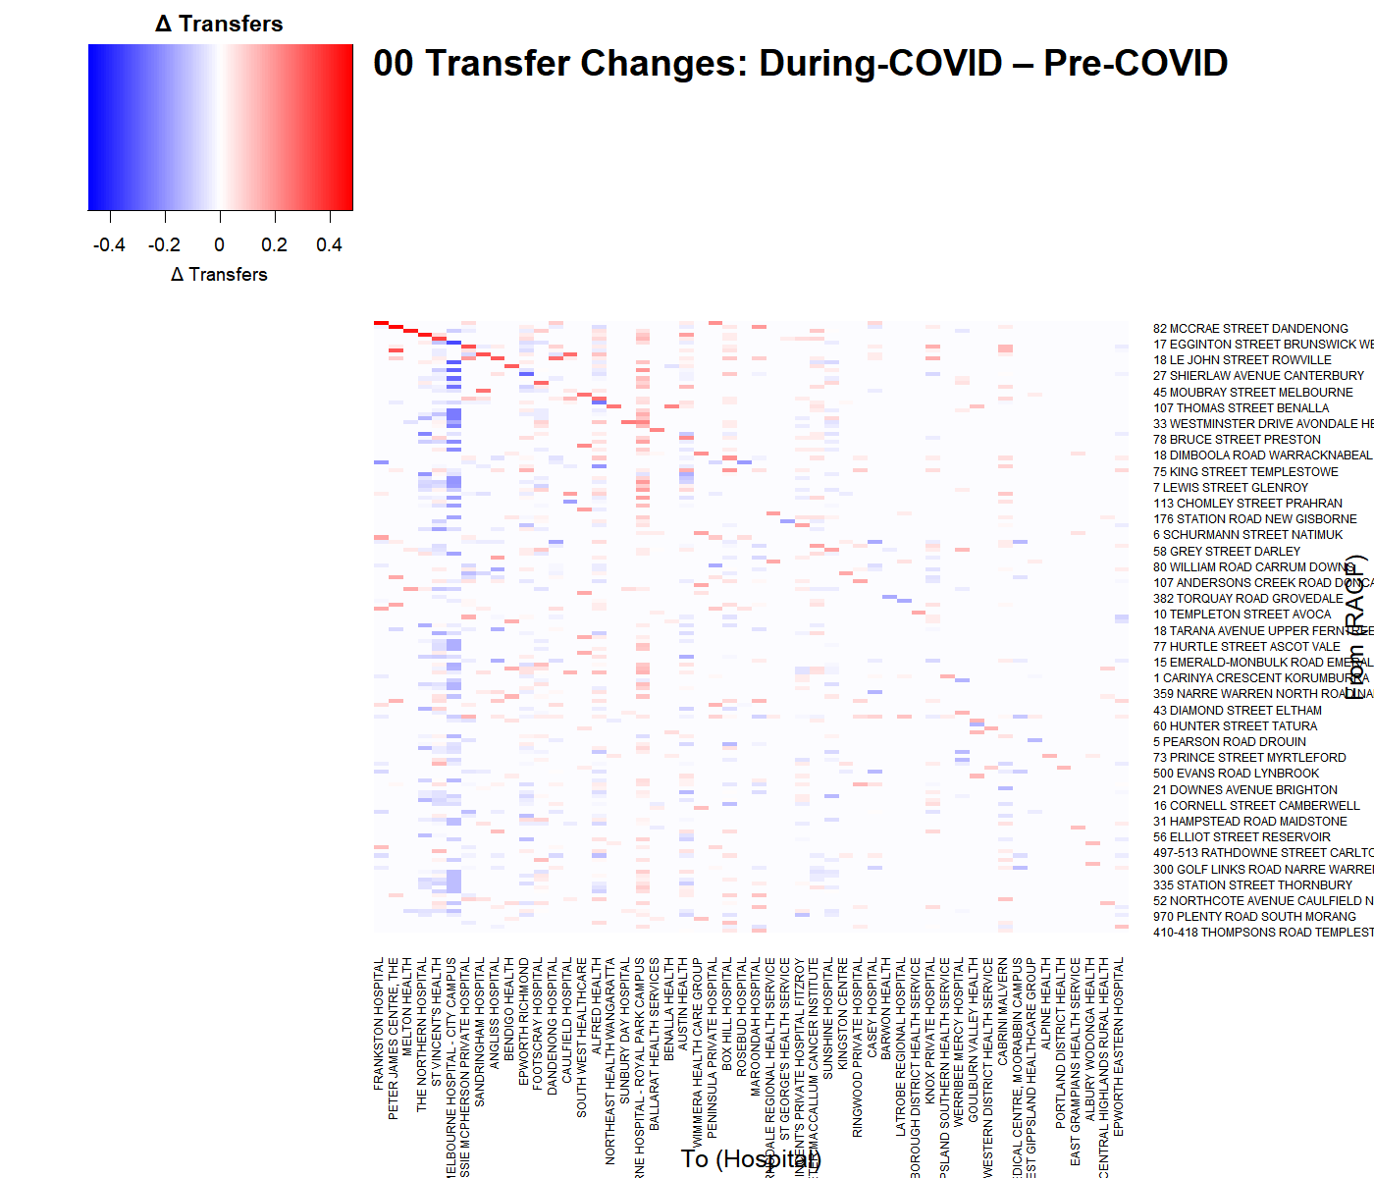

*Figure 11: Heat map of transfer difference before and during COVID period*

Figure 11 visualizes changes in transfer patterns between Residential Aged Care Facilities and hospitals during the COVID-19 period compared to the pre-COVID period. Each cell represents a transfer from a specific RACF (row) to a hospital (column), with color indicating the direction and magnitude of change-red for increased transfers, blue for decreased transfers, and white for no change or masked low-activity pairs. The adjacency matrices used to construct the heat map ensure that all locations are represented with consistent dimensions and ordering, allowing for meaningful visual comparison. Only the top 200 most significant changes are shown to highlight the most impacted transfer links, making it easier to detect patterns such as hot spots of increased hospital demand or reduced mobility during the pandemic. This plot shows both some increase and decrease before and after COVID, as their number of transfers are similar obtained in previous section.

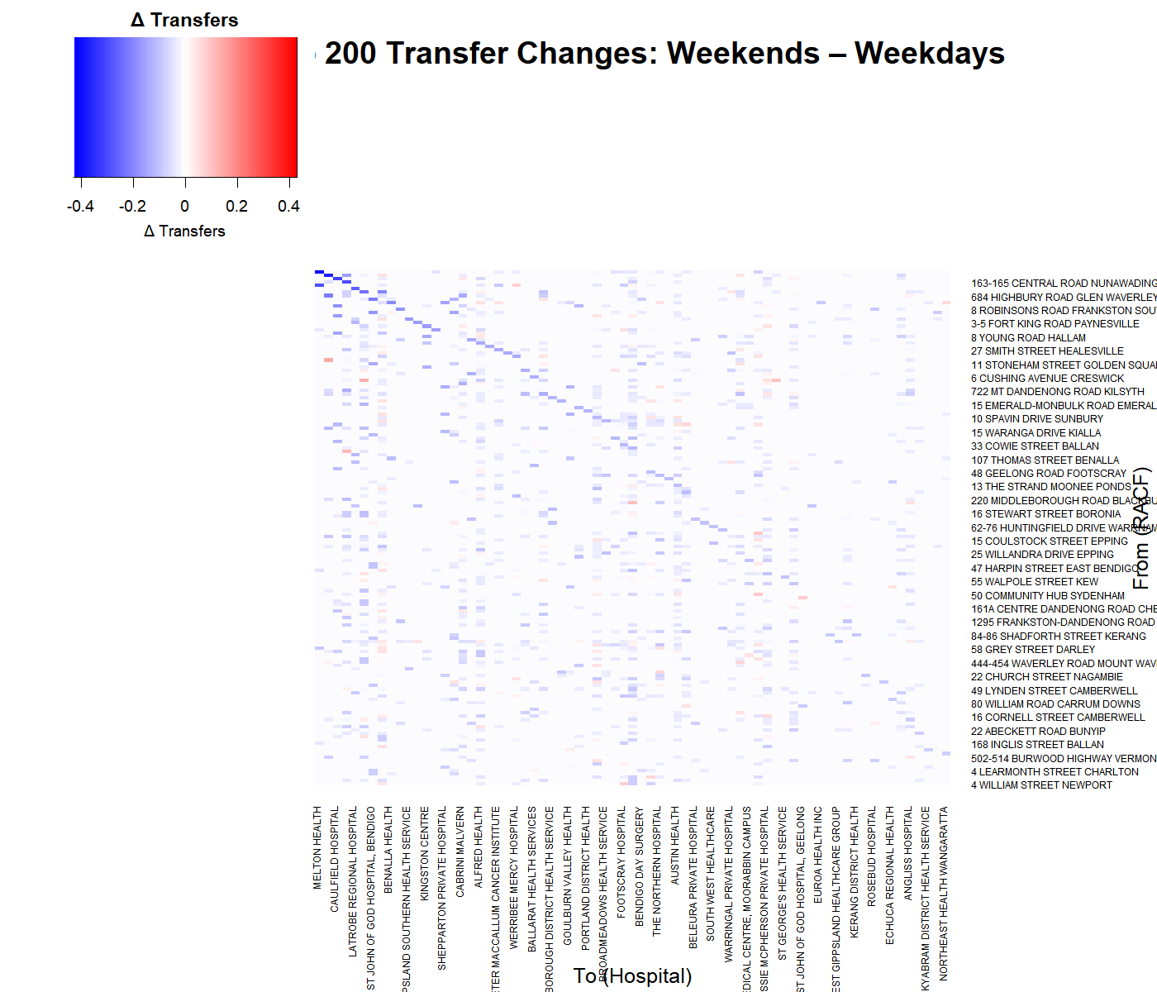

*Figure 12: Heat map of transfer difference between weekdays and weekends*

The difference of subtracting weekends transfers from weekdays transfers are shown in the Figure 12. The overwhelming prevalence of blue cells across the heat map indicates that transfers significantly drop on weekends across most pairs. This supports earlier EDA results, suggesting lower system activity during weekends, possibly due to reduced staffing, limited scheduling capacity, or delayed hospital admissions. Blue cells are especially concentrated along the diagonal, suggesting that same-facility (self-loop or short-range) transfers drop more during weekends, which potentially reflecting deferrals in routine care or transport arrangements.

## 3.Conclusion

This project has developed a directed, weighted network capturing patient transfers between Residential Aged Care Facilities (RACFs) and hospitals across Victoria using Ambulance Victoria data. Exploratory data analysis has been done on each category of the data. We have processed and cleaned the dataset, assigned temporal labels (pre-COVID, COVID, weekday, weekend), and standardised transfer frequencies based on time coverage. By generating and comparing adjacency matrices, we revealed meaningful patterns, such as decentralisation of hospital use during COVID and reduced transfer volumes on weekends. These insights were visualised using heatmaps that highlighted spatial-temporal variations in transfer intensity. Nonetheless, limitations remain, such as ambiguous facility naming, potentially incomplete address data, and difficulty distinguishing between RACFs and hospitals purely from free-text fields. In future work, we aim to systematically identify all possible structural patterns within the transfer network, including central hubs, regional clusters, and recurring transfer pathways. For next steps, we will test different modeling approaches, including gravity models and bipartite stochastic block models, to understand and predict these patterns. We may also add spatial data and simulate how diseases spread through the network to improve aged care operations and emergency response planning.

# Timeline

|  |  |  |  |
| --- | --- | --- | --- |
| Phase | Time | Activities | Progress |
| Phase 1: Preparation | Month1-2 | - Obtain and clean transfer data from Ambulance Victoria - Ethic Approval  - Set up analysis environment (R) | All done |
| Phase 2: Network Construction & EDA | Month 3–4 | - Construct the directed weighted transfer network - Perform exploratory data analysis (e.g., degree distributions, geospatial visualisation) - Identify basic patterns and anomalies | All done |
| Phase 3: Model Development | Month 5–6 | - Fit candidate models (Gravity model, SBM) - Prepare covariates and distance matrices | Look for the candidate model, depending on the previous pattern findings |
| Phase 4: Model Evaluation | Month 7 | - Compare models using AIC, BIC, RMSE, cross-validation - Perform sensitivity and robustness checks - Interpret model coefficients | - |
| Phase 5: Optional Simulation | Month 8 | - (Optional) Simulate infection spread on network - Analyse outcomes under various transmission scenarios - Identify high-risk nodes | - |
| Phase 6: Synthesis | Month 9 | - Consolidate results and prepare key findings - Generate figures and tables - Discuss policy implications and limitations | - |
| Phase 7: Final Write-up | Month 10 | - Draft final report - Review and revise content - Submit research proposal and prepare for presentation | - |

*Table 3 : project timetable and progress*

# Proposed Thesis Structure

1. Introduction

Background, motivation, research aims

1. Literature Review

Network models in healthcare, spatial models, aged care systems

1. Data and Methods

Dataset description, network construction, modeling approaches

1. Results and Model Comparison

Network visualization, model outcomes, robustness analysis

1. (Optional) Infection Risk Simulation

Scenario modeling, centrality analysis, intervention strategies

1. Discussion

Policy implications, limitations, directions for future work

1. Conclusion

Summary of findings, contributions

# Expected Outcomes of the Study

* A detailed network representation of aged care–hospital transfers in Victoria
* Empirical evaluation of spatial and structural models (gravity model or alternatives)
* Identification of key predictors of transfer behaviour
* Optional risk maps or simulation outputs for infection scenarios
* Methodological template applicable to other jurisdictions

# References

Donker, T., Wallinga, J., & Grundmann, H. (2010). Patient referral patterns and the spread of hospital-acquired infections through national health care networks. PLoS Computational Biology, 6(3), e1000715.

Donker, T., et al. (2012). Hospital networks and the risk of hospital-acquired infections. Journal of the Royal Society Interface, 9(76), 2648–2656.

Assab, R., et al. (2017). Healthcare-associated infection transmission across networked hospital settings. BMC Medicine, 15(1), 157.

Newman, M. E. J. (2010). Networks: An Introduction. Oxford University Press.

Pei, S., Morone, F., Liljeros, F., Makse, H., & Shaman, J. L. (2018). Inference and control of the nosocomial transmission of methicillin-resistant Staphylococcus aureus. eLife, 7, e40977. [https://doi.org/10.7554/eLife.40977](https://doi.org/10.7554/eLife.40977" \t "_new)

# Appendix