Lin Files - a Starter Roger Pfister RogerPf.com/aaBridge
Perhaps one of the following applies to you
You have a collection of hands and would like to easily upload them to BBO,
or maybe, you would like to turn them into a set of 'problems'.
AND in both cases you probably do not want to delve deeply into lin files.
If you do not have actual deals available now, skip down the page to –
"Using the supplied example file".
otherwise
First get the hands as lin files
(the videos below really are worth watching):
aaBridge on YouTube docs from the Doc collection
video 002 & 003 Get a BBO hand into aaBridge
video 006 Enter (Type) Hands into aaBridge
(see the suggestions for editors, etc at the end of this document)
Now you know how to download deals from BBO you can copy all of the deals you want to into a single lin file. That is, you could just copy and paste all of the text of each lin file and add it to the one you want to be the single file.
DO NOT worry about the format, just copy everything from each lin file to the end of the target .lin file. BUT adding a blank line AFTER each deal is a good idea.
Using the supplied example file - BBO format
Follow the instructions on the next page using the supplied example lin file that should come along with this document. It is called :
Lin_Fl.lin
Drag and drop this lin file on to an open aaBridge window. When you click Flow or (recommended) use your mouse wheel to step through the file you will see that it contains two deals numbered o3 and o7 both of which show as bumps on the navbar. And that the first Deal (3) has West as the declarer and that the second has North as the declarer.
(FYI – the first deal was downloaded from BBO. The second was also originally downloaded from BBO from a teaching table.)
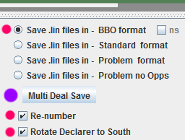
Now you are going to save these deals. In the example there are just two, but YOU could have any number.
In aaBridge raise the lower (bottom) divider bar to show the additional settings.
Check the three values on the right (red dots) and have only those set.
Now click Multi Deal Save (purple dot)
Multi Deal Save works on ALL the deals in a SINGLE lin file. If your deals are in multiple files, first join them together. Read
Joining Multiple Lin Files.doc

This will create (or overwrite) a new file next to your existing lin file called
Lin_Fl__BBO.lin
Now drag and drop BOTH files on to your aaBridge window and now both names will be visible in the left hand column. You can move from looking at one to looking at the other by clicking on each name in the gray left hand column. Note that the resulting hands are
● Deals numbered 1 and 2 and 'bumps' for o1 and o2 show in the navbar.
● Declarer is in the South seat for both Hands.
● The new .lin file will upload both deals to BBO (the originals will not upload both correctly).
To see how to upload deals to BBO please watch the FINAL 30 seconds
of aaBridge on YouTube video 006 mentioned earlier.
Standard format
This time select Standard format and keep the other settings as they were.
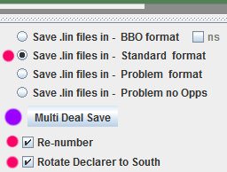
click Multi Deal Save
This will create (or overwrite) a new file next to your existing lin file called
Lin_Fl__Std.lin
Again, select all the lin files and drag and drop them on aaBridge so you can see all their names in the aaBridge grey left hand column. Compare the two created lin files by how the appear in aaBridge you will see that the only difference is that the Std Format has the bumps in the navbar number 1 and 2 whereas they are o1 and o2 in the BBO format .lin.
If you try, you will discover that you can move between BBO and Standard format and still preserve all the information in the deals.
BBO upload format requires that all of one deal is on one line. The older Standard format is not so fussy so with the extra linefeed (enters) in the text it is much easier for human beings to read.
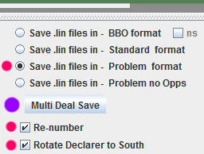
Problem format
Again do a Multi Deal Save this time using Problem format. Once again drag ALL the lin files into aaBridge so you can compare them.
Try solving the problems while playing the PROBLEM format file – YES Try them out.
As you will see Problem format works well for Deal 1 – except it might be nice if the ... additional play was removed. Deal 2, ASKS after the opening lead and so just misses the point of the problem entirely.
The next section is how to fix these issues with the minimum of effort.

This is a ONE page aside - just here for your information
How aaBridge 'sees' a lin file
The way aaBridge (and all lin file playing programs) understand lin files is not what you might expect. Below is a shortened version of a lin file
All stuff before any command is ALWAYS skipped overqx|9|pn|GG_Bridge,W,RogerPfi,E|rh| |ah|Board 9 Short Version|md|3sKJT653dA987cAJT,s7hKQ9872dQ64c975,hAT653dKJ532cQ83,sAQ9842hJ4dTcK642|this skipped over as wellsv |n|sk| |pg| |mb|p|mb|2S|an|Weak 2|mb|p|mb|p|mb|p|pg| |pc|s3|pg| |also skippedpc|s7|pc|d3|pc|s8|pg| |mc|5|pg| |
aaBridge works by looking for a two letter command. It does this by searching for a bar character '|' and then it looks at the two characters that come immediately before that '|'. The first command in the above example are the letters qx which come just in front of the first bar, ie: the end pair of what looks like the 'word' - overqx.
The red shows where aaBridge is hunting for a command letter pair and the blue shows text that is then treated as data for that (just found) command. When aaBridge finds the next bar character '|' it knows that the data for that command has ended and it goes back to hunting for the yet another bar which will define the next command letter pair.
Some commands like rh|| (remove header, end of first line) have no data hence the need for two bar characters next to each other.
New lines and spaces play no part when hunting for the next command
Notice that spaces and new lines play NO PART in the cmd|data|cmd|data|cmd|data pattern. When processing a lin file aaBridge treats them as any other character. If looking for a command they are ignored and when sucking up data they are 'given' to the command as part of its data.
<Back to the main text on the next page>
Fixing the two Issues
Go back to the
Lin_Fl__Std.lin
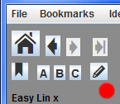
lin file and if the 'edit' pencil icon works on your system, use it (click it)
For how to set up 'quick' editing see the
Quick Lin File Editing.doc in the doc collection.
if the pencil icon is NOT set up on your system, just open the recently created ...Std.lin file in your text editor in the normal way.
NOTE The play that comes after the lead and before the start of the problem is called the Early Play.
Board 1
Some of Board 1 (roughly lines 5 to 14) should look something like this
mb|1H|mb|p|mb|2N!|an|4 @h's 12+|mb|p|mb|3C!|an|cue|mb|...
pc|s9|pg||
pc|sA|pc|s5|pc|s6|pg||
pc|hA|pc|s2|pc|h2|pc|h6|pg||
pc|h5|pc|c2|pc|hK|pc|h7|pg||
pc|h3|pc|h8|pc|hQ|pc|d2|pg||
pc|sQ|pc|sK|pc|h4|pc|s8|pg||
pc|d5|pc|d4|pc|dK|pc|d3|pg||
pc|sJ|pc|s4|pc|c6|pc|d7|pg||
pc|sT|pc|c3|pc|d6|pc|hJ|pg|| (pc = play card)
pc|dQ|pg||
mc|12|pg||

Delete all the lines AFTER the opening lead 's9' so it now looks like this.
mb|1H|mb|p|mb|2N!|an|4 @h's 12+|mb|p|mb|3C!|an|cue|mb|...
pc|s9|pg||

NOTE in the examples to come eb|y| is shown as eb|y___| using
just eb|y| will work perfectly. The longer form is used so YOU can see it more easily in the lin files and, just to help YOU, aaBridge will save it that way.
Board 2
Some of Board 2 should look like this
mb|2S|mb|3C|mb|3S|mb|p|mb|p|mb|p|pg||
pc|cK|pg||
pc|c3|pc|c4|pc|c2|pg||
pc|cA|pc|cT|pc|c5|pc|c9|pg||
pc|cQ|pc|cJ|pc|c8|pc|d4|pg||
pc|d8|pc|dA|pc|dQ|pc|d5|pg||
pc|sK|pc|s7|pc|s2|pc|sA|pg||
pc|s3|pg||
mc|9|pg||

Delete all the PLAY following the play of the 'd4' so it now looks like this.

mb|2S|mb|3C|mb|3S|mb|p|mb|p|mb|p|pg||
pc|cK|pg||
pc|c3|pc|c4|pc|c2|pg||
pc|cA|pc|cT|pc|c5|pc|c9|pg||
pc|cQ|pc|cJ|pc|c8|pc|d4|pg||

REPLACE pc|d4| (the last card played) with eb|y___| it needs to go before the final pg|| so it now looks like this

mb|2S|mb|3C|mb|3S|mb|p|mb|p|mb|p|pg||
pc|cK|pg||
pc|c3|pc|c4|pc|c2|pg||
pc|cA|pc|cT|pc|c5|pc|c9|pg||
pc|cQ|pc|cJ|pc|c8|eb|y___|pg||

The presence of the eb|y___| tells aaBridge (when it makes the 'problem' lin file) that you want the ASK point to be THERE and not at the opening lead. You can also have additional play after the ask point if you want.
Save the file
Now that you have finished editing the file Lin_Fl__Std.lin use THAT file to generate a Problem file it will be called
Lin_Fl__Std__Prob.lin (you can rename it to something sensible later)
When you play THIS file then Problem 2 becomes a real Problem.
---------------------------------------------
You convert any format file to any other so you can go from Problem to BBO
What if there is no Early Play and I need to add it ?

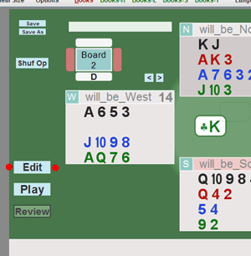
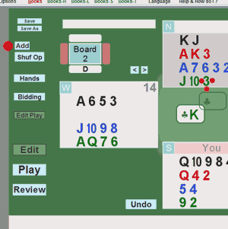
In the above examples there was, too much play, and you could easily delete it. If you need to add it then use aaBridge to enter the play. In exactly the same way that you use aaBridge to enter the lead see video 006.

The first image above shows the second of the two deals in Lin_Fl.lin
Here it has already been rotated so the declarer is South and it is renumbered as 2.
After clicking Edit (red dots) you can, if you need, to Undo any play you do not want and then enter the play you do want.
In the second diagram you can see the North would now play the 3 of clubs. (3 small red dots) and so can click on that. After you have added all the early play you can click on the little Add button (one large red dot) that is visible just above the Shuf Op button. The Add button will add the eb|y___| at that point in the play.
So when you save, normally to the file called __xxx.lin (
This is, as was said above, following the same approach as given in YouTube video 006.
And then add the appropriate contents of that file to the lin file you are editing.

Help from - Help and How do I ? More on eb|y___|

Look in the Help and How do I menu , and entry to wards then in red is -
What goes on inside a .lin file.
Go into that lin file and on the he LEFT hand side (below half way) is the entry
eb mx kc E Blocker, Keep cards
Click on the blue eb mx kc (you will be taken to the E Blocker lin file)
Early in the Navbar is the entry for eb y
In the middle of the Navbar is the entry for ebY+
What is the mx|x| command
The mx|x| command mentioned above (see eb mx kc) is an older way of doing a similar thing to the eb|y| command. With eb|y| the user clicks the 1st button and will be taken to the eb|y| point in the play and can play on from there against the aaBridge bots. (The user is restricted from going backwards in the play).
With mx|x|, when the user is told to press the Cont button (which they will be told to do on the pg|| command BEFORE the mx|x| command) the user will be taken into the deal and can play FORWARDS from that point BUT can see none of the play that is ahead. (They are not restricted to going backwards in the play).
The mx|x| command effectively is like an 'end of scene' cut in a Hollywood movie.
Once the user flows through the mx|x| they are in the next scene and pressing the Cont button will show them all the play that they could not see before.
Unlike the eb|y| cmd the mx|x| cmd is NEVER saved as part of a deal.
The eb mx kc lin file mentioned above also contains a working mx|x| command and full description .
What of – Problem no Opps ?
This as you will see by trying out Problem no Opps starting from the
Lin_Fl__Std.lin
file that you EDITED in the earlier section. When you create
Lin_Fl__Std__Pr-nop.lin
you will see that the early play is preserved and this EVEN after users have clicked the 1st button and then clicked Shuf Op
This way users can play the deal against many different layouts of the Opps hands.
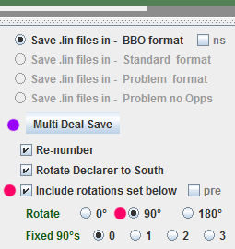
What of – Include rotations ?
These settings are there for use by Teachers and others.
Suppose a teacher has a set of files which illustrate a particular point of declarer play. The settings on the right will take her lin file with all the deals in it and will produce a finished lin file where each seat around the table gets to be declarer in order.
This way the teacher needs only keep one master file and can rotate is before uploading to BBO.
Fixed 90's are used to select the first seat to be declarer. Selecting '1' would make West (not South) be the first declarer.
<end of subject – more on the next page>
Suggestions for Editors and other tweaks -
to make your computer easy to use

An improved version of these hints (with images) can be found in the document
Quick Lin File Editing from inside aaBridge.doc

If you are running Windows
1. Install the latest aaBridge
As always, it can be downloaded from http://RogerPf.com/aaBridge
2. Please get and install the wonderful Free text editor. NotePad++
https://notepad-plus-plus.org/
(also see the aaBridge doc collection for Notepad++ How to setup for Windows )
3. Set your computer to show the 'extensions' at the end of filenames. See
http://windows.microsoft.com/en-us/windows/show-hide-file-name-extensions

If you are running a Mac
1. Install the latest aaBridge
As always, it can be downloaded from http://RogerPf.com/aaBridge
2. Please get and install the BBEdit
http://www.barebones.com/products/bbedit/
You do not need the 'pay for' features. And they won’t mind if you keep using it that way. Older Mac's should try to get the older TextWrangler
3. Set your computer to show the 'extensions' at the end of filenames. See
https://support.apple.com/kb/PH19072?locale=en_US
<end document>

