How to install aaBridge on a Mac

compiled by Roger Pfister

The description here covers OS X Mountain Lion other modern versions of the Mac OS should be similar.
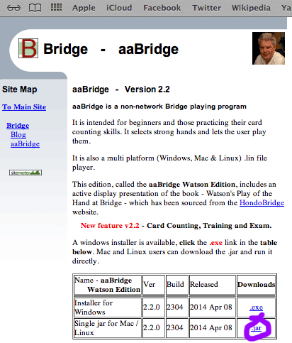

In Safari go to
http://rogerpf.com/aaBridge

The page should look something like the image.

Click the .jar link shown ringed in purple above.

A file with a name like aaBridge_Watson_Edition_2.2.0.2304_setup.jar
will now start to download.

<end of page>
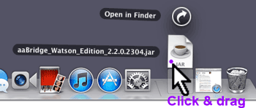
When it has finished downloading the download icon will bounce in the normal way and you can click on it (not shown). This will show all your downloaded files including the aaBridge and jar.

When you can see the .jar file click on it and drag it to a more convienent place. For example, on to the desktop.
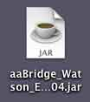
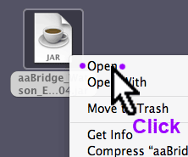
If you dbl-click on the .jar file now it may not work. What may happen is that you will get an error dialog telling you that the developer of aaBridge is unidentified.

In order to run aaBridge you needed to give it permission.

Click on the jar icon in the normal way that will display the mouse button menu. Try Ctrl and normal/dbl click

Java - Mavericks, Yosemite (and MAC OSX versions to come)
(If you have an older system e.g. Mountain Lion then please skip this section)

Since Mavericks (OSX 10.9) Apple have stopped including 'built-in' Java in OSX.
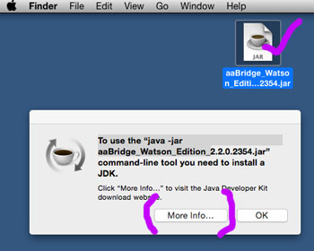
Upgraders to Mavericks should be OK but (apparently) all Yosemite systems will need to get and install a new Java.

When you click on the aaBridge jar you will see a message like the one shown on the right.

Click the More Info. . . button

<end of page>

If you don't see this message/button then you can use the link below.

http://www.oracle.com/technetwork/java/javase/downloads/index.html

This is the link used by the Yosemite “button”. It takes you to –

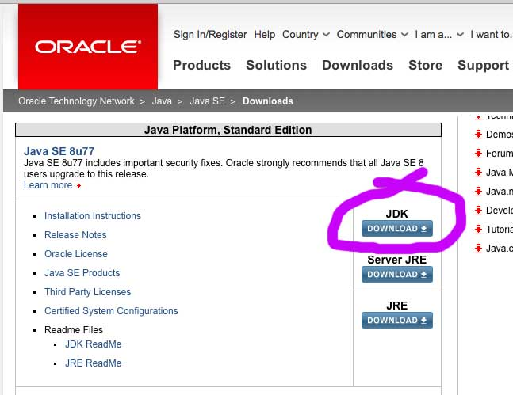

You want the JDK so click that button

You will now be taken to the JDK download page - see next sheet.

<end of page>
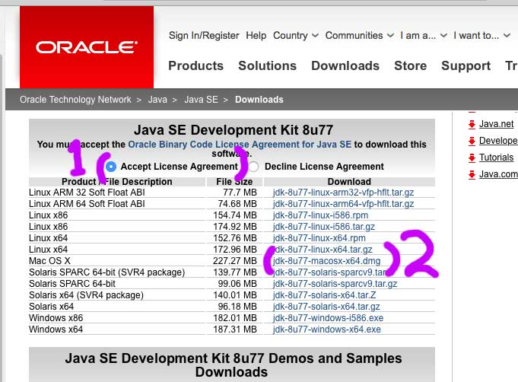

Please accept the License Agreement (1) and then (2) click the file name to download it. You want the entry that looks like -

MAC OS X x64 <size> jdk-XuXX-macosx-x64.dmg

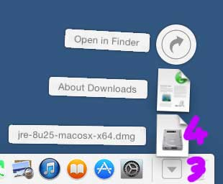
the dmg at the end is important the tar.gz version is no use to you.

Now open (3) the downloaded list of files as normal and (4) double click the new jre file and –

follow the normal instructions that will install Java on your system.

<end of page>
This is where the normal instructions resume (for systems that already have Java installed)

In order to run aaBridge you may needed to give it permission. Try double clicking first to check – if not then ...

Click on the jar icon in the normal way that will display the mouse button menu.

Click on Open in the menu as shown in the image.

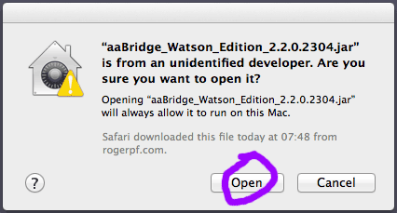
A dialog will be displayed.

This is basicaly asking if you trust aaBridge and its developer. This is sound question, you should not proceed unless you trust this software. This is true for any Software you are installing. Did you get this document from a reputable place? Has aaBridge been recommend to you? Do you know people who use it?

If you don't trust it don't go any further – only proceed if you have decided that you can trust the aaBridge program then –

Click the Open button from now dbl-clicking the .jar file will start aaBridge

<end of page>

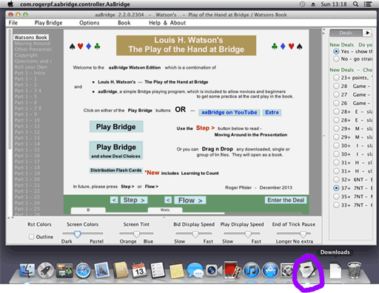
A Java cup will now appear on the main bar next to the downloads icon. The Java cup (ringed in purple in the large image) shows that the aaBridge app has started to run.

The very first time aaBridge starts it may take a while for the big window to appear.

If the aaBridge window has started hidden then you can make it appear by clicking on the Java Cup icon.

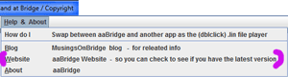
aaBridge is old fashioned in that the, check for new versions is done manually. Click on the menu item Help & About and click on the website option shown in the image with a purple markers.

Especially if you are a regular user it is worth checking every month or so.

If you are using aaBridge for the first time it you are advised to read the Click new Home button (TOP LEFT - not shown) and then click Flow >

and follow the New User Read me through its pages.

<end of page>

Drag & Drop to Play Bridge Movies
If you wish to use aaBridge to play Bridge Movies that you already have on your computer then open the folder containing the Bridge movies and drag & drop them on to an open aaBridge window like the one shown earlier.

A list of the Bridge movies you have just dragged and dropped will now appear at in the grey column on the left, you can click on the one you wish to play now.

How to play Bridge Movies from the Web

In Safari go to your favorite Bridge Site that has good Bridge Movies. Click on on a Bridge movie link.

The .lin file will download and the added to the Mac downloads in the normal way. Click on the download icon to open the curved list and drag the new lin file and drop it onto an open aaBridge window like the one shown earlier.

It will open in the same way as described above.

<end of page>

Hints on Using aaBridge

The navigation bar is the line of bumps, some of which may have characters on, which you can see at the bottom of the aaBridge screen.

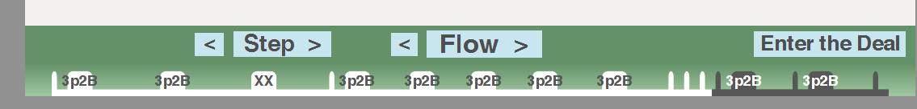
You can click anywhere on this line and you will be jumped immediately to that part of that bridge movie. The bumps represent markup points that the author has put into the file to give it some structure. With aaBridge you are not limited to just the bumps you can click between the bumps and jump to that position.

When you are in a book with multiple chapters, each chapter is its own bridge movie, then you will see in the grey bar on your left the names of each chapter. Click on one to jump there.

You can also use the forward and backwards arrows on your keyboard. When you get to the end of a chapter then the forward arrow will move you to the next chapter. The same applies if you are going backwards.

Step and Flow buttons

In a bridge movie's you move forward to the next stopping point, often called a page, by clicking on the Step and Flow buttons. Additionally, if can't play all bidding is being shown to you then the flow button will show each card will bid being played a very short pause after each.

You can set the duration of the pauses by using the time the sliders at the bottom of the screen, grab and raise the horizontal divider.

You are strongly encouraged to go through all the options. They were put there for you. Grab the vertical divider on the right and move it left.

<end of document>

