A Slam and Game script for BBO

Written by Roger Pfister http://RogerPf.com/aaBridge

The actual script is very simple it is just the text between the two lines below

# ===================================================

r1 = hascard(west,2C)
r2 = hascard(east,3D)
h = hcp(north) + hcp(south)
c = 16 <= hcp(north) || 16 <= hcp(south)
Hi = c && (31 <= h) && (h <= 32)
Me = c && (29 == h) && (r1 || r2)
Lo = c && (25 == h) && (r1)
condition Hi || Me || Lo

# ===================================================

Copy the eight lines of script above and Paste them as described below...
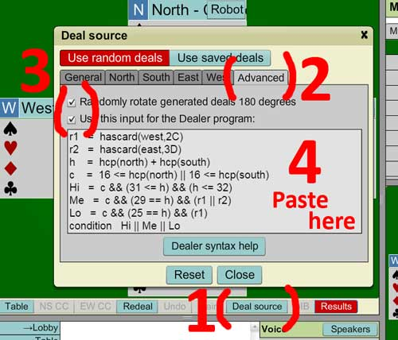
Login to BBO.

Start a Bidding or Teaching table.

Click on the Deal source, button, 1 in the image.

Click the Advanced tab, 2 in the image.

Check the two buttons at, 3 in the image.

Paste the script into the box, 4 in the image.

Click the Close button. (Showing just above 1)

From now on, when you click the Redeal button you and your partner will get one of the following hands.

27 % ● Game / near game
27 % ● Easy game / near slam OR is it a slam ?
45 % ● Slam zone BUT is it there OR will it make seven ?

To help Precision players practice their 1 Club slam bidding, one of either N or S will have 16+ hcp.

See next page for a second script

This script has an increased frequency of 5 card and longer suits

# ===================================================

r1 = hascard(west,2C)
r2 = hascard(east,3D)
r3 = hascard(east,3C)
h = hcp(north) + hcp(south)
Nf = shape(north, xxxx - any 4333 - any 4432 - any 4441)
Sf = shape(south, xxxx - any 4333 - any 4432 - any 4441)
f = Nf || Sf
c = 16 <= hcp(north) || 16 <= hcp(south)
Hi = c && (f || r3) && (31 <= h) && (h <= 32)
Me = c && (f || r3) && (29 == h) && (r1 || r2)
Lo = c && (f || r3) && (25 == h) && (r1)
condition Hi || Me || Lo

# ===================================================

Long suits in BOTH hands if you edit the 7th line above

f = Nf || Sf

and change it to the following

f = Nf && Sf

then both hands are more likely to have long suits

Fewer Big Slam Hands if you edit the 9th line above (or in the first script)

Hi = c && f && (31 <= h) && (h <= 32)

and change it to the following

Hi = c && f && (31 <= h) && (h <= 31)

then you will have fewer Slam hands and the ratio will now be about 33% 33% 33%

FYI aaBridge contains a dealer package to help you write you own dealer scripts.

<end document>

