Draft of the LP problem that will help us to find the minimum set of regulated reactions (regulated by Gene Expression) in order to minimize the Error between the Predicted and Observed Growth rate.

Draft of the LP Formulation….

Minimize $\sum_{i =1}^{N= 10}{}\left(μ{}_{i}-μ{}_{i}^{Observed}\right){}^{2}$

$s.t. S{}_{i}v{}_{i} = 0$

$v{}_{i} -v{}_{max}*GeX{}_{i} ≤ (1-indicator)10{}^{6}$

$v{}_{i} -v{}_{min}*GeX{}_{i} ≥ -(1-indicator)10{}^{6}$

$indicator = \{0,1\}$

If indicator = 1, then $v{}_{min }*GeX{}_{i}≤v{}_{i}≤v{}_{max} * GeX{}_{i}$

if indicator = 0 , then $-10{}^{6}+ v{}_{min}*GeX{}_{i}≤v{}_{i}≤10{}^{6} + v{}_{max }*GeX{}_{i}$

Where $i = \{1,...,10\}$ represents the 10 simulated conditions, $μ$ is the biomass flux value (growth rate), $S{}_{i}$ is the stoichiometric matrix, $v{}_{i }$ is the vector of unknowns (fluxes), $v{}_{max}$ and $v{}_{min}$ is the vector of Upper bounds calculated by FVA for the Baseline condition, $GeX{}_{i}$ is the Gene Expression Ratio, and $indicator$ is the binary variable that indicates whether a reaction is regulated or not.

Possible matrix transformation...

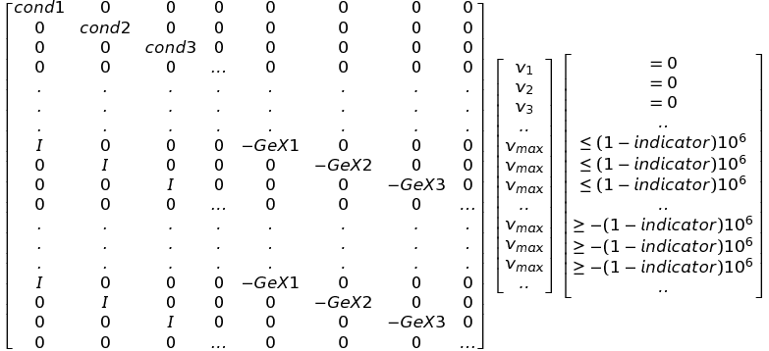

second (similar) idea...

$s.t. S{}_{i}v{}_{i} = 0$

$v{}_{i} -v{}_{max}*GeX{}_{i} -10{}^{6}α ≤ 0$

$v{}_{i} -v{}_{min}*GeX{}_{i }+ 10{}^{6}α ≥ 0$

$α = \{0,1\}$

If $α$ = 0, then $-v{}_{min }*GeX{}_{i}≤v{}_{i}≤v{}_{max} * GeX{}_{i}$

if $α$ = 1 , then $-10{}^{6}+ v{}_{min}*GeX{}_{i}≤v{}_{i}≤10{}^{6} + v{}_{max }*GeX{}_{i}$