***Week 2: Exploratory Data Analysis, Dataset Telecom_Churn***

1 – Number of samples

First, we will import the data set required for this exercise. We will print the information about this dataset to see how many samples we have in it.

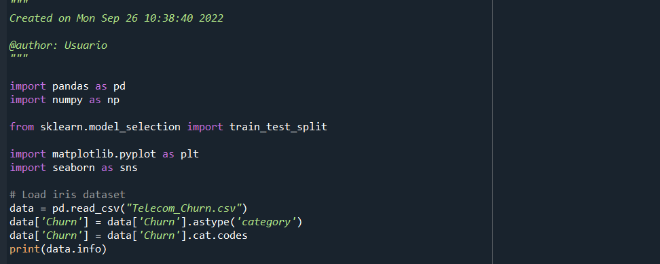

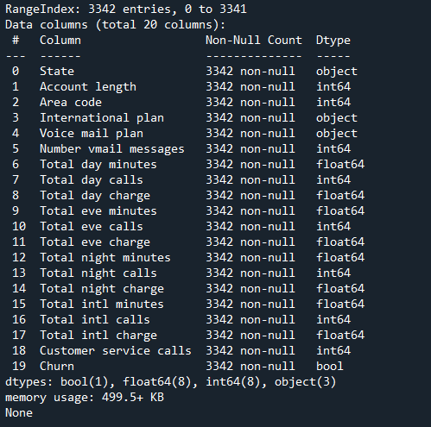

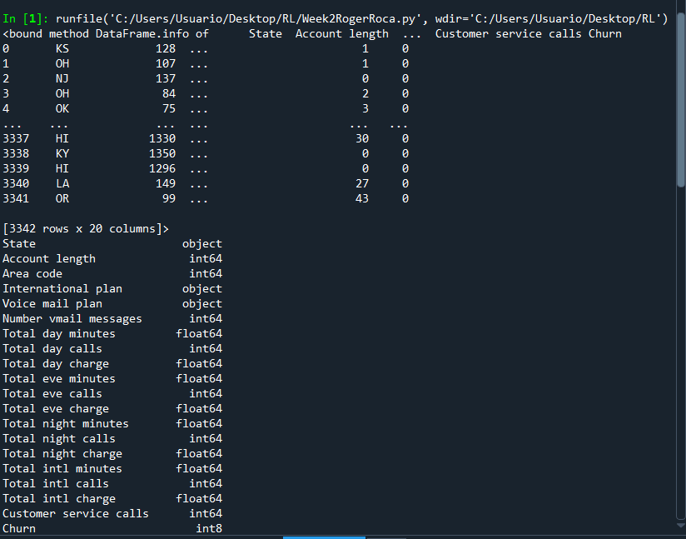

After the import and running the previous code, we can see that there are 3342 samples.

2-Are there values in every attribute?

When observing the previous data, we see that Spyder tells us that all of the columns (20) are non-null which means there are values in all of the attributes.

3- Correlation plot

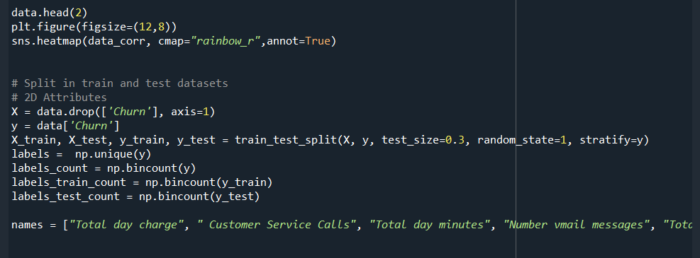

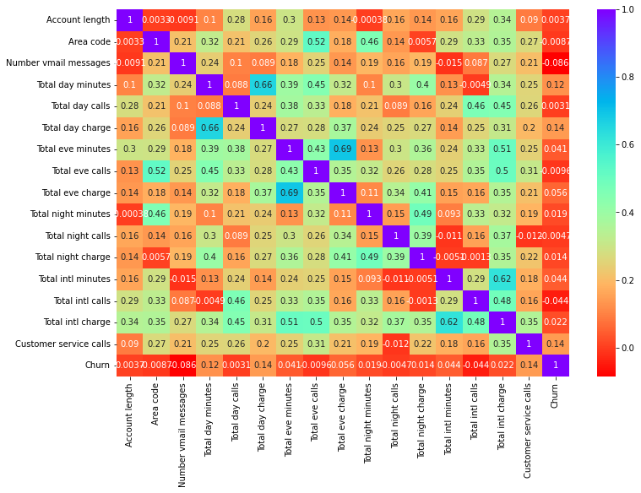

Another way of representing the same correlation matrix is the following one but we get less information since we do not have the exact values of each correlation. Therefore we left the code for the first one since it is a more appropriate answer.

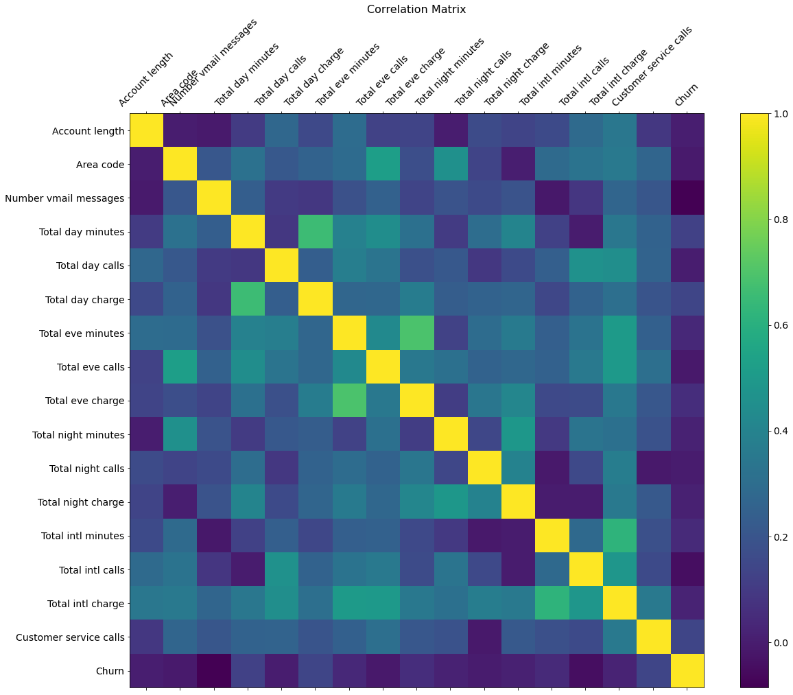

Now we will pay attention to the Churn correlation. Observing the row, we can see which is the highest value. There are two things that have a correlation of 0.14. Those are Total day charge and Customer service calls. This means that these two particular things are the ones that affect Churn the most.