***Week 3: Metrics, Dataset Telecom_Churn***

1 – Accuracy and times

First, we will import the data set required for this exercise.

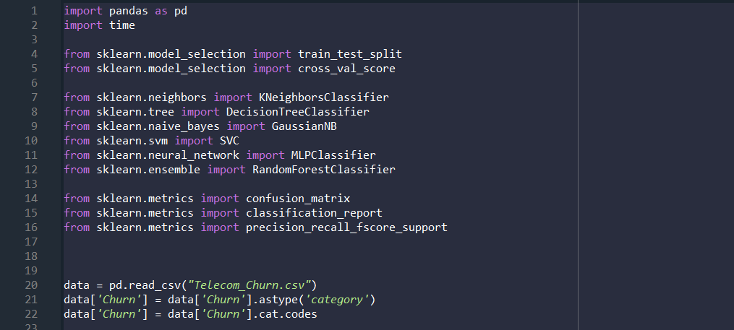

When working with this dataset we have to be careful with the strings since they cannot be converted to float. Therefore, we have to drop all the information in the document stored in strings. Opening the document, we can see that the string data is stored in State, International plan and Voice mail plan.

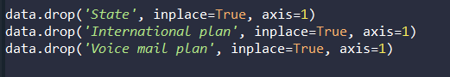

We split, create the classifier, train and predict. We choose the RandomForestClassifier with a number of estimators of 10 since it is the one that works the best.

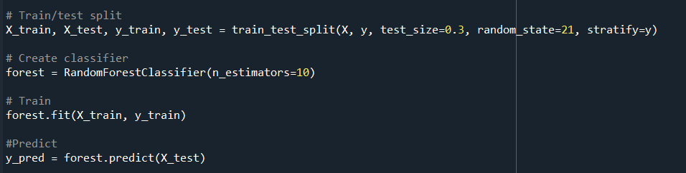

Here we create the classification repor..

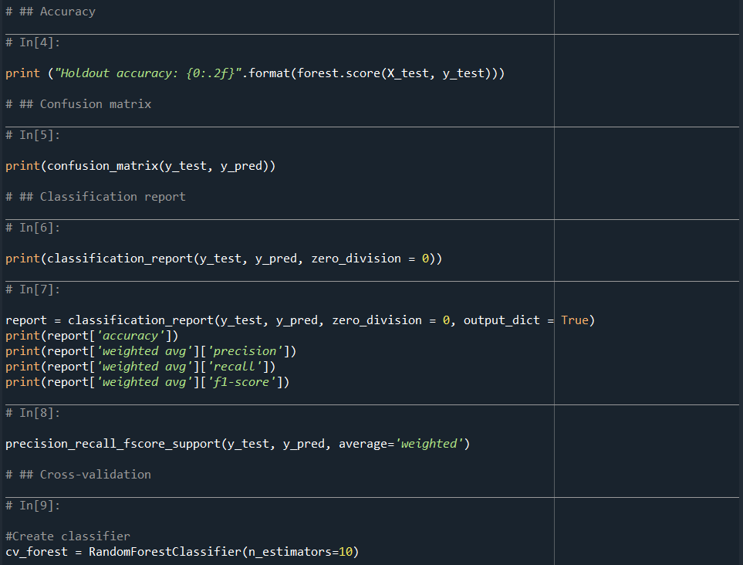

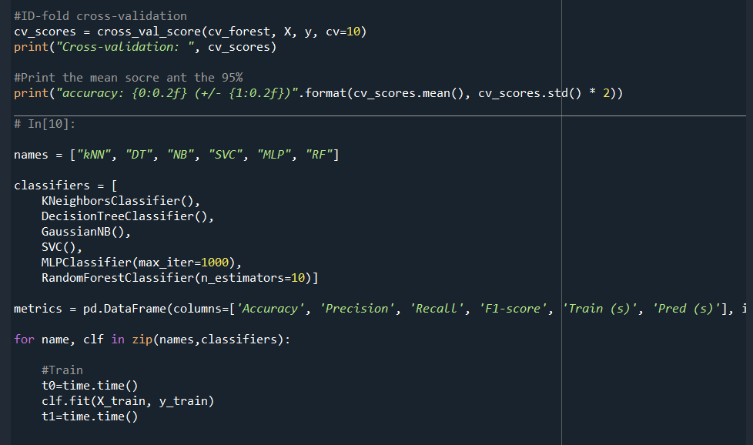

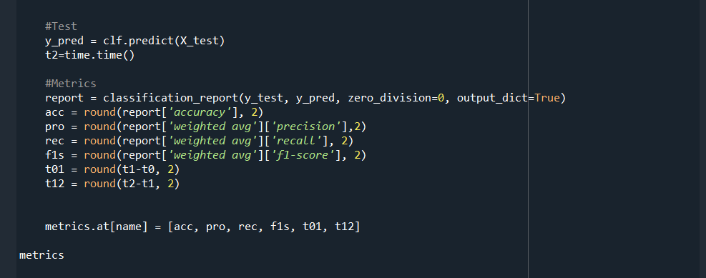

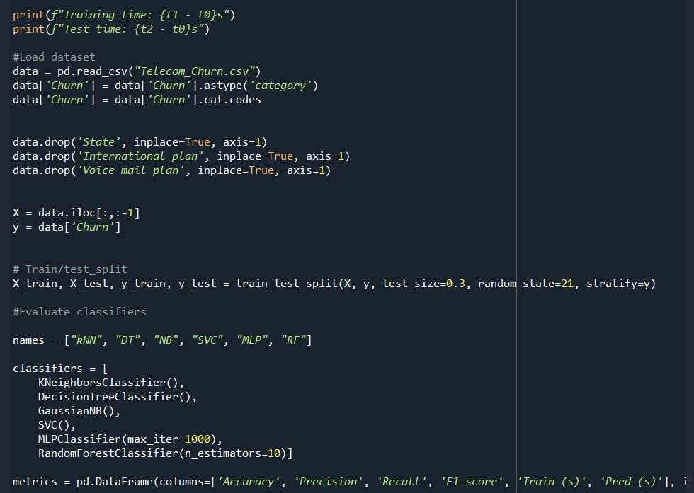

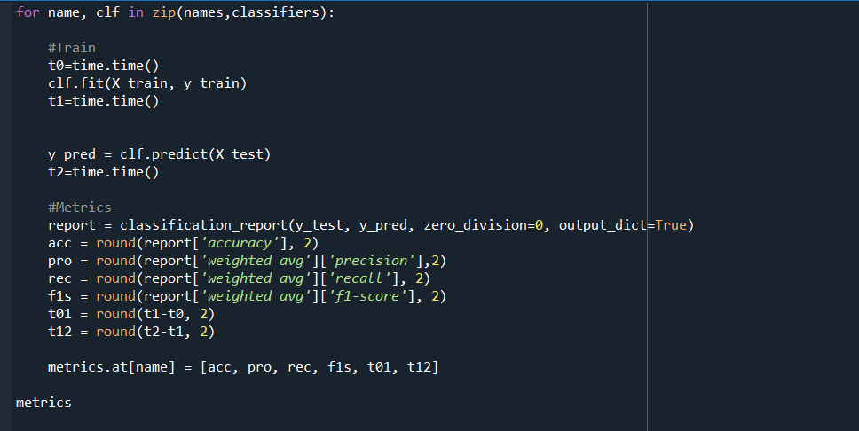

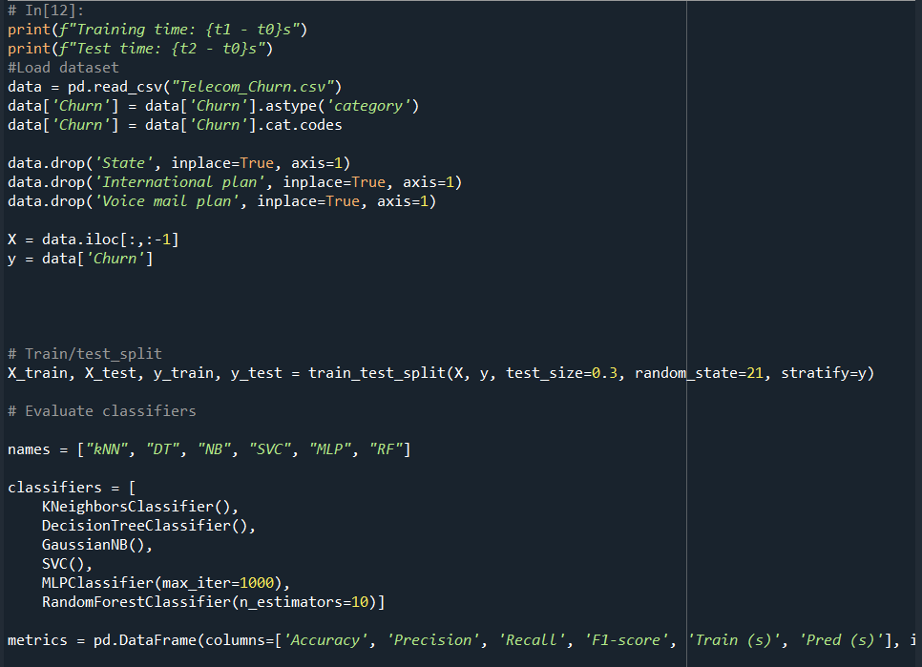

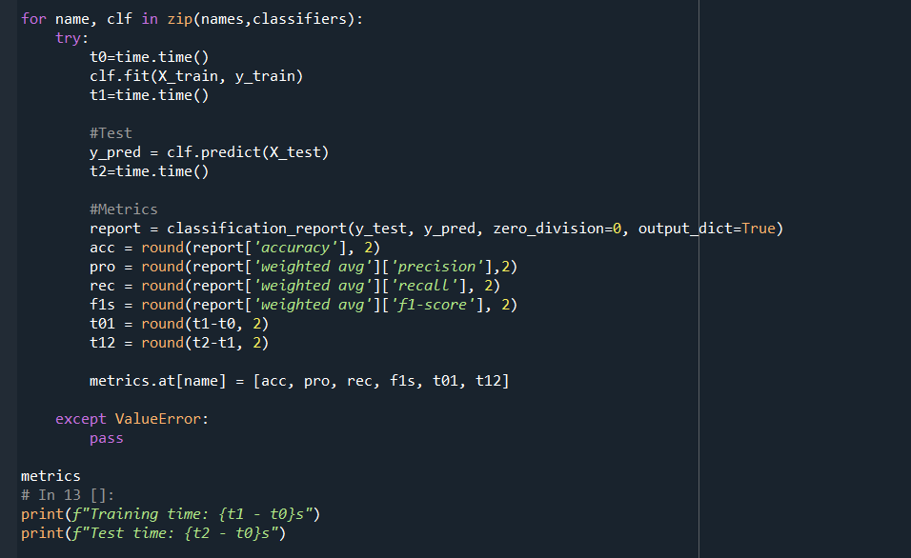

And after running the code we just presented we obtain the results:

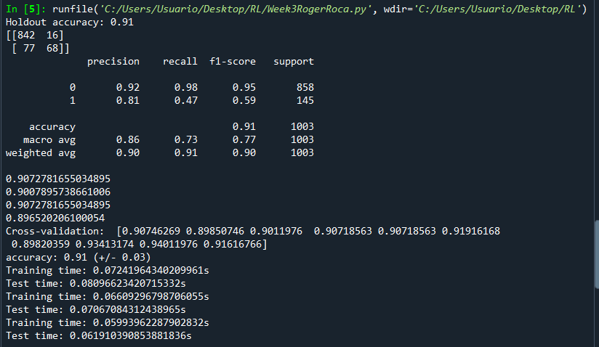

We can observe that the training time is reduced form the beginning and the same with the test time.

We know this code is not the best one we could have obtained but it is the one we ended up writing since it, more or less, accomplishes the exercises proposed.