Week 5: 03_09 _Metrics_MNIST
First, we will import the data set required for this exercise.

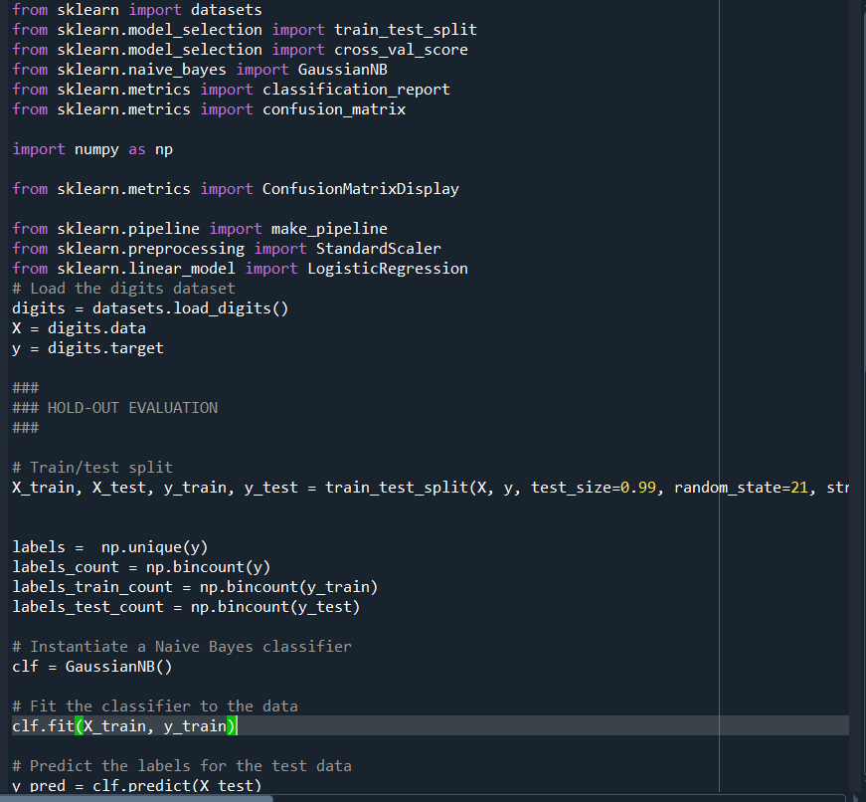

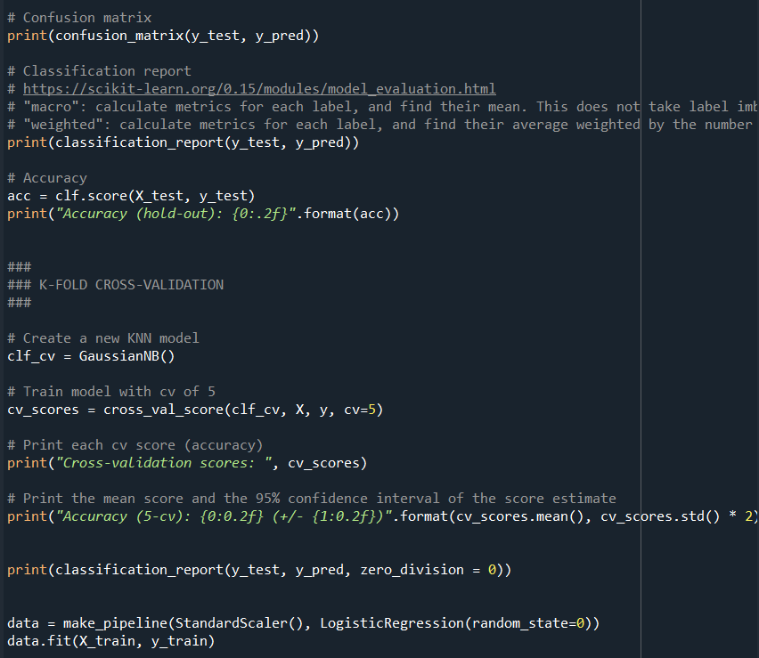
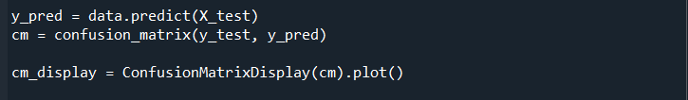

After running the code with a test size of 0.3 we obtain the following confusion matrix:

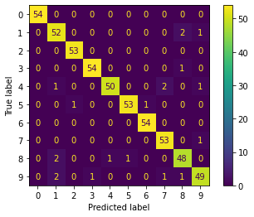
As a first impression and analysis of the results we might think that the predictor is working properly and that has no issues to determine which number we are looking at.
However, when increasing the test size to a value of 0.99:

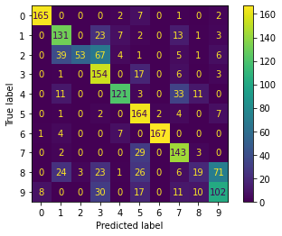
Or to 10:

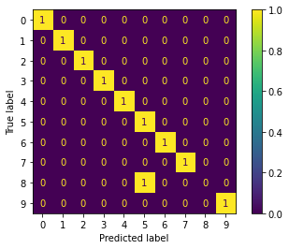
We can observe that we will have issues, particularly with number 8. In the confusion matrix with a test size of 0.99 we can observe that the values of 8.1, 8.3, 8,5 and 8.9 are greater than the value in 8.8 which means that we will have issues with this, since there are more “wrong” answers than “correct” ones and by a margin.
When modifying the CV score from 5 to 9 we still get the same confusion matrix. But, as a result, the accuracy goes up:
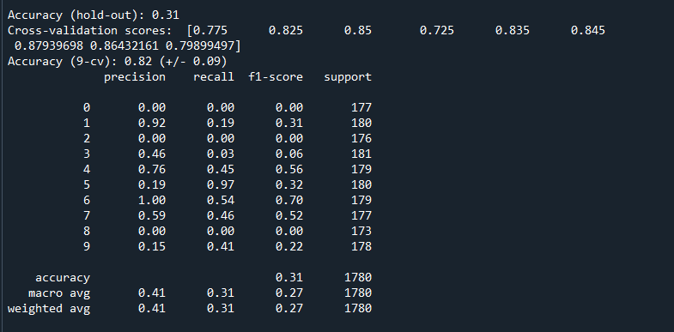
If we decrease the CV:
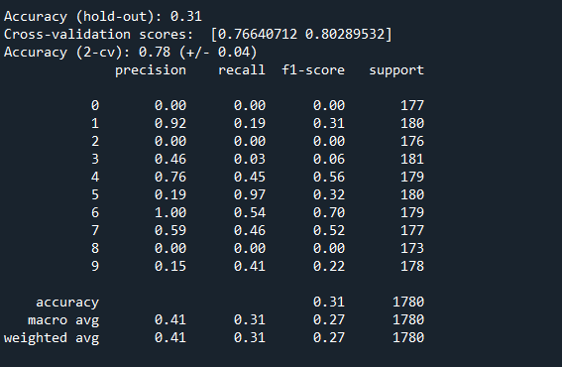
The accuracy decreases.
When eliminating the cross-validation part in this particular code:
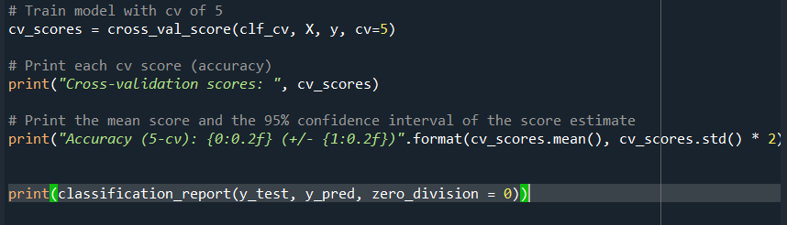

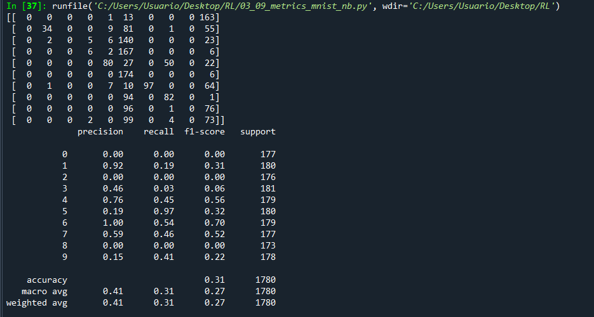

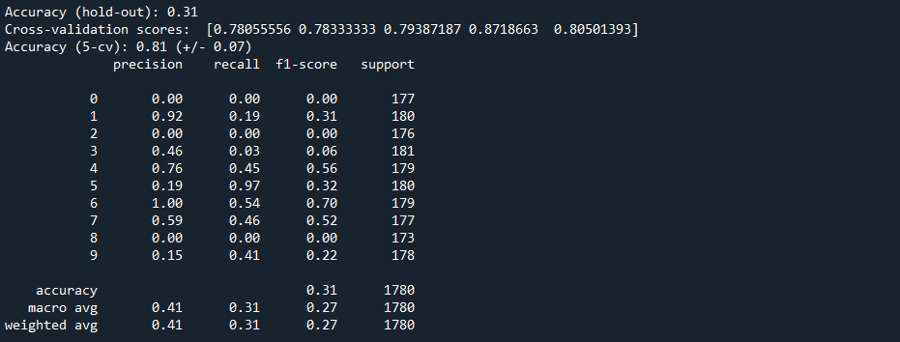

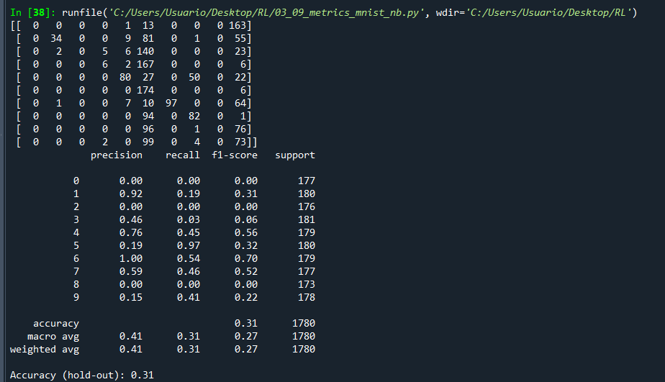

So, in conclusion, Cross-Validation is better in this case since it allows us to train a model on multiple train-test splits.

