Week 6: Clustering with the data set customers_clustering

First, we will import the data set required for this exercise. We will then set the Annual Income and the Spending score as the values to plot.

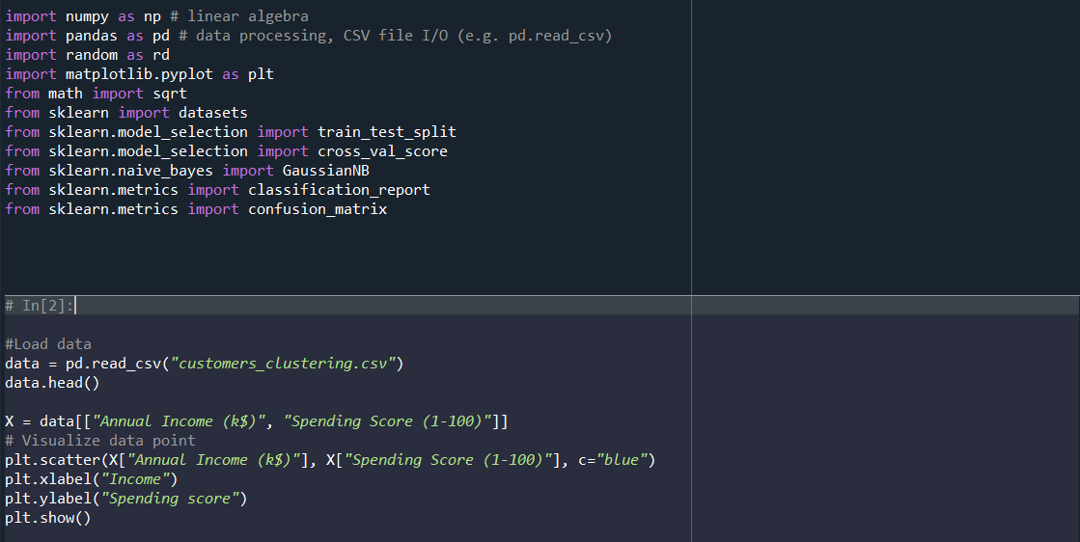

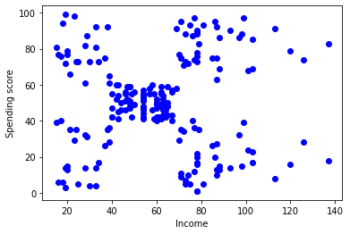
Here we can see the Spending score vs the Income of the client. We will now use different number of centroids to see where they are placed.

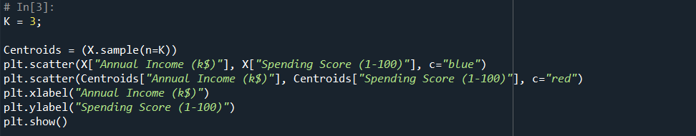
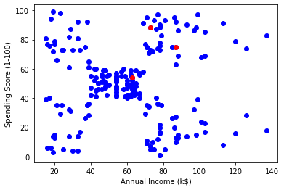
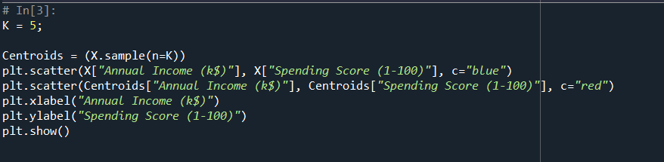
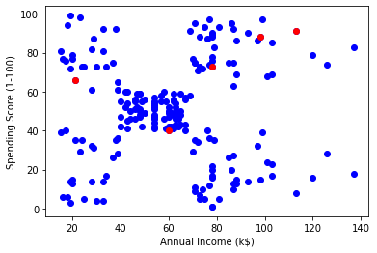
With K = 5 we can observe that there are some centroids that might not be appropriate so we will not use K = 5 and we will divide it in 4 groups (K = 4).

We will create the clusters now and recalculate the centroids.
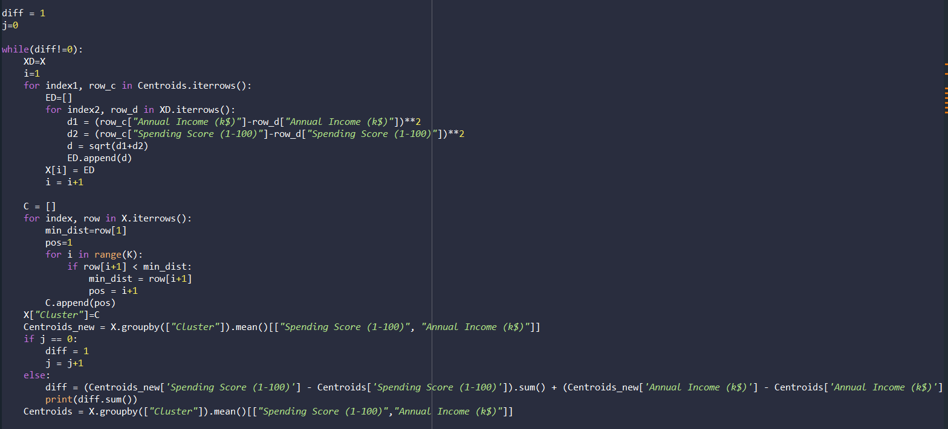
And we will plot the data according to which centroid it is the closest to.

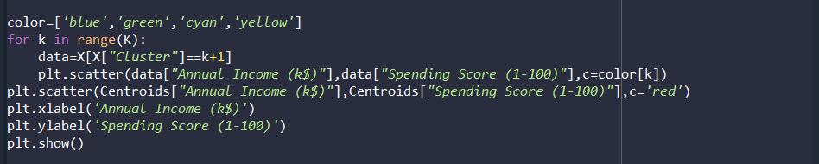

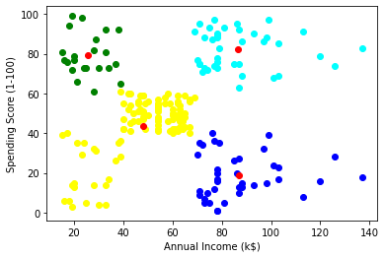

So here we can see the clients divided in 4 different groups. The yellow ones are people that earn less than (more or less) 67.5k annually and have a spending score below 60. The green ones are people who earn less than 40k annually but have a spending score above 60. The dark blue are people who earn between 67.5k and 140k and have a spending score below 40 and the cyan ones are people who earn between 67.5k and 140k but have a spending score above 60.

