Week 7: Apriori
As always, we will start importing the data set basket.csv and reading the data it contains.
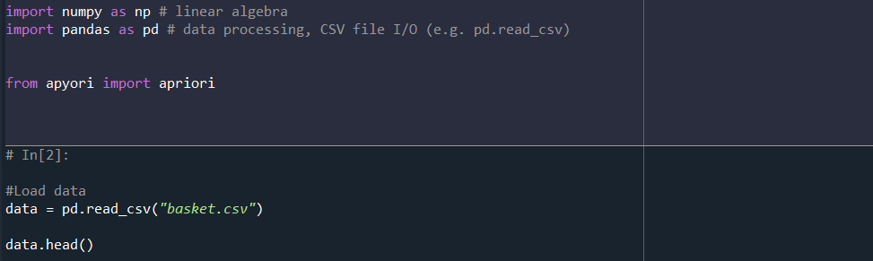

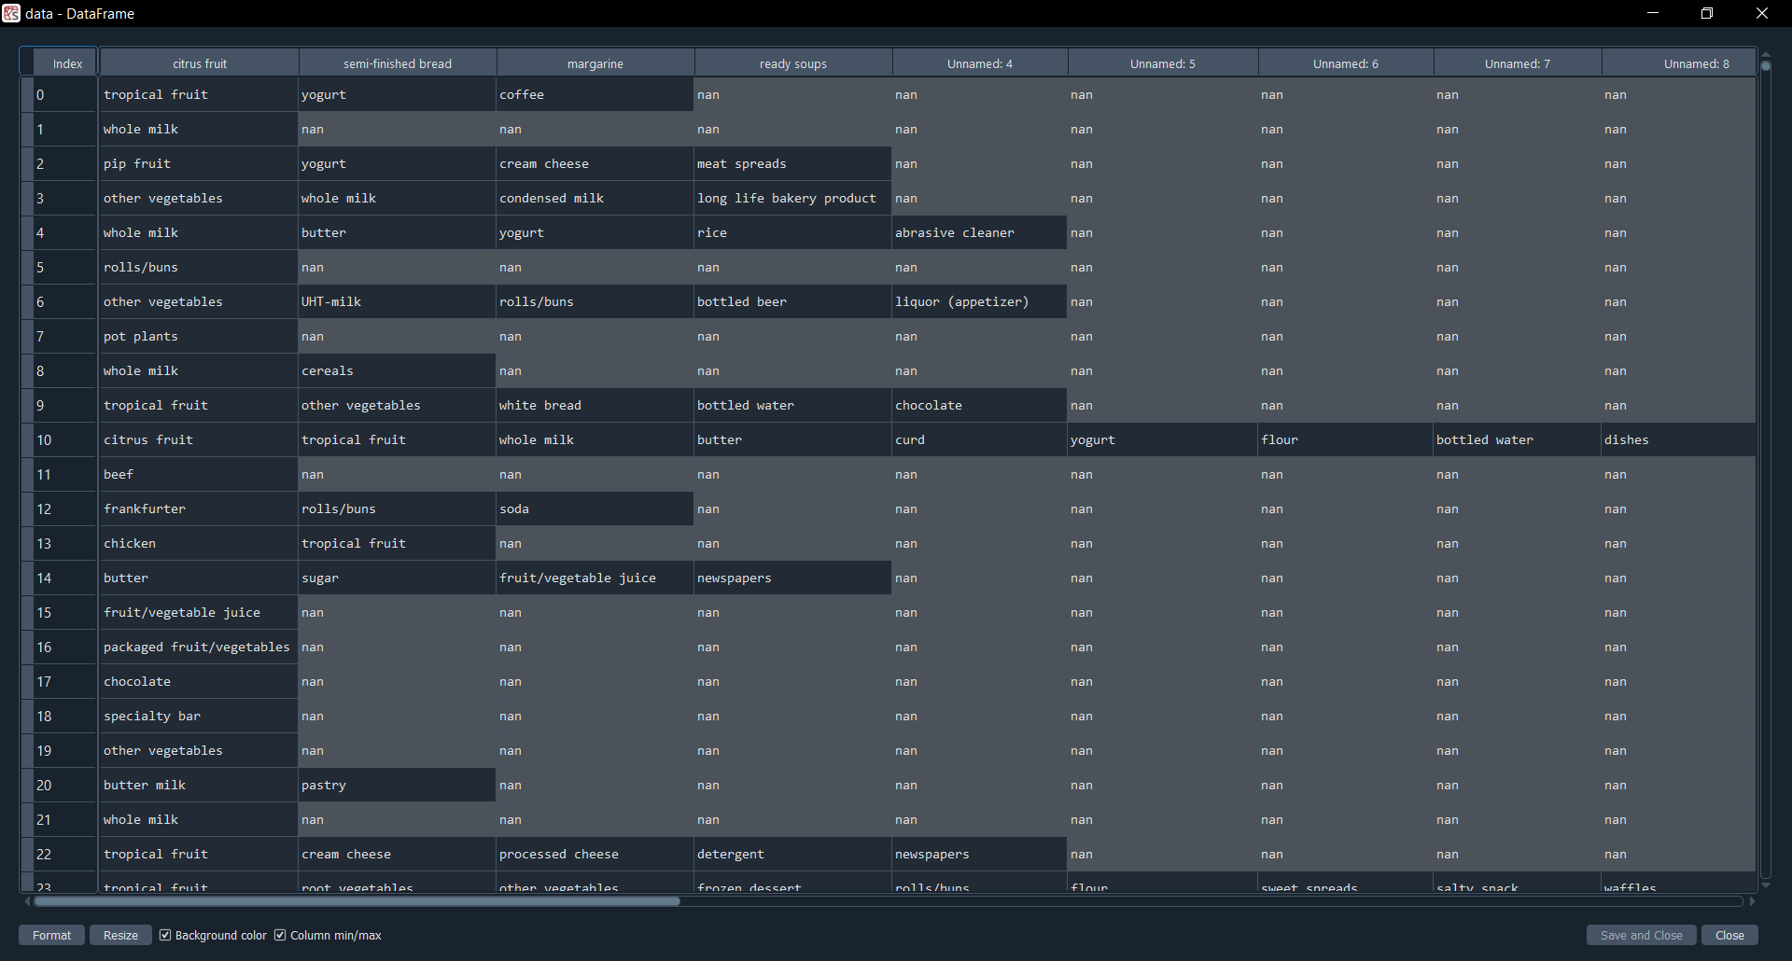

Once the dataset has been imported and we have seen the data stored there we will apply the apriori concepts to see which association rules we can extract.
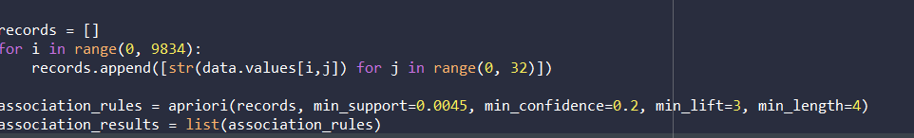

At first, we obtain this:
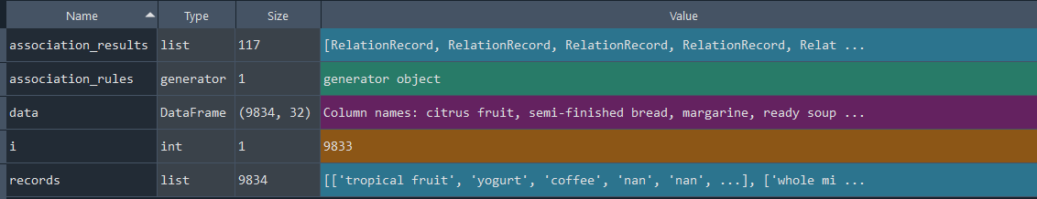
If we modify the min_support value to, for instance, 0.2:
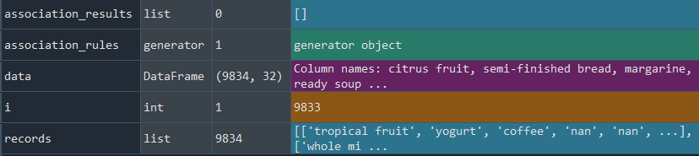
And if we go beyond that and set a support value of 0.0025:
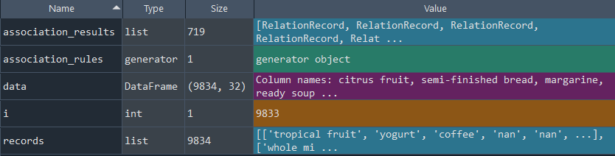
So, we can see that we require an appropriate support value because if not we end up with no association rules since there are not enough results. But if we decrease that number too much, we end up with too many association rules too (and we are going to spend much more time processing the data). So, we have to use an optimal value.
With a support of 0.01 we end up having 8 association rules and with 0.0075 we have 25.

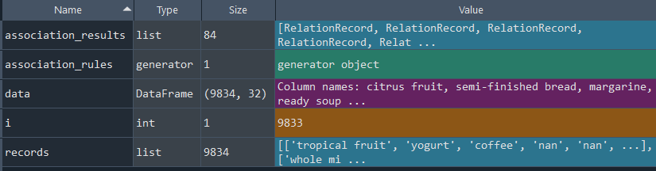

And now we ill try to print all the values ordered by support with a minimum value of 0.012. We had to erase the line that starts with association results since it did not allow us to print the values properly.

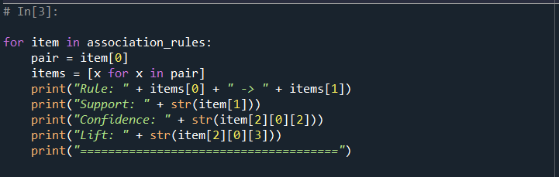

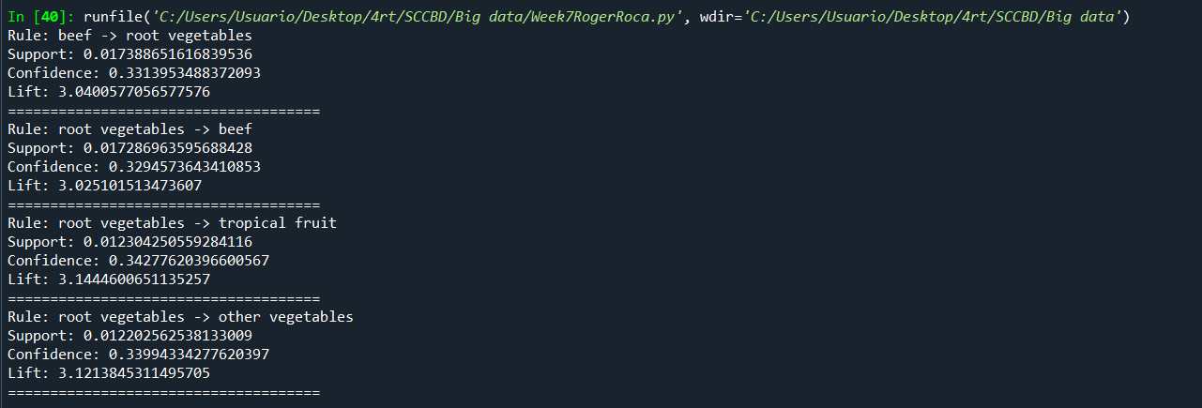
However, we can get to the conclusion that some of those rules are the same but inverted, since at the end it is the same buying beef and root vegetables than buying root vegetables then beef.
If we decrease the support (to 0.01 for instance):
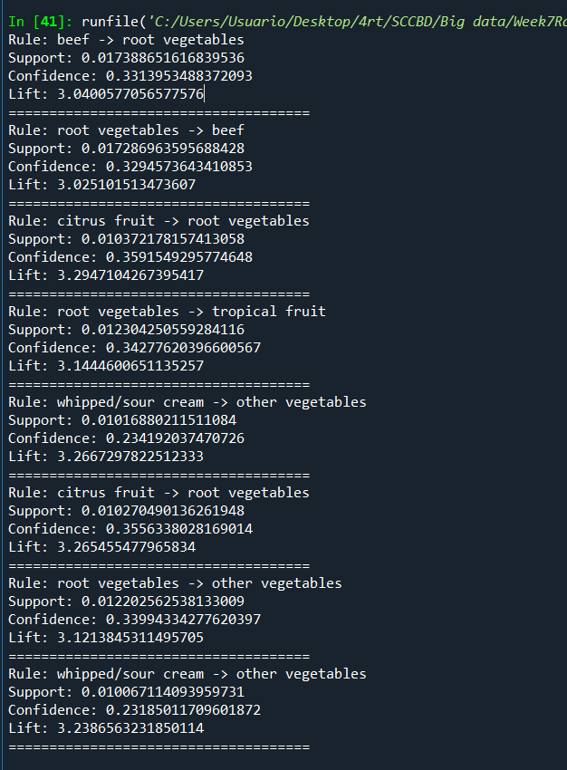
So, as we suspected, modifying the support will give us more results or less. We have decided to let this value but we can observe repetitions in the rules.
IMPORTANT: Some of the values are NaN. Those values are empty. We tried to use data.dropna() but when resetting the index we had some issues so we decided not to use that function, even though that might lead to “incorrect” rules.

Week 7: Lineal regression

As always, we will start reading the data and seeing how the csv file has in it.

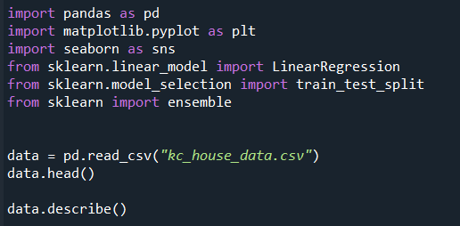

When trying to calculate the price of a new house there are many factors to consider. The area is an important information, but so are the zip code, the number of bedrooms and where is it exactly located.

First, we plotted the number of bedrooms the houses have:
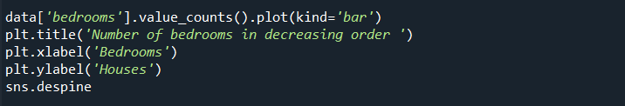
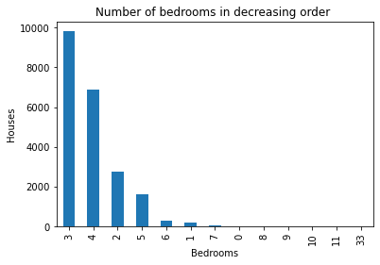
We can see that most houses have 3 or 4 bedrooms. About 80% of the houses are in those 2 values.
Then we will plot the latitude and longitude of each house in the file:
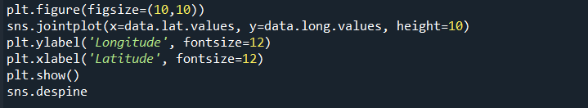

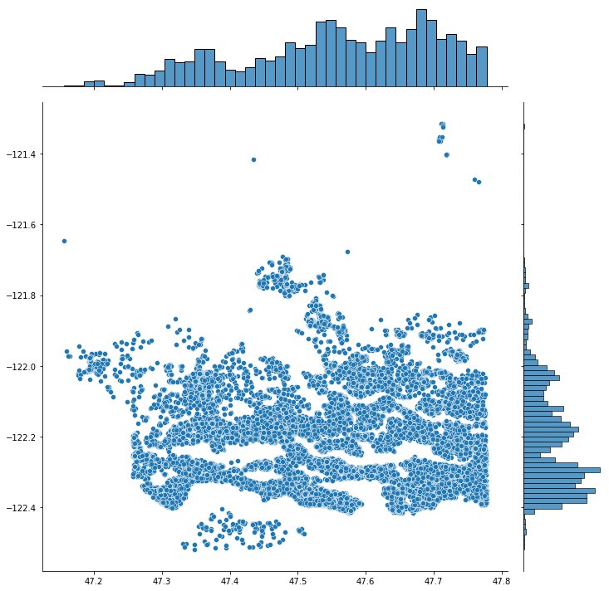
These coordinates belong to the United States of America.
We have also plotted many more things to obtain a deeper insight on the data.
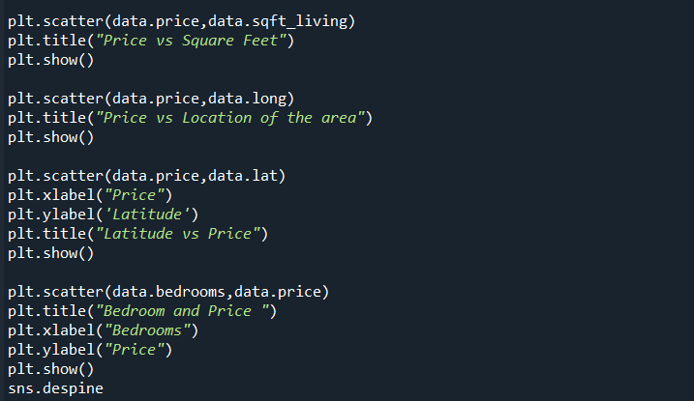

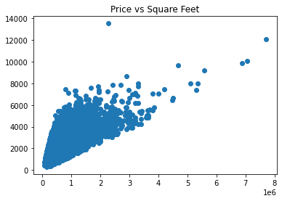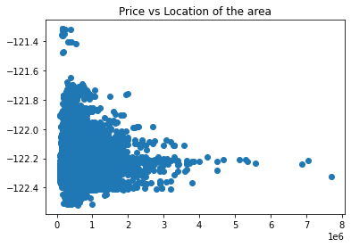
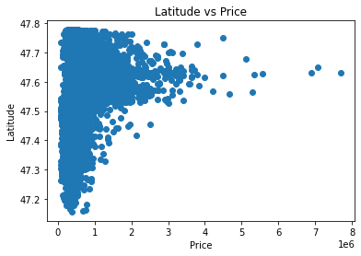
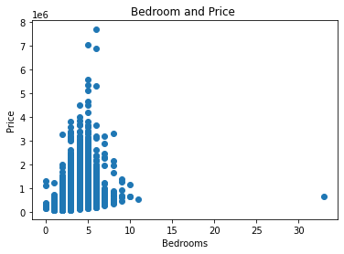

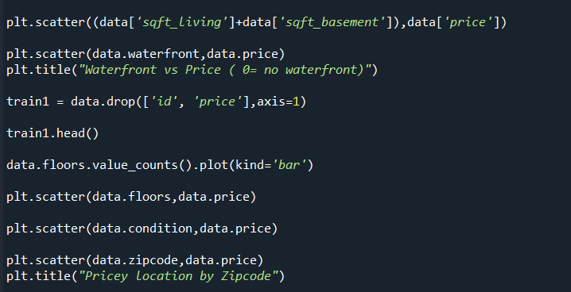

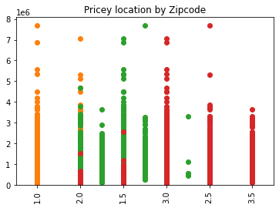

And finally, we split the data and train the model, printing the overall score.

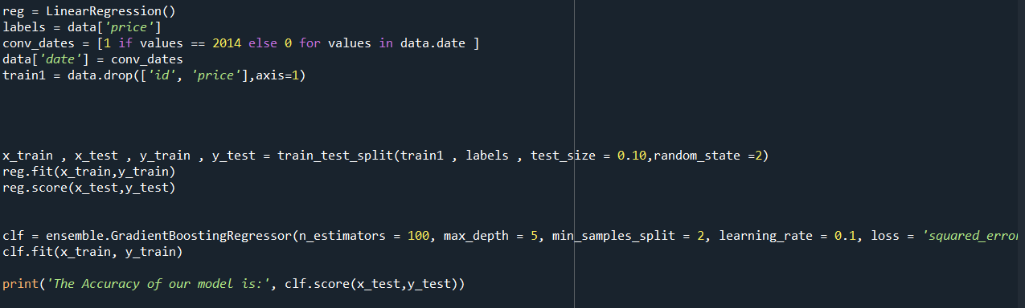

We have predicted the price properly 91.34% of the time.

