Sales Dashboard Report

Business Performance Overview
Name: Roger Samuel
Date: 25/04/25

Dashboard Overview
The dashboard was designed with the following objectives:
- Highlight overall business performance through KPIs.
- Analyze sales trends over time to identify patterns and anomalies.
- Identify best-performing product lines.
- Understand country-wise contributions to sales.
- Offer an interactive experience with filters and slicers for deep exploration.
The dashboard includes:
- Cards showing Total Order Numbers and Total Sales.
- Line Chart showing Sales Over Time.
- Bar Charts showing Sales by Product Line and Sales by Country.
All visual elements are unified with a consistent color theme and are fully interactive.

Key Metrics
- Total Orders: 29 Million
- Total Sales Revenue: $10.03 Million
These KPIs provide a snapshot of the business scale and financial achievement during the given period.

Time-Series Analysis (Sales Over Time)
The time-series chart depicts the Sum of Sales by Order Date.
Observations:
- The highest sales occurred at the beginning of the period.
- A gradual downward trend is visible as time progresses.
- This suggests possible seasonality effects or market saturation over time.
Insight:
To maintain steady growth, it may be beneficial to investigate factors causing the decline and explore strategies like product innovation or new market expansion.

Sales by Product Line
The bar chart illustrates the Sum of Sales categorized by different product lines.
Top Performing Product Lines:
- Classic Cars — Highest contributor to overall sales.
- Vintage Cars — Second-highest performing segment.
Other notable segments include:
- Motorcycles
- Trucks and Buses
- Planes
Insight:
The company’s strength lies in its Classic and Vintage vehicle segments. Investments in expanding these product lines could yield higher returns. Less popular segments like Ships and Trains may require either repositioning or reconsideration.

Sales by Country
The analysis of sales by country reveals geographical contributions.
Top Countries:
- USA — Leading contributor with nearly 4 million in sales.
- Spain, France, and Australia — Other major markets.
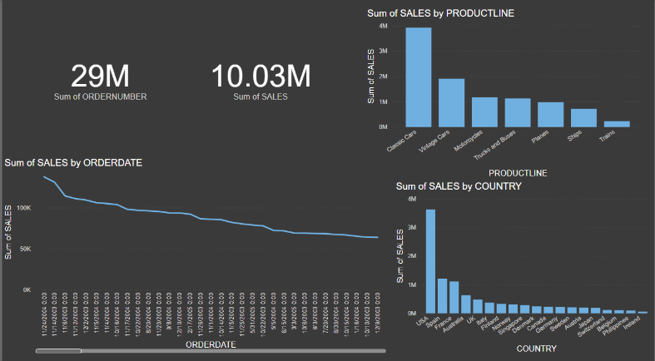
Insight:
While the USA remains the core market, there is significant opportunity for growth in Spain, France, and Australia. Regional marketing strategies and tailored product offerings could further boost revenues in these areas.

Conclusion & Recommendations
The dashboard has successfully provided a high-level and detailed view of business performance.
From the analysis, the following recommendations are suggested:
- Focus marketing and inventory efforts on Classic Cars and Vintage Cars.
- Investigate and address the declining sales trend over time.
- Strengthen presence in growing international markets like Spain and Australia.
- Continuously monitor product and market performance through dashboards for real-time decision-making.

