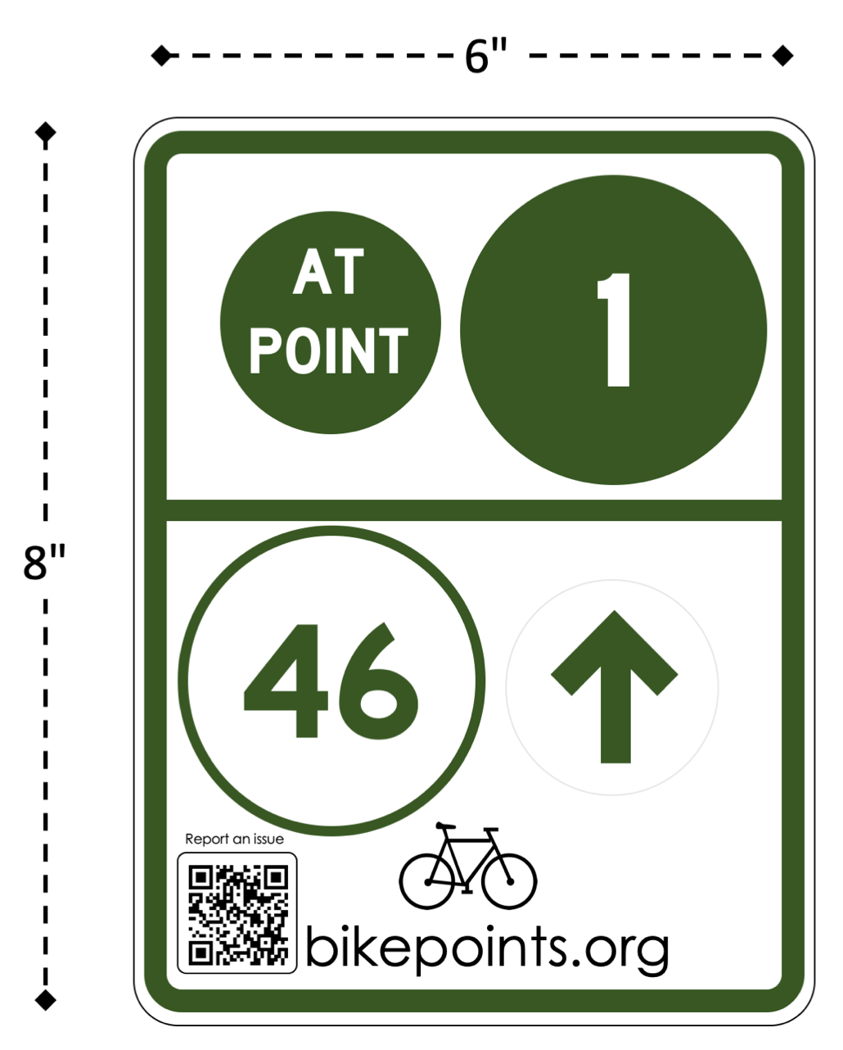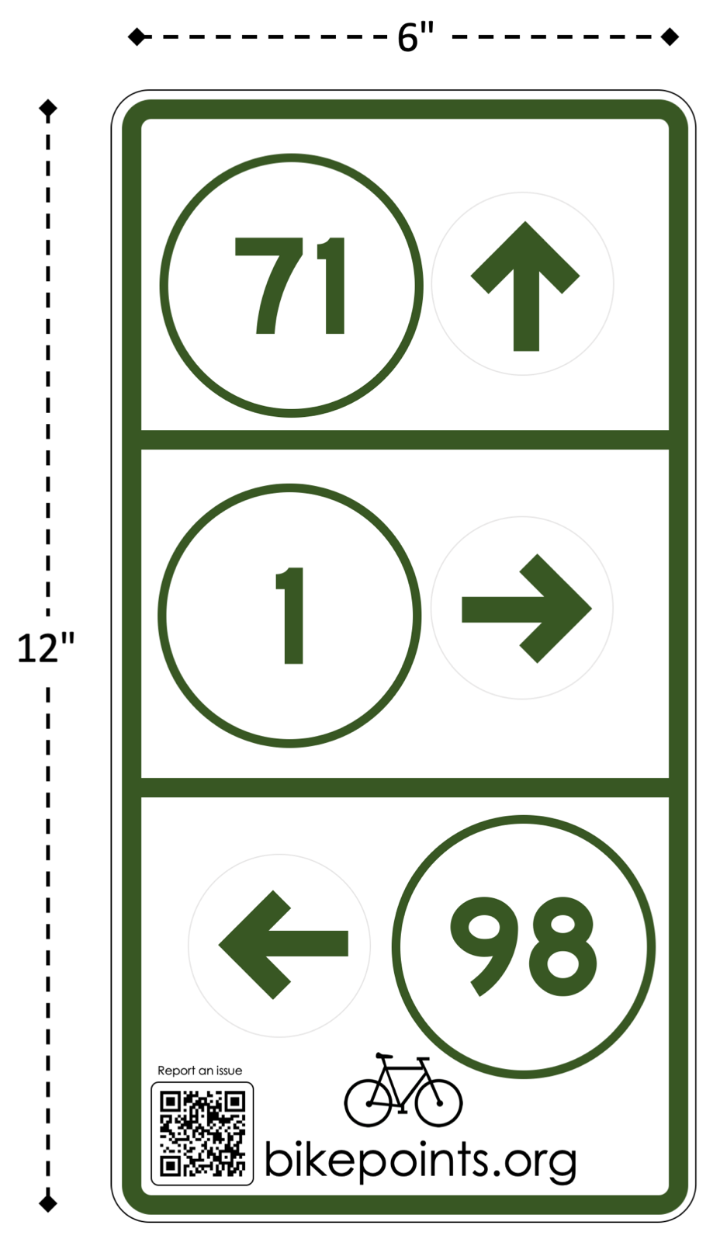

This image is at 1:1 scale, when printed on 8.5” x 11”paper

8”

6”

This image is at 3:4 scale, when printed on 8.5” x 11”paper

12”

6”

# Sample Sign (Small)

Notes:



1. **Green circles** indicate the current bike point.
2. **White circles** combined with an arrow indicate upcoming points. Arrows are placed on the right side by default, except for left turn arrows, which are placed on the left
3. **Low cost stickers** are used for numbers, arrows, and QR codes. Signs and stickers are printed in bulk to lower costs.
4. **QR codes** are meant to track sign positions, help people report misplaced arrows, and allow people to plan their route with an online map. Each sign receives a unique QR code. The city periodically receives data on signage issues. A website mockup is included on a later page.

This sign would be placed on the southwestern side of point 1 on the previous map, indicating that the bicyclist can continue straight down Memorial Drive Park towards point 46.

# Sample Sign (Large)



Notes:

1. **Signs come in two sizes**, helping minimize costs.
2. **Temporary arrow stickers are used for construction and detours.**
3. **Highway Gothic font** is used for sign text, except for “bikepoints.org” and “report an issue,” which use Century Gothic.
4. **These signs are similar to the Dutch design**, which the author finds to be easier to follow and cheaper to implement than the Belgian and German designs. In addition, the Dutch design is significantly more popular.

This sign would be placed on the northeast-bound side of Vassar Street approaching Mass Ave. It indicates that the cyclist can continue straight towards point 71, turn right towards point 1, or turn left to point 98.

# QR Code Linked Website

Notes:

Report an issue



1. 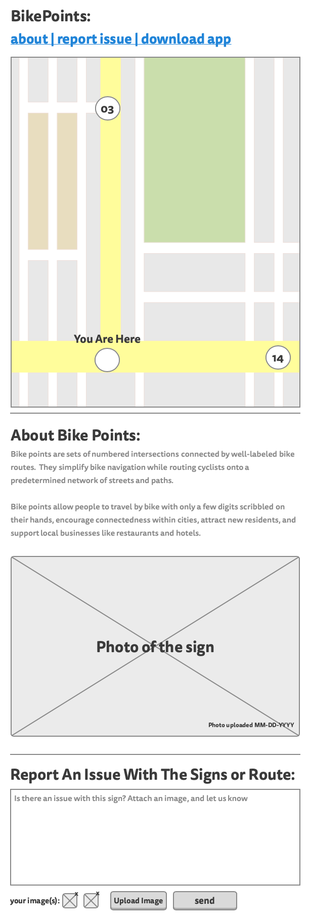**This is a mockup of the website that a sign QR code will link to.**

bikepoints.nl/points/XX-XX-XXXX



1. **QR codes are primarily used to create a database of sign locations and issues with them** such as incorrectly positioned arrows. In a well-performing system, people on bikes would use QR codes infrequently.
2. **There is a local bike point map** for casual users, but this is not the primary purpose of the QR code.
3. **Public utilities can record the location of a sign** by uploading a geo-tagged photo.
4. **Users can download a bike points mapping application**

This website is still currently under construction.

**For the city, QR codes are an easily and cost-effective way to solicit structured feedback on sign placement without the overhead of the Cambridge city app or 311.**

(iPhone X and Reload images by Nikita Kozin and Shashank Sing respectively, both from the Noun project)