# 目录

Qt计算器v1.0 2

目的与要求 2

实验内容 2

1创建程序 2

2实现功能 5

3运行程序 10

Qt计算器v2.0 10

目的要求： 10

实验内容 10

Qt计算器v3.0 13

1目的要求 13

2实验内容 14

Qt计算器v4.0 24

目的要求 24

实验内容 24

实验步骤 25

Qt计算器v5.0 26

目的要求 26

实验内容 26

Qt计算器v6.0 31

目的要求 31

实验步骤 31

# 

# Qt计算器v1.0

## 目的与要求

编写程序，实现一个简单的可以进行两个数的加减乘除的计算器

## 实验内容

编写程序，实现一个简单的可以进行两个数的加减乘除的计算器

### 1创建程序

1. 新建Qt Widgets应用，项目名称为calculator

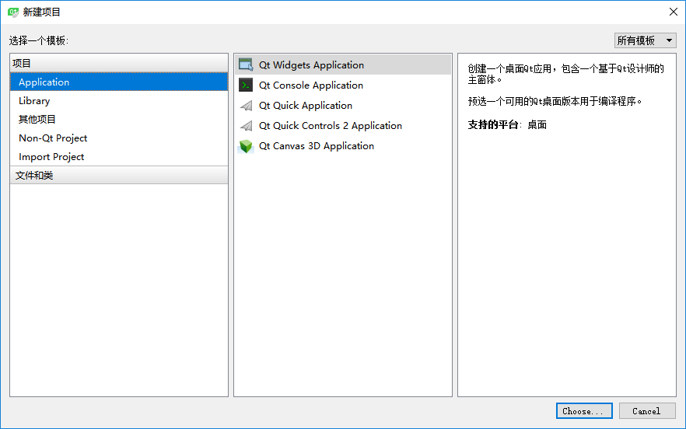

图1.1

选择QWidget作为为基类

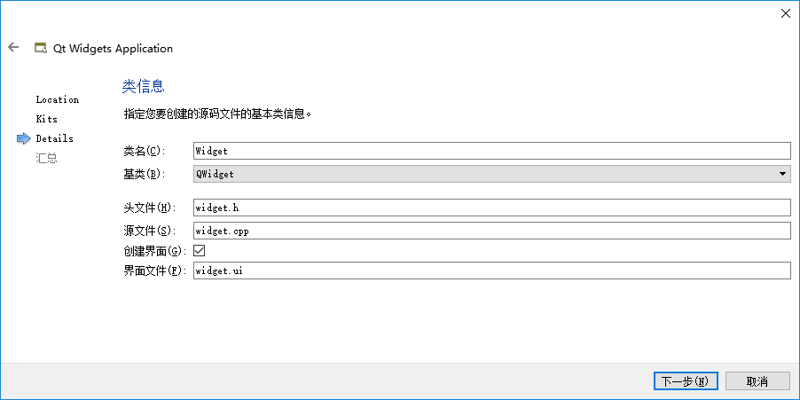

图1.2

（2）完成项目创建后，双击widget.ui进入设计模式

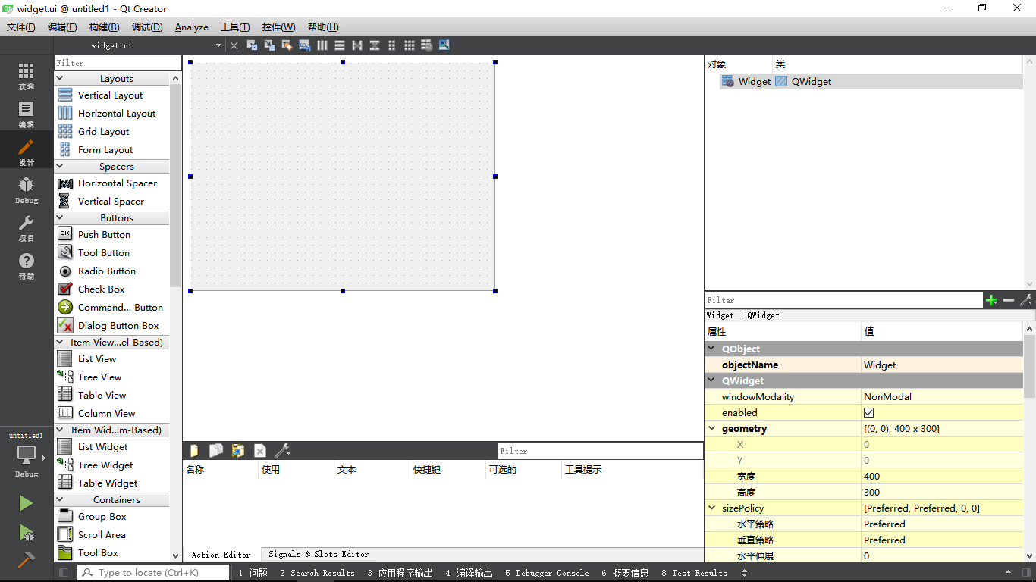

图1.3

然后向界面上拖动19个QPushButton和一个QlineEdit部件，修改其显示文本，如下图所示

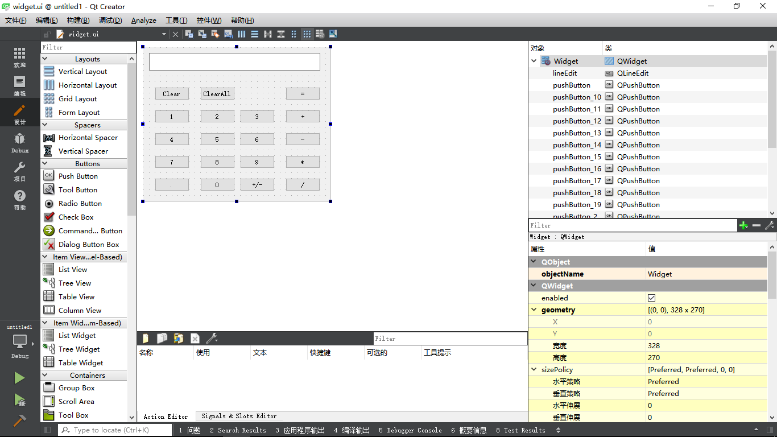

图1.4

然后按ctrl+G使用栅格布局对窗口进行布局管理

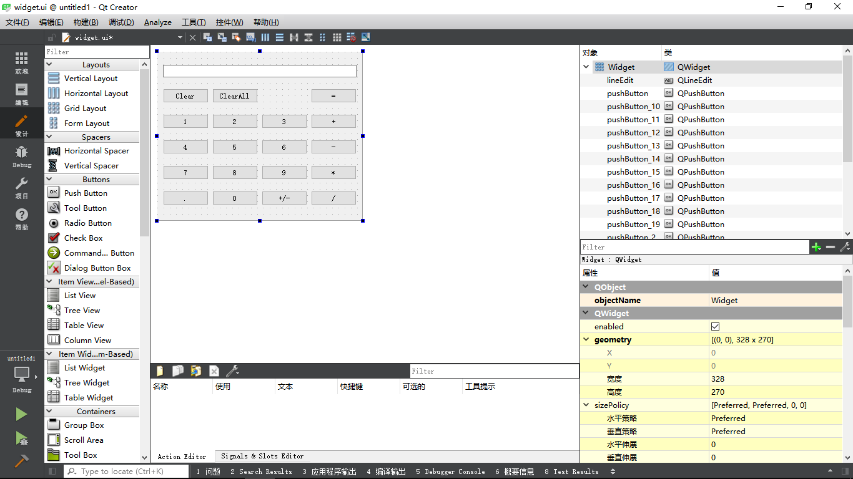

图1.5

1. 下面修改部分部件的objectName属性，将数字按钮的objectName设置为digitBtn加上表示的数字，如：digitBtn1, digitBtn2。将表示运算符号的按钮的objectName，按照加减乘除分别命名为:addBtn, subtractBtn, mulBtn, divisionBtn。将Clear和ClearAll按钮objectName设置为clearBtn和clearAllBtn。将=按钮设置为equalBtn。将小数点按钮设置为pointBtn，符号按钮设置为signBtn;
2. 选中lineEdit, 将alignment的水平的属性设置为AlignRight, 将readOnly选中，如下图1.6所示

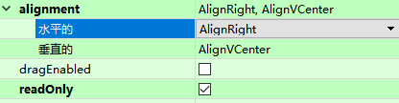

图1.6

1. 选中主窗口，将windowTitle改为Calculator,然后运行程序，确保程序如图1.7所示

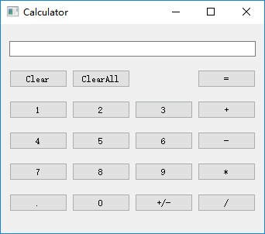

图1.7

### 2实现功能

1. 在widget.h里面添加几个私有成员和私有函数

private:

bool calculate(double operand, QString pendingOperator);

//终止运算，清除数据，报错

void abortOperation();

//连接信号和槽

void connectSlots();

//储存运算符

QString pendingOperator;

//储存运算结果

double result;

//标记是否等待一个操作数

bool waitForOperand;

在widget.cpp里面添加函数的实现

先在widget.cpp的开头添加头文件#include <QMessageBox>

bool Widget::calculate(double operand, QString pendingOperator)

{

if(pendingOperator == "+")

{

result += operand;

}

else if(pendingOperator == "-")

{

result -= operand;

}

else if(pendingOperator == "*")

{

result *= operand;

}

else if(pendingOperator == "/")

{

if(operand == 0.0)

return false;

result /= operand;

}

return true;

}

void Widget::abortOperation()

{

result = 0.0;

pendingOperator.clear();

ui->lineEdit->setText("0");

waitForOperand = true;

QMessageBox::warning(this, "运算错误", "除数不能为零");

}

void Widget::connectSlots()

{

QPushButton *digitBtns[10] = {

ui->digitBtn0, ui->digitBtn1, ui->digitBtn2, ui->digitBtn3,

ui->digitBtn4, ui->digitBtn5, ui->digitBtn6, ui->digitBtn7,

ui->digitBtn8, ui->digitBtn9

};

for (auto btn : digitBtns)

connect(btn, &QPushButton::clicked, this, &Widget::digitClicked);

QPushButton *operatorBtns[4] = {

ui->addBtn, ui->subtractionBtn, ui->mulBtn, ui->divisionBtn,

};

for (auto btn : operatorBtns)

connect(btn, &QPushButton::clicked, this, &Widget::operatorClicked);

}

（2）在widget.h里面添加几个槽函数

private slots:

void on_clearBtn_clicked();

void on_clearAllBtn_clicked();

void on_equalBtn_clicked();

void digitClicked();

void on_signBtn_clicked();

void operatorClicked();

void on_pointBtn_clicked();

在widget.cpp里添加槽函数实现

void Widget::digitClicked()

{

QPushButton *digitBtn = static_cast<QPushButton*>(sender());

QString value = digitBtn->text();

if(ui->lineEdit->text() == "0" && value == "0")

return;

if(waitForOperand)

{

ui->lineEdit->setText(value);

waitForOperand = false;

}

else

{

ui->lineEdit->setText(ui->lineEdit->text() + value);

}

}

void Widget::on_clearBtn_clicked()

{

//将当前显示的数归零

ui->lineEdit->setText("0");

waitForOperand = true;

}

void Widget::on_clearAllBtn_clicked()

{

//将当前显示的数据归零，并将之前保存的数据运算清除

ui->lineEdit->setText("0");

waitForOperand = true;

result = 0.0;

pendingOperator.clear();

}

void Widget::on_equalBtn_clicked()

{

double operand = ui->lineEdit->text().toDouble();

if(pendingOperator.isEmpty())

return;

if(!calculate(operand, pendingOperator))

{

abortOperation();

return;

}

ui->lineEdit->setText(QString::number(result));

pendingOperator.clear();

result = 0.0;

waitForOperand = true;

}

void Widget::on_signBtn_clicked()

{

QString text = ui->lineEdit->text();

double value = text.toDouble();

if(value > 0)

{

text.prepend('-');

}

else if(value < 0)

{

text.remove(0, 1);

}

ui->lineEdit->setText(text);

}

void Widget::operatorClicked()

{

QPushButton *clickedBtn = qobject_cast<QPushButton *>(sender());

QString clickedOperator = clickedBtn->text();

double operand = ui->lineEdit->text().toDouble();

if(!pendingOperator.isEmpty())

{

if(!calculate(operand, pendingOperator))

{

abortOperation();

return;

}

ui->lineEdit->setText(QString::number(result));

}

else

{

result = operand;

}

pendingOperator = clickedOperator;

waitForOperand = true;

}

void Widget::on_pointBtn_clicked()

{

if (waitForOperand)

ui->lineEdit->setText("0");

if (!ui->lineEdit->text().contains('.'))

ui->lineEdit->setText(ui->lineEdit->text() + ".");

waitForOperand = false;

}

1. 链接信号和槽

在Widget类的构造函数里添加代码如下

Widget::Widget(QWidget *parent) :

QWidget(parent),

ui(new Ui::Widget)

{

ui->setupUi(this);

ui->lineEdit->setText("0");

result = 0.0;

waitForOperand = true;

connectSlots();

}

### 3运行程序

编译运行程序，效果如图1.8所示

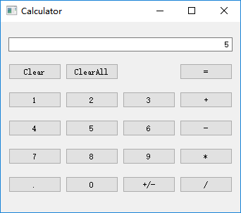

图1.8

# Qt计算器v2.0

## 目的要求：

对实验一的计算器进行改良，使其能够接受键盘输入；

## 实验内容

1. 打开实验一的项目，在widget.h私有成员里面添加一个函数

void setShortcutKeys();

（2）在widget.cpp

然后再添加代码的实现

void Widget::setShortcutKeys()

{

Qt::Key key[18] = {

Qt::Key_0, Qt::Key_1, Qt::Key_2, Qt::Key_3,

Qt::Key_4, Qt::Key_5, Qt::Key_6, Qt::Key_7,

Qt::Key_8, Qt::Key_9,

Qt::Key_Plus, Qt::Key_Minus, Qt::Key_Asterisk, Qt::Key_Slash,

Qt::Key_Enter, Qt::Key_Period, Qt::Key_Backspace, Qt::Key_M

};

QPushButton *btn[18] = {

ui->digitBtn0, ui->digitBtn1, ui->digitBtn2, ui->digitBtn3,

ui->digitBtn4, ui->digitBtn5, ui->digitBtn6, ui->digitBtn7,

ui->digitBtn8, ui->digitBtn9,

ui->addBtn, ui->subtractionBtn, ui->multiplicationBtn, ui->divisionBtn,

ui->equalBtn, ui->pointBtn, ui->clearBtn, ui->signBtn

};

for (int i = 0; i < 18; i++)

btn[i]->setShortcut(QKeySequence(key[i]));

ui->clearAllBtn->setShortcut(QKeySequence("Ctrl+Backspace"));

}

在构造函数中调用改函数

Widget::Widget(QWidget *parent) :

QWidget(parent),

ui(new Ui::Widget)

{

initUi();

result = 0.0;

waitForOperand = true;

connectSlots();

setShortcutKeys();

}

（3）

运行程序，检查是否可以使用键盘输入数据。

# Qt计算器v3.0

## 1目的要求

1. 在Qt计算器v2.0的基础上进行完善，使得计算器能够计算一个表达式的值

## 2实验内容

1. 双击widget.ui文件，转到设计模式，先打破布局，再向界面中拖入三个新的按钮，修改内容，再重新布局，使其如图3.1所示

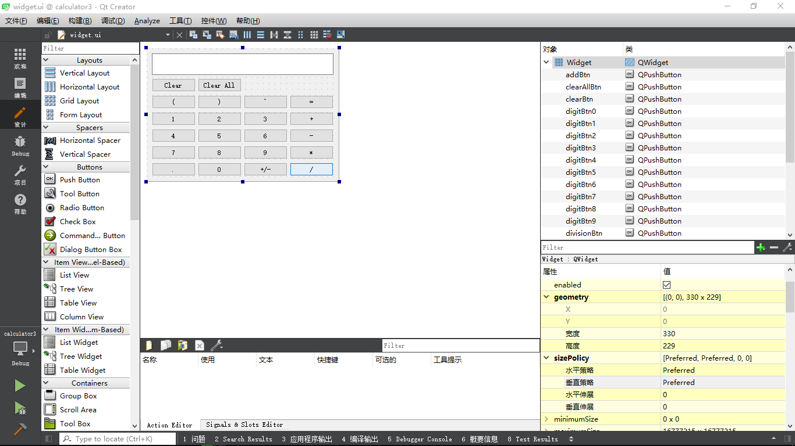

图3.1

之后修改按钮的名字，按照(, ), ^分别命名为leftBracketBtn, rightBracketBtn, powBtn.

（2）双击widget.h文件，将文件中的私有成员改为

private:

//将表达式转化为后缀表达式

QString inToPost(QString infix) throw(const char*);

//计算后缀表达式的结果

double compute(QString s) throw(const char*);

void abortOperation();

Ui::Widget *ui;

bool waitForOperand;

QString error;

1. 转到widget.cpp文件中，添加几个要用到的头文件

#include <map>

#include <stack>

#include <cmath>

修改Widget构造函数的内容

改为

Widget::Widget(QWidget *parent) :

QWidget(parent),

ui(new Ui::Widget)

{

initUi();

waitForOperand = true;

connectSlots();

setShortcutKeys();

}

删除掉calculate函数的定义

将abortOperation的函数定义修改为

void Widget::abortOperation()

{

ui->lineEdit->setText("0");

waitForOperand = true;

QMessageBox::warning(this, "运算错误", error);

}

将digitClicked的函数修改为

void Widget::digitClicked()

{

QPushButton *digitBtn = static_cast<QPushButton*>(sender());

QString value = digitBtn->text();

if(ui->lineEdit->text() == "0" && value == "0")

return;

if(waitForOperand)

{

ui->lineEdit->setText(value);

waitForOperand = false;

}

else

{

ui->lineEdit->setText(ui->lineEdit->text() + value);

}

}

将on_equalBtn_clicked的函数修改为

void Widget::on_equalBtn_clicked()

{

double result = 0.0;

try

{

result = compute(inToPost(ui->lineEdit->text()));

}

catch(const char *er)

{

error = er;

abortOperation();

return;

}

ui->lineEdit->setText(ui->lineEdit->text() + '=' + QString::number(result));

waitForOperand = true;

}

将on_sign_clicked的实现修改为

void Widget::on_signBtn_clicked()

{

QString text = ui->lineEdit->text();

QChar sign = text[text.size() - 1];

if(sign == '-')

{

text.remove(text.size() - 1, 1);

}

else

{

text.append('-');

}

ui->lineEdit->setText(text);

}

将operatorClicked的函数实现修改为

void Widget::operatorClicked()

{

QPushButton *clickedBtn = qobject_cast<QPushButton *>(sender());

QString clickedOperator = clickedBtn->text();

ui->lineEdit->setText(ui->lineEdit->text() + clickedOperator);

}

将pointClicked的函数实现修改为

void Widget::on_pointBtn_clicked()

{

if (waitForOperand)

ui->lineEdit->setText("0");

ui->lineEdit->setText(ui->lineEdit->text() + ".");

waitForOperand = false;

}

将setShortCutKeys的函数实现更改为

void Widget::setShortcutKeys()

{

Qt::Key key[21] = {

Qt::Key_0, Qt::Key_1, Qt::Key_2, Qt::Key_3,

Qt::Key_4, Qt::Key_5, Qt::Key_6, Qt::Key_7,

Qt::Key_8, Qt::Key_9,

Qt::Key_Plus, Qt::Key_Minus, Qt::Key_Asterisk, Qt::Key_Slash,

Qt::Key_Enter, Qt::Key_Period, Qt::Key_Backspace, Qt::Key_M,

Qt::Key_ParenLeft, Qt::Key_ParenRight, Qt::Key_AsciiCircum

};

QPushButton *btn[21] = {

ui->digitBtn0, ui->digitBtn1, ui->digitBtn2, ui->digitBtn3,

ui->digitBtn4, ui->digitBtn5, ui->digitBtn6, ui->digitBtn7,

ui->digitBtn8, ui->digitBtn9,

ui->addBtn, ui->subtractionBtn, ui->multiplicationBtn, ui->divisionBtn,

ui->equalBtn, ui->pointBtn, ui->clearBtn, ui->signBtn,

ui->leftBracketBtn, ui->rightBracketBtn, ui->powBtn

};

for (int i = 0; i < 21; i++)

btn[i]->setShortcut(QKeySequence(key[i]));

ui->clearAllBtn->setShortcut(QKeySequence("Ctrl+Backspace"));

}

修改connectSlots函数的实现

QPushButton *digitBtns[10] = {

ui->digitBtn0, ui->digitBtn1, ui->digitBtn2, ui->digitBtn3,

ui->digitBtn4, ui->digitBtn5, ui->digitBtn6, ui->digitBtn7,

ui->digitBtn8, ui->digitBtn9

};

for (auto btn : digitBtns)

connect(btn, &QPushButton::clicked, this, &Widget::digitClicked);

QPushButton *operatorBtns[7] = {

ui->addBtn, ui->subtractionBtn, ui->multiplicationBtn, ui->divisionBtn,

ui->leftBracketBtn, ui->rightBracketBtn, ui->powBtn

};

for (auto btn : operatorBtns)

connect(btn, &QPushButton::clicked, this, &Widget::operatorClicked);

最后再添加刚才在私有成员里声明的的函数实现

QString Widget::inToPost(QString infix) throw(const char*)

{

std::stack<char> stack;

char current = 0;//读入的字符

QString postfix;//写入后缀表达式的字符串

std::map<char,int> priority;//运算符号优先级表

priority['+'] = 0;

priority['-'] = 0;

priority['*'] = 1;

priority['/'] = 1;

priority['^'] = 2;

for(int i = 0; i < infix.length() ;++i)//逐个读取中缀表达式字符串中的字符

{

current =infix[i].toLatin1();

if(isdigit(current))//如果是数字直接输出

{

postfix.push_back(current);

continue;

}

switch(current)

{

case '+':

case '-':

case '*':

case '/':

case '^':

if(infix[i-1] != ')') //如果运算符的前一项不是右括号则说明前一个数字输入完毕，用#标识前面几个字符组成一个数字

{

if(infix[i-1].isDigit())

postfix.push_back('#');

else

throw "expression is illegality";

}

if(!stack.empty())//比较目前符号与栈顶符号优先级，低于则出栈，并输出字符串

{

char tempTop=stack.top();

while(tempTop != '(' && priority[current]<=priority[tempTop])

{

stack.pop();

postfix.push_back(tempTop);

if(stack.empty())

break;

tempTop=stack.top();

}

}

stack.push(current);//符号全部出栈或者遇到了'('或者大于栈顶符号的优先级，将新符号压入栈中

break;

case '.':

postfix.push_back(current);

break;

case '%':

postfix.push_back(current);

break;

case '(':

stack.push(current);//左括号直接入栈

break;

case ')':

postfix.push_back('#');//右括号说明前方数字输入完成，标识一下

char tempTop;

tempTop=stack.top();

while(tempTop !='(')//直到栈顶元素是左括号才停止循环

{

stack.pop();

postfix.push_back(tempTop);

tempTop=stack.top();

}

stack.pop();

break;

default:

throw "expression has illegality character";

break;

}

}

if(infix[infix.size()-1] != ')')

{

if(infix[infix.size()-1].isDigit())

postfix.push_back('#');

else

throw "expression is illegality";

}

while(!stack.empty())

{

char tempOut=stack.top();

stack.pop();

postfix.push_back(tempOut);

}

return postfix;

}

double Widget::compute(QString s) throw(const char*)

{

std::stack<double> stack;

QString str;

double curr;

double temNum1;

double temNum2;

for(auto i = s.begin();i != s.end(); i++)

{

if((*i).isDigit())

{

str.push_back(*i);

continue;

}

switch((*i).toLatin1())

{

case '+':

temNum1=stack.top();

stack.pop();

temNum2=stack.top();

stack.pop();

stack.push(temNum2 + temNum1);

break;

case '-':

temNum1=stack.top();

stack.pop();

temNum2=stack.top();

stack.pop();

stack.push(temNum2 - temNum1);

break;

case '*':

temNum1=stack.top();

stack.pop();

temNum2=stack.top();

stack.pop();

stack.push(temNum2 * temNum1);

break;

case '/':

temNum1=stack.top();

stack.pop();

temNum2=stack.top();

stack.pop();

stack.push(temNum2 / temNum1);

break;

case '^':

temNum1=stack.top();

stack.pop();

temNum2=stack.top();

stack.pop();

stack.push(pow(temNum2, temNum1));

break;

case '.':

str.push_back(*i);

break;

case '#':

curr =str.toDouble();//字符串转换为浮点型

str.clear();

stack.push(curr);

break;

case '%':

curr = stack.top();

stack.pop();

curr*=0.01;

stack.push(curr);

break;

default:

throw "expression has illegality character";

break;

}

}

curr=stack.top();

return curr;

}

1. 运行程序，如图3.2所示

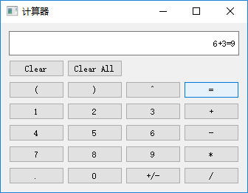

图3.2

# Qt计算器v4.0

## 目的要求

在实验三Qt计算器v3.0的基础上进行升级

可以将剪切板里的内容，复制到显示框内

## 实验内容

从本实验开始，需要在程序内添加一些特别的功能，此时，再用QWidget作为顶级窗口有些不合适了，应当选用QMainWIndow作为顶级窗口，因为QMainWindow与QWidget相比多了一些部件如菜单栏，可以用来放各种功能。

### 实验步骤

1. 新建一个项目文件，选择QMainWindow作为基类，之后，按照实验三的界面设置界面，再将实验三中的代码复制过来，但注意要改函数前面的类名要改为MainWidow.之后运行程序，确保如图3.1所示

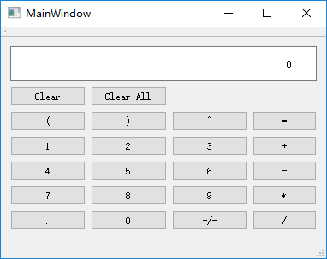

图3.1

1. 关闭程序，双击mainwindow.ui文件，点击菜单栏，在上面输入菜单，然后在菜单中添加粘贴，如图3.2所示（若无法输入中文，在别的地方写完，复制粘贴过来即可）

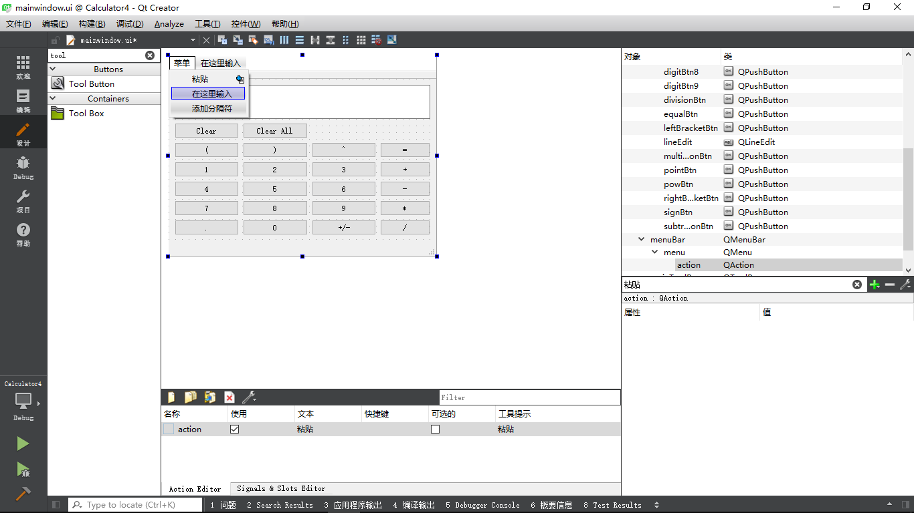

图3.2

右键点击下方的action,选择转到槽，选择triggered函数，点确定

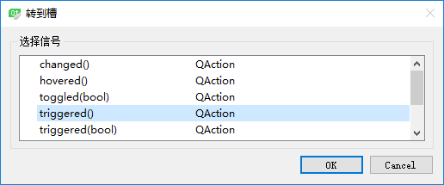

在槽函数中添加内容

void MainWindow::on_action_triggered()

{

QClipboard *board = QApplication::clipboard();

QString text = board->text();

ui->lineEdit->setText(text);

}

1. 运行程序，检查是否能够将复制的内容粘贴进输入框内。

# Qt计算器v5.0

## 目的要求

在计实验4Qt计算器v4.0的基础上进行改进，使得计算器能够记录计算历史

并且能够随时调出和消除历史

## 实验内容

1. 打开实验四的项目文件，双击mainwindow.ui, 将QLineEdit输入框删除，拖入一个QTextEdit作为输入框。之后在转到，mainwindow.h中，添加两个私有函数

//获取当前表达式的值

QString currentText();

//设置当前行的值

void setCurrentText(QString text);

和一个私有成员变量

QString log;

将bool waitForOperand改为 bool waitForOperator

这是因为，从此版本开始，每次将计算结果打印到下一行，使得可以继续进行计算，这时需要判断是否程序正在等待用户输入一个运算符。

之后转到mainwindow.cpp中添加头文件

#include <QTextBlock>

修改构造函数为

MainWindow::MainWindow(QWidget *parent) :

QMainWindow(parent),

ui(new Ui::MainWindow)

{

ui->setupUi(this);

setCurrentText("0");

waitForOperator = false;

connectSlots();

setShortcutKeys();

}

需要修改的函数如下

void MainWindow::abortOperation()

{

setCurrentText("0");

waitForOperator = true;

statusBar()->showMessage(error, 4000);

}

void MainWindow::digitClicked()

{

QPushButton *digitBtn = static_cast<QPushButton*>(sender());

QString value = digitBtn->text();

QString current = currentText();

if(current == "0" && value == "0")

return;

if(waitForOperator)

{

log.append(current + '\n');

ui->textEdit->append(value);

waitForOperator = false;

}

else

{

if(current != "0")

setCurrentText(current + value);

else

setCurrentText(value);

}

}

void MainWindow::on_clearBtn_clicked()

{

//将当前显示的数归零

setCurrentText("0");

waitForOperator = true;

}

void MainWindow::on_clearAllBtn_clicked()

{

//将当前显示的数据归零，并将之前保存的数据运算清除

ui->textEdit->setText("0");

waitForOperator = true;

}

void MainWindow::on_equalBtn_clicked()

{

double result = 0.0;

try

{

result = compute(inToPost(currentText()));

}

catch(const char *er)

{

error = er;

abortOperation();

return;

}

log.append(currentText() + '\n');

ui->textEdit->append(QString::number(result));

waitForOperator = true;

}

void MainWindow::on_signBtn_clicked()

{

QString text = currentText();

QChar sign = text[text.size() - 1];

if(sign == '-')

{

text.remove(text.size() - 1, 1);

}

else

{

text.append('-');

}

setCurrentText(text);

}

void MainWindow::operatorClicked()

{

QPushButton *clickedBtn = qobject_cast<QPushButton *>(sender());

QString clickedOperator = clickedBtn->text();

setCurrentText(currentText() + clickedOperator);

waitForOperator = false;

}

void MainWindow::on_pointBtn_clicked()

{

if (waitForOperator)

setCurrentText("0");

setCurrentText(currentText() + ".");

waitForOperator = false;

}

再添加两个函数实现

QString MainWindow::currentText()

{

QTextDocument *document = ui->textEdit->document();

QTextBlock block = document->lastBlock();

return block.text();

}

void MainWindow::setCurrentText(QString text)

{

QString allText = ui->textEdit->toPlainText();

int pos = allText.lastIndexOf('\n');

if(pos >= 0)

allText.replace(allText.lastIndexOf('\n') + 1, allText.size(), text);

else

allText = text;

ui->textEdit->setText(allText);

}

之后编译，确保程序能够运行

1. 现在程序能够记录历史了，但清除后历史就消失了，现在添加一个功能，让程序可以随时将记录的历史显示出来，而且还能将记录的历史清除。双击mainwindow.ui,像之前一样，向菜单中添加两个“历史记录”、“清除记录”。然后再拖动下方的action，将“历史纪录”和“清除记录”拖动到工具栏中。如图5.1所示。

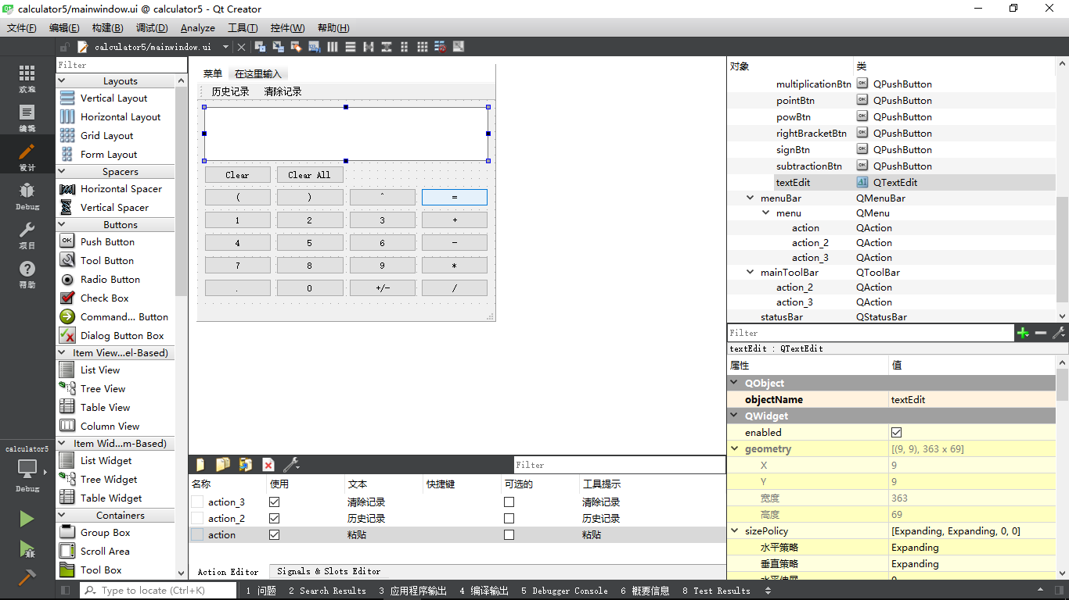

图5.1

右键点击下方的历史记录和清除记录，选择转到槽，选择triggered信号，分别添加槽函数的实现

void MainWindow::on_action_2_triggered()

{

ui->textEdit->setText(log);

setCurrentText("0");

waitForOperator = false;

}

void MainWindow::on_action_3_triggered()

{

log.clear();

}

（3）运行程序，查看功能是否实现。

# Qt计算器v6.0

## 目的要求

在实验5Qt计算器v5.0的基础上进行改进，使得计算拥有更多的功能，并且在用户不需要的情况下隐藏这些功能。

## 实验步骤

（1）

打开实验5的项目文件，双击mainwindow.ui进入设计模式，打破原有布局，向界面中再拖入6个按钮，并修改其显示文本为%，sin，cos，tan，ln，lg。再向“菜单”中添加一个Action“科学计算器”，并将其属性中的checkable选中。之后将所有按钮选中，应用栅格布局，再选中主窗口应用纵向布局。确保如图6.1所示

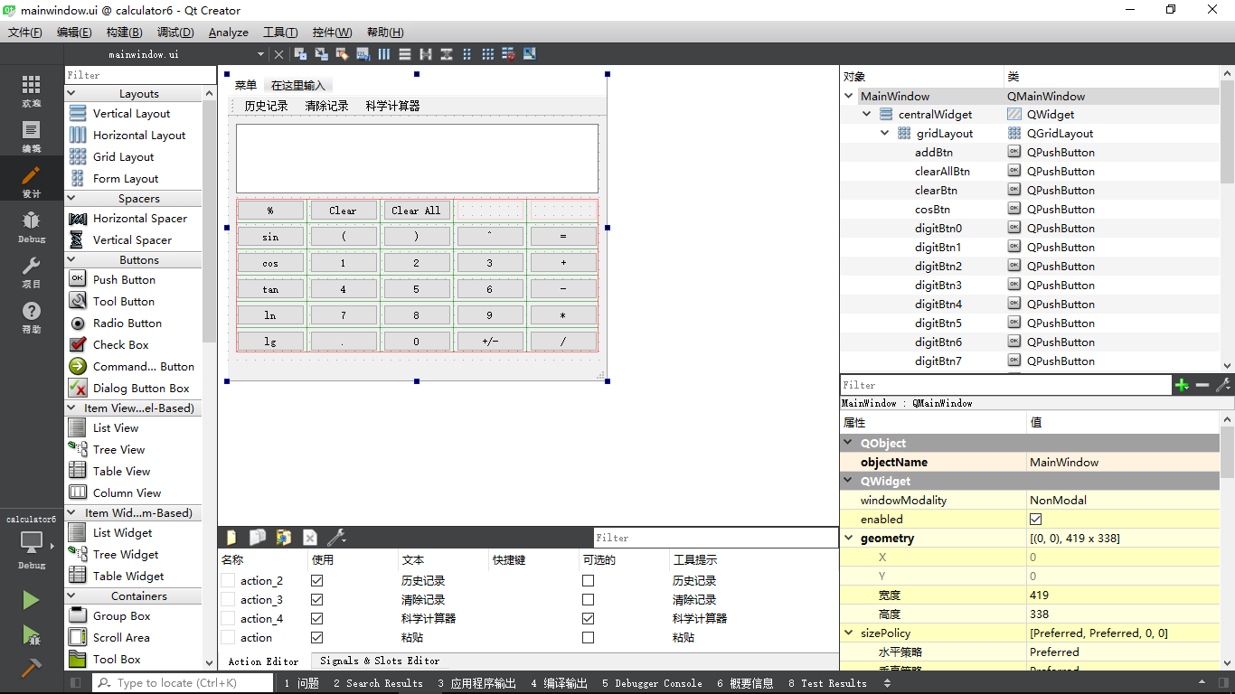

图6.1

之后按照%，sin，cos，tan，ln，lg将按钮分别命名为percentBtn, sinBtn, cosBtn, tanBtn, lnBtn, lgBtn.

选中Action“科学计算器”选择转到槽，选择triggered(bool)信号，添加槽函数实现如下

void MainWindow::on_action_4_triggered(bool checked)

{

if(checked)

{

ui->percentBtn->show();

ui->sinBtn->show();

ui->cosBtn->show();

ui->tanBtn->show();

ui->lnBtn->show();

ui->lgBtn->show();

}

else

{

ui->percentBtn->hide();

ui->sinBtn->hide();

ui->cosBtn->hide();

ui->tanBtn->hide();

ui->lnBtn->hide();

ui->lgBtn->hide();

}

}

1. 转到mainwindow.h中，添加一个槽函数，

void specialOperatorClicked();

之后转到mainwindow.cpp中，添加函数实现

void MainWindow::specialOperatorClicked()

{

QPushButton *specialOperatorBtn = static_cast<QPushButton*>(sender());

QString value = specialOperatorBtn->text();

QString current = currentText();

if(waitForOperator)

{

log.append(current + '\n');

ui->textEdit->append(value);

waitForOperator = false;

}

else

{

if(current != "0")

setCurrentText(current + value);

else

setCurrentText(value);

}

}

部分有改动的函数如下

MainWindow::MainWindow(QWidget *parent) :

QMainWindow(parent),

ui(new Ui::MainWindow)

{

initUi();

waitForOperator = false;

on_action_4_triggered(false);

connectSlots();

setShortcutKeys();

}

void MainWindow::connectSlots()

{

QPushButton *digitBtns[10] = {

ui->digitBtn0, ui->digitBtn1, ui->digitBtn2, ui->digitBtn3,

ui->digitBtn4, ui->digitBtn5, ui->digitBtn6, ui->digitBtn7,

ui->digitBtn8, ui->digitBtn9

};

for (auto btn : digitBtns)

connect(btn, &QPushButton::clicked, this, &MainWindow::digitClicked);

QPushButton *operatorBtns[8] = {

ui->addBtn, ui->subtractionBtn, ui->multiplicationBtn, ui->divisionBtn,

ui->leftBracketBtn, ui->rightBracketBtn, ui->powBtn, ui->percentBtn

};

for (auto btn : operatorBtns)

connect(btn, &QPushButton::clicked, this, &MainWindow::operatorClicked);

QPushButton *specialOperatorBtns[5] = {

ui->sinBtn, ui->cosBtn, ui->tanBtn, ui->lnBtn,

ui->lgBtn

};

for (auto btn : specialOperatorBtns)

connect(btn, &QPushButton::clicked, this, &MainWindow::specialOperatorClicked);

}

void MainWindow::setShortcutKeys()

{

Qt::Key key[27] = {

Qt::Key_0, Qt::Key_1, Qt::Key_2, Qt::Key_3,

Qt::Key_4, Qt::Key_5, Qt::Key_6, Qt::Key_7,

Qt::Key_8, Qt::Key_9,

Qt::Key_Plus, Qt::Key_Minus, Qt::Key_Asterisk, Qt::Key_Slash,

Qt::Key_Enter, Qt::Key_Period, Qt::Key_Backspace, Qt::Key_M,

Qt::Key_ParenLeft, Qt::Key_ParenRight, Qt::Key_AsciiCircum,Qt::Key_Percent,

Qt::Key_S, Qt::Key_C, Qt::Key_T, Qt::Key_N,

Qt::Key_G

};

QPushButton *btn[27] = {

ui->digitBtn0, ui->digitBtn1, ui->digitBtn2, ui->digitBtn3,

ui->digitBtn4, ui->digitBtn5, ui->digitBtn6, ui->digitBtn7,

ui->digitBtn8, ui->digitBtn9,

ui->addBtn, ui->subtractionBtn, ui->multiplicationBtn, ui->divisionBtn,

ui->equalBtn, ui->pointBtn, ui->clearBtn, ui->signBtn,

ui->leftBracketBtn, ui->rightBracketBtn, ui->powBtn, ui->percentBtn,

ui->sinBtn, ui->cosBtn, ui->tanBtn, ui->lnBtn,

ui->lgBtn

};

for (int i = 0; i < 27; i++)

btn[i]->setShortcut(QKeySequence(key[i]));

ui->clearAllBtn->setShortcut(QKeySequence("Ctrl+Backspace"));

}

QString MainWindow::inToPost(QString infix) throw(const char*)

{

std::stack<char> stack;

char current = 0;//读入的字符

QString postfix;//写入后缀表达式的字符串

std::map<char,int> priority;//运算符号优先级表

priority['+'] = 0;

priority['-'] = 0;

priority['*'] = 1;

priority['/'] = 1;

priority['^'] = 2;

priority['s'] = 3;

priority['c'] = 3;

priority['t'] = 3;

priority['n'] = 3;

priority['g'] = 3;

priority['%'] = 3;

for(int i = 0; i < infix.length() ;++i)//逐个读取中缀表达式字符串中的字符

{

current =infix[i].toLatin1();

if(isdigit(current))//如果是数字直接输出

{

postfix.push_back(current);

continue;

}

switch(current)

{

case '+':

case '-':

case '*':

case '/':

case '^':

case '%':

if(infix[i-1] != ')') //如果运算符的前一项不是右括号则说明前一个数字输入完毕，用#标识前面几个字符组成一个数字

{

if(infix[i-1].isDigit())

postfix.push_back('#');

else if(infix[i-1] == '%')// 什么也不做，跳出

infix.begin();

else

throw "表达式是非法的";

}

if(!stack.empty())//比较目前符号与栈顶符号优先级，低于则出栈，并输出字符串

{

char tempTop=stack.top();

while(tempTop != '(' && priority[current]<priority[tempTop])

{

stack.pop();

postfix.push_back(tempTop);

if(stack.empty())

break;

tempTop=stack.top();

}

}

stack.push(current);//符号全部出栈或者遇到了'('或者大于栈顶符号的优先级，将新符号压入栈中

break;

case 's':

case 'c':

case 't':

if(i > 0 && infix[i-1].isDigit())

throw "表达式非法";

if(!stack.empty())//比较目前符号与栈顶符号优先级，低于则出栈，并输出字符串

{

char tempTop=stack.top();

while(tempTop != '(' && priority[current]<priority[tempTop])

{

stack.pop();

postfix.push_back(tempTop);

if(stack.empty())

break;

tempTop=stack.top();

}

}

stack.push(current);

i+=2;

break;

case 'l':

if(infix[i-1].isDigit())

throw "表达式非法";

if(!stack.empty())//比较目前符号与栈顶符号优先级，低于则出栈，并输出字符串

{

char tempTop=stack.top();

while(tempTop != '(' && priority[infix[i+1].toLatin1()] < priority[tempTop])

{

stack.pop();

postfix.push_back(tempTop);

if(stack.empty())

break;

tempTop=stack.top();

}

}

stack.push(infix[i+1].toLatin1());

i++;

break;

case '.':

postfix.push_back(current);

break;

case '(':

stack.push(current);//左括号直接入栈

break;

case ')':

postfix.push_back('#');//右括号说明前方数字输入完成，标识一下

char tempTop;

tempTop=stack.top();

while(tempTop !='(')//直到栈顶元素是左括号才停止循环

{

stack.pop();

postfix.push_back(tempTop);

tempTop=stack.top();

}

stack.pop();

break;

default:

throw "表达式中含有非法字符";

break;

}

}

if(infix[infix.size()-1] != ')')

{

if(infix[infix.size()-1].isDigit())

postfix.push_back('#');

else if(infix[infix.size()-1] == '%') // 什么也不做

infix.begin();

else

throw "表达式非法";

}

while(!stack.empty())

{

char tempOut=stack.top();

stack.pop();

postfix.push_back(tempOut);

}

return postfix;

}

double MainWindow::compute(QString s) throw(const char*)

{

//qDebug() << s;

const double PI = std::acos(-1.0);

std::stack<double> stack;

QString str;

double curr;

double temNum1;

double temNum2;

for(auto i = s.begin();i != s.end(); i++)

{

if((*i).isDigit())

{

str.push_back(*i);

continue;

}

switch((*i).toLatin1())

{

case '+':

temNum1=stack.top();

stack.pop();

temNum2=stack.top();

stack.pop();

stack.push(temNum2 + temNum1);

break;

case '-':

temNum1=stack.top();

stack.pop();

temNum2=stack.top();

stack.pop();

stack.push(temNum2 - temNum1);

break;

case '*':

temNum1=stack.top();

stack.pop();

temNum2=stack.top();

stack.pop();

stack.push(temNum2 * temNum1);

break;

case '/':

temNum1=stack.top();

stack.pop();

temNum2=stack.top();

stack.pop();

stack.push(temNum2 / temNum1);

break;

case '^':

temNum1=stack.top();

stack.pop();

temNum2=stack.top();

stack.pop();

stack.push(pow(temNum2, temNum1));

break;

case 's':

temNum1 = stack.top();

stack.pop();

stack.push(std::sin(temNum1/180.0*PI));

break;

case 'c':

temNum1 = stack.top();

stack.pop();

stack.push(std::cos(temNum1/180.0*PI));

break;

case 't':

temNum1 = stack.top();

stack.pop();

stack.push(std::tan(temNum1/180.0*PI));

break;

case 'n':

temNum1 = stack.top();

stack.pop();

stack.push(std::log(temNum1));

break;

case 'g':

temNum1 = stack.top();

stack.pop();

stack.push(std::log10(temNum1));

break;

case '.':

str.push_back(*i);

break;

case '#':

curr =str.toDouble();//字符串转换为浮点型

str.clear();

stack.push(curr);

break;

case '%':

curr = stack.top();

stack.pop();

curr*=0.01;

stack.push(curr);

break;

default:

throw "表达式中含有非法字符";

break;

}

}

curr=stack.top();

return curr;

}

（3）运行程序，测试程序功能。