1. Why should one use Azure Key Vault when working in the Azure environment? What are the pros and cons? What are the alternatives?

Pros
  - Enhances security and management as it requires authentication of key access, authorization of key usage, and services or applications do not have direct access to keys
  - Allows for creation and import of encryption keys quickly
  - Allows for easy monitoring of keys through usage and access logs

Cons
  - Need to design and ensure proper recovery methods in the event key vault gets deleted or corrupted. Otherwise keys/certificates will need to be re-instantiated

Alternatives
  - AWS Key Management Service
  - Google Key Management Service
  - CyberArk

2. How do you achieve loop functionality within a Azure Data Factory pipeline? Why would you need to use this functionality in a data pipeline?

- “ForEach” activity defines a repeating control flow in an Azure Data Factory pipeline and allows for iteration of a specific function over a collection
  - Select and add one or more ForEach activities that will be applied for each item
  - Select Items (folders, etc) that the ForEach activity should iterate over
- “ForEach” functionality helps in executing repetitive tasks over a collection of items (e.g Copying from the same source file in Azure Blob to multiple destination files in Azure Blob)

3. What are expressions in Azure Data Factory? How are they helpful when designing a data pipeline? Please explain with an example.

- Expressions are JSON based formulas which allows for the modification of variables or any other parameters within a pipeline, action, or connection. They can be used to add dynamic values (different folders, filepaths, etc) required within different stages or actions of the pipeline during runtime
- Function expressions are also possible
  - For instance, if a user would like to execute part of a pipeline only when the job is run before noon, instead of creating a new pipeline with a new trigger, they can use an “if condition” expression that checks whether the current time is before noon.
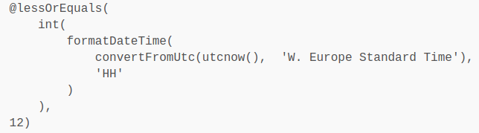

4. What are the pros and cons of parametrizing a dataset’s activity in Azure Data
Factory?

Pros
- Parametrization of generic datasets relating to areas such as passing values that are from the pipeline or resolved at runtime within the pipeline (e.g file/table location, file/table name, data attributes) offer benefits to different scenarios
- Allows for Conditional Programming and a much more flexible pipeline solution that reduces the cost of maintenance and speeds up implementation of new features into existing pipelines
- Minimizes the amount of hard coding and increases the number of reusable objects and processes in a solution
- An example would be dynamic input file names coming in from an external service or dynamic output table names
  - If a user wanted to copy a number of different CSV files into different tables in a database, parameterizing the datasets eliminates the need to create new dataset objects for every CSV file they wish to copy into a table. A user can create a parameter for the dataset populated with the CSV file path they wish to copy
  - Alternatively, when creating the Table dataset object, the user can create a parameter that should be populated with the name of the table they wish to populate
  - Once these parameters are created for the datasets, a dynamic variable can be passed to the dataset objects through the pipeline to populate them
    - In a regular pipeline, for every additional file a user wishes to copy over into the database, they need to create additional objects. For transferring a large number of files, this requires more overhead in creating additional objects. Furthermore, an increasing scale of work is prone to more errors
Regular Pipeline
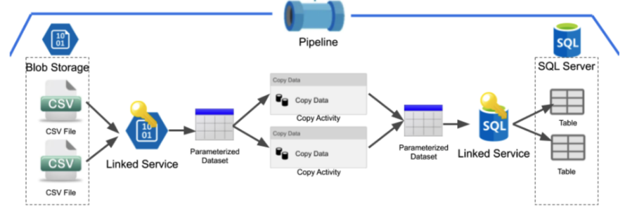

    - In a “Parameterized Pipeline”, the copy activity will pass variables to both the CSV and Table dataset objects at runtime indicating what data they should be referencing
Parameterized Pipeline
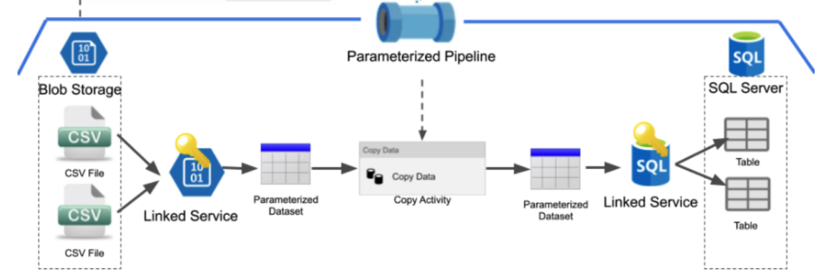

Cons

Cons
- Parametrizing passwords/secrets, or even making linked services dynamic can increase security risks and maintenance challenges for flow controls and credential handling leading to potentially great harm
- For complicated and varied datasets, the maintenance, management, and documentation of the pipeline and its parameters may lead to significant overhead

5. What are the different supported file formats and compression codecs in Azure Data Factory? When will you use a Parquet file over an ORC file?Why would you choose an AVRO file format over a Parquet file format?

Types of compression codecs
  - Avro, Binary, JSON, Parquet, ORC, and XML

AVRO vs Parquet
  - Since AVRO is stored in a row format whereas Parquet is stored in a flat columnar format, Parquet will be more efficient when for querying a few columns from “wide” tables since it eliminates the need to read and extract unnecessary information, thereby reducing IO
  - AVRO is an excellent exchange format for moving data, especially to and from landing zones where the entire data needs to be used and passed for further processing downstream
  - Parquet is best for read-heavy analytical workloads where it needs to query a transformed dataset in the final or “end” stages of pipeline, whereas AVRO is best for write-heavy transactional workloads within the initial exchanges and stages of data that requires querying all columns
  - AVRO is more mature than Parquet when it comes to schema evolution. Parquet only supports schema append whereas AVRO supports a more functionality (e.g adding or modifying columns)

ORC vs Parquet
  - ORC stores collections of rows in one file and within the collection the row data is stored in a columnar format
  - For complex nested data structure, Parquet is more flexible as its fields can be read individually without the need to read all the fields in the nested structure. Parquet was particularly designed keeping nested data structures in mind
  - Parquet has a much broader range of support for the majority of the projects in the Hadoop ecosystem, while ORC only supports Hive and Pig
  - ORC is better optimized for Hive and not only supports ACID properties, but also provides a more efficient and better way to store data
  - Parquet works really well with Apache Spark and is the default file format for writing and reading data in Apache Spark
  - ORC has more predicate push-down capabilities which are applied to more levels than Parquet. ORC files have three levels of indexing: file statistics, stripe statistics, and row group indexes. Predicates are applied only to the first two levels. Parquet files have two levels of statistics: rowgroup statistics and page statistics. Predicates are only applied to the first level

