**INSCRIÇÕES ATÉ 13.04**

Agora são oferecidos dois cursos de Cloud da Google,

o básico e tradicional Cloud Computing Foundations e

este **novo curso de Cloud Engineering,** recomendado

para alunos que já completaram o Foundations.

**

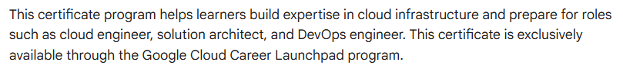

https://www.cloudskillsboost.google/paths/621

**Informações do Curso Inscrições Mackenzie WhatsApp Cursos**

**Google Mackenzie**

<https://forms.gle/Ei5cpGuABKpCCsny5>

<https://chat.whatsapp.com/BsIBXKBB3HPEQXUDdOTjiA>