**Title:** Investigating effects of solar proton events and Forbush decreases on ground-level potential gradient recorded at middle and low latitudes and different altitudes

**Authors**: Tacza1,2,*, J., Odzimek1, A., Tueros3, E., Raulin2, J.-P., Kubicki1, M., Fernandez4, G., Marun5, A.

1. Institute of Geophysics, Polish Academy of Sciences, Warsaw, Poland.

2. Center of Radio Astronomy and Astrophysics Mackenzie, Engineering School, Mackenzie Presbyterian University, Sao Paulo, Brazil

3. National Institute for Space Research, Sao Jose dos Campos, Brazil

4. Complejo Astronomico El Leoncito, CASLEO, San Juan, Argentina

5. Instituto de Ciencias Astronomicas de la Tierra y el Espacio, ICATE-CONICET-UNSJ, San Juan, Argentina

*Corresponding author: E-mail address: josect1986@gmail.com

**Abstract**

High-energetic charged particles, such as solar proton events, and phenomena as Forbush decreases are potential candidates to affect the global electric circuit. We can study these effects by analyzing disturbances of the potential gradient in ground-based measurements in fair weather regions. In this paper, we investigate deviations of the potential gradient daily curve, during solar proton events and Forbush decreases, from mean values obtained in fair weather conditions. Using the superposed epoch analysis, in order to enhance the visualization of small effects, we study the potential gradient data recorded between January 2010 and December 2019 at two stations located in low and mid-latitudes, and two different altitudes: the Complejo Astronómico El Leoncito (CASLEO), Argentina (31.78°S, 2550 m a.s.l.) and the Geophysical Observatory in Swider, Poland (52.12°N, 100 m a.s.l.), respectively. For intense solar proton events (>100 MeV) we found a statistically significant increase of the potential gradient after solar proton events recorded at CASLEO and no such deviation in the potential gradient recorded at Swider. For Forbush decrease events (greater than 4%), no significant deviation of the potential gradient after the start of the event in both stations was found, however for very intense Forbush decreases (>7%) we found an increase of the potential gradient recorded at CASLEO.

**Plain Language Summary**

The Earth's atmosphere is constantly bombarded by highly energetic charged particles from the Sun, our galaxy and other galaxies. These energetic charged particles interact with the particles of the Earth's atmosphere affecting our environment. In this study, we focus on the impact of solar proton events (high solar energetic charged particles) and Forbush Decreases (suppression of energetic charged particle flux), on the Earth’s electrical activity. Particularly, we evaluate the impact of these phenomena in the atmospheric electric field (or potential gradient) recorded at ground level in two different stations located at different latitudes and in different altitudes. Our results show that the potential gradient is sensitive to solar proton events and Forbush Decrease at stations located at high altitudes.

**1. Introduction**

The Earth's atmosphere is usually bombarded by cosmic rays. Dorman (2004) defines cosmic rays “as particles and photons with energies at least several orders of magnitude higher than the average energy of thermal particles of background plasma”. Cosmic rays have different origins, as for instance: extragalactic (up to 1021 eV), galactic (at least up to 1015-1016 eV) and solar (with energy up to 15-30 GeV) (Dorman, 2004). Solar cosmic rays constitute a population of energetic charged particles ejected by the Sun during transient events (e.g., solar flares). Most of solar cosmic rays are protons; thus, sometimes they are called “solar proton events” (SPEs) (e.g., Bazilevskaya, 2005). Cosmic rays lose their energy throughout interactions with the atmosphere of the Earth producing secondary particles, and can then be detected by neutron monitors (NM) installed on the ground. Solar disturbances can produce cosmic ray variations detected by the NM, such as: Ground Level Enhancements (GLEs) and Forbush decreases (FD) which are sudden increases and depressions of the cosmic ray flux, respectively (Cane, 2000; Poluianov et al., 2017).

These energetic charged particles interact with the middle and lower atmosphere of the Earth. They deposit their energy by ionization, by modifying atmospheric chemistry. This topic has been studied for a long time and it remains important in the relationship between Space Weather and tropospheric climate. However, the involved mechanisms are not well understood. Although the influence of solar variability in the lowest atmosphere is probably weak, the coupling between Space Weather and the tropospheric climate has been recognized as potentially important for the human environment (Gray et al., 2010; Lilensten et al., 2016). This coupling could exist through the Global Electric Circuit (Rycroft et al., 2012). Previous works have shown various short-term effects of SPE and FD events on the GEC parameters (Mironova et al., 2015; Golubenko et al., 2020). For example, balloon measurements recorded at ~30 km showed an increase of the electrical conductivity and decrease of the atmospheric electric field, in fair weather conditions, after the occurrence of intense SPEs (Holzworth et al., 1987; Holzworth and Mozer, 1979; Kokorowski et al., 2006; Reagan et al., 1983). These variations were caused by ionization in the lower atmosphere. Furthermore, SPE effects were also observed in the atmospheric electric field variation recorded at ground levels in fair weather regions (Cobb, 1967; Elhalel et al., 2014; Nicoll and Harrison, 2014; Reiter, 1969; Reiter, 1971; Sartor, 1980; Sheftel et al., 1994; Märcz, 1987, Takagi and Iwata, 1984). However, a correct choice for isolated SPEs was not performed, meaning that during the SPEs onset, other solar disturbances may have happened simultaneously (e.g., geomagnetic disturbances or FDs). Tacza et al. (2018) performed the analysis of 15 SPEs clearly isolated from the occurrence of geomagnetic storms or FDs. The authors found an average increase of ~10 V/m of the atmospheric electric field after the SPE onset, when compared with mean values. The explanation of the atmospheric electric field increase due to SPEs can be based on the model of Farrell and Desch (2002), which proposed that SPEs increase the electrical conductivity above the “batteries” (thunderstorms and electrified shower clouds) of the GEC, reducing the ohmic resistance above them, and allowing more current to flow upward. This produces an increase of the atmospheric electric field in fair weather regions. Recently, Wu et al. (2020) found an increase in the lightning density after very intense SPEs, which brings new insights in that SPEs not only changes the electrical conductivity above the ‘batteries’ of the GEC, but also could change the ‘batteries’ amount itself.

Additionally, the impact of FDs in the GEC has been reported. Several authors have discussed the relationship between FDs and clouds coverage (Harrison and Ambaum, 2010; Svensmark, et a., 2009; Todd and Kniveton, 2001). Sheftel et al. (1994) used several mid-latitude stations and found an immediate increase of the current density following the onset of six Forbush decrease events. Todd and Kniveton (2001) found a significant reduction of up to 1.4% in the global-scale cloud cover from 1 day prior to 1 day following the onset of the FDs, where the significant cloud anomalies were concentrated mainly in high latitudes. Furthermore, Svensmark et al. (2009) reported a liquid water decrease in low clouds following FDs. These changes in the cover amount and microphysical properties of clouds can produce variations in the current flowing in the GEC (Nicoll and Harrison, 2016; Tinsley et al., 2007; Tinsley, 2008). FDs and its connection with lightning occurrences were also analyzed. Okike and Umahi (2019) found a reduction in the lightning occurrence on a global scale during the FD onset. Furthermore, Okike (2019) reported that lightning occurrences reduction during FDs showed significant correlations at the United States latitude band and within the African region. In fair weather conditions, Märcz (1997) found a decrease of the atmospheric electric field after FD events. However, Engfer and Tinsley (1999) found no significant variation in the atmospheric electric field after FDs.

In this context, there is a clear need for more observational studies to assess the impact of energetic charged particles during SPEs and the effects of FDs on the GEC. The aim of this paper is to study the variations of the potential gradient[1] daily curve observed in fair weather conditions during two types of events: (I) solar proton events (SPEs) and (II) Forbush decreases (FDs). We use potential gradient data recorded between January 2010 and December 2019 at two stations at different latitudes in both hemispheres and different altitudes: the high-altitude Complejo Astronómico El Leoncito (31.798°S, 69.295°W, magnetic latitude 21.95°S[2], 2550 m a.s.l.) and the lowland Swider Geophysical Observatory (52.12°N, 21.23°E, magnetic latitude 50.28°N, 100 m a.s.l.). In section 2, the observation sites and instrumentation are described. The methodology and results are presented in sections 3 and 4, respectively. Finally, we discuss and summarize our results in the last section.

**2. Observation Site and Instrumentation**

We focus on PG measurements recorded in the Complejo Astronómico El Leoncito, CASLEO (31.798°S, 69.295°W, altitude 2550 masl), located in the Argentinian Andes, and in the Swider Geophysical Observatory (52.12°N, 21.23°E, altitude 100 masl), located in Poland, during the period between January 2010 and December 2019. A detailed description of the site locations and the instrumentation are described in previous works (Tacza et al., 2021; Kubicki et al., 2016) and we only provide a brief description here.

CASLEO observatory is an astronomical observatory located in “El Leoncito,” an area characterized with more than 250 clear-sky days per year, no clouds, almost no wind blowing, and a typically diaphanous, contamination-free atmosphere. The nearest town, Barreal, is located 40 km away. The PG measurements[3] are recorded by a BOLTEK field mill sensor. The sensor is mounted on steel support 0.4 m above the surface. The PG values have been reduced to the value at free flat area at ground level. The fair-weather conditions are defined by days with wind speed < 6 m/s, no rain precipitation, relative humidity < 90% and low cloud cover at the measurement site. In a previous work, Tacza et al. (2021) highlighted the possibility of providing reliable PG diurnal variations in fair weather conditions. To fulfill the criteria of fair-weather (e.g. Imyanitov and Chubarina 1967) at CASLEO we have used a Vantage Pro (Davis Instruments) and a Cloud Sensor II (Boltwood Systems Corporation).

Swider station is located 25 km South-Southeast of Warsaw city, and 2.5 km North-Northwest of the Otwock town. The Observatory is surrounded by pine and deciduous trees. Long term analysis of meteorological elements at Swider station shows the annual mean cloudiness is 4/8. Weak winds (< 2 m/s) dominate within a year, while strong winds (> 6 m/s) occur during spring. At Swider station, rural continental aerosols of natural origin prevail, with an influence of anthropogenic pollution especially during winter months. We use atmospheric electric field measurements recorded by a rotating dipole field mill (Berlinski et al., 2007). The field mill is mounted on steel support towers with a boom 2.5 m above the surface. The field-mill measured values have been reduced to the value at free flat area at ground level. The fair-weather conditions were chosen with low cloudiness (< 4/8), no hydrometeors (rain precipitation, drizzle, snow, hail, fog), and wind speed less than 6 m/s (as stated in Kubicki et al., 2016), based on the observatory meteorological records.

**3. Methodology**

We analyze the PG daily variation, in fair weather conditions, during two different types of events:

(I) intense solar proton events (SPE), with significant proton flux above 100 MeV as detected by GOES particle instruments, and

(II) intense Forbush decreases (FD), selected by the IZMIRAN catalogue (MagnM>4)[4].

In the case (I), to get rid of the effects of other solar and/or geomagnetic disturbances, we chose SPE events such that the Kp index remains lower than 4 (Kp < 4) during three consecutive days, that is, one day before and two days after the events. Similarly, we disregard SPE events for which an FD occurred during this three-day period. In the case (II), we verify that no SPE occurred during the FD period. The list of SPE and FD events are listed in Appendix A and B, respectively. Finally, in both cases (I) and (II), during the three-day period around the event, we remove for all stations PG hourly values that did not meet fair weather conditions as defined in section 2.

The methodology adopted in the analysis is as follows: first, monthly mean curves of the PG daily variation, in fair weather conditions, were calculated for each month (monthly standard curve). Second, for each SPE event (case I), a time window of 24 hours before and 48 hours after the start time of the event is used, where the start time of the SPE is defined as the beginning of the ≥100 MeV proton flux enhancement at the GOES satellite. On the other hand, for FD events (case II) we chose a time window of 170 hours before and after the start time of the FD, where the start time is defined as the beginning of the decrease observed in the Neutron Monitor stations[5]. Third, the difference between the PG values, of every time window, and their monthly standard curves were calculated to get PG excesses. Finally, we applied the superposed epoch analysis (SEA) to the excess’s curves.

**4. Results**

In this section we present the behavior of the potential gradient recorded at CASLEO (PG CASLEO) and SWIDER (PG SWIDER), during Solar Proton Events (SPE) and Forbush Decreases (FD). The following subsections show our results.

**4.1 Potential Gradient Response to Solar Proton Events**

Figure 1 shows the result of the superposed epoch analysis applied to the PG CASLEO deviations (black line) during seventeen (17) SPEs, where the time zero represents the start of the SPE. Features of each SPE are described in the Appendix A. The error bars represent one standard error of the mean. Two events were strong enough to produce Ground Level Enhancement (GLE): the SPE of 2012, May 17 (GLE71[6]) and 2017, September 10 (GLE72). The blue dashed line is the result of the superposed epoch analysis (SEA) without considering these two GLEs. Each gray line is the result of the superposed epoch analysis choosing random starting times for the 17 SPEs. We have performed 30000 iterations, and the solid red line in Figure 1 is the average of these 30000 iterations, and the dashed red lines are +/- 2.5 σ (σ is the standard deviation) of the average (99% confidence level). A clear increase of ~11 V/m in the PG CASLEO is observed after the start of the SPE. This increase corresponds to an excess of ~13% with respect to PG mean fair weather values.

Figure 2 shows the scatter between PG CASLEO hourly deviations and solar proton particle flux (N, units of protons.cm-2s-1sr-1), with energies > 100 MeV. For this particular case, the time window only correspond to the day of the onset of the SPE until its return to background levels, for each of the 17 events (~ 479 hours). The color indicates N ranges: N=[0,2] (blue), N=[2,10] (black) and N>10 (red). Figure 3 shows the linear regression between PG CASLEO deviations and N, separated for each N range. For N between [0,2] the Pearson correlation coefficient (R) is almost zero. For N between [2,10], a positive correlation was found (R=0.45) and for N >10, we note a negative correlation (R=-0.4). The SPE events with N > 10 correspond to the two GLE events: GLE71 and GLE72.

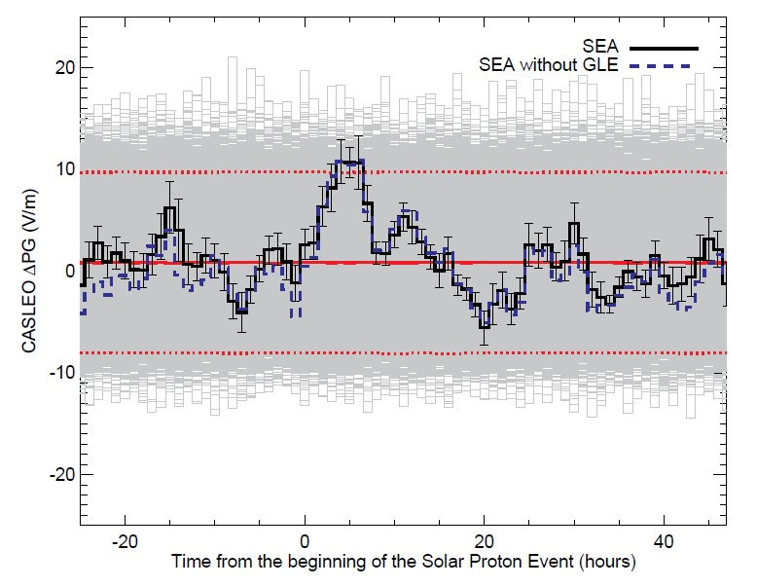

**Figure 1.** Superposed epoch analysis (SEA) of the PG CASLEO deviation response to SPE (black curve). The error bars represent one standard error of the mean. The grey lines show the result of 30000 iterations doing the average of the 17 events for random starting times. The solid red line is the average of the iterations and the dashed red lines represent +/- 2.5 standard deviations. The blue dashed line is the SEA without considering the two Ground Level Enhancement (GLE) events.

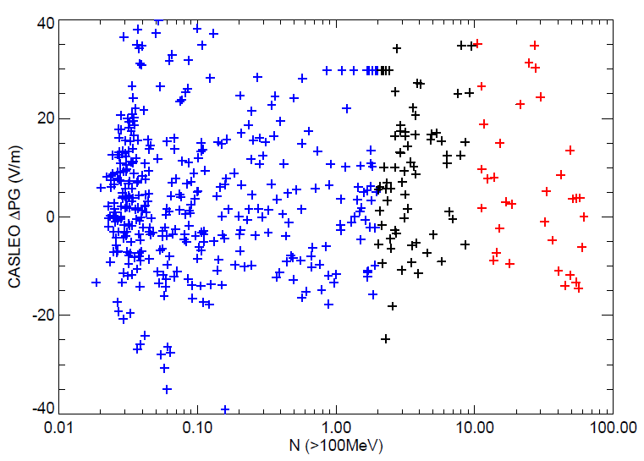

**Figure 2.** PG CASLEO hourly deviations against N (protons/(cm2.s.sr)) for proton flux with energy >100MeV, during the day of the SPE for each of the 17 events. The colors are separated for N ranges: blue (N=[0,2]), black (N=[2,10]) and red (N>10).

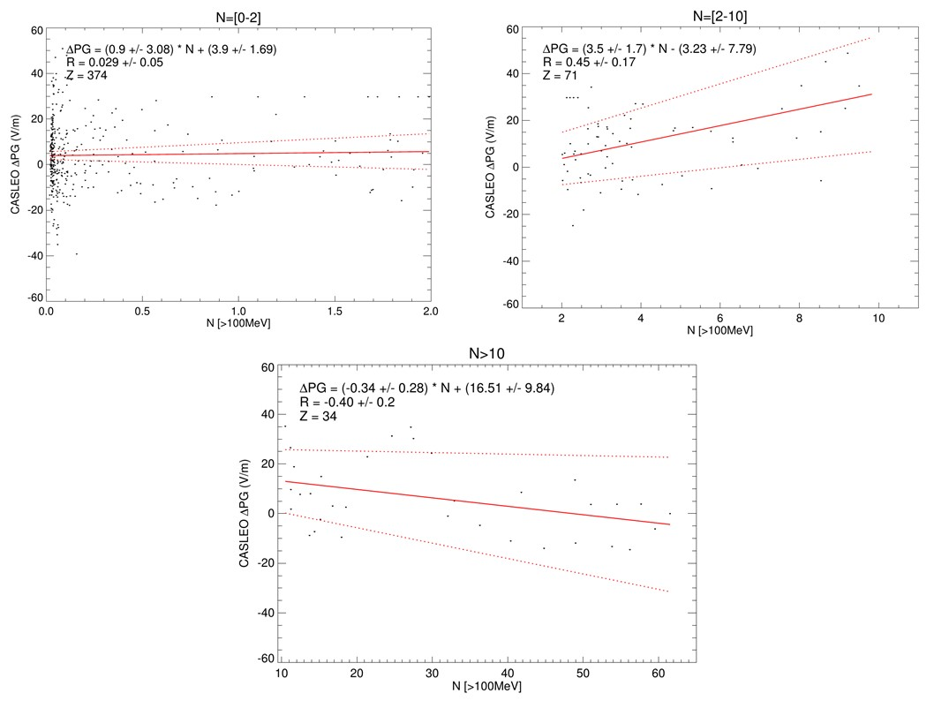

**Figure 3.** Linear regression betweenPG CASLEO hourly deviation and N (protons/(cm2.s.sr)) for energy >100MeV, for N ranges between [0,2], [2,10] and N > 10. Here, R indicates the Pearson correlation coefficient and Z is the number of points. Each parameter in the equation (slope and coefficient) and the correlation coefficient also indicate the 95% confidence interval. Red dotted lines indicate the 95% confidence interval.

As we have done for PG CASLEO, Figure 4 shows the result of the superposed epoch analysis applied to the PG SWIDER deviations (black line). Eight (8) SPEs have been analyzed. The error bars represent one standard error of the mean. As in Figure 1, each gray line is the result of applying the superposed epoch analysis using random starting times for the SPE events (30000 iterations). The solid red line is the average of these 30000 iterations and the dashed red lines are +/- 2.5 σ of the average. We do not observe any significant PG deviation after the start of SPEs.

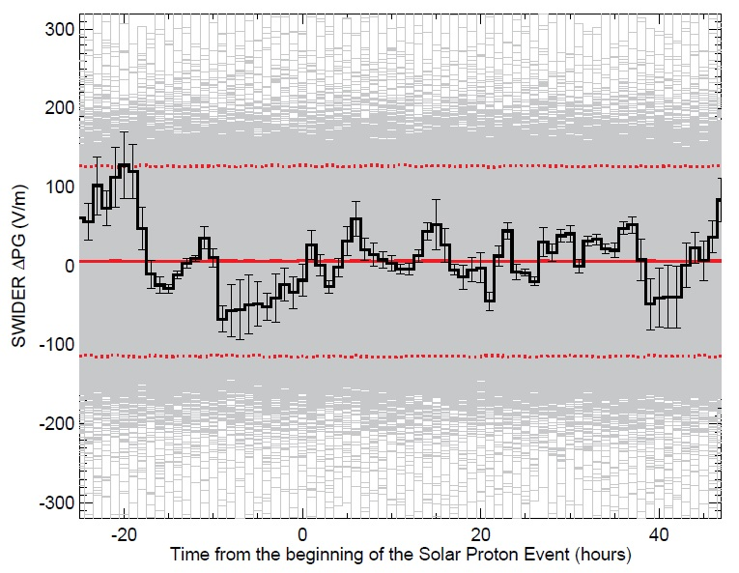

**Figure 4.** Superposed epoch analysis of the PG SWIDER response to SPE (black curve). The grey lines shows the result of 30000 iterations doing the average of the 8 events with different starting times. The solid red line is the average of the iterations and the dashed red lines represent +/- 2.5 σ.

**4.2 Potential Gradient Response to Forbush Decreases**

Figure 5 and 6 show the results of the SEA applied to the PG CASLEO and PG SWIDER deviations (black line in both cases), respectively, during FD events. As we have done before for SPEs, the time zero represents the starting time of the FD. Figures illustrate 18 events for CASLEO and 15 events for SWIDER, since the number of detected events at a given place depends on fair-weather conditions. Features of the FDs are described in the Appendix B. The error bars represent one standard error of the mean. Each gray line is the result of the superposed epoch analysis choosing FDs random starting times (30000 iterations). The solid red line is the average of these 30000 iterations, and the dashed red lines are +/- 2.5 σ of the average (99% confidence level). No significant PG deviation is observed.

Figures 7, 8 and 9, show individual analysis for three very pronounced FDs that occurred during: 21-27 of June 2015 (MagnM>10.4%), 12-18 of July 2012 (MagnM>8.2%) and 15-21 of July 2017 (MagnM>6.7%), respectively. Each figure shows the daily variation of the Dst (black curve) and Kp (red curve) index in the first panel from the top. Second panels show the relative (to the daily mean) variation of the cosmic ray fluxes detected in three neutron monitor stations: Oulu (blue curve), LMKS (Slovakia, red curve) and MXCO (Mexico, black curve). In these figures, Rc indicates the geomagnetic rigidity cutoff in each station. Additionally, the solar proton fluxes above 100 MeV (green curve) are plotted. The third panels (from the top) show the cosmic ray flux (in counts per 500 milliseconds) detected by the CARPET monitor (installed at CASLEO, Rc=9.8GV). The PG CASLEO daily variation and the PG CASLEO monthly standard curve is shown in the fourth panels (black curve and gray curve, respectively). The error bar indicates +/- 1 σ. Bottom panels show the PG CASLEO deviation. In Figures 7 and 8, the PG SWIDER deviation is also shown (red curve) in the bottom panels. Gaps in the PG variation indicate the absence of fair-weather conditions and these PG values were removed, as explained in the methodology section.

The FD that occurred between 21 and 27 of June 2015 (Figure 7), was associated with an intense geomagnetic storm, where the Dst index reached its minimum on June 23th at ~4UT (Dst = -200 nT, Kp = 8). A similar temporal behavior is observed when comparing the cosmic ray flux detected in the three neutron monitors and the CARPET detector, all showing two pronounced minima. The first minimum occurred at the same time as the minimum Dst, and the second minimum was observed on June 25th at ~0UT. There is a large variability observed in the PG CASLEO values, around +/- 30 %, but there is a sustainable increase of the PG CASLEO values specially for June 23th, which coincides in time with the first minimum on the cosmic ray flux and minimum Dst index. No significant change of the PG CASLEO values is observed during the second minimum. For PG SWIDER, most of the first pronounced minimum on June 23th was outside fair weather conditions, and no significant variation is observed during the second minimum.

The FD that occurred between 12 and 18 of July 2012 (Figure 8) was also associated with an intense geomagnetic storm, where the Dst index reached its minimum on July 15th at ~16UT (Dst = -139 nT, Kp=7). There is a broad minimum observed in the NM during 15 and 16 of July and for the CARPET detector there is a clear minimum at the end of July 15th and start of July 16th. A clear increase is detected in the PG CASLEO values, which occurred at the same time of the minimum observed in the CARPET data. Nonsignificant variation in the PG SWIDER values was observed.

On the other hand, the FD that occurred between 15 and 21 July 2017 (Figure 9) was associated with a moderate geomagnetic storm, where the Dst index reached its minimum on July 16th at ~15UT (Dst = -72 nT, Kp = 5). A minimum occurs at the end of July 16th which is detected in the three NM stations. Interestingly, the minimum in the CARPET detector is more pronounced at the start of July 17th. There is a clear increase of the PG CASLEO values at the time of the cosmic ray flux minima detected by NMs.

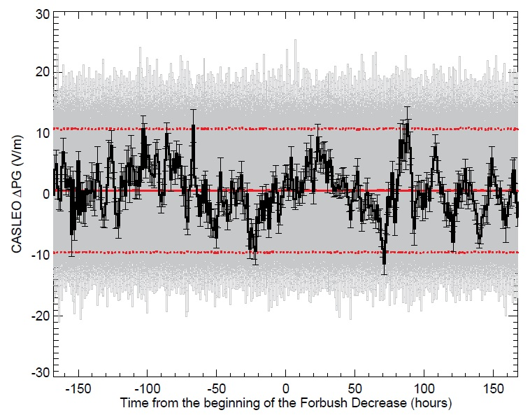

**Figure 5.** Superposed epoch analysis of the PG CASLEO deviation response to Forbush Decrease (black curve). The grey lines show the result of 1000 iterations doing the average of the X events in different times. The solid red line is the average of the iterations and the dashed red lines represent +/- 2.5 σ.

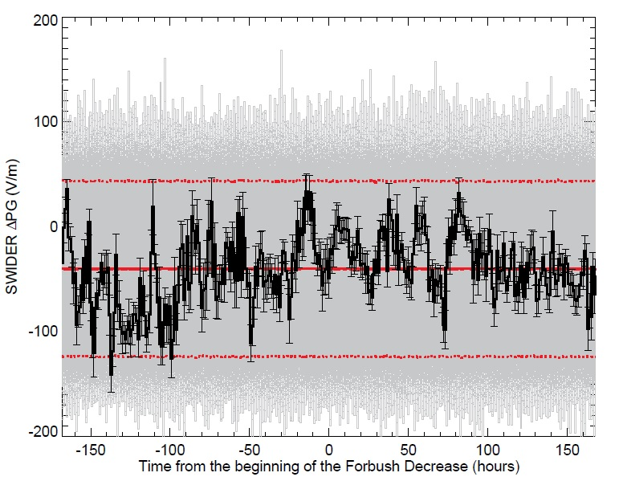

**Figure 6.** Superposed epoch analysis of the PG SWIDER deviation response to Forbush Decrease (black curve). The grey lines show the result of 1000 iterations doing the average of the X events in different times. The solid red line is the average of the iterations and the dashed red lines represent +/- 2.5 σ.

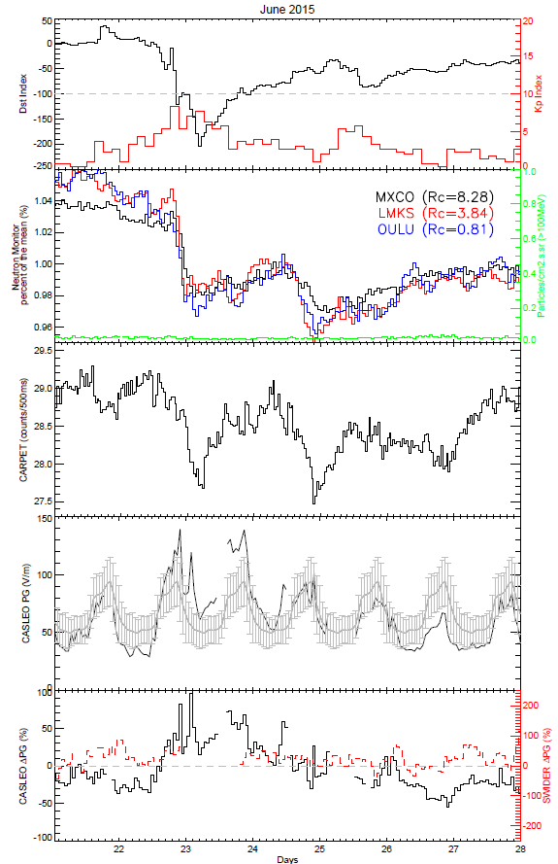

**Figure 7.** (first panel) Dst index (black curve) and Kp index (red curve) daily variation for the period between 21 and 27 June 2015. (second panel) Neutron monitor count rate enhancements at Mexico (black curve), LMKS (red curve) and Oulu (blue curve) stations. The energetic protons flux in the channel ≥100 MeV (green curve) are also shown. (third panel) Cosmic ray counting ray in the detector CARPET. (fourth panel) CASLEO PG hourly values for the day of the event (black curve) and the monthly standard curve (gray curve) with their respective error bars of +/- 1 standard deviation (+/- 1σ). (fifth panel) PG deviations for CASLEO (black curve) and SWIDER (red curve) stations. Gaps in the PG values are due to not meet fair weather conditions.

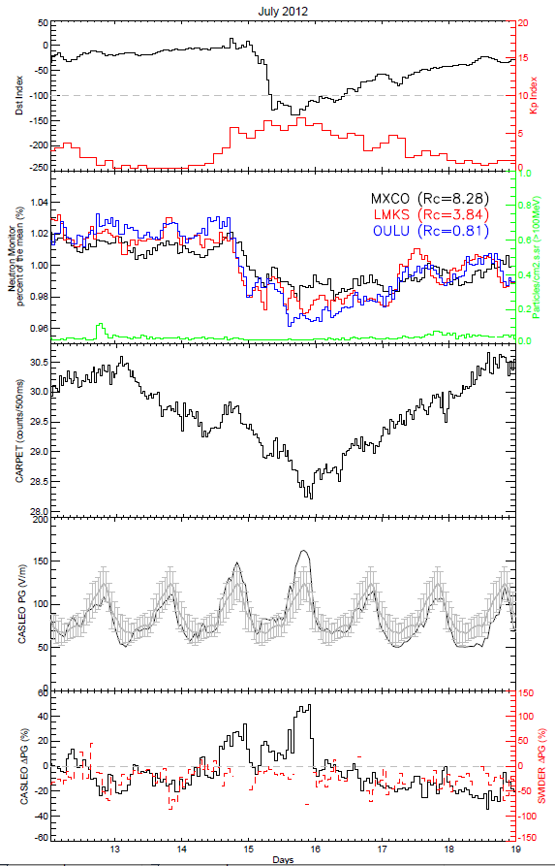

**Figure 8.** As described for Figure 7 but for the period between 12 and 18 July 2012.

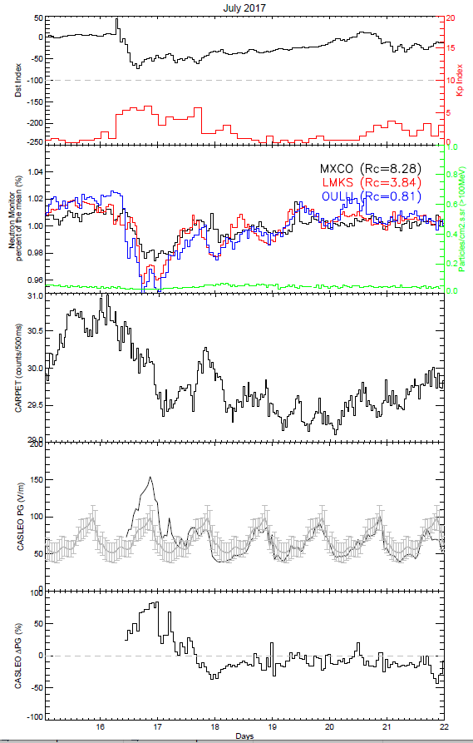

**Figure 9.** As described for Figure 7 but for the period between 15 and 21 July 2017.

**5. Discussions and Summary**

In this article, we reported the PG variation during very intense Solar Proton Events (SPE), case I, and Forbush Decrease (FD), case II. The analysis was performed for PG data, under fair weather conditions, recorded at two stations located in low and middle latitudes, and at two different altitudes: CASLEO (2550 m a.s.l.) and SWIDER (100 m a.s.l.). We applied the superposed epoch analysis in order to enhance some possible weak effects and remove the noise produced by meteorological parameters.

For case I, the results obtained show an increase of the PG values (~10V/m) after the SPE recorded at CASLEO station (Figure 1), which represents an increase of ~13% with respect to the PG mean values. It is noted that the PG increase is greater than the background variability (+/- 6V/m). Furthermore, Figure 3 indicates that the increase is directly related with the solar proton flux particles (N). When N=[0,2] there are not any changes in the PG (Pearson correlation coefficient, R~0), but when N=[2,10] a positive correlation was found with the PG (with R~0.45). PG increases associated with SPEs have been reported by other authors (e.g., Cobb, 1967; Reiter, 1971). Although it is very unlikely that SPE itself can reach the ground level (except GLEs), they can reach altitudes around ~30-40 km. In this way, Farrell and Desch (2002) proposed that SPEs can increase the electrical conductivity above thunderstorms allowing more current flows in the global electric circuit, and thus, producing an increase in the potential gradient in fair weather conditions.

On the other hand, for N>10, a negative correlation was found (R~-0.4). Only two SPEs contributed to this analysis and, moreover, these SPEs were strong enough to reach the ground level. These events were catalogued as Ground Level Enhancements (GLE 71 and GLE72). In Tacza et al. (2018), the authors showed in detail the PG analysis during GLE71, discarding any meteorological or geomagnetic effects. The authors suggested that GLE71 increased the electrical conductivity at the ground level and, by Ohm’s law, this produced a decrease of the PG. This seems also to be the case for GLE72, when any meteorological or geomagnetic effects were also discarded. Nevertheless, more GLE events are necessary to evaluate and support our hypothesis.

However, no significant PG variation was found at SWIDER station. A reason could be the very few events included in the analysis (8 events). SWIDER PG data show high variability of the background level (+/- 80V/m) and it can be hiding any SPE effect. Although SPEs effects on the PG variation have mostly been reported at locations remote from cities and elevated regions, such as mountains (Cobb, 1967; Reiter, 1971; Tacza et al., 2018), there are also reports of SPE effects on the PG close to urban sites (e.g., Nicoll and Harrison, 2014). However, air pollution in urban sites is a big problem, since aerosol particles attach to ions producing an increase on the PG values (Kubicki et al., 2016). An analysis of more SPEs at other locations can bring light on this issue.

For case II, no significant PG variation was found at CASLEO or SWIDER stations after the FD onset (Figures 5 and 6, respectively). It is worth mentioning that we chose FD with MagnM > 4 (according to the IZMIRAN database). We selected 18 events for CASLEO and 15 events for SWIDER, among which 6 and 8 events were greater than MagnM > 6 for CASLEO and SWIDER, respectively. In a previous work, Engfer and Tinsley (1999) studied PG variation recorded at Mauna Loa (3400 m a.s.l.) in association with FD events. The authors analyzed 93 FDs and didn’t found any significant PG variation. Additionally, Märcz (1997) reported the PG variation recorded at Nagycenk Observatory (Hungary, altitude: 154 m a.s.l.) during 60 FD events. The author found a PG decrease during the following 2-4 days after the FD onset. However, as reported by the author, this result is in contrast with some models which argue that intense FD events produce a decrease of the electrical conductivity profile, which increases the potential gradient and the air-Earth current at ground level (e.g., Makino and Ogawa, 1984). In earlier studies Märcz (1987) discovered an increase of SWIDER PG on the sixth day after intense solar flares compared to the monthly level which he related to after-effects in the ionospheric absorption.

In our study, individual analysis of the three larger FD events in Table 1 that occurred during 21-27 June 2015 (MagnM=10.4), 12-18 July 2012 (MagnM=8.2) and 15-21 July 2017 (MagnM=6.7), showed an increase of the PG values at CASLEO (Figures 7, 8 and 9, respectively). It agrees with the models reported. Furthermore, a decrease of the cosmic ray flux at CASLEO station was also observed, supporting the general idea that the electrical conductivity profile might also have decreased. On the other hand, there was no significant variation for PG SWIDER values (Figures 7 and 8). To this respect, it is worthwhile to mention that the PG values did not meet fair weather conditions (values were removed) during most part of the minimum observed in the cosmic rays. These results suggest that only very intense FD events can produce PG variation measured at ground levels, and this can be a reason why it was not observed using the superposed epoch analysis (many events with MagnM < 6).

This paper reports results of study of the effects of energetic particles (Solar Proton Events) and Forbush decreases on the potential gradient variation in more detail by looking at simultaneously variations recorded at two stations located at low (CASLEO) and mid (SWIDER) geographical latitudes and at different altitudes. In summary, our results confirm the SPEs influence on the PG variation recorded at ground level at a clean and high-altitude site, similar in nature to those observed by Cobb at Mauna Loa (1967) and Reiter (1969) at Zugspitze, and in the initial investigation at CASLEO (Tacza et al, 2018). Our findings support the suggestions that SPE effect is observed only at high-altitude sites (Reiter 1971, Märcz 1987). On the other hand highly-energetic charged particle effects, such as Ground Level Enhancement, and phenomena as Forbush decreases, can modulate the electrical conductivity profile producing local changes in the PG at the ground level such as observed by Märcz (1997) at Nagycenk or Kleimenova et al. (2009) at Swider for selected cases. Such an effect also emerges at CASLEO during GLE events 71 and 72. Our work is still ongoing, and future studies will focus on analysis of a larger dataset of different stations worldwide.

**Data Availability Statement**

CASLEO and SWIDER PG data, and CARPET data are available via: http://doi.org/10.5281/zenodo.5553010. Dst index, Kp index and solar proton flux were obtained from https://omniweb.gsfc.nasa.gov/form/dx1.html. Neutron monitor data were obtained from https://www.nmdb.eu/nest/. Forbush decreases list were obtained from http://spaceweather.izmiran.ru/eng/dbs.html. GLEs list were obtained from https://gle.oulu.fi/#/.

**Acknowledgments**

JT acknowledges the Polish National Agency for Academic Exchange for funding of the Ulam Program scholarship agreement no PPN/ULM/2019/1/00328/U/00001.

**Appendix A: Solar Proton Event List**

Table A1 lists the solar proton events chosen according to the criteria described in section 2. Information was obtained from ftp://ftp.swpc.noaa.gov/pub/indices/SPE.txt and ftp://ftp.swpc.noaa.gov/pub/warehouse. The two events classified as GLE were 17 May 2012 (GLE 71) and 10 September 2017 (GLE 72) (https://gle.oulu.fi/#/)

|  |  |  |  |  |  |
| --- | --- | --- | --- | --- | --- |
| **N°** | **Date** | **Start**  **(UT)** | **Particles (MeV)** | **Proton Fluence**  **(protons/cm2daysr)** | **PG station where FW was accomplished** |
| 1 | 2011/03/21 | 4 | >=100 | 8.4e + 03 | CASLEO/SWIDER |
| 3 | 2011/09/06 | 23 | >=100 | 5.0e + 03 | SWIDER |
| 4 | 2011/09/23 | 2 | >=100 | 7.7e + 03 | CASLEO |
| 5 | 2012/01/27 | 18 | >=100 | 1.6e + 05 | CASLEO/SWIDER |
| 6 | 2012/05/17 | 2 | >=100 | 3.2e + 05 | CASLEO |
| 7 | 2012/07/12 | 17 | >=100 | 3.7e + 03 | CASLEO |
| 8 | 2012/07/19 | 7 | >=100 | 1.9e + 04 | CASLEO |
| 9 | 2012/07/23 | 7 | >=100 | 2.9e + 04 | SWIDER |
| 10 | 2012/09/28 | 1 | >=100 | 5.0e + 03 | CASLEO |
| 11 | 2013/04/11 | 8 | >=100 | 7.0e + 04 | CASLEO |
| 12 | 2013/05/15 | 12 | >=100 | 2.8e + 03 | CASLEO/SWIDER |
| 13 | 2013/05/22 | 14 | >=100 | 9.4e + 04 | CASLEO |
| 14 | 2013/09/30 | 2 | >=100 | 6.5e + 03 | CASLEO/SWIDER |
| 15 | 2013/10/28 | 18 | >=100 | 4.1e + 03 | SWIDER |
| 16 | 2014/01/06 | 8 | >=100 | 9.4e + 04 | CASLEO |
| 17 | 2014/01/07 | 19 | >=100 | 6.1e + 04 | CASLEO |
| 18 | 2014/02/20 | 8 | >=100 | 2.2e + 03 | CASLEO |
| 19 | 2014/04/18 | 12 | >=100 | 1.3e + 04 | CASLEO |
| 20 | 2015/10/29 | 3 | >=100 | 4.7e + 04 | CASLEO/SWIDER |
| 21 | 2017/09/10 | 15 | >=100 | 1.1e + 06 | CASLEO |

**Appendix B: Forbush Decrease List**

Table A2 lists the Forbush decreases events chosen according to the criteria described in section 2. Information was obtained from http://spaceweather.izmiran.ru/eng/dbs.html

|  |  |  |  |  |  |  |  |
| --- | --- | --- | --- | --- | --- | --- | --- |
| **N°** | **Date – Time**  **(YY/MM/DD – HH:MM:SS UT)** | **MagnM**  (%) | **Bmax**  (nT) | **Bzmin**  (nT) | **Vmax**  (Km/s) | **Dstmin**  (nT) | **PG station where FW was accomplished** |
| 1 | 2011/06/22 - 03:00:00 | 4.4 | 10.5 | -5.3 | 661 | -26 | CAS |
| 2 | 2011/08/05 - 17:51:00 | 5.1 | 29.4 | -18.7 | 611 | -115 | CAS/SWI |
| 3 | 2011/09/26 - 12:35:00 | 5.6 | 34.2 | -16.4 | 704 | -101 | CAS |
| 4 | 2011/10/24 - 18:31:00 | 6.8 | 24 | -11.6 | 516 | -147 | SWI |
| 5 | 2012/06/16 - 20:19:00 | 4.8 | 40.1 | -16.0 | 519 | -86 | CAS/SWI |
| 6 | 2012/07/14 - 18:09:00 | 8.2 | 27.3 | -17.7 | 667 | -133 | CAS/SWI |
| 7 | 2012/11/12 - 23:11:00 | 4.5 | 22.8 | -17.5 | 454 | -109 | CAS |
| 8 | 2012/11/23 - 21:51:00 | 4.2 | 15.1 | -6.9 | 409 | -42 | CAS |
| 9 | 2013/03/17 - 05:59:00 | 5.0 | 17.8 | -14.0 | 725 | -132 | CAS/SWI |
| 10 | 2013/04/13 - 22:54:00 | 5.3 | 12.9 | -4.5 | 516 | -16 | CAS |
| 11 | 2013/06/23 - 04:26:00 | 6.0 | 7.6 | -5.0 | 697 | -49 | CAS |
| 12 | 2014/02/15 - 13:16:00 | 4.3 | 16.2 | -8.3 | 450 | -27 | SWI |
| 13 | 2014/02/27 - 16:50:00 | 5.5 | 16.6 | -12.7 | 483 | -99 | CAS/SWI |
| 14 | 2014/04/18 - 02:00:00 | 4.2 | 10.2 | -6.7 | 506 | -13 | CAS/SWI |
| 15 | 2014/06/07 - 16:52:00 | 4.5 | 26.0 | -8.7 | 616 | -38 | SWI |
| 16 | 2014/09/12 - 15:53:00 | 6.9 | 31.7 | -9.5 | 730 | -75 | SWI |
| 17 | 2014/12/21 - 19:11:00 | 7.0 | 16.7 | -15.5 | 429 | -51 | CAS |
| 18 | 2015/03/17 - 04:45:00 | 6.6 | 31.5 | -24.1 | 683 | -223 | CAS/SWI |
| 19 | 2015/06/22 - 18:33:00 | 10.4 | 37.7 | -26.3 | 742 | -204 | CAS/SWI |
| 20 | 2015/08/25 - 18:00:00 | 4.2 | 14.2 | -13.1 | 417 | -77 | SWI |
| 21 | 2015/11/06 - 18:18:00 | 4.0 | 19.4 | -10.3 | 677 | -96 | CAS |
| 22 | 2017/07/16 - 05:59:00 | 6.7 | 23.7 | -20.4 | 625 | -72 | CAS/SWI |
| 23 | 2017/09/07 - 23:00:00 | 9.3 | 27.3 | -23.6 | 821 | -142 | CAS/SWI |

**References**

Berlinski, J., Pankanin, G., Kubicki, M., 2007. Large scale monitoring of troposphere electric field. Proceedings of the 13th International Conference on Atmospheric Electricity, Beijing, China, August 13-18, 2007 (Beijing: International Conference on Atmospheric Electricity), 124-126.

Cane, H.V., 2000. Coronal Mass Ejections and Forbush Decreases. Space in Science Reviews, 93, 55.

Cobb, W. E., 1967. Evidence of a solar influence on the atmospheric electric elements at Mauna Loa observatory. Monthly Weather Review, 95(12), 905–911.

Dorman, L.I., 2004. Cosmic rays in the Earth’s Atmosphere and underground. Astrophysics and Space Science Library, Vol 303, Dordrecht: Kluwer Academic Publishers.

Elhalel, G., Yair, Y., Nicoll, K., Price, C., Reuveni, Y., Harrison, R. G., 2014. Influence of short-term solar disturbances on the fair weather conduction current. Journal of Space Weather and Space Climate, 4, A26.

Engfer, D., Tinsley, B.A., 1999. An investigation of short-term solar wind modulation of atmospheric electricity at Mauna Loa Observatory. Journal of Atmospheric and Solar-Terrestrial Physics, 61, 943-953.

Farrell, W. M., Desch, M. D., 2002. Solar proton events and the fair weather field at ground. Geophysical Research Letters, 29(9), 1323.

Gray, L.J., Beer, J., Geller, J., Haigh, J.D., Lockwood, M., Matthes, K., Cubasch, U., Fleitmann, D., Harrison, G., Hood, L., Luterbacher, J., Meehl, G.A., Shindell, D., van Geel, B., White, W., 2010. Solar influences on climate. Reviews of Geophysics, 48, RG4001.

Golubenko, K., Rozanov, E., Mironova, I., Karagodin, A., Usoskin, I., 2020. Natural sources of ionization and their impact on atmospheric electricity. Geophysical Research Letters, 47, e2020GL088619.

Harrison, R.G., Ambaum, M.H.P., 2010. Observing Forbush decreases in cloud at Shetland. Journal of Atmospheric and Solar-Terrestrial Physics, 72, 1408-1414.

Holzworth, R., Mozer, F. S., 1979. Direct evidence of solar flare modification of stratospheric electric field. Journal of Geophysical Research, 84 (A6), 2559–2566.

Holzworth, R. H., Norville, K. W., Williamson, P. R., 1987. Solar flares perturbations in stratospheric current systems. Geophysical Research Letters, 14(8), 852–855.

Imyanitov, I. M. and Chubarina, Ye.V., 1967. Electricity of free atmosphere, Technical Translation from Russian, NASA, Washington, TT F-425

Kleimenova, N., Kozyreva, O., Kubicki, M., Michnowski, S., 2009. Variations of mid-latitude atmospheric electric field (Ez) associated with geomagnetic disturbances and Forbush decreases of cosmic rays, Publs. Inst. Geophys. Pol. Acad. Sci., 412, D-73, 55-64

Kokorowski, M., Sample, J. G., Holzworth, R. H., Bering, E. A., Bale, S. D., Blake, J. B., et al., 2006. Rapid fluctuations of stratospheric electric field following a solar energetic particle event. Geophysical Research Letters, 33, L20105.

Kubicki, M., Odzimek, A., Neska, M., 2016. Relationship of ground-level aerosol concentration and atmospheric electric field at three observation sites in the Arctic, Antarctic and Europe. Atmospheric Research, 178-179, 329-346.

Lilensten, J., Dudok de Wit, T., Matthes, K., 2016. Earth’s climate response to a Changing Sun. EDP Sciences, Paris.

Poluianov, S.V., Usoskin, I.G., Mishev, A.L., Shea, M.A., Smart, D.F., 2017. GLE and Sub-GLE redefinition in the light of High-Altitude Polar Neutron Monitors. Solar Physics, 292, 176.

Makino, M., Ogawa, T., 1984. Responses of atmospheric electric field and air-earth current to variation of conductivity profiles. Journal of Atmospheric and Solar-Terrestrial Physics, 46 (5), 431-445.

Märcz, F., 1987. Atmospheric electric potential gradient following selected solar flare events, Publs. Inst. Geoph. Pol. Acad. Sci., 198, D-26, 85-96

Märcz, F., 1997. Short-term changes in atmospheric electricity associated with Forbush decreases. Journal of Atmospheric and Solar-Terrestrial Physics, 59, 9, 975-982.

Mironova, I.A., Aplin, K.A., Arnold, F., Bazilevskaya, GA., Harrison, R.G., Krivolutsky, A. A., Nicoll, K.A., Rozanov, E.V., Turunen, E., Usoskin, I.G., 2015. Energetic particle influence on the Earth’s Atmosphere. Space Science Reviews, 194: 1-96.

Nicoll, K.A., Harrison, R.G., 2014. Detection of lower tropospheric responses to solar energetic particles at midlatitudes. Physical Review Letters, 112(22), 225,001 (1-5).

Nicoll, K. A., Harrison, R. G. (2016). Stratiform cloud electrification: comparison of theory with multiple in-cloud measurements. Quarterly Journal of the Royal Meteorological Society, 142 (700), 2679–2691.

Okike, O., 2019. Investigation of Forbush Decreases and Other Solar/Geophysical Agents Associated With Lightning Over the U.S. Latitude Band and the Continental Africa. Journal of Geophysical Research: Space Physics, 124.

Okike, O., Umahi, A. E., 2019. Cosmic ray-global lightning causality. Journal of Atmospheric and Solar-Terrestrial Physics, 189, 35–43.

Reagan, J. B., Meyerott, R. E., Evans, J. E., Imhof, W. L., Joiner, R. G., 1983. The effects of energetic particle precipitation on the atmospheric electric circuit. Journal of Geophysical Research, 88(C6), 3869–3878.

Reiter R., 1969. Solar flares and their impact on potential gradient and air-Earth current characteristics at high-mountain stations, Pure Appl. Geophys. 72, 259-267

Reiter R., 1971. Further evidence for impact of solar flares on potential gradient and air-Earth current characteristics at high-mountain stations, Pure Appl. Geophys. 86, 142-158

Rycroft, M.J., Nicoll, K.A., Aplin, K.L., Harrison, R.G., 2012. Recent advances in global electric circuit between the space environment and the troposphere. Journal of Atmospheric and Solar-Terrestrial Physics, 90-91, 198–211.

Sartor, D., 1980. Electric field perturbations in terrestrial clouds and solar flare events. Monthly Weather Review, 198, 499–505.

Sheftel, V.M., Bandilet, O.I., Yaroshenko, A.N., Chernyshev, A.K., 1994. Space-time structure and reasons of global, regional, and local variations of atmospheric electricity. J. Geophys. Res. 99, D10797

Svensmark, H., Bondo, T., Svensmark, J., 2009. Cosmic ray decreases affect atmospheric aerosols and clouds. Geophysical Research Letters, 36, L15101.

Takagi, Y., Iwata, A., 1984. Solar influence on the Earth’s electric field, paper presented at seventh international conference on atmospheric electricity. Albany, NY: American Meteorological Society. Jun 4-8

Tacza, J., Raulin, J.-R., Mendonca, R.R.S., Makhmutov, V.S., Marun, A., Fernandez, G., 2018. Solar effects on the atmospheric electric field during 2010-2015 at low latitudes. Journal of Geophysical Research: Atmospheres, 123.

Tacza, J., Raulin, J.-P., Morales, C. A., Macotela, E., Marun, A., Fernandez, G., 2021. Analysis of long-term potential gradient variations measured in the Argentinian Andes. Atmospheric Research, 248, 105200.

Tinsley, B. A., Burns, G. B., Zhou, L., 2007. The role of the global electric circuit in solar and internal forcing of clouds and climate. Advances in Space Research, 40 (7), 1126-1139.

Tinsley, B.A., 2008. The global atmospheric electric circuit and its effects on cloud microphysics. Reports on Progress in Physics, 71, 6.

Todd, M.C., Kniveton, D.R., 2001. Changes in cloud cover associated with Forbush decreases of galactic cosmic rays. Journal of Geophysical Research, 106, D23, 32031-32041.

Wu, Q., Li, H., Wang, Ch., 2020. Shor-term Lightning Response to Ground Level Enhancements. Frontiers in Physics, 8:348.

1. Potential Gradient (PG) = -EZ (where EZ is the vertical atmospheric electric field).
2. According to the IGRF-13 model and 2015 epoch, calculated at WDC for Geomagnetism, Kyoto website http://wdc.kugi.kyoto-u.ac.jp/igrf/gggm/index.html
3. More precisely we use measurements of the atmospheric electric field near ground level. In the atmospheric electricity convention PG and fair-weather atmospheric electric field have the same sign.
4. MagnM: FD magnitude for particles with 10 GV rigidity, corrected on magnetospheric effect with Dst-index (http://spaceweather.izmiran.ru/dbs/fds/full-list-parameters-eng.pdf).
5. It was used the Neutron Monitor stations located at Oulu (Finland), Mexico and Lomnický štít (Slovakia).
6. GLE database (https://gle.oulu.fi/)