Figure S1. Selection of adult decedents.
AIH - authorisation for hospital admission. Records are from the reduced files of the Sistema de Informações Hospitalares; a stay is all AIHs sharing a number. Duplicate death records are AIHs of the same stay submitted again. The year of a stay is the year of discharge (death). COVID-19 codes are U07.1, U07.2 and B34.2 in any diagnosis field of any AIH of the stay.
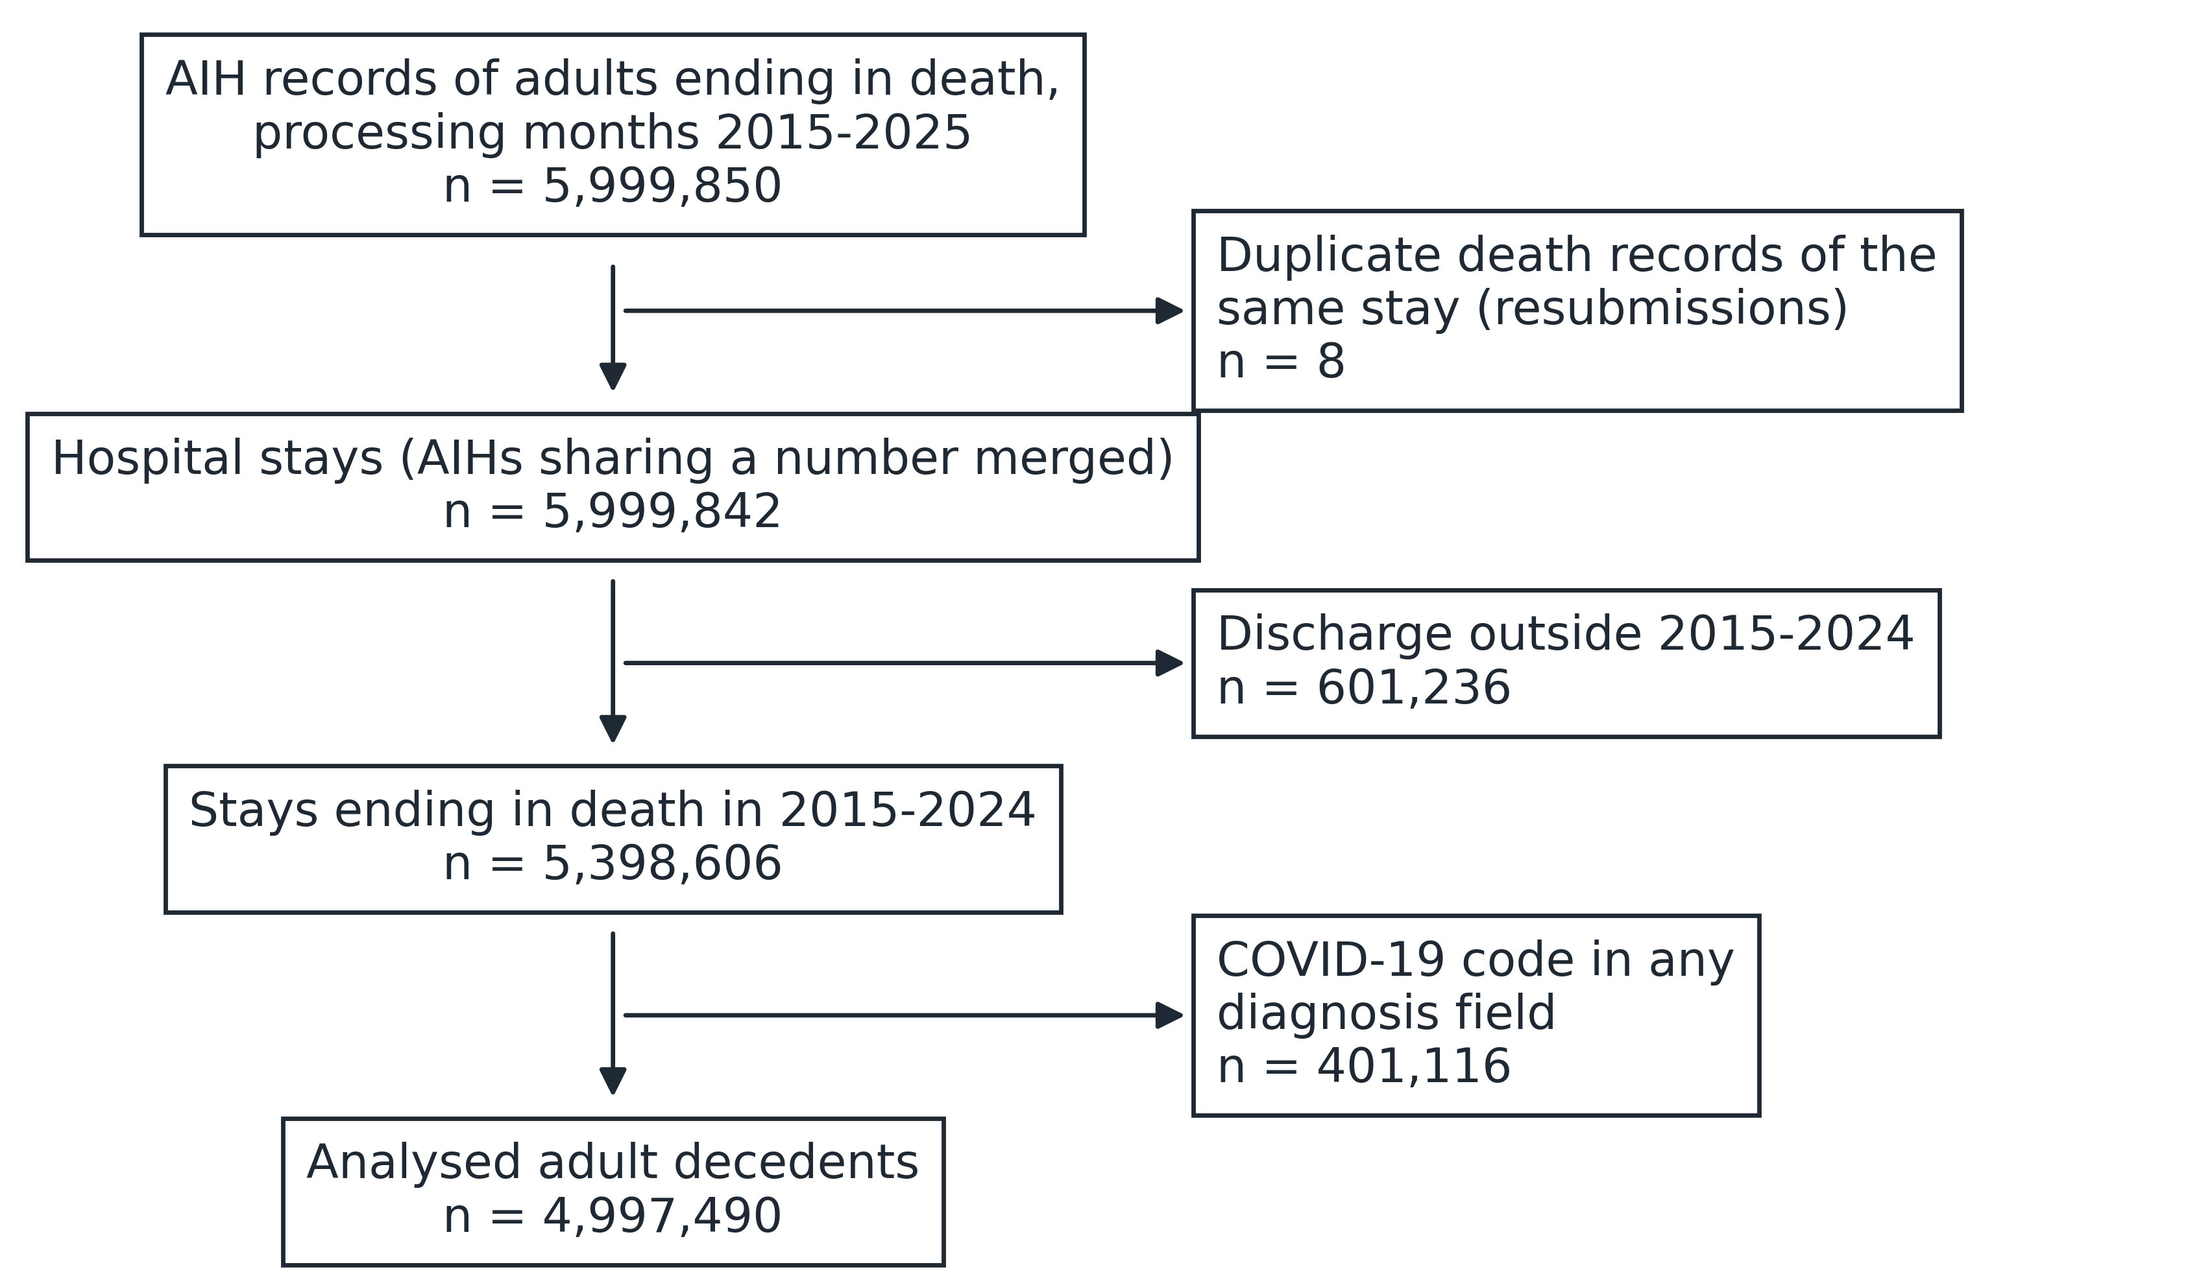
Table S1. The analysed files against the official DATASUS TabNet tabulation.
Processing year | Months | Approved AIHs, TabNet | Approved AIHs, analysed files | Admissions, TabNet | Admissions, analysed files | Deaths, TabNet | Deaths, analysed files | Months identical on all three counts | Largest monthly difference, records | Largest monthly difference, %
2015 | 12 | 11,638,853 | 11,638,853 | 11,377,716 | 11,377,716 | 475,839 | 475,839 | 12 | 0 | 0.0000
2016 | 12 | 11,527,712 | 11,527,712 | 11,297,068 | 11,297,068 | 495,250 | 495,250 | 12 | 0 | 0.0000
2017 | 12 | 11,675,269 | 11,675,269 | 11,469,861 | 11,469,861 | 491,691 | 491,691 | 12 | 0 | 0.0000
2018 | 12 | 12,000,838 | 12,000,838 | 11,816,641 | 11,816,641 | 502,992 | 502,992 | 12 | 0 | 0.0000
2019 | 12 | 12,356,283 | 12,356,283 | 12,181,726 | 12,181,726 | 525,448 | 525,448 | 12 | 0 | 0.0000
2020 | 12 | 10,688,203 | 10,688,203 | 10,532,859 | 10,532,859 | 592,523 | 592,523 | 12 | 0 | 0.0000
2021 | 12 | 11,629,002 | 11,629,005 | 11,481,939 | 11,481,942 | 768,670 | 768,670 | 10 | 2 | 0.0002
2022 | 12 | 12,520,838 | 12,520,914 | 12,377,242 | 12,377,318 | 605,535 | 605,542 | 0 | 13 | 0.0042
2023 | 12 | 13,355,585 | 13,355,814 | 13,215,017 | 13,215,246 | 588,617 | 588,636 | 0 | 31 | 0.0081
2024 | 12 | 14,170,948 | 14,171,364 | 14,037,412 | 14,037,828 | 622,189 | 622,230 | 0 | 44 | 0.0124
2025 | 12 | 14,646,926 | 14,647,505 | 14,511,714 | 14,512,292 | 630,257 | 630,308 | 0 | 72 | 0.0121
2015-2025 | 132 | 136,210,457 | 136,211,760 | 134,299,195 | 134,300,497 | 6,299,011 | 6,299,129 | 82 | 72 | 0.0124
National totals by processing month, summed to the year. Admissions are AIHs of type 1; approved AIHs include continuation AIHs of long stays. A month is identical when all three counts are equal. The largest difference is the largest of the three monthly differences, analysed files minus TabNet, in records and as a percentage of TabNet; the two need not come from the same month. For December 2020 the tabulation by place of admission is incomplete and the tabulation of the same files by place of residence was used.
Figure S2. Intensive care during the terminal admission by year and age.
Share of adult decedents with ICU care during the terminal admission (values in Table S2); the shaded band marks 2020-2021. In (A), the share for all adults changed by +0.2 percentage points a year from 2015 to 2021 and by +2.2 a year from 2021 to 2024.
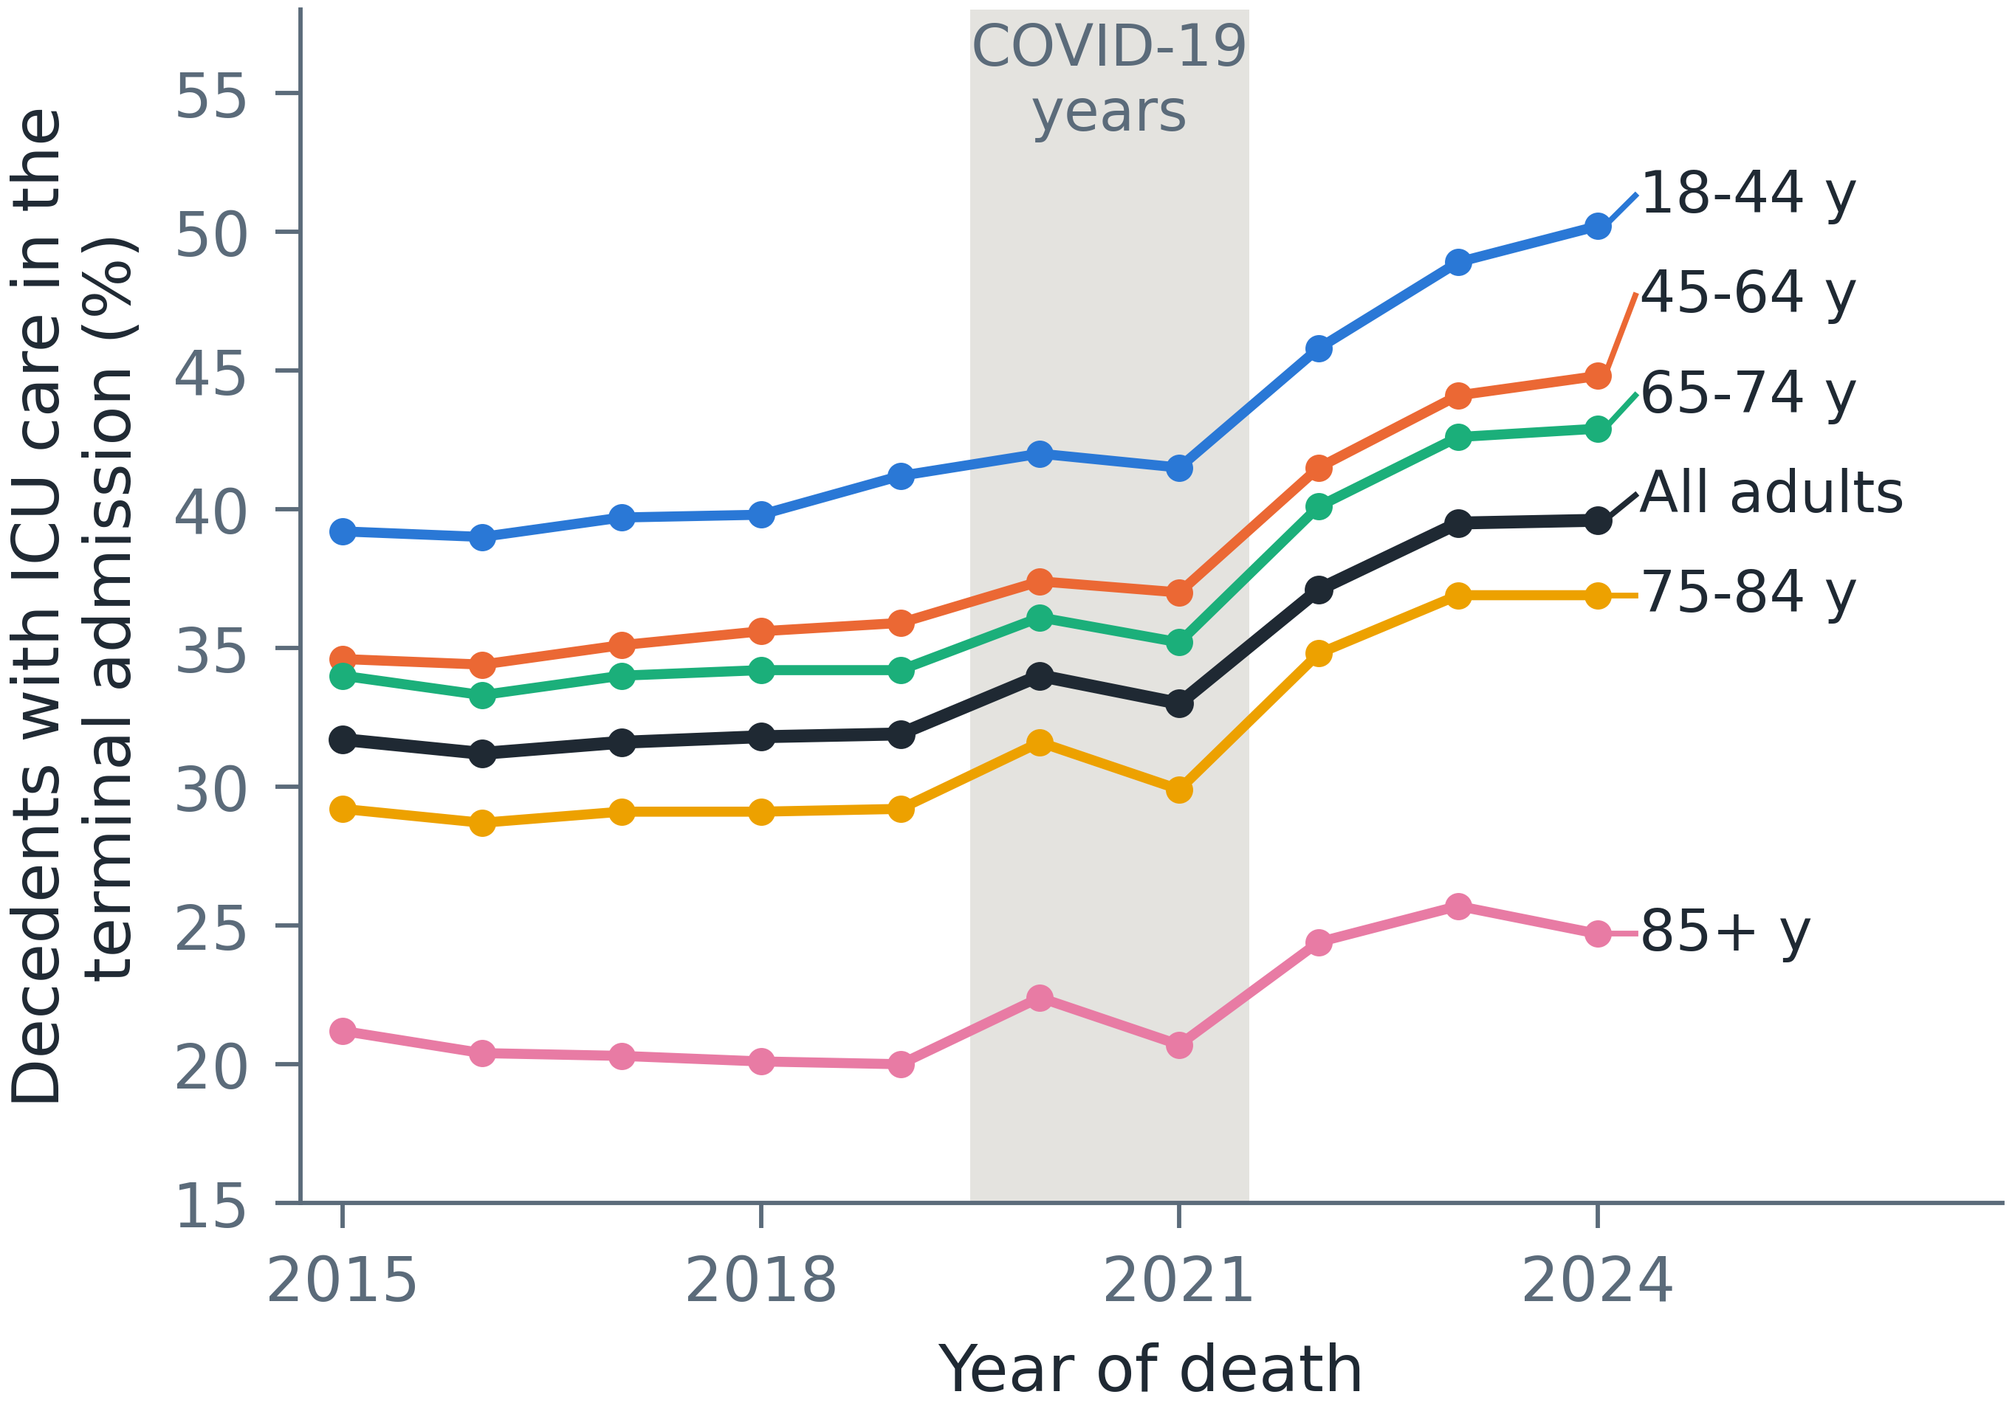
Table S2. Intensive care during the terminal admission by year and age.
Year of death | Adult decedents | All ages, % | 18-44 y, % | 45-64 y, % | 65-74 y, % | 75-84 y, % | 85+ y, %
2015 | 446,629 | 31.7 | 39.2 | 34.6 | 34.0 | 29.2 | 21.2
2016 | 464,383 | 31.2 | 39.0 | 34.4 | 33.3 | 28.7 | 20.4
2017 | 465,173 | 31.6 | 39.7 | 35.1 | 34.0 | 29.1 | 20.3
2018 | 476,992 | 31.8 | 39.8 | 35.6 | 34.2 | 29.1 | 20.1
2019 | 497,321 | 31.9 | 41.2 | 35.9 | 34.2 | 29.2 | 20.0
2020 | 465,040 | 34.0 | 42.0 | 37.4 | 36.1 | 31.6 | 22.4
2021 | 488,010 | 33.0 | 41.5 | 37.0 | 35.2 | 29.9 | 20.7
2022 | 541,738 | 37.1 | 45.8 | 41.5 | 40.1 | 34.8 | 24.4
2023 | 557,962 | 39.5 | 48.9 | 44.1 | 42.6 | 36.9 | 25.7
2024 | 594,242 | 39.6 | 50.2 | 44.8 | 42.9 | 36.9 | 24.7
Values plotted in Figure S2. Percentages are of adult decedents in each year and age group.
Figure S3. Intensive care during the terminal admission by principal diagnosis and age.
Share of adult decedents with ICU care, by ICD-10 chapter of the principal diagnosis of the terminal admission (ordered by number of deaths) and age at death, 2015-2024.
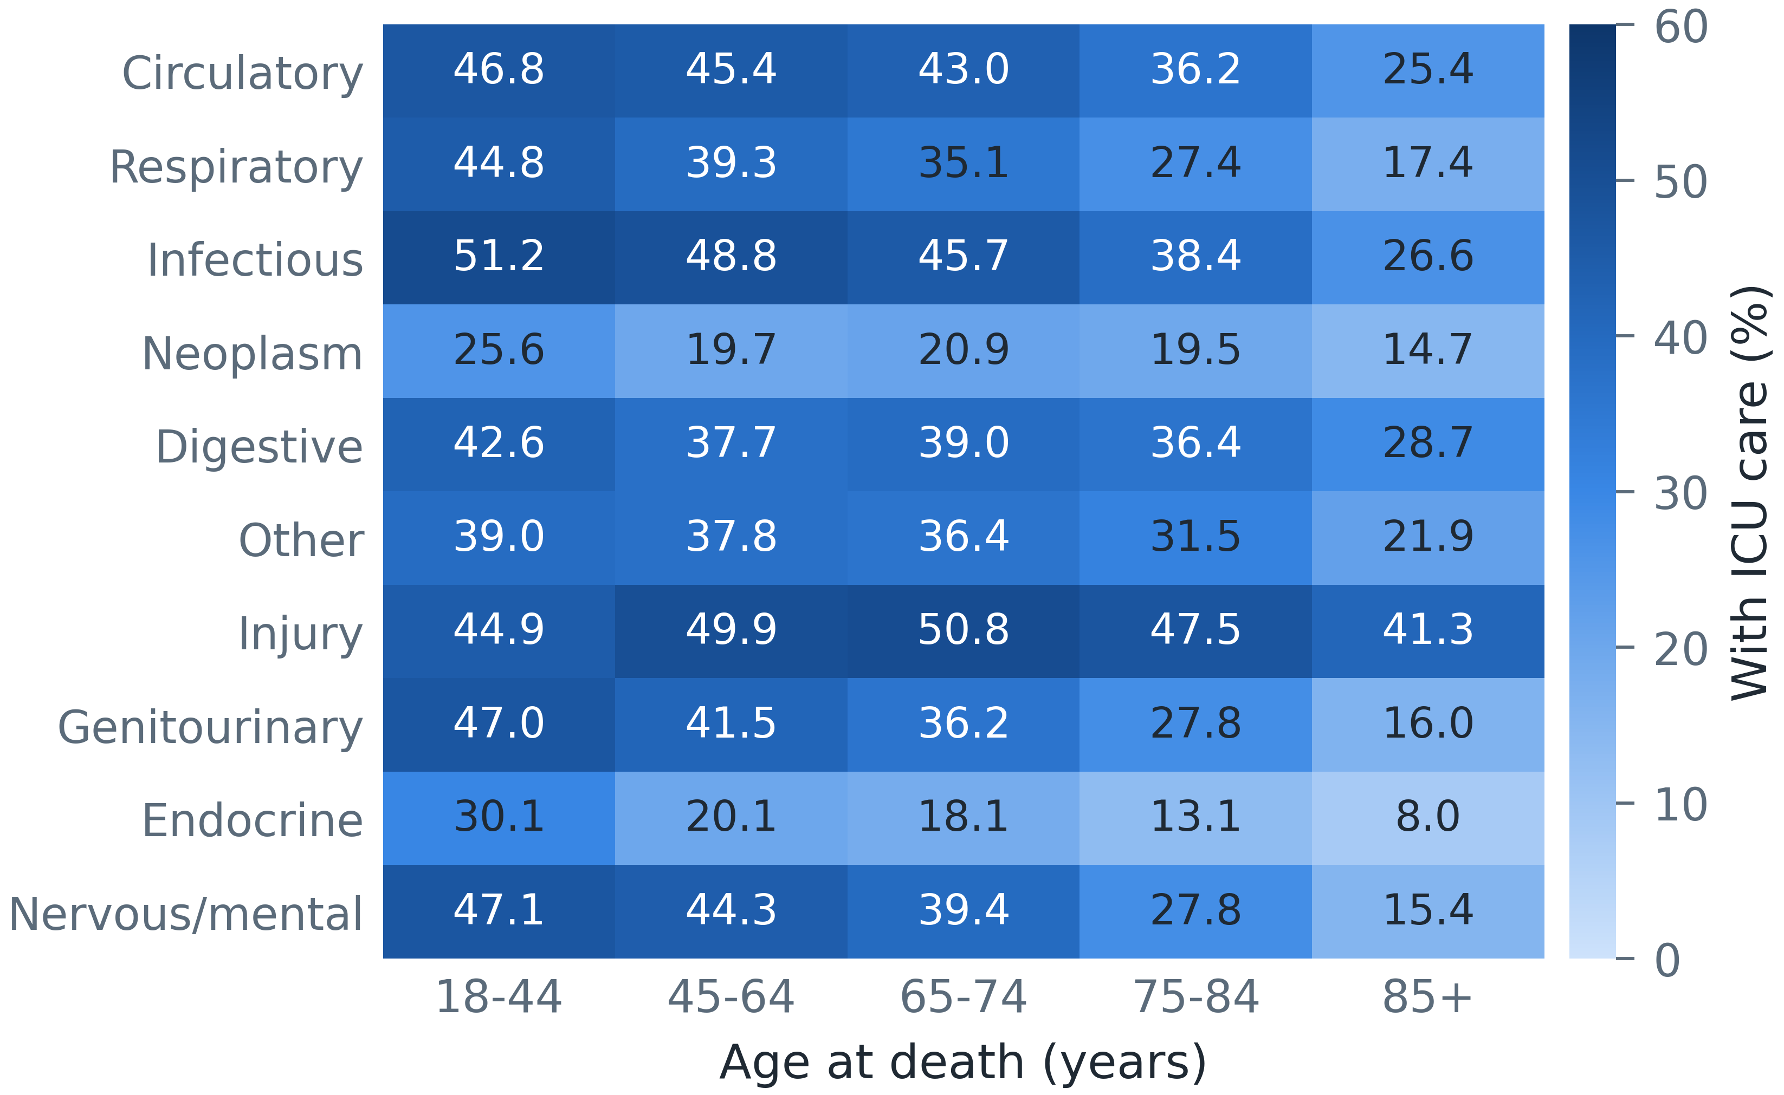
Table S3. Intensive care during the terminal admission by state.
State | Region | Adult decedents | With ICU care, crude % | Observed/expected (95% CI) | Standardised % | Died in a hospital without ICU billing, %
DF | Centre-West | 60,904 | 21.5 | 0.61 (0.60-0.62) | 21.1 | 16.0
GO | Centre-West | 121,084 | 47.3 | 1.36 (1.35-1.37) | 46.7 | 20.8
MS | Centre-West | 68,076 | 41.8 | 1.25 (1.23-1.26) | 42.9 | 13.9
MT | Centre-West | 62,970 | 39.6 | 1.12 (1.10-1.13) | 38.5 | 24.5
AC | North | 14,221 | 20.8 | 0.56 (0.54-0.58) | 19.3 | 16.9
AM | North | 55,157 | 24.5 | 0.65 (0.64-0.66) | 22.5 | 16.0
AP | North | 9,132 | 13.9 | 0.37 (0.35-0.39) | 12.8 | 32.5
PA | North | 108,034 | 38.0 | 1.06 (1.05-1.07) | 36.5 | 26.6
RO | North | 32,666 | 39.9 | 1.12 (1.10-1.14) | 38.7 | 23.8
RR | North | 10,010 | 18.7 | 0.54 (0.51-0.56) | 18.4 | 9.5
TO | North | 25,915 | 24.5 | 0.73 (0.71-0.74) | 25.0 | 18.7
AL | Northeast | 63,216 | 38.6 | 1.09 (1.07-1.10) | 37.4 | 5.7
BA | Northeast | 294,542 | 29.0 | 0.85 (0.84-0.85) | 29.2 | 29.3
CE | Northeast | 187,377 | 27.8 | 0.80 (0.80-0.81) | 27.7 | 24.3
MA | Northeast | 103,374 | 36.3 | 0.99 (0.98-1.00) | 34.1 | 25.6
PB | Northeast | 87,558 | 40.1 | 1.20 (1.19-1.21) | 41.4 | 16.2
PE | Northeast | 230,497 | 30.9 | 0.86 (0.85-0.86) | 29.5 | 12.4
PI | Northeast | 62,393 | 28.1 | 0.80 (0.79-0.81) | 27.6 | 24.6
RN | Northeast | 62,804 | 31.2 | 0.89 (0.88-0.90) | 30.7 | 21.4
SE | Northeast | 45,278 | 22.1 | 0.64 (0.63-0.65) | 22.0 | 25.5
PR | South | 335,451 | 49.6 | 1.44 (1.43-1.45) | 49.6 | 12.3
RS | South | 386,068 | 31.9 | 0.96 (0.95-0.96) | 33.0 | 20.7
SC | South | 204,672 | 31.9 | 0.96 (0.96-0.97) | 33.2 | 16.9
ES | Southeast | 94,460 | 40.1 | 1.22 (1.20-1.23) | 41.8 | 13.1
MG | Southeast | 574,958 | 42.1 | 1.26 (1.26-1.27) | 43.4 | 19.6
RJ | Southeast | 478,081 | 25.4 | 0.71 (0.71-0.71) | 24.4 | 26.5
SP | Southeast | 1,218,592 | 33.4 | 0.98 (0.98-0.98) | 33.7 | 12.0
Expected counts come from the logistic model without geography. A hospital without ICU billing is a facility that billed no adult ICU day to the Sistema Único de Saúde in that year. States are identified by their two-letter abbreviations.
Figure S4. Standardised share of decedents with intensive care during the terminal admission, by state.
Standardised for age, sex, principal diagnosis, admission type and year (values in Table S3). State boundaries from IBGE.
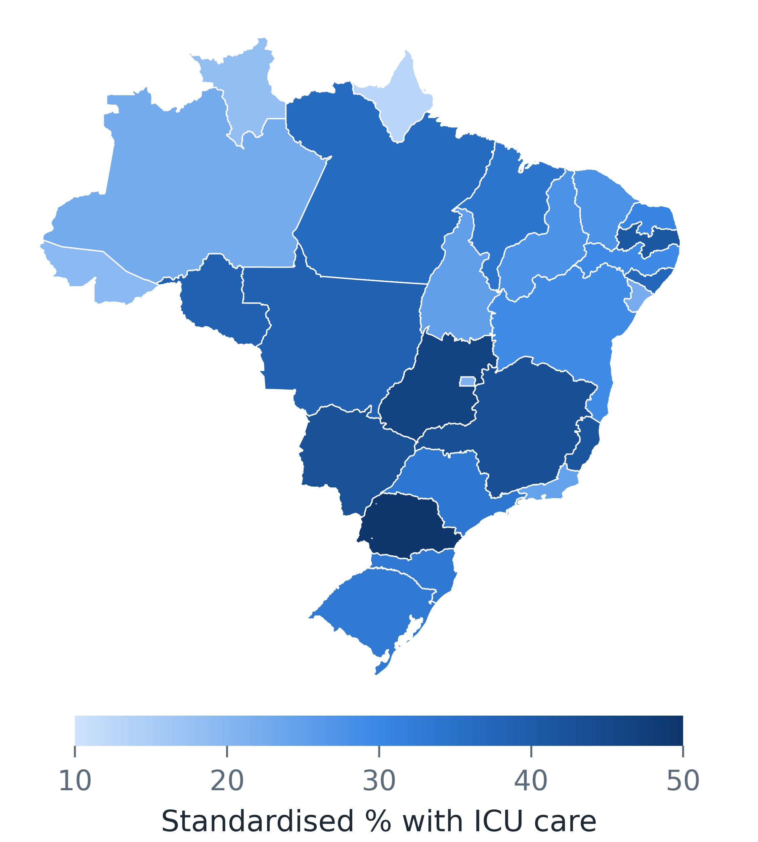
Table S4. Spread of intensive care during the terminal admission between hospitals within each state.
State | Hospitals | Observed/expected ratio, 10th percentile | Observed/expected ratio, 90th percentile | Ratio of 90th to 10th percentile
AL | 20 | 0.88 | 1.78 | 2.0
BA | 65 | 0.50 | 1.90 | 3.8
CE | 43 | 0.46 | 1.86 | 4.0
DF | 16 | 0.25 | 2.17 | 8.7
ES | 30 | 0.64 | 1.73 | 2.7
GO | 48 | 0.81 | 2.18 | 2.7
MA | 37 | 0.61 | 1.83 | 3.0
MG | 151 | 0.68 | 1.84 | 2.7
MS | 19 | 0.81 | 1.72 | 2.1
MT | 22 | 0.63 | 1.72 | 2.7
PA | 35 | 0.75 | 2.01 | 2.7
PB | 29 | 0.59 | 1.93 | 3.3
PE | 51 | 0.30 | 2.27 | 7.6
PI | 15 | 0.39 | 1.76 | 4.5
PR | 79 | 0.96 | 1.94 | 2.0
RJ | 101 | 0.12 | 1.74 | 14.5
RN | 25 | 0.54 | 2.18 | 4.0
RO | 12 | 0.45 | 2.19 | 4.9
RS | 91 | 0.38 | 1.39 | 3.7
SC | 49 | 0.61 | 1.47 | 2.4
SP | 252 | 0.48 | 1.57 | 3.3
The 21 states with at least 10 hospitals meeting the criteria of Figure 2. Percentiles are of the hospitals' observed/expected ratios. Median ratio of 90th to 10th percentile across these states, 3.3.
Table S5. Deaths in hospitals without intensive care billing, by age.
Age, years | Adult decedents | With ICU care, % | Died in a hospital without ICU billing, % | With ICU care among deaths in hospitals with ICU billing, %
18-44 | 491,588 | 42.8 | 12.4 | 48.8
45-64 | 1,379,863 | 38.2 | 14.1 | 44.5
65-74 | 1,176,929 | 37.1 | 16.4 | 44.4
75-84 | 1,175,355 | 31.8 | 21.3 | 40.4
85+ | 773,755 | 22.2 | 27.9 | 30.8
All adults | 4,997,490 | 34.4 | 18.3 | 42.1
A hospital without ICU billing is a facility that billed no adult ICU day to the Sistema Único de Saúde in the year of death.
Table S6. Adult intensive care funded by the Sistema Único de Saúde spent in stays that ended in death, 2015-2024: stays, days and payments.
Year | Hospitals billing adult ICU care | Adult ICU stays | Ending in death, % | ICU days | In stays ending in death, % | ICU payments, BRL million, nominal | In stays ending in death, % (nominal) | ICU payments, BRL million, December 2024
2015 | 986 | 547,824 | 25.9 | 3,486,095 | 32.9 | 1,817.3 | 32.8 | 2,993.9
2016 | 1,001 | 564,167 | 25.7 | 3,587,182 | 32.8 | 1,874.2 | 32.7 | 2,839.4
2017 | 1,012 | 593,633 | 24.8 | 3,712,842 | 31.9 | 1,945.0 | 31.8 | 2,848.5
2018 | 1,019 | 621,527 | 24.4 | 3,826,255 | 31.8 | 2,013.5 | 31.6 | 2,844.7
2019 | 1,034 | 673,350 | 23.6 | 4,027,737 | 31.3 | 2,124.3 | 31.1 | 2,893.0
2020 | 1,260 | 640,748 | 24.7 | 3,815,705 | 32.0 | 2,150.2 | 32.4 | 2,837.2
2021 | 1,414 | 645,378 | 25.0 | 3,915,421 | 32.3 | 2,378.7 | 33.3 | 2,898.3
2022 | 1,340 | 834,150 | 24.1 | 5,350,019 | 31.8 | 3,474.0 | 31.7 | 3,873.2
2023 | 1,241 | 951,607 | 23.1 | 6,004,443 | 31.1 | 3,959.3 | 30.9 | 4,220.6
2024 | 1,250 | 1,027,821 | 22.9 | 6,409,409 | 31.1 | 4,230.4 | 30.9 | 4,320.5
2015-2024 | - | 7,100,205 | 24.2 | 44,135,108 | 31.8 | 25,967.0 | 31.7 | 32,569.3
ICU - intensive care unit; BRL - Brazilian real. ICU payments are the ICU component of the hospital bill (VAL_UTI), as billed (nominal) and converted to December 2024 reais with the mean IPCA consumer price index of each year (IBGE). Hospitals billing adult ICU care are facilities with at least one adult ICU day billed in the year. Stays with a COVID-19 code are excluded. Within each year the share of payments in stays ending in death is the same in nominal and deflated values; over 2015-2024 it was 31.8% of deflated payments. Stays are counted in each year in which they have an ICU billing record, so a stay whose ICU billing spans two years is counted in both: 33 stays in the 2015-2024 total, 17 of them ending in death (hence 17 more than the decedents with ICU care in Table 1).
Figure S5. Adult ICU stays billed and hospitals billing adult ICU care, 2015-2024.
Each series indexed to 2015 = 100 (values in Table S6); the shaded band marks 2020-2021. Stays with a COVID-19 code are excluded.
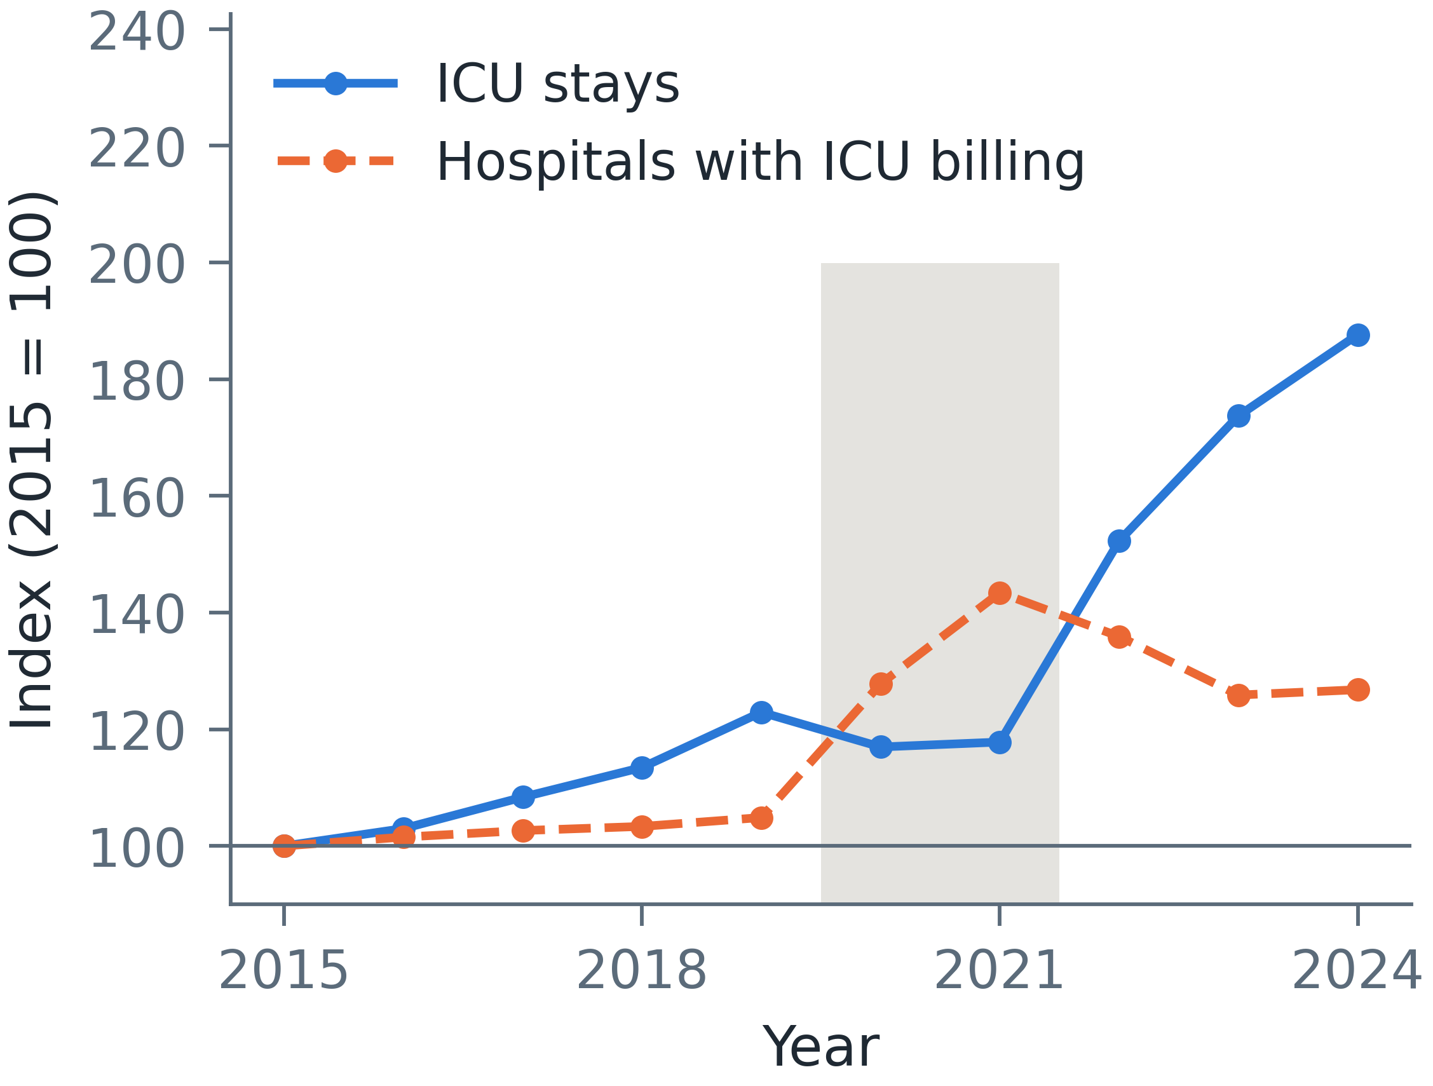
Figure S6. Care received in urgent admissions for the four conditions by distance to the nearest hospital with ICU billing.
Distance from the seat of the municipality of residence to the nearest municipal seat with a hospital with ICU billing (0 km: such a hospital in the patient's own municipality). (A) Admissions with at least one ICU day billed, by condition (values in Table S7). (B) Admissions to a hospital without ICU billing and discharges by transfer to another hospital (values in Table 3).
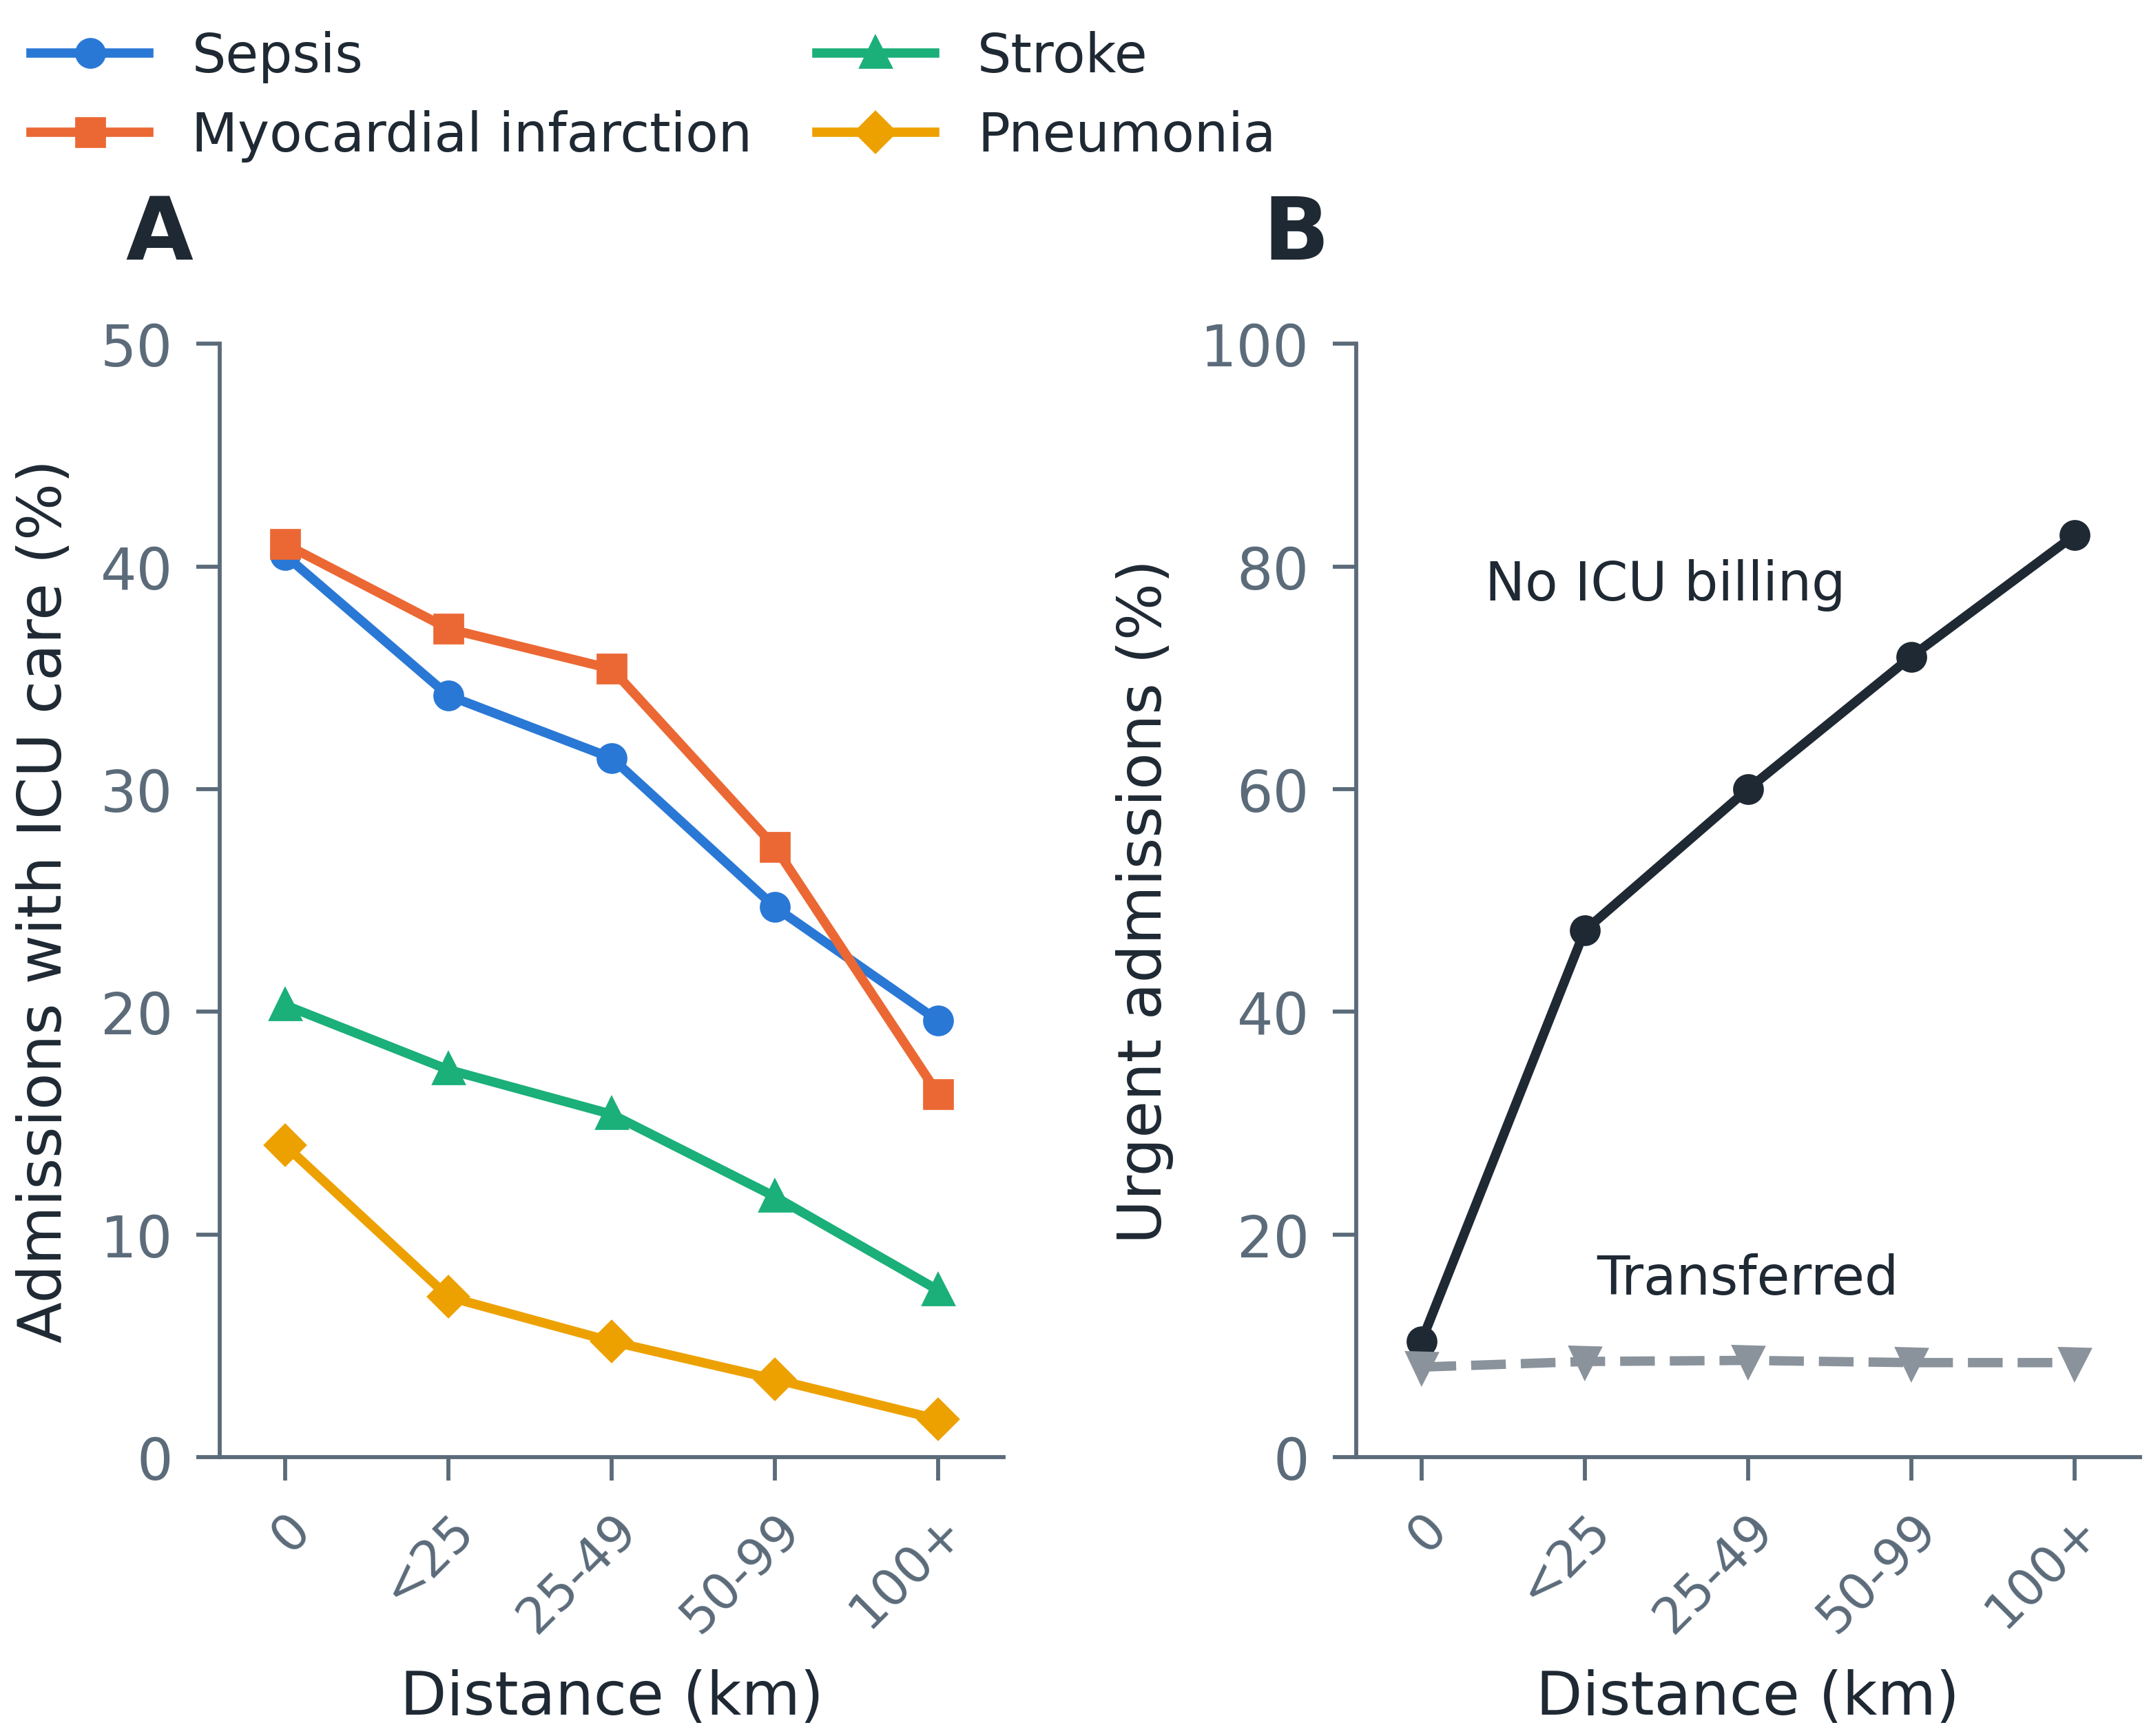
Table S7. Intensive care during urgent admissions by condition and distance to the nearest hospital with ICU billing.
Group | 0 (own municipality), % (n) | <25 km, % (n) | 25-49 km, % (n) | 50-99 km, % (n) | 100+ km, % (n)
ICU care during the admission
Sepsis | 40.5 (746,239) | 34.2 (153,474) | 31.4 (125,344) | 24.7 (70,457) | 19.6 (21,946)
Pneumonia | 14.0 (1,647,489) | 7.2 (535,534) | 5.2 (639,338) | 3.5 (476,386) | 1.7 (238,916)
Stroke | 20.3 (1,246,726) | 17.4 (283,638) | 15.4 (267,704) | 11.7 (191,888) | 7.5 (90,838)
Myocardial infarction | 41.0 (793,395) | 37.2 (164,898) | 35.4 (137,488) | 27.4 (88,275) | 16.3 (38,160)
Died in hospital (all four) | 39.0 (1,002,962) | 31.8 (217,418) | 29.7 (189,834) | 24.8 (118,993) | 16.5 (45,975)
Percentages with the number of admissions. ICU care is at least one ICU day billed; the row 'Died in hospital (all four)' is restricted to admissions for any of the four conditions that ended in death in hospital.
Table S8. Sensitivity analyses of the primary estimate.
Analysis | Adult decedents | With ICU care, %
Primary (2015-2024, COVID admissions excluded) | 4,997,490 | 34.4
Excluding 2020-2021 entirely | 4,044,440 | 34.6
Stays billed on a single AIH (IDENT 1 death record) | 4,984,529 | 34.5
ICU defined by ICU days or any ICU type code | 4,997,490 | 34.4
Hospitals with ICU billing that year only | 4,081,956 | 42.1
Stays of 2 days or longer | 3,951,436 | 38.0
The primary analysis counts a stay as receiving intensive care if any of its AIHs billed at least one ICU day. Stays shorter than 2 days were 20.9% of adult decedents.
Figure S7. Sensitivity analyses of the primary estimate.
Share of adult decedents with ICU care during the terminal admission under each definition in Table S8; the dashed line is the primary analysis.


