BANJAXED
A Game of Magnificent Contraptions and Spectacular Failure
First Edition Rules — Version 1.0

2–5 Players | 45–90 Minutes | Ages 10+

You are an eccentric inventor of questionable genius. Your rivals are worse. Build the most elaborate mechanism imaginable to complete your secret Blueprint — but beware: every spring, cog, and cable you add is another point of catastrophic failure waiting to happen. And your rivals will ensure you never stop adding them.

1. What's In The Box

Component Cards (110 cards) — The building blocks of every mechanism. Springs, gears, pistons, cables, and more. Includes 10 Widget wildcards.
Spanner Cards (10 cards) — Action cards. Play at any time from your hand to destroy a component, fix a component, or reduce a Tolerance dial. See the Spanners in the Works expansion rules.
Blueprint Cards (30 cards) — Your secret mission. Each describes a machine to build and a task it must accomplish.
Banjax Dice (15 dice) — Custom six-sided dice rolled after every Build Phase. You need one per upright component in your mechanism.
Tolerance Dials (5) — Personal dials numbered 1–12 tracking how close your machine is to catastrophic collapse.
Player Blueprints (5) — The personal tableau in front of each player where component cards are physically arranged.
Reference Cards (5) — Per-player quick reference of die faces, Tolerance thresholds, and turn structure.
This Rulebook. — You are reading it.

2. The Premise

Players are eccentric inventors racing to complete Blueprint Cards using increasingly unwieldy contraptions. Every component added to your mechanism makes it more powerful and more fragile simultaneously. Other players can gift you components you never asked for, sabotaging your machine with weaponised generosity.
The game ends when one player completes 2 Blueprints, or when the draw pile is exhausted — at which point the player with the highest cumulative score wins.

3. Setup

- Shuffle all 110 Component Cards (including Widgets) and all 10 Spanner Cards together into the draw pile and place it face-down in the centre of the table.
- Shuffle all 30 Blueprint Cards. Deal 2 to each player face-down. Each player reads both privately, keeps 1, and returns the other face-down to the bottom of the Blueprint deck. Players keep their chosen Blueprint secret.
- Each player draws 4 Component Cards to form their starting hand.
- Each player sets their Tolerance Dial to 3.
- The player who most recently broke something valuable goes first.

4. Turn Structure

Each round has a simultaneous Draft Phase, followed by individual Build, Banjax Roll, and Repair phases resolved in clockwise order.

Phase 1 — Draft (Simultaneous)
All players draw 2 Component Cards from the top of the draw pile at the same time. Each player keeps 1 and passes the other face-up to their immediate left or right neighbour — their choice. The recipient must add the gifted card to their mechanism immediately, subject to the polarity and placement rules below.
Retrieval (optional): Once per Draft Phase, each player may remove one upright card from their mechanism and return it to their hand. This can be done before or after keeping and gifting. The retrieved card carries its edge configuration with it and must be legally placed again if replayed.
A card may only be retrieved if removing it leaves every remaining card in the mechanism with at least one edge-adjacent neighbour — the mechanism must stay physically connected. You cannot retrieve a card that acts as the only bridge between two parts of your mechanism. A two-card mechanism cannot have either card retrieved. Upside-down cards cannot be retrieved.
Gifting is never neutral. You are choosing which copy of a card to keep and which to pass, which neighbour receives it, and which edge configuration they have to deal with. Retrieval adds another layer: a card you pull back into hand can be replayed elsewhere, or held to deny it from your opponents as a gift.

Phase 2 — Build
In clockwise order, each player plays 1 to 3 Component Cards from their hand onto their Blueprint tableau. Each card played raises their Tolerance dial by the card's Tolerance cost. Polarity rules and Placement Conditions must be satisfied, or the Bodge rule applied (see Section 6).
You must play at least 1 card if you have any in hand. If your hand is empty, draw 1 card and play it immediately.

The 13-Component Limit
At the start of your Build Phase, if your mechanism contains 13 or more components (upright and upside-down combined), you must immediately declare Complete — or collapse.
Declare: If your upright components satisfy your Blueprint, declare Complete and score normally (see Section 9).
Collapse: If you cannot satisfy your Blueprint, you collapse immediately — all upside-down components are discarded, upright components survive, Tolerance resets to 3, and you draw a new Blueprint. The 13-component check happens before you play any cards that turn.
This limit also applies mid-round: if a gifted card or a Eureka card pushes your mechanism to 13, the same forced declaration or collapse triggers at the start of your next Build Phase. There is no grace period and no exception.

Phase 3 — The Banjax Roll
After building, each player in clockwise order rolls one Banjax Die per upright component in their mechanism. Upside-down components do not add dice — they contribute nothing, including to the roll. Resolve all dice:

Blank (3 faces) No effect.
Wobble (2 faces) +1 to your Tolerance dial.
Eureka! (1 face) Draw 2 cards from the top of the deck. Immediately play 1 onto your Blueprint (obeying all polarity and placement rules, or Bodging). Return the other to the top or bottom of the deck. If playing the card pushes your mechanism to 13, the forced declaration or collapse triggers at the start of your next Build Phase. Resolve multiple Eurekas one at a time.

Tolerance Thresholds:
- Tolerance 7–8: Disadvantage — all Blank results become Wobbles instead.
- Tolerance 9–11: Every Wobble result becomes a Banjax.
- Tolerance 12 — Collapse! All upside-down components are discarded. Upright components survive — they stay in your mechanism. Reset Tolerance Dial to 3. Discard your Blueprint and draw a new one. You are not eliminated — you are merely humbled.

What is a Banjax? When a Banjax result occurs, the rolling player chooses one of their own upright components and flips it upside-down. An upside-down component contributes nothing to Blueprint completion until repaired.

Phase 4 — Repair (Optional)
Each player may discard 1 card from their hand to do one of the following:
- Flip one of your upside-down components upright.
- Reduce your Tolerance dial by 1.
You may not do both in the same turn. Repair is optional.

5. The Gifting Rule

When you pass a card during the Draft Phase, it goes to your immediate left or right neighbour — your choice. You cannot gift to any other player.
The recipient must place the gifted card into their mechanism subject to all polarity and placement rules. If the card is unplaceable — meaning no valid position exists even with a Bodge — they may discard it with no penalty. If a Bodge position exists, they may choose to Bodge or discard; the choice is theirs.
The 13-component limit makes gifting sharper. Pushing a neighbour from 11 to 12 components is a threat. Pushing them from 12 to 13 forces an immediate declaration or collapse at their next Build Phase. A well-timed gift of the right card — or the wrong one — can be decisive.
Edge configuration matters. Each copy of a card has a unique arrangement of +, −, and blank edges. When choosing which card to pass, you are choosing which edge layout your neighbour has to deal with. A copy that fits neatly into their mechanism is a gift. A copy that forces a Bodge or a discard is a weapon.

6. Polarity & The Bodge Rule

Every Component Card has four edges. Three carry a polarity symbol — either + or − — and the fourth is blank. The polarity layout is unique to each individual card and varies between copies of the same type.

Polarity Rules
- + connects only to − A + edge may only be placed touching a − edge on a neighbouring card.
- − connects only to + A − edge may only be placed touching a + edge on a neighbouring card.
- Blank edges are dead ends Nothing may connect to a blank edge, and a card may not connect outward through its own blank edge. This applies in both directions — if your card's blank edge faces a neighbour's edge, that connection is illegal regardless of what symbol the neighbour carries.
- All touching edges must obey polarity simultaneously. If a card has two neighbours, both touching edges must be polarity-legal. There are no exceptions except the Bodge rule below.

The Bodge Rule
If no polarity-legal position exists for a card — or if you choose to place it somewhere that violates + / − matching — you may Bodge it:
- +3 Tolerance immediately.
- The card is placed ignoring + / − mismatches and any Placement Conditions.
- Blank edges cannot be Bodged. A card may never connect through a blank edge, even with a Bodge. If all available positions require a blank-edge connection, the card is unplaceable.
- Unplaceable cards: If no valid position exists even with a Bodge, the player may discard the card with no penalty. If a Bodge position exists, the player may choose to Bodge or discard — always their choice.
- One Bodge covers everything: A single +3 Tolerance payment overrides both polarity mismatches and Placement Conditions for that card. You do not pay separately for each violation.

7. Widgets

Widgets are mysterious miscellaneous components of uncertain provenance. They are wildcards — adaptable, unprincipled, and useful in a pinch.
- Polarity-free: Widget edges connect to any edge on any neighbouring card. The +/− polarity rules do not apply to Widget edges in either direction. A Widget can be placed touching a blank edge, a + edge, or a − edge without restriction.
- Placement-free: Widgets ignore all Placement Conditions. They may be placed anywhere in your mechanism without restriction.
- Type-flexible: A Widget counts as any component type for the purpose of satisfying Blueprint requirements. If your Blueprint requires a Lever and you have a Widget, the Widget satisfies it.
- Score zero: Widgets contribute 0 base points at declaration. They do not count toward the Base Points total even when used to satisfy a required slot. They can contribute to the Excess Bonus as extra upright cards.
- Upside-down penalty applies: An upside-down Widget at declaration costs −2 points, the same as any other upside-down component.
- Count toward the 13-component limit: Widgets are components. They count toward the 13-card ceiling the same as any other card.
- Can be retrieved: Widgets may be retrieved during the Draft Phase under the same rules as any upright card — subject to the connectivity constraint.
Strategic note: A Widget is a pressure valve, not a free win. Using a Widget to satisfy a required slot costs you the base points for that slot while still consuming one of your 13 component spaces and adding a die to your Banjax Roll. The trade-off is access over score — useful when you need to declare but the right card hasn't arrived.

8. Adjacency

Components are physically arranged as playing cards on your Blueprint tableau. Adjacency is determined by shared edges only — diagonal contact does not count.
Cards may be placed in any orientation (portrait or landscape). A landscape card shares its long edges with neighbours above and below, and its short edges with neighbours to either side. Both orientations are legal anywhere on your Blueprint. Your mechanism may sprawl as far as the table allows — there is no size limit on the tableau itself, only the 13-component limit on your mechanism.
Connectivity: Your mechanism must always remain a single connected group — every card must have at least one edge-adjacent neighbour. This matters most during Retrieval: you cannot remove a card if doing so would leave any other card isolated. A card that acts as the only bridge between two clusters cannot be retrieved. Think carefully about your layout — mechanisms with no removable cards have no exit routes when Tolerance climbs or component count approaches 13.

9. Completing a Blueprint

When you believe your upright components satisfy your Blueprint Card, declare Complete! at the start of your turn instead of drawing.
Reveal your Blueprint. Count only upright components. Widgets count as any component type for satisfying Blueprint requirements. If the Blueprint is satisfied, score:
- Base Points = number of specific (non-Widget) components required by your Blueprint. Widgets used to satisfy requirements score zero base points for that slot.
- Excess Bonus = +1 per upright component beyond the minimum required, up to a maximum of +3. Widgets count toward excess but contribute 0 to base, so a mechanism filled with Widgets scores only excess points.
- Upside-Down Penalty = −2 per upside-down component in your mechanism, including upside-down Widgets.
After scoring, discard your entire mechanism, reset your Tolerance Dial to 3, draw a new Blueprint Card, and draw 4 new Component Cards. Your next turn begins normally.
Failed Declaration: If your upright components do not satisfy the Blueprint — even accounting for Widgets — suffer +3 Tolerance immediately. The Blueprint remains secret.

10. Winning the Game

Blueprint Victory: The first player to complete 2 Blueprints wins immediately.
Score Victory: If the draw pile is exhausted before anyone completes 2 Blueprints, the player with the highest cumulative score wins. Tiebreaker: fewest components currently in their mechanism.
A clean 5-card machine completed cleanly will outscore a 15-card monstrosity with upside-down components scattered through it. Knowing when to stop is as important as knowing what to build.

11. Banjax Dice — Quick Reference

3 × Blank No effect.
2 × Wobble +1 Tolerance. At Tolerance 9–11, Wobble becomes Banjax instead.
1 × Eureka! Draw 2 cards, play 1 immediately to your Blueprint (obeying all polarity and placement rules, or Bodging), return the other to top or bottom of deck.

Tolerance 1–6 Normal rolling. One Banjax Die per upright component.
Tolerance 7–8 Disadvantage: all Blank results become Wobbles.
Tolerance 9–11 All Wobble results become Banjaxes.
Tolerance 12 — Collapse! Upside-down cards discarded. Upright cards survive. Tolerance resets to 3. New Blueprint Card drawn.

12. Example Contraption Blueprints

The following ten blueprints show example machines as card tableaux — the way they actually appear on a player's Blueprint mat during play. Cards are arranged in portrait or landscape orientation, with arrows showing the direction of mechanical force. Edge adjacency determines which cards are considered neighbours for Placement Condition purposes. Components shown in brackets are outputs — real-world objects the machine acts on — and are not card requirements.

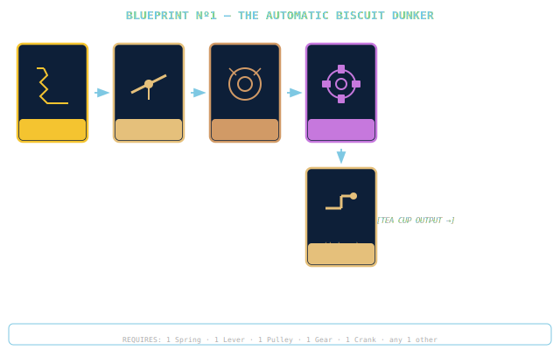
Blueprint Nº1 — The Automatic Biscuit Dunker
Spring-loaded via a lever and pulley, a gear drives a crank arm that dunks a biscuit into tea at a pre-calibrated depth. The crank is the final output stage. Too shallow: underdunked. Too deep: structural biscuit failure.

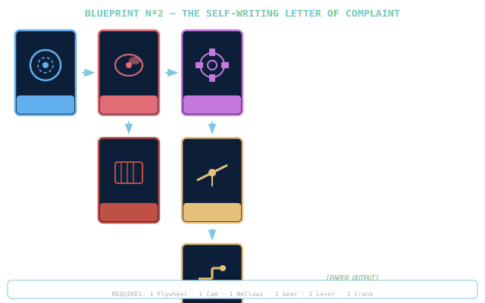
Blueprint Nº2 — The Self-Writing Letter of Complaint
A flywheel drives a cam through a gear-and-lever rack arrangement into a bellows, which pressurises a crank-mounted pen nib. Output is a document of grievance. Legibility is not guaranteed and is not part of the Blueprint.

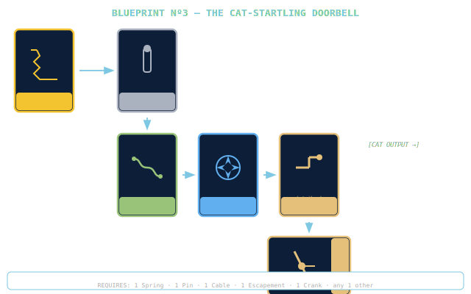
Blueprint Nº3 — The Cat-Startling Doorbell
A spring releases a pin which routes through a cable loop into an escapement, which drives a crank-mounted striker arm against a bell housing. The cat is the output. The cat did not consent to this role.

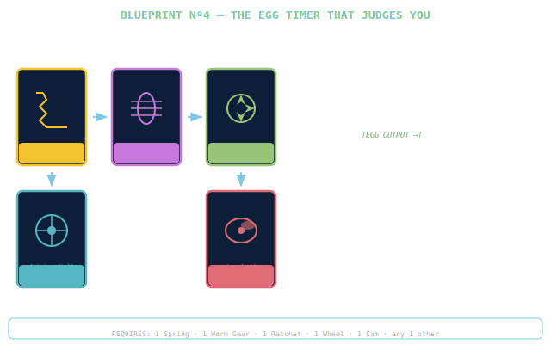
Blueprint Nº4 — The Egg Timer That Judges You
A torsion spring drives a worm gear through a ratchet into a timing wheel (clock-face style). A cam output stage renders the verdict on a facial display. The verdict is always Disapproving. This is by design.

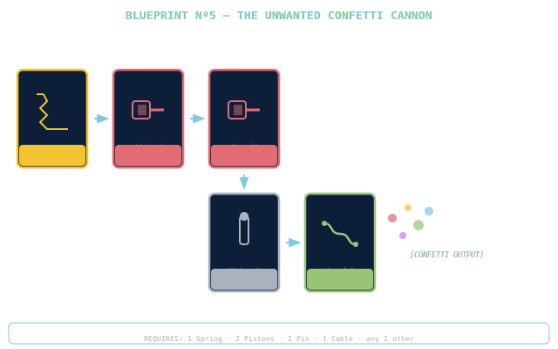
Blueprint Nº5 — The Unwanted Confetti Cannon
A compression spring drives two pistons in sequence. A pin releases the mechanism at peak pressure, routed through a cable nozzle. Range: further than expected. Clean-up time: longer than the party.

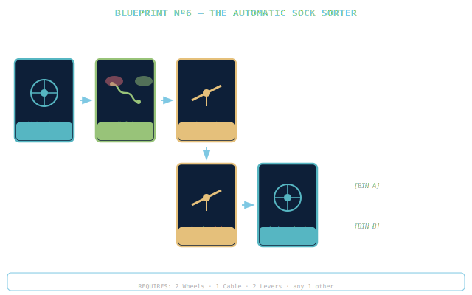
Blueprint Nº6 — The Automatic Sock Sorter
A wheel-and-cable conveyor carries socks under a sensing lever. The sensor lever shares an edge with a sort gate lever below it, which diverts items left or right. A second wheel drives the return belt. The machine cannot reliably distinguish dark grey from black. This is a known issue.

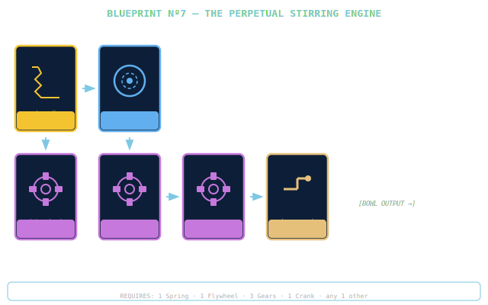
Blueprint Nº7 — The Perpetual Stirring Engine
A wound spring (torsion) drives a flywheel for momentum, then through three gears into a crank that orbits a spoon through the bowl. The machine stirs indefinitely provided nothing enters the gear train. Things will enter the gear train.

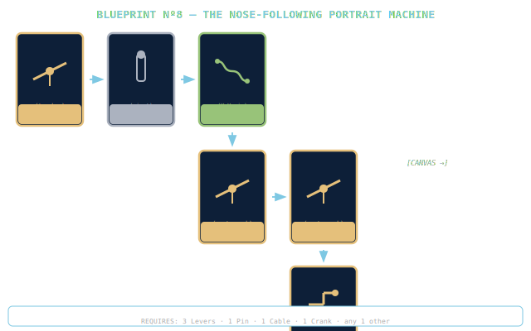
Blueprint Nº8 — The Nose-Following Portrait Machine
A tracker lever reads nose position, transmits via a pin pivot and cable rig to a crossed-lever pantograph, which maps motion onto a crank-mounted pen arm. The portrait reliably captures the nose. Other features are negotiable.

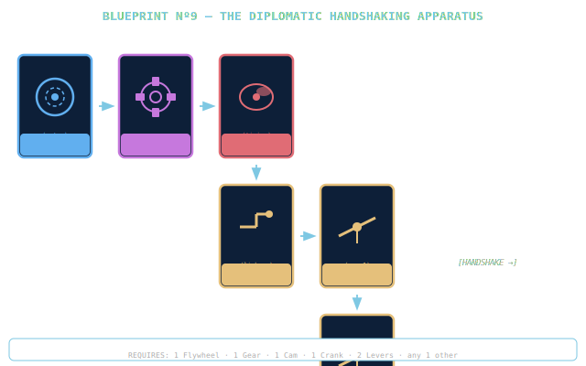
Blueprint Nº9 — The Diplomatic Handshaking Apparatus
A flywheel-and-gear clockwork motor drives a cam through a crank linkage which animates two lever arms in a 3-pump handshake cycle. The grip is described by observers as appropriate but somehow unsettling.

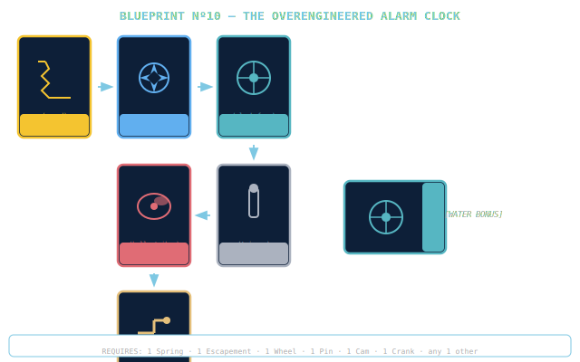
Blueprint Nº10 — The Overengineered Alarm Clock
A wound spring regulates through an escapement into a timing wheel, releasing a pin trigger that fires a cam with three lobes striking three bell housings simultaneously. The water bucket in the corner is a bonus component added just in case.

13. Card Anatomy

Every Component Card shares the same layout. Understanding the anatomy of a card is essential to understanding Banjaxed — the edge symbols control where a card can legally be placed, and the Tolerance cost controls what playing it costs you.

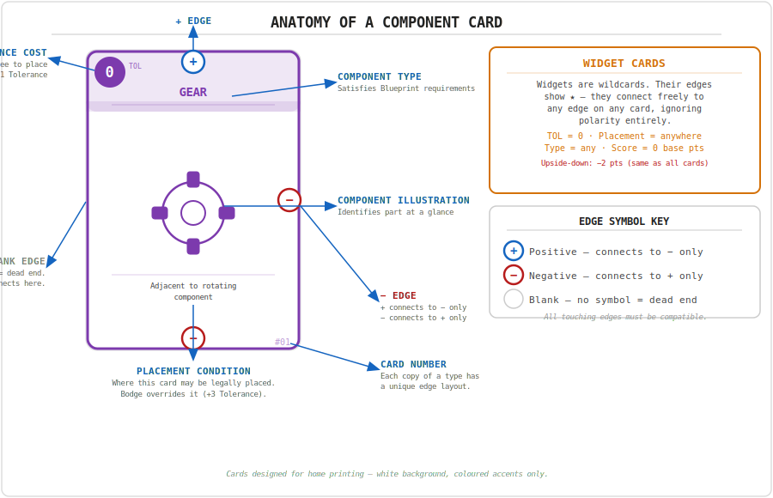

Edge symbols are printed on the physical card border at the midpoint of each of the four edges. Every card has exactly three symbol edges and one blank edge. The blank edge is a permanent dead end — nothing connects to it and nothing connects through it, even with a Bodge. The three symbol edges carry either + or −. The exact layout of symbols varies between individual copies of the same card type, making each physical card unique.
Widgets show ★ on all four edges instead of +/− symbols, indicating they connect freely to anything. Their blank-edge rule does not apply.

14. Component Card Catalogue

All 110 Component Cards in the first edition of Banjaxed. Each card shown is one copy — multiple copies of the same type exist in the deck, each with a unique edge layout. The card number (#01, #02 etc.) appears in the bottom corner of the physical card.

Common Parts — Springs (×10, TOL 0)
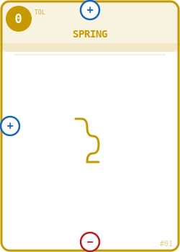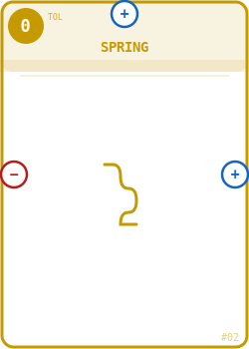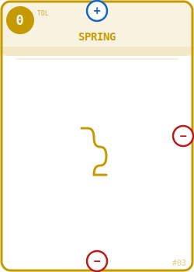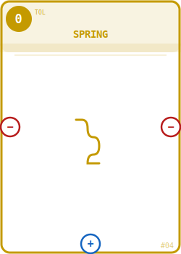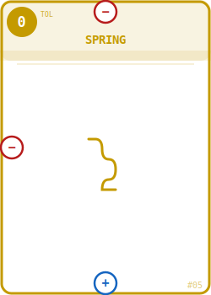
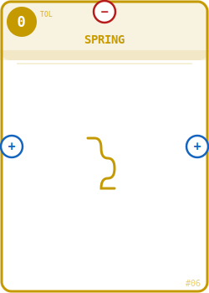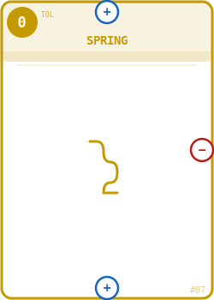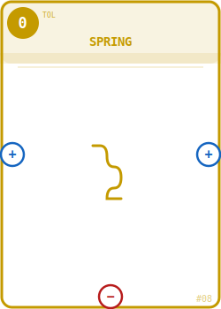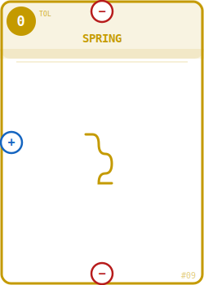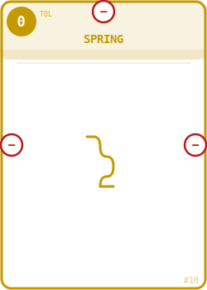

Common Parts — Gears (×10, TOL 0)
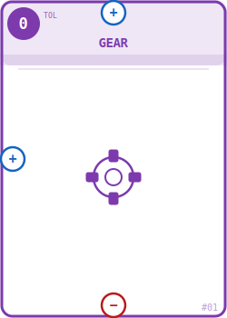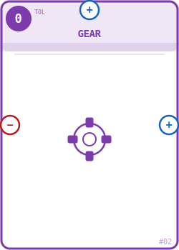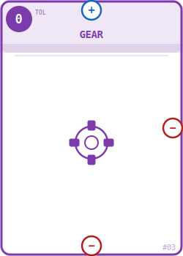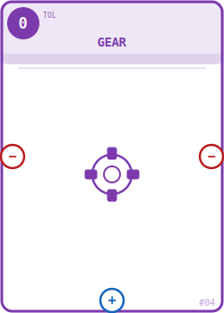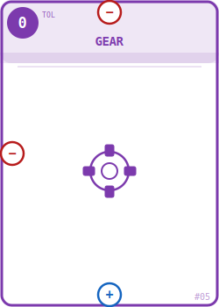
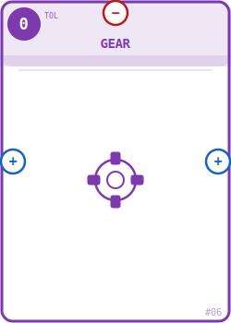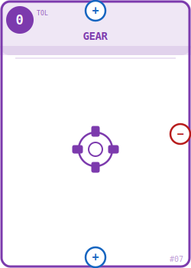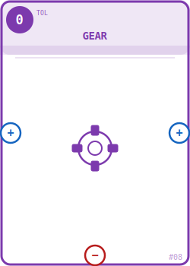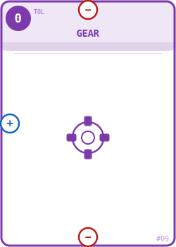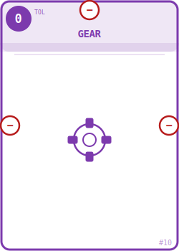

Common Parts — Pistons (×10, TOL 0)
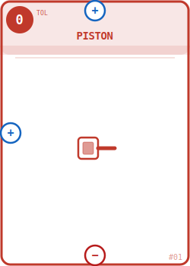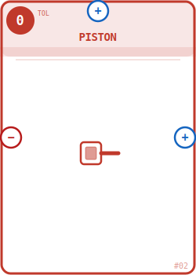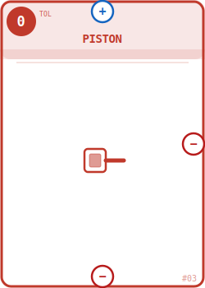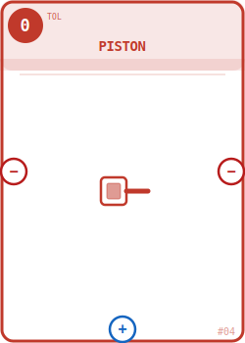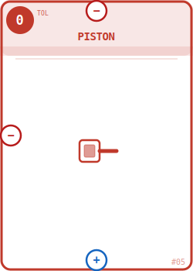
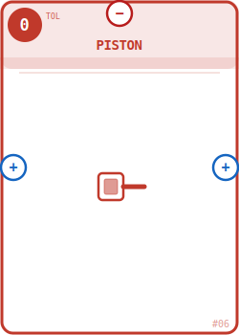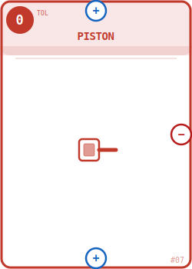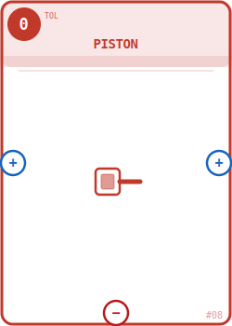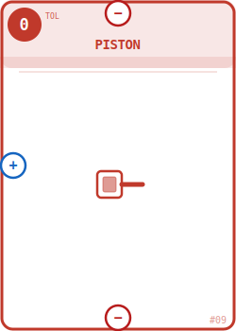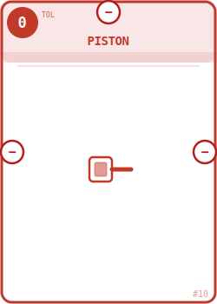

Common Parts — Cables (×10, TOL 0)
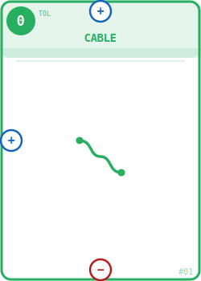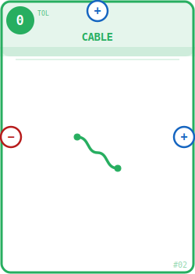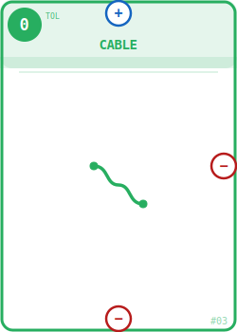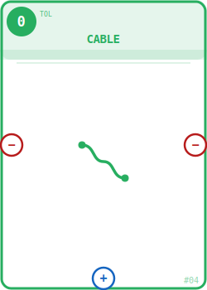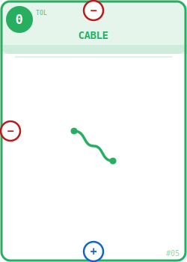
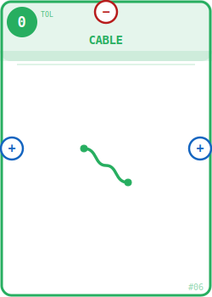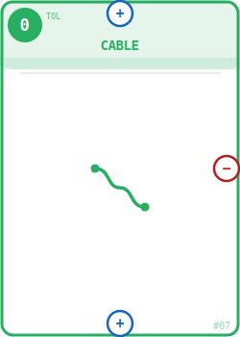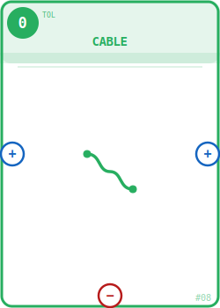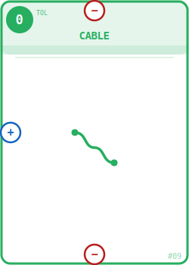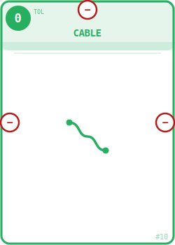

Common Parts — Wheels (×10, TOL 0)
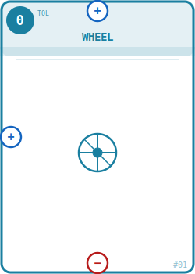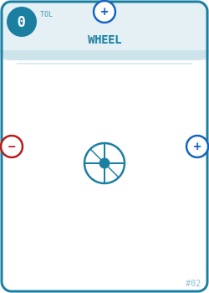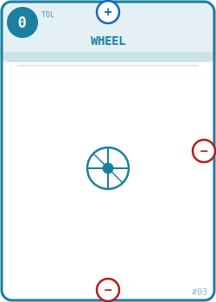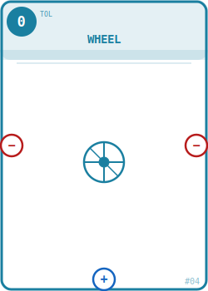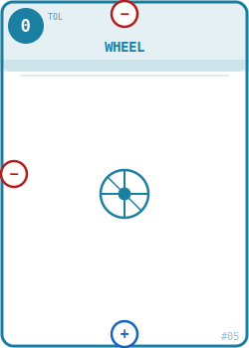
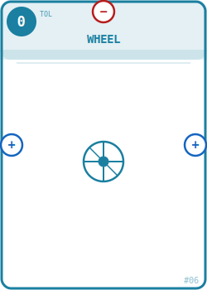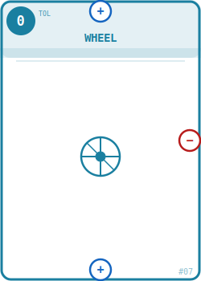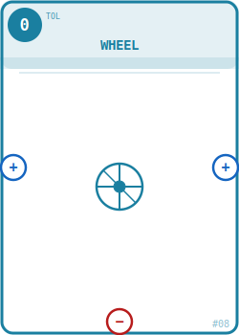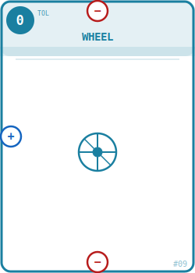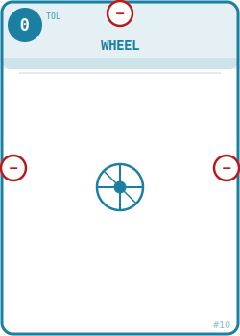

Specialist Parts — Levers (×5, TOL 1)
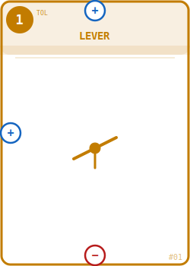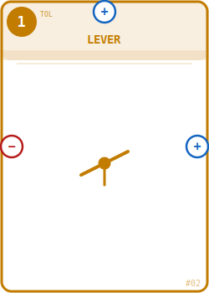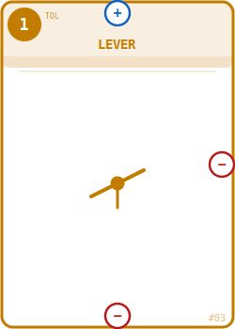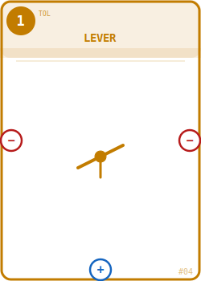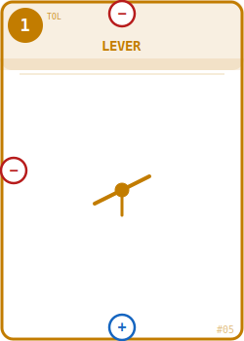

Specialist Parts — Pulleys (×5, TOL 1)
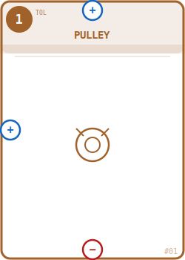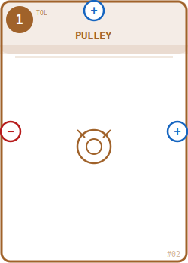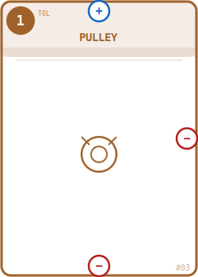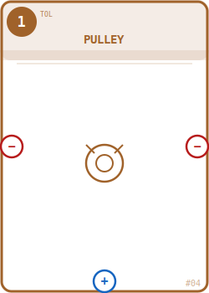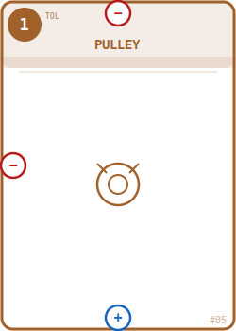

Specialist Parts — Flywheels (×5, TOL 1)
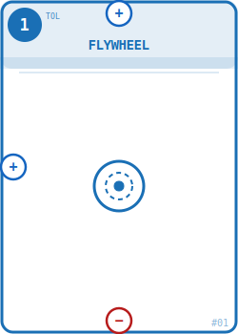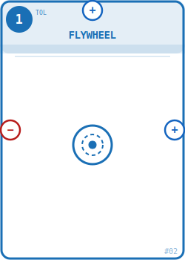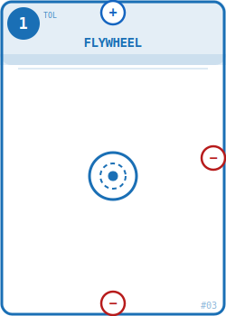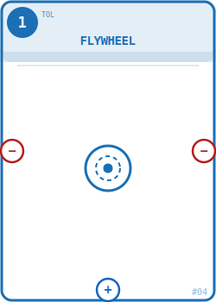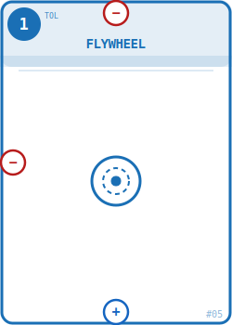

Specialist Parts — Bellows (×5, TOL 1)
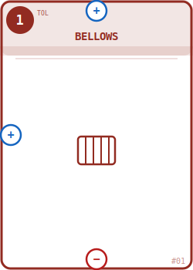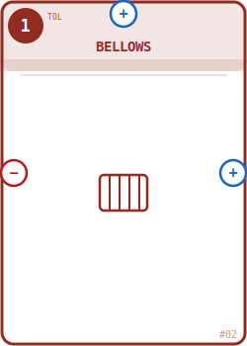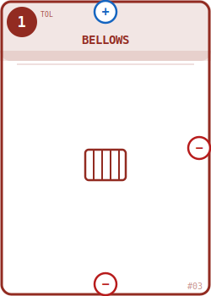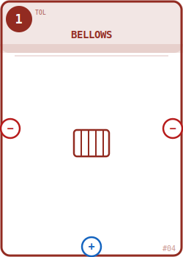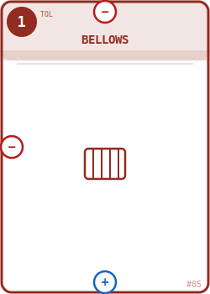

Specialist Parts — Pins (×5, TOL 1)
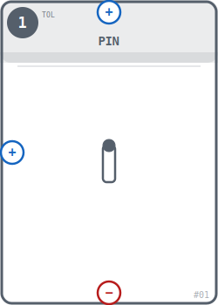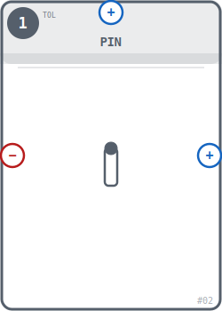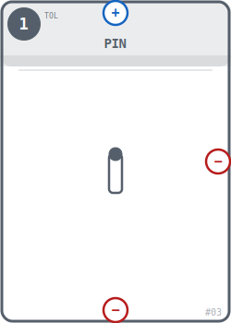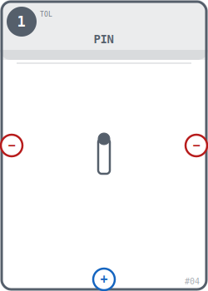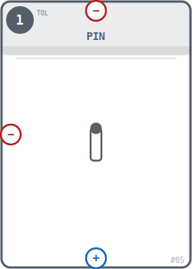

Specialist Parts — Cams (×5, TOL 1)
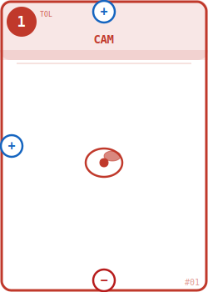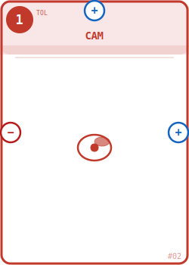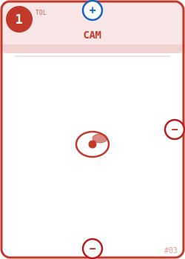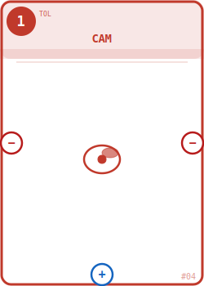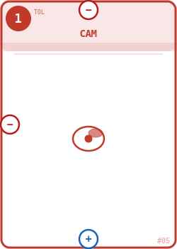

Specialist Parts — Ratchets (×5, TOL 1)
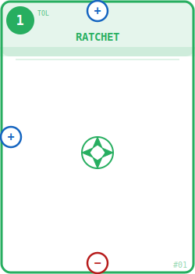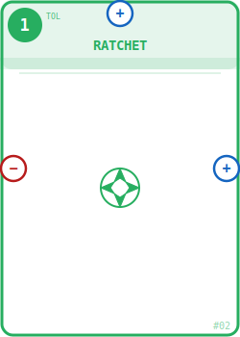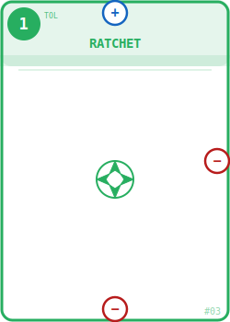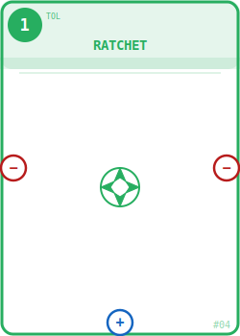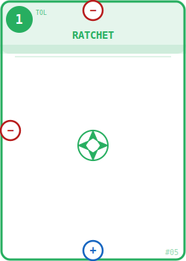

Specialist Parts — Worm Gears (×5, TOL 1)
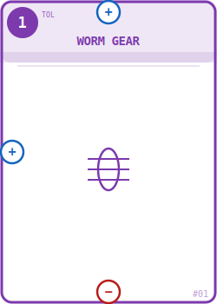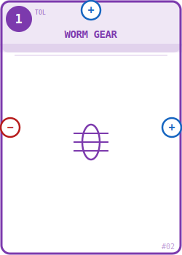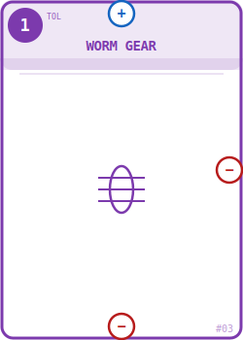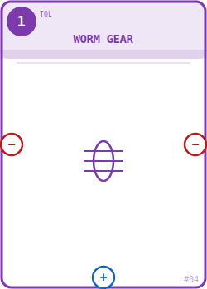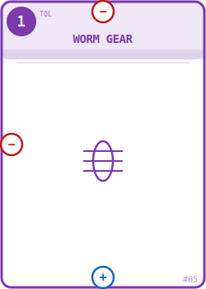

Specialist Parts — Escapements (×5, TOL 1)
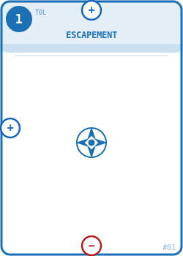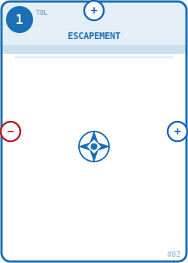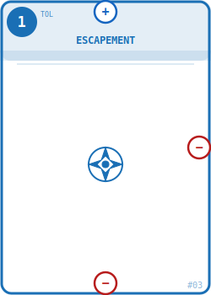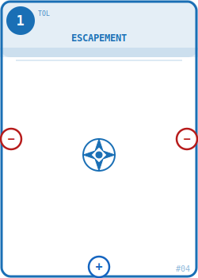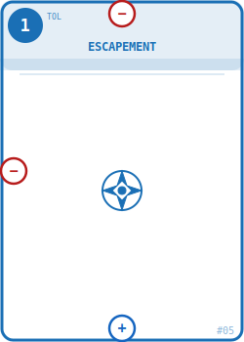

Specialist Parts — Cranks (×5, TOL 1)
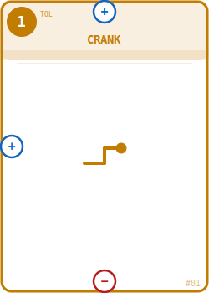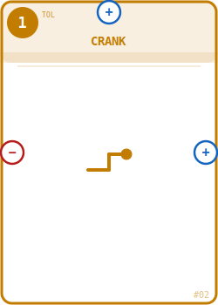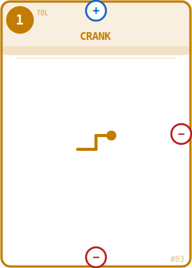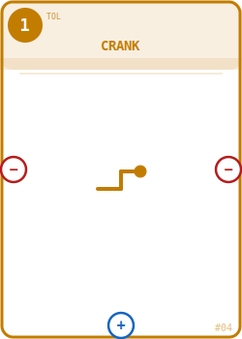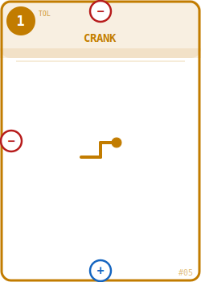

Wildcard Parts — Widgets (×10, TOL 0)
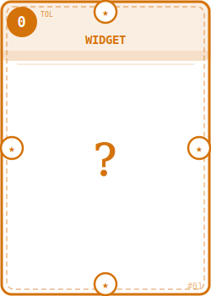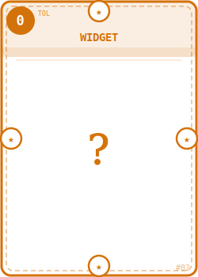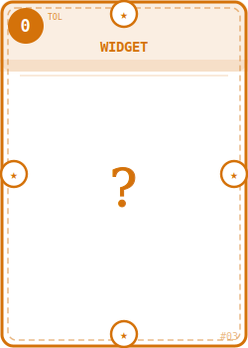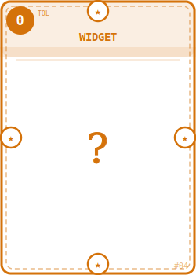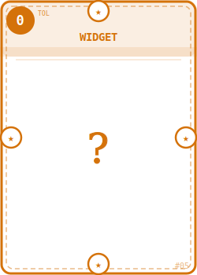
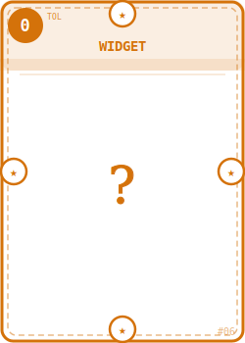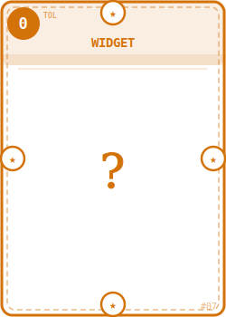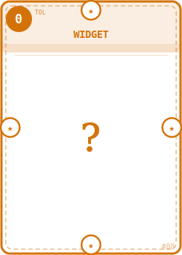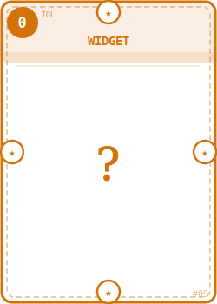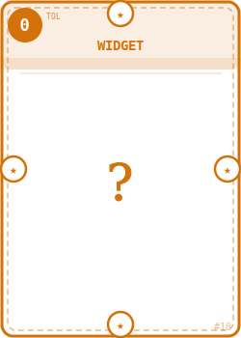

14. Designer's Notes

Banjaxed operates on four competing pressures working simultaneously:
- Greed — More upright components means higher scores and easier Blueprint. Each one also adds another die to your Banjax Roll. But every card brings you closer to 13 — the point of no return.
- Sabotage — Gifting is never neutral. Every Draft Phase forces a genuine dilemma: keep what you need, or pass your neighbour the card that costs them the most. Gifting someone their 13th component forces a declaration or collapse at their next Build Phase. Gifting an unplaceable card when they're at 12 is a move that feels polite and isn't.
- Timing — Declaring too early leaves Excess Bonus points on the table. Waiting too long risks hitting 13 before your Blueprint is satisfied, forcing a collapse. Retrieval gives you a third option: pull a card back, shrink your count, and buy yourself another round.
- Connectivity — Your mechanism is a physical graph on the table. The Retrieval rule means layout decisions matter beyond polarity. A mechanism with no retrievable cards — where every card is a bridge — has no exit routes as component count climbs toward 13.
The Eureka die face is deliberately dangerous. A large mechanism rolls many dice, which means frequent Eurekas, which means more components added involuntarily — and if an Eureka pushes you to 13, the reckoning waits at the start of your next Build Phase.
Collapse at Tolerance 12 means upside-down cards are discarded but upright cards survive. This asymmetry is intentional — it rewards players who repair before declaring and punishes those who ignore creeping damage. A mechanism that has been Banjaxed repeatedly but never repaired will haemorrhage points at declaration even if the upright components satisfy the Blueprint.
The 13-component limit solves the problem of infinite hoarding. It creates a hard forcing function: you must either be ready to declare by 13, or accept the consequences. Combined with retrieval, it means every round involves a genuine count — how many components do I have, how many do I need, and what happens when my neighbour gifts me one more?
Widgets introduce a calculated compromise. Drawing a Widget when you need a specific component is always a dilemma: use it to declare now and sacrifice the base points for that slot, or hold on and hope the right card arrives before you hit 13. That dilemma is the point. The Widget's zero score makes it a tool of desperation or efficiency, never of dominance.
The draw-2-pick-1 Blueprint setup gives players immediate agency and investment. Choosing between two Blueprints at the start creates a private strategy from the first moment — and the unchosen Blueprint returning to the bottom of the deck means it may appear again for an opponent, creating the possibility of racing toward the same machine.
The 5×10 / 10×5 / 1×10 card split is a first-edition estimate. Commons are expected to be the most-gifted parts, hence 10 copies each. Widgets at 10 copies means roughly one Widget per player per game will circulate — rare enough to feel significant, common enough to reliably appear. Adjust counts after playtesting.

BANJAXED — First Edition — Version 1.0
All mechanisms depicted are fictional. Any resemblance to functioning engineering is unintentional and mildly alarming.

SPANNERS IN THE WORKS
A First Edition Expansion for Banjaxed

Sometimes a well-placed spanner is worth more than any spring or gear. Whether you're sabotaging a rival's masterpiece, rescuing your own crumbling contraption, or simply relieving pressure on a dial that's heading somewhere catastrophic — a Spanner in the Works is exactly that.

What's In The Expansion

10 Spanner Cards — Shuffled into the main Component deck at setup. Spanners are action cards: they are played from your hand, take immediate effect, and are discarded. They are never placed in your mechanism.

Spanner Cards (×10)
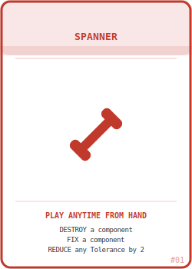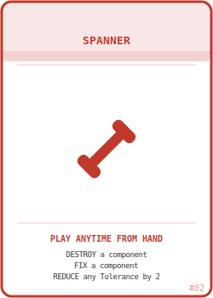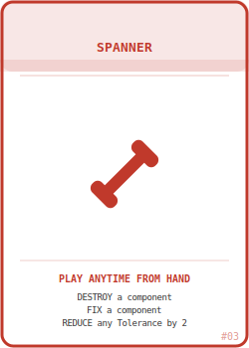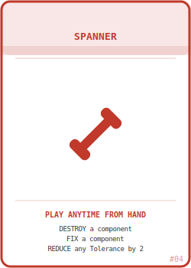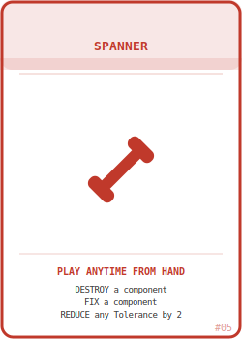
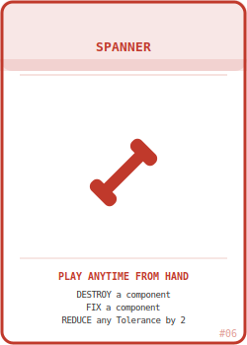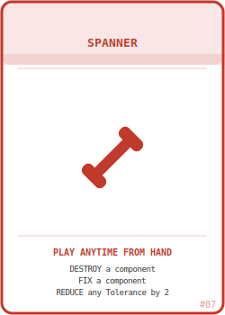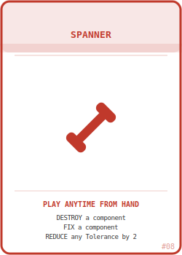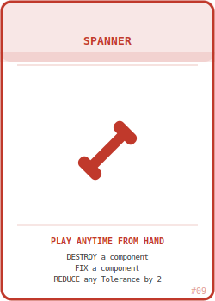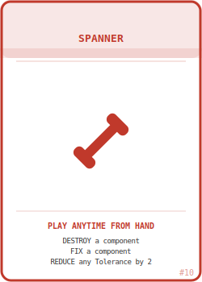

Rules

When you draw a Spanner Card, it goes into your hand like any other card. Unlike Component Cards, Spanners are never placed in your mechanism and never count toward your 13-component limit. They sit in your hand until you choose to play them.

When to Play
A Spanner may be played at any point on your turn — before, during, or after any phase. You may also play a Spanner on an opponent's turn, with the following restriction: you may only play a Spanner in response to something that has just happened (a card being placed, a Banjax result, a Eureka card being played). You cannot play a Spanner speculatively between opponents' turns.
Playing a Spanner is free. It costs no Tolerance and counts as neither a card play nor a component placement. Discard it immediately after use.
You may hold any number of Spanners. They do not count against hand size and do not need to be played by any deadline. Hoard them if you wish — but remember they take up hand space that a needed component could occupy.

The Three Actions

DESTROY — Remove one component from any player's mechanism and place it in the discard pile. The component is gone entirely — it does not go to the owner's hand.

You may target any upright or upside-down component in any player's mechanism, including your own.
You may not destroy a component that would leave any other card in that mechanism physically isolated — the bridge card rule applies here exactly as it does to Retrieval. If destroying a card would split the mechanism into two disconnected groups, that card cannot be targeted.
If destroying the component causes the mechanism to drop below a previous declaration threshold, that is the target player's problem.

FIX — Flip any one upside-down component in any player's mechanism back to upright.

You may target any player's mechanism, including your own.
No Placement Condition check is triggered. The card simply returns to upright. Whatever polarity configuration it had before it was flipped remains unchanged — it was never moved.
Fixing a component on an opponent's mechanism is a tactical choice. It may enable them to declare, reduce their upside-down penalty, or reduce the number of dice they are about to roll. Use accordingly.

REDUCE TOLERANCE — Reduce any one player's Tolerance dial by 2.

You may target any player, including yourself.
Tolerance cannot be reduced below 1. If the target is at Tolerance 2, their dial moves to 1, not below.
This is the most targeted sabotage action in the game. Used offensively, it pulls a player back from the brink of collapse. Used defensively on yourself, it buys two extra rolls before the next threshold. Used on a player at Tolerance 2, it is entirely wasted — choose your targets accordingly.

Strategic Notes

Spanners are rare — 10 cards in a 120-card deck means each player can expect to see roughly 2–3 Spanners over the course of a game. That scarcity is intentional. A Spanner should feel like a significant event, not a routine action.
Destroy is the most aggressive action. Removing a component that an opponent needs for their Blueprint, or breaking their connectivity so they cannot retrieve, are both valid and devastating uses. Destroying the 12th component from a mechanism that was about to hit 13 is an act of calculated mercy that will not be received as such.
Fix is the most flexible action. Fixing your own component before declaring saves 2 penalty points per card. Fixing an opponent's component seems counterproductive — but if it enables them to declare now rather than continuing to build a mechanism that is generating gifts your way, it may be the correct move.
Reduce Tolerance is the most surgical action. The difference between Tolerance 9 and Tolerance 7 is enormous — at 9 all Wobbles become Banjaxes, at 7 all Blanks become Wobbles. Dropping someone from 9 to 7 on their roll is a significant intervention. Dropping yourself from 8 to 6 before a large Banjax Roll restores normal dice behaviour for one crucial round.
Spanners in the Works does not change any existing rules. All base game mechanics apply unchanged. Spanners simply add a new layer of direct interaction on top of the gifting and polarity systems already in play.

SPANNERS IN THE WORKS — First Edition Expansion
Compatible with Banjaxed First Edition. Shuffle Spanner Cards into the main deck at setup.

