,rogerio,rogerio-is1422,23.02.2026 19:36,file:///home/rogerio/.config/libreoffice/4;

Home » SQL Cheat Sheet

SQL Cheat Sheet

The SQL cheat sheet provides you with the most commonly used SQL statements for your reference. You can download the SQL cheat sheet as follows:
Download the 3-page SQL cheat sheet in PDF format
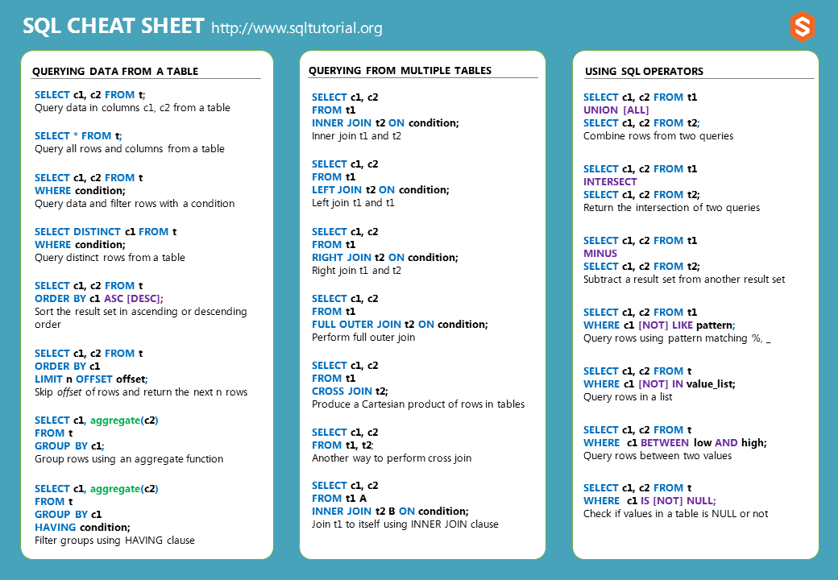

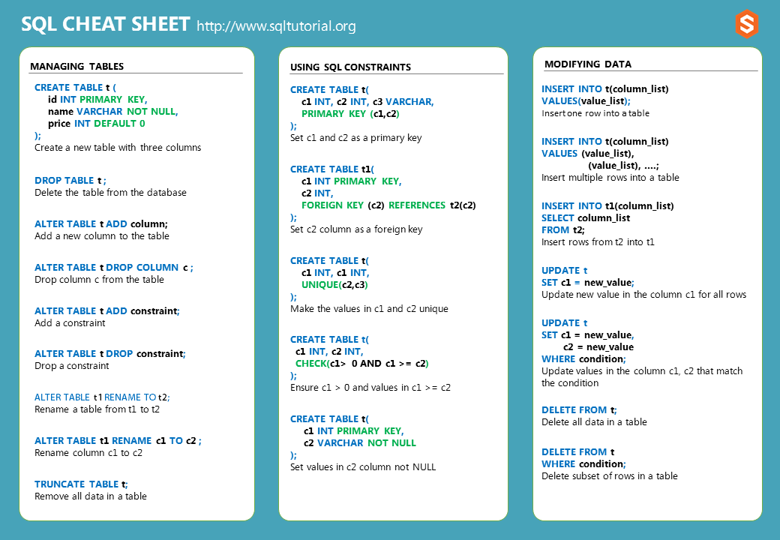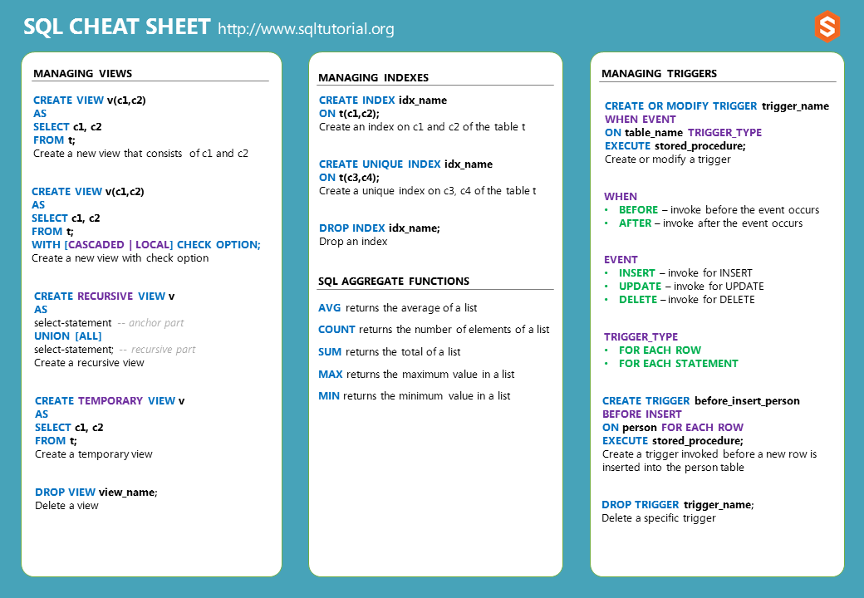

Querying data from a table
Query data of column1 and column2 from a table:
SELECT
column1,
column2
FROM
table_name;
Code language: SQL (Structured Query Language) (sql)
Query all data from a table:
SELECT
*
FROM
table_name;
Code language: SQL (Structured Query Language) (sql)
Retrieve specific rows based on a condition:
SELECT
column1,
column2
FROM
table_name
WHERE
condition;
Code language: SQL (Structured Query Language) (sql)
Query distinct rows from the column1 and column2 from a table:
SELECT DISTINCT
column1,
column2
FROM
table_name;
Code language: SQL (Structured Query Language) (sql)
Sort the result set in ascending order:
SELECT
column1,
column2
FROM
table_name
ORDER BY
column1;
Code language: SQL (Structured Query Language) (sql)
Sort the result set in descending order:
SELECT
column1,
column2
FROM
table_name
ORDER BY
column2 DESC;
Skip m rows before returning the next n rows from a table:
SELECT
column1,
column2
FROM
table_name
ORDER BY
column1
LIMIT
n
OFFSET
m;
Code language: SQL (Structured Query Language) (sql)
Group rows and apply an aggregate function to each group:
SELECT
column1,
aggregate_fn (column2)
FROM
table_name
GROUP BY
column1;
Code language: SQL (Structured Query Language) (sql)
Filter groups by a condition using HAVING clause:
SELECT
column1,
aggregate_fn (column2)
FROM
table_name
GROUP BY
column1
HAVING
condition;
Code language: SQL (Structured Query Language) (sql)

Querying data from multiple tables
Perform an inner join of two tables:
SELECT
column1,
column2
FROM
table1
INNER JOIN table2 ON condition;
Code language: SQL (Structured Query Language) (sql)
Perform a left join of two tables:
SELECT
column1,
column2
FROM
table1
LEFT JOIN table2 ON condition;
Code language: SQL (Structured Query Language) (sql)
Perform a right join of two tables:
SELECT
column1,
column2
FROM
table1
RIGHT JOIN table2 ON condition;
Code language: SQL (Structured Query Language) (sql)
Perform a full outer join:
SELECT
column1,
column2
FROM
table1
FULL OUTER JOIN table2 ON condition;
Code language: SQL (Structured Query Language) (sql)
Perform a cross-join:
SELECT
column1,
column2
FROM
table1
CROSS JOIN table2;
Code language: SQL (Structured Query Language) (sql)
Perform a self-join using an inner join:
SELECT t1.column1, t2.column2
FROM table1 t1
INNER JOIN table1 t2 ON condition;
Code language: SQL (Structured Query Language) (sql)

Set operations
Return the union of two result sets:
SELECT column1, column2
FROM table1
UNION [ALL]
SELECT column1, column2
FROM table2;
Code language: SQL (Structured Query Language) (sql)
Return the intersection of two result sets:
SELECT column1, column2
FROM table1
INTERSECT [ALL]
SELECT column1, column2
FROM table2;
Code language: SQL (Structured Query Language) (sql)
Subtract a result set from another result set:
SELECT column1, column2
FROM table1
MINUS
SELECT column1, column2
FROM table2;
Code language: SQL (Structured Query Language) (sql)

Logical operators
Query rows using pattern matching:
SELECT column1, column2
FROM table_name
WHERE column1 [NOT] LIKE pattern;
Code language: SQL (Structured Query Language) (sql)
Check if a value in a set of values:
SELECT column1, column2
FROM table_name
WHERE column1 [NOT] IN (v1, v2, v3);
Code language: SQL (Structured Query Language) (sql)
Check if a value is in a range of values:
SELECT column1, column2
FROM table_name
WHERE column1 [NOT] BETWEEN low AND high;
Code language: SQL (Structured Query Language) (sql)
Check if a value is NULL or not:
SELECT column1, column2
FROM table_name
WHERE column1 IS [NOT] NULL;
Code language: SQL (Structured Query Language) (sql)

Managing tables
Create a new table:
CREATE TABLE IF NOT EXISTS table_name (
column1 datatype PRIMARY KEY,
column2 datatype constraint,
table_constraint
);
Code language: SQL (Structured Query Language) (sql)
Remove a table from the database:
DROP IF EXISTS TABLE table_name ;
Code language: SQL (Structured Query Language) (sql)
Add a new column to the table:
ALTER TABLE table_name
ADD column1 datatype constraint;
Code language: SQL (Structured Query Language) (sql)
Drop a column from the table:
ALTER TABLE table_name
DROP COLUMN column1;
Code language: SQL (Structured Query Language) (sql)
Add a constraint:
ALTER TABLE table_name
ADD constraint;
Code language: SQL (Structured Query Language) (sql)
Drop a constraint:
ALTER TABLE table_name
DROP constraint;
Code language: SQL (Structured Query Language) (sql)
Rename a table:
ALTER TABLE table1
RENAME TO table2;
Code language: SQL (Structured Query Language) (sql)
Rename a column:
ALTER TABLE table1
RENAME column1 TO column2;
Code language: SQL (Structured Query Language) (sql)
Remove all data from a table fast:
TRUNCATE TABLE table_name;
Code language: SQL (Structured Query Language) (sql)

Using SQL constraints
Create a composite primary key:
CREATE TABLE table_name (
column1 datatype,
column2 datatype,
column3 datatype,
PRIMARY KEY (column1, column2)
);
Code language: SQL (Structured Query Language) (sql)
Create a foreign key constraint:
CREATE TABLE table_name (
column1 datatype PRIMARY KEY,
column2 datatype,
FOREIGN KEY (column2) REFERENCES table2(column2) ON DELETE CASCADE ON UPDATE CASCADE
);
Code language: SQL (Structured Query Language) (sql)
Create a unique constraint that includes two columns:
CREATE TABLE table_name (
column1 data_type,
column2 data_type,
column3 data_type,
UNIQUE(column2,column3)
);
Code language: SQL (Structured Query Language) (sql)
Create a CHECK constraint:
CREATE TABLE table_name (
column1 datatype,
column2 datatype,
CHECK(expression)
);
Code language: SQL (Structured Query Language) (sql)
Set a NOT NULL constraint:
CREATE TABLE table_name (
column1 datatype,
column2 datatype NOT NULL
);
Code language: SQL (Structured Query Language) (sql)

Modifying Data
Insert one row into a table:
INSERT INTO table_name(column_list)
VALUES(value_list);
Code language: SQL (Structured Query Language) (sql)
Insert multiple rows into a table:
INSERT INTO table_name(column_list)
VALUES (value_list),
(value_list);
Code language: SQL (Structured Query Language) (sql)
Insert data selected from the table2 into table1:
INSERT INTO table1(column_list)
SELECT column_list
FROM table2;
Code language: SQL (Structured Query Language) (sql)
Update the new value in the column for all rows:
UPDATE table_name
SET column1 = new_value;
Code language: SQL (Structured Query Language) (sql)
Update values in two columns in rows that match the condition:
UPDATE table_name
SET column1 = new_value,
column2 = new_value
WHERE condition;
Code language: SQL (Structured Query Language) (sql)
Delete all data in a table:
DELETE FROM table_name;
Code language: SQL (Structured Query Language) (sql)
Delete a subset of rows in a table:
DELETE FROM table_name
WHERE condition;
Code language: SQL (Structured Query Language) (sql)

Managing Views
Create a new view based on a query:
CREATE VIEW view_name(column1,column2)
AS
query;
Code language: SQL (Structured Query Language) (sql)
Create a new view with the WITH CHECK OPTION:
CREATE VIEW view_name(column1, column2)
AS
query
WITH [CASCADED | LOCAL] CHECK OPTION;
Code language: SQL (Structured Query Language) (sql)
Create a recursive view:
CREATE RECURSIVE VIEW view_name
AS
query -- anchor part
UNION [ALL]
query; -- recursive part
Code language: SQL (Structured Query Language) (sql)
Create a temporary view:
CREATE TEMPORARY VIEW view_name
AS
query;
Code language: SQL (Structured Query Language) (sql)
Delete a view:
DROP VIEW IF EXISTS view_name;
Code language: SQL (Structured Query Language) (sql)

Managing indexes
Create an index on column1 and column2 of the table table_name:
CREATE INDEX index_name
ON table_name(column1,column2);
Code language: SQL (Structured Query Language) (sql)
Create a unique index on column3 and column4 of the table_name:
CREATE UNIQUE INDEX index_name
ON table_name(column3, column4)
Code language: SQL (Structured Query Language) (sql)
Drop an index:
DROP INDEX index_name;
Code language: SQL (Structured Query Language) (sql)

Managing triggers
Create or replace a trigger:
CREATE OR MODIFY TRIGGER trigger_name
WHEN EVENT
ON table_name TRIGGER_TYPE
EXECUTE stored_procedure;
Code language: SQL (Structured Query Language) (sql)
Delete a specific trigger:
DROP TRIGGER trigger_name;
Code language: SQL (Structured Query Language) (sql)

Previously
SQL List All Tables
Up Next
SQL Functions
Search for:

Getting Started
- What Is SQL
- SQL Syntax

Selecting Data
- SELECT

Sorting Rows
- ORDER BY Clause

Limiting Rows
- DISTINCT
- LIMIT
- FETCH

Filtering Data
- WHERE Clause
- AND Operator
- OR Operator
- BETWEEN Operator
- IN Operator
- LIKE Operator
- IS NULL Operator
- NOT Operator

Joining Tables
- Inner Join
- Left Join
- Right Join
- Self Join
- Full Outer Join
- Cross Join

Grouping Rows
- GROUP BY
- HAVING
- GROUPING SETS
- ROLLUP
- CUBE

Set Operations
- UNION
- INTERSECT
- MINUS

Managing Tables
- CREATE TABLE Statement
- Primary Key
- NOT NULL Constraint
- DROP TABLE Statement
- Identity Column
- ALTER TABLE Statement
- ADD COLUMN
- DROP COLUMN
- TRUNCATE TABLE
- Foreign Key Constraint
- UNIQUE Constraint
- CHECK Constraint
- ALTER TABLE

Modifying Data
- INSERT
- UPDATE
- DELETE

Views & Triggers
- Views
- Triggers

Conditional Expressions & Functions
- CASE Expression
- COALESCE Function
- NULLIF Function

Subquery
- Subquery
- Correlated Subquery
- ALL Operator
- ANY Operator
- EXISTS Operator

SQL Aggregate Functions
- AVG Function
- ANY_VALUE Function
- COUNT Function
- MAX Function
- MIN Function
- SUM Function

About SQL Tutorial
SQLTutorial.org helps you master the SQL language quickly through the use of simple yet practical examples, accompanied by easy-to-understand explanations.
Search for:

Latest Tutorials
- SQL RIGHT JOIN
- SQL RPAD Function
- SQL LPAD Function
- SQL RIGHT Function
- SQL LEFT Function

Site Links
- Home
- About
- Contact
- Privacy Policy
Copyright © 2009 - Present by www.sqltutorial.org. All Rights Reserved.

