1

1. There are 1460 samples and 79 features in the training set. MSSubClass, MSZoning, Street, Alley, LotShape, LandContour, Utilities, LotConfig, LandSlope, Neighborhood are some of the categorical features.
2. “1stFlrSF”, “GarageArea”, “LotArea” seems to have be highly co-related with SalePrice.

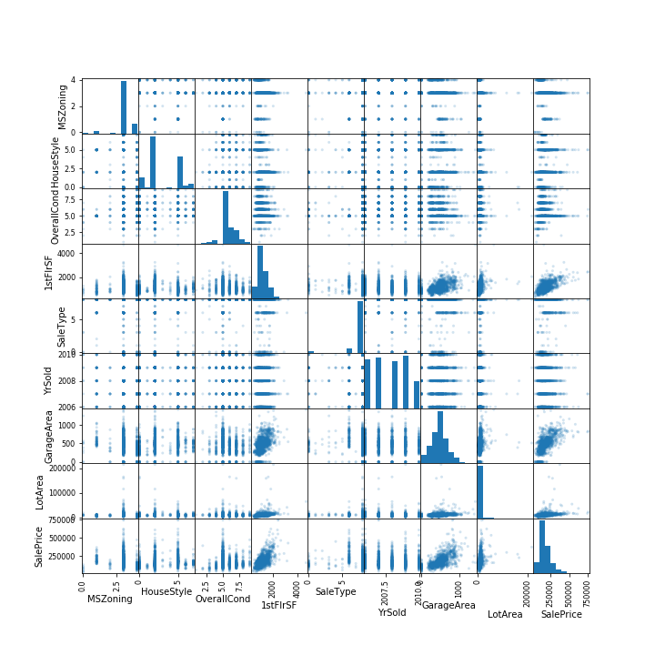

1. The statsmodel shows that 37 of the all 79 features have a 95% confidence interval that do not contain 0. In other words, 37 coefficients are significant.

|  |  |  |  |  |  |  |  |
| --- | --- | --- | --- | --- | --- | --- | --- |
|  | **coef** | **std err** | **t** | **P>|t|** | **[0.025** | **0.975]** | **Significant** |
| MSSubClass | -66.73 | 42.37 | -1.58 | 0.12 | -149.85 | 16.38 | No |
| MSZoning | -2086.23 | 1456.68 | -1.43 | 0.15 | -4943.78 | 771.32 | No |
| LotFrontage | -130.55 | 47.15 | -2.77 | 0.01 | -223.04 | -38.06 | Yes |
| LotArea | 0.42 | 0.10 | 4.14 | 0.00 | 0.22 | 0.61 | Yes |
| Street | 34320.00 | 13200.00 | 2.60 | 0.01 | 8436.47 | 60200.00 | Yes |
| Alley | -2820.06 | 2447.86 | -1.15 | 0.25 | -7621.97 | 1981.86 | No |
| LotShape | -758.48 | 617.06 | -1.23 | 0.22 | -1968.96 | 451.99 | No |
| LandContour | 1752.05 | 1259.33 | 1.39 | 0.16 | -718.34 | 4222.45 | No |
| Utilities | -46690.00 | 31000.00 | -1.51 | 0.13 | -108000.00 | 14200.00 | No |
| LotConfig | 1.04 | 510.55 | 0.00 | 1.00 | -1000.50 | 1002.58 | No |
| LandSlope | 4609.02 | 3571.45 | 1.29 | 0.20 | -2397.03 | 11600.00 | No |
| Neighborhood | 379.42 | 146.10 | 2.60 | 0.01 | 92.83 | 666.02 | Yes |
| Condition1 | -659.72 | 948.05 | -0.70 | 0.49 | -2519.50 | 1200.05 | No |
| Condition2 | -9405.49 | 3129.98 | -3.01 | 0.00 | -15500.00 | -3265.47 | Yes |
| BldgType | -2936.09 | 1399.45 | -2.10 | 0.04 | -5681.37 | -190.81 | Yes |
| HouseStyle | -672.43 | 610.81 | -1.10 | 0.27 | -1870.65 | 525.79 | No |
| OverallQual | 10230.00 | 1108.09 | 9.23 | 0.00 | 8054.18 | 12400.00 | Yes |
| OverallCond | 5799.21 | 978.93 | 5.92 | 0.00 | 3878.87 | 7719.55 | Yes |
| YearBuilt | 237.82 | 73.73 | 3.23 | 0.00 | 93.19 | 382.46 | Yes |
| YearRemodAdd | 15.48 | 63.90 | 0.24 | 0.81 | -109.88 | 140.84 | No |
| RoofStyle | 1029.48 | 1050.29 | 0.98 | 0.33 | -1030.85 | 3089.81 | No |
| RoofMatl | 4563.46 | 1403.48 | 3.25 | 0.00 | 1810.29 | 7316.63 | Yes |
| Exterior1st | -1093.27 | 489.01 | -2.24 | 0.03 | -2052.54 | -134.00 | Yes |
| Exterior2nd | 673.80 | 442.19 | 1.52 | 0.13 | -193.63 | 1541.23 | No |
| MasVnrType | 3779.43 | 1377.90 | 2.74 | 0.01 | 1076.43 | 6482.44 | Yes |
| MasVnrArea | 32.16 | 5.66 | 5.68 | 0.00 | 21.06 | 43.25 | Yes |
| ExterQual | -9895.16 | 1837.88 | -5.38 | 0.00 | -13500.00 | -6289.82 | Yes |
| ExterCond | 777.43 | 1170.89 | 0.66 | 0.51 | -1519.47 | 3074.33 | No |
| Foundation | 50.42 | 1571.04 | 0.03 | 0.97 | -3031.46 | 3132.30 | No |
| BsmtQual | -7165.04 | 1265.24 | -5.66 | 0.00 | -9647.04 | -4683.05 | Yes |
| BsmtCond | 2332.21 | 1223.01 | 1.91 | 0.06 | -66.94 | 4731.36 | No |
| BsmtExposure | -2923.30 | 817.65 | -3.58 | 0.00 | -4527.26 | -1319.34 | Yes |
| BsmtFinType1 | -325.54 | 581.74 | -0.56 | 0.58 | -1466.74 | 815.65 | No |
| BsmtFinSF1 | 7.86 | 2.76 | 2.85 | 0.00 | 2.45 | 13.27 | Yes |
| BsmtFinType2 | 2320.40 | 1045.69 | 2.22 | 0.03 | 269.09 | 4371.72 | Yes |
| BsmtFinSF2 | 12.67 | 5.04 | 2.52 | 0.01 | 2.79 | 22.55 | Yes |
| BsmtUnfSF | -2.62 | 2.76 | -0.95 | 0.34 | -8.04 | 2.80 | No |
| TotalBsmtSF | 17.91 | 3.47 | 5.16 | 0.00 | 11.10 | 24.73 | Yes |
| Heating | -1873.05 | 2995.47 | -0.63 | 0.53 | -7749.20 | 4003.11 | No |
| HeatingQC | -449.09 | 574.29 | -0.78 | 0.43 | -1575.67 | 677.48 | No |
| CentralAir | 845.05 | 4188.38 | 0.20 | 0.84 | -7371.21 | 9061.31 | No |
| Electrical | -576.96 | 847.90 | -0.68 | 0.50 | -2240.28 | 1086.35 | No |
| 1stFlrSF | 20.85 | 5.72 | 3.65 | 0.00 | 9.63 | 32.08 | Yes |
| 2ndFlrSF | 23.95 | 5.12 | 4.68 | 0.00 | 13.90 | 33.99 | Yes |
| LowQualFinSF | -25.15 | 13.08 | -1.92 | 0.06 | -50.80 | 0.51 | No |
| GrLivArea | 19.65 | 5.13 | 3.83 | 0.00 | 9.60 | 29.71 | Yes |
| BsmtFullBath | 5393.97 | 2278.67 | 2.37 | 0.02 | 923.95 | 9864.00 | Yes |
| BsmtHalfBath | -853.71 | 3593.54 | -0.24 | 0.81 | -7903.09 | 6195.67 | No |
| FullBath | 1687.25 | 2515.19 | 0.67 | 0.50 | -3246.75 | 6621.24 | No |
| HalfBath | -320.91 | 2365.33 | -0.14 | 0.89 | -4960.94 | 4319.12 | No |
| BedroomAbvGr | -4281.96 | 1555.79 | -2.75 | 0.01 | -7333.93 | -1229.99 | Yes |
| KitchenAbvGr | -18440.00 | 4708.94 | -3.92 | 0.00 | -27700.00 | -9206.48 | Yes |
| KitchenQual | -7336.03 | 1350.68 | -5.43 | 0.00 | -9985.64 | -4686.43 | Yes |
| TotRmsAbvGrd | 4420.21 | 1097.11 | 4.03 | 0.00 | 2268.03 | 6572.40 | Yes |
| Functional | 3573.87 | 882.95 | 4.05 | 0.00 | 1841.81 | 5305.93 | Yes |
| Fireplaces | 8196.07 | 2459.16 | 3.33 | 0.00 | 3371.98 | 13000.00 | Yes |
| FireplaceQu | -1347.16 | 738.64 | -1.82 | 0.07 | -2796.13 | 101.81 | No |
| GarageType | 372.98 | 586.13 | 0.64 | 0.53 | -776.83 | 1522.79 | No |
| GarageYrBlt | -25.99 | 65.58 | -0.40 | 0.69 | -154.64 | 102.65 | No |
| GarageFinish | -2270.87 | 1332.59 | -1.70 | 0.09 | -4884.98 | 343.24 | No |
| GarageCars | 9827.77 | 2620.54 | 3.75 | 0.00 | 4687.10 | 15000.00 | Yes |
| GarageArea | 6.61 | 9.06 | 0.73 | 0.47 | -11.17 | 24.38 | No |
| GarageQual | -2214.90 | 1558.92 | -1.42 | 0.16 | -5273.00 | 843.20 | No |
| GarageCond | 230.18 | 1640.49 | 0.14 | 0.89 | -2987.94 | 3448.29 | No |
| PavedDrive | 2173.76 | 1933.23 | 1.12 | 0.26 | -1618.61 | 5966.13 | No |
| WoodDeckSF | 20.07 | 7.02 | 2.86 | 0.00 | 6.30 | 33.85 | Yes |
| OpenPorchSF | -6.04 | 13.39 | -0.45 | 0.65 | -32.30 | 20.23 | No |
| EnclosedPorch | -3.67 | 14.64 | -0.25 | 0.80 | -32.39 | 25.06 | No |
| 3SsnPorch | 28.83 | 27.10 | 1.06 | 0.29 | -24.33 | 81.99 | No |
| ScreenPorch | 47.53 | 15.01 | 3.17 | 0.00 | 18.09 | 76.97 | Yes |
| PoolArea | 752.16 | 59.47 | 12.65 | 0.00 | 635.50 | 868.82 | Yes |
| PoolQC | -209600.00 | 15100.00 | -13.85 | 0.00 | -239000.00 | -180000.00 | Yes |
| Fence | 122.77 | 836.62 | 0.15 | 0.88 | -1518.41 | 1763.94 | No |
| MiscFeature | -1606.44 | 1567.59 | -1.03 | 0.31 | -4681.55 | 1468.68 | No |
| MiscVal | 0.41 | 1.72 | 0.24 | 0.81 | -2.96 | 3.78 | No |
| MoSold | -75.86 | 294.39 | -0.26 | 0.80 | -653.36 | 501.65 | No |
| YrSold | -338.16 | 82.32 | -4.11 | 0.00 | -499.65 | -176.68 | Yes |
| SaleType | -686.75 | 538.27 | -1.28 | 0.20 | -1742.66 | 369.16 | No |
| SaleCondition | 3655.03 | 774.29 | 4.72 | 0.00 | 2136.11 | 5173.95 | Yes |

1. According to the result, the backward stepwise regression with 10-fold cross validation performs the best. The relevant parameter and accuracy of these regression methods are as follows:

|  |  |  |  |  |  |  |
| --- | --- | --- | --- | --- | --- | --- |
|  | OLS | k-NN | Ridge-10 fold | Lasso-10 fold | BSR-10 fold | FSR-10 fold |
| parameter |  | K=9 |  |  | p=30 | p=27 |
| Accuracy | 0.884 | 0.668 | 0.821 | 0.757 | 0.832 | 0.831 |

1. After adding the quadratic features, the number of features is bigger than the number of training samples. This means that the adjusted-R2 is negative. We haven’t figure out a proper way to deal with this.
2. The following table shows the variables retained by FSR and Lasso 10-fold. In most cases, they match our intuitions.

|  |  |  |
| --- | --- | --- |
|  | Retained by FSR 10 Fold | Retained by Lasso 10 Fold |
| OverallQual | 1 |  |
| GrLivArea | 1 | 1 |
| BsmtFinSF1 | 1 | 1 |
| ExterQual | 1 |  |
| GarageCars | 1 |  |
| MSSubClass | 1 | 1 |
| KitchenQual | 1 |  |
| YearBuilt | 1 | 1 |
| OverallCond | 1 |  |
| LotArea | 1 | 1 |
| BsmtQual | 1 |  |
| BsmtCond | 1 |  |
| Fireplaces | 1 |  |
| Functional | 1 |  |
| MasVnrArea | 1 | 1 |
| BsmtFullBath | 1 |  |
| BsmtExposure | 1 |  |
| ScreenPorch | 1 | 1 |
| GarageCond | 1 |  |
| WoodDeckSF | 1 | 1 |
| SaleCondition | 1 |  |
| MasVnrType | 1 |  |
| Street | 1 |  |
| KitchenAbvGr | 1 |  |
| Neighborhood | 1 |  |
| MiscFeature | 1 |  |
| PavedDrive | 1 |  |
| YearRemodAdd |  | 1 |
| BsmtFinSF2 |  | 1 |
| TotalBsmtSF |  | 1 |
| GarageArea |  | 1 |
| MiscVal |  | 1 |

1. For the Kaggle test set, the accuracy is 0.82581, which is lower than the hold-out validation accuracy. The hold-out validation test set is used to search for the best features, possibly resulting in overfitting. Because of the intrinsic variance of real test data, it’s reasonable that the model reports slightly lower accuracy for the Kaggle test set.



2

1. Yes, the labels are balanced. there are 500 positive and 500 negative reviews in each of the three files. We read the files, strip and split them line by line.
2. We did all of the processing.
   1. By using only the lowercase and lemmatized words, the algorithm avoids treating the same words as different ones.
   2. We strip punctuation because, given the special way the algorithm works, it doesn’t contribute to better understanding of the meaning of the review.
   3. We use a dictionary to strip the stop words to reduce the noise, so that the words that convey important information get deserved attention.
3. We put the 2400 training reviews in list ‘“train_comments” and the 600 testing reviews in “test_comments”.
4. We printed the feature vector of the first and last of the training review set.
5. We adopted the  because it’s not sensitive to outliers and is easy to compute.
6. The accuracy rate is 0.807. The confusion matrix is:

|  |  |  |
| --- | --- | --- |
|  | Predicted positive | Predicted negative |
| Actual positive | 233 | 67 |
| Actual negative | 49 | 251 |

* 1. For the logistic regression with L2 (Ridge) penalty, the accuracy is 0.812. The most important words are:

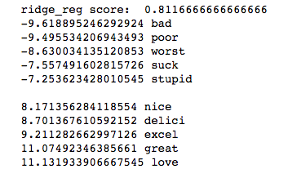

* 1. With L1 (Lasso) penalty, the accuracy is 0.802. The most important words are:

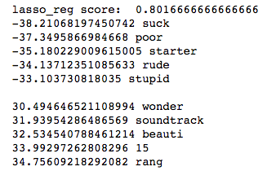

1. For the 2-gram model, we also use the -normalization. The accuracy is 0.838. The confusion matrix is as follows.

|  |  |  |
| --- | --- | --- |
|  | Predicted positive | Predicted negative |
| Actual positive | 240 | 60 |
| Actual negative | 37 | 263 |

Also, both the ridge and lasso regularization get higher accuracy than the previous model.

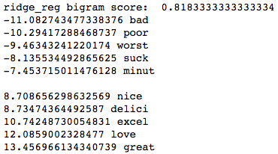 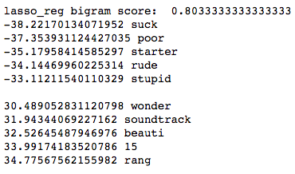

1. According to the results above, the logistic regression with 2-grams performs the best in the prediction task. First of all, 2-grams sequences are more independent with each other. Secondly, they also provide additional information. For the language used in the reviews, we found that strong words such as “bad” and ”great” are the most significant indicator of positive or negative reviews.

Written Exercise

1.







Let , we have . That is:



2.

(a) According to Bayes optimal classifier, the probability of pneumonia is 0, the probability of flu is 1/3 and the probability of healthy is 1/3.







(b)







We can force these three values sum to 1 by normalizing them.

3.





Obviously, . Therefore, we predict the new example will buy a computer.