PLANETARY ATMOSPHERES PRELAB

1. Find pictures of Venus, Earth, and Mars in an astronomy textbook or other book or online at a website. Estimate, to the nearest 10%, the percentage of surface of each planet covered by high albedo features, e.g. clouds, snow and ice, or liquid water.
2. Think about your lifetime experience with environmental temperature. What are the hottest and coldest temperatures that you could imagine reasonably tolerating on an everyday basis? I.e. what range of temperatures would you consider acceptable in a place where you’d be living? Take these maximum and minimum temperatures and convert them to Kelvin.

What will you learn in this Lab?

How important is a planet’s atmosphere in controlling its surface temperature? What keeps the Earth at a habitable temperature, its distance from the Sun or the thickness of its atmosphere? You will learn some important concepts in atmospheric physics and use them to calculate the current and past surface temperatures of the terrestrial planets, taking into account various factors that affect the climate of a planet.

What do I need to bring to the Class with me to do this Lab?

For this lab you will need:

* A copy of this lab script
* A pencil or pen
* A scientific calculator

Introduction:

The Sun provides the energy that heats the surfaces of the planets. For bodies without an atmosphere, like Mercury and the Moon, there isn’t much more to their climates than bake in sunlight and freeze in the shade. For bodies with an atmosphere, there is more to the story. Each planet’s atmosphere reflects away or stores a different fraction of the solar energy, so Venus, Earth, and Mars have very different climates. What are the current surface temperatures on these planets and what were they like in the past? What factors make their climates the way they are and what makes them so different today? This lab exercise explores these questions and poses a few more to think about.

PART I: Atmosphere Concepts

Balance of Energy:

The total energy emitted from the Sun per second is a constant known as the solar luminosity, LSun. As this energy leaves the Sun, it spreads out over a sphere of area 4πr2, where r is the distance from the Sun. The amount of solar energy per second a planet receives is the product of the planet’s surface area facing the Sun times the energy per second passing through each square meter of space at that distance from the Sun. Since the planet presents a circular face to the Sun, its area is just πrp2, where rp is the radius of the planet.

Energy received by planet per second =

(Planet’s Sun-facing area) times (solar energy per unit area) = 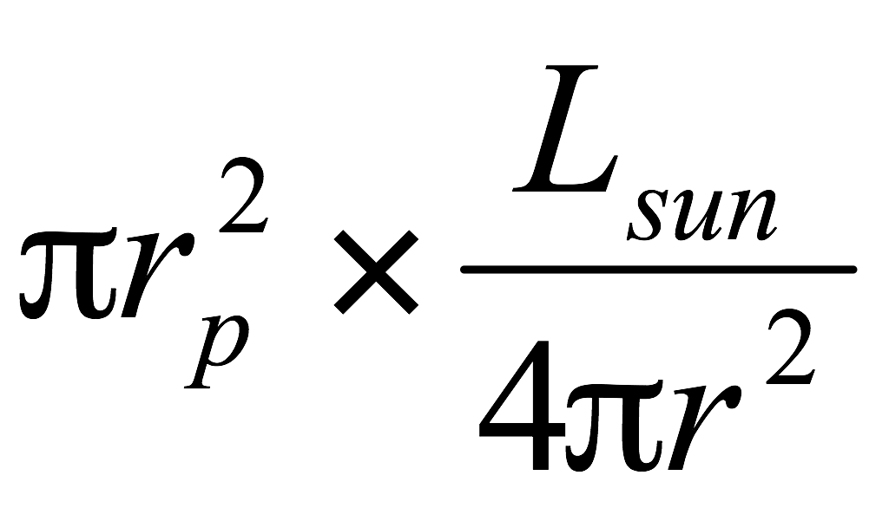

where rp is the radius of the planet, LSun is the luminosity of the Sun (3.8x1026 watts), and r is the distance from the Sun to the planet. In words, this equation means that the amount of solar energy a planet receives increases with the size of the planet, and decreases for larger distances from the Sun.

If a planet stored all the energy it received, it would get extremely hot. Planets radiate energy just as any object does that has a finite temperature. Specifically, a planet must radiate away as much energy as it receives, otherwise the planet would never achieve a stable temperature. The total amount of energy an object radiates per second is proportional to its surface area, so the larger the object, the more energy it radiates. An object also radiates energy in proportion to the fourth power of its temperature. This is known as the Stefan-Boltzmann law. For rapidly rotating planets, the planet gets heated roughly equally, so its whole surface radiates energy away. Since a planet is a sphere, it has a surface area of 4πrp2:

Energy radiated by a planet per second =

(Planet’s radiating area) times (energy radiated at temperature T) = 

The letter sigma, σ, stands for the Stefan-Boltzmann constant (5.67x10-8 watts per square meter per Kelvin4) and is just the amount of radiation from one square meter of an object at a temperature of 1 Kelvin. The Kelvin temperature scale (K) is an absolute scale; there are no negative temperatures, unlike the Celsius and Fahrenheit temperature scales. 273 Kelvin = 0o C (freezing point of water) and 373 K = 100o C (boiling point of water).

If we set ***energy input equal to energy output***, and solve for *T*, using the known values of LSun and σ:

 Equation 1

 Equation 2

where the distance from the Sun, r, is in astronomical units (AU = 1.5x1011 meters) and the resulting Teff is in Kelvin. We call the temperature in Equation 2 the effective temperature, Teff, because it is just calculated from a need to balance incoming energy with outgoing energy. We have not yet taken into account the surface or atmosphere of the planet.

Albedo:

In the previous discussion we assumed that all the solar energy intercepted by the planet heats its surface. In reality, some fraction of the incoming solar energy is reflected away by clouds and dust in the air, by bodies of water, or by snow and ice on the ground. The fraction of energy reflected away is called the *albedo*. The albedo of a surface is always between one (total reflection) and zero (total absorption).

If the fraction of energy that is reflected is *a*, the fraction that actually heats the surface is what’s absorbed, 1-a. A planetary surface as dark as charcoal has an albedo near zero, while an icy or cloud-enshrouded body has an albedo near one. Taking into account a planet’s albedo modifies the left side of Eq. 1 and changes the form of Eq. 2:

 Equation 3

 Equation 4

where r is in AU, a is unitless, Talb is in Kelvin, and Teff is from Equation 2. Since 1-a is always less than one, Talb is less than Teff. In other words, real surfaces reflect some of the energy back into space, so they are cooler than Teff.

Atmospheres and Optical Depth:

Sunlight warms the surface of a planet. As a warm object, the planet’s surface radiates energy, in the form of infrared light. Without an atmosphere, this energy escapes into space. With an atmosphere, the infrared radiation from the ground is reflected back to the surface by the planet’s atmosphere. The atmosphere of a planet acts like a blanket of insulation, slowing the rate of energy loss and raising the surface temperature. This process is called the *greenhouse effect*. While this term has a negative meaning to some, the greenhouse effect is an important natural part of a planet’s climate.

The effectiveness of the atmosphere to trap infrared radiation from the surface is measured by the *optical depth*, written as τ. Zero optical depth corresponds to no atmosphere and thus no heat trapped – the energy escapes freely into space. The larger the optical depth, the slower the energy escapes through the atmosphere into space.

While the physics underlying the process of this energy leakage is complex, a planetary atmosphere can be described by a simple equation:

 Equation 5

where Talb is from Equation 4, Tatmo is in Kelvin, and τ is unitless. This equation implies that the larger the optical depth, the larger the temperature, Tatmo, becomes compared to the effective temperature, Talb.

Carbon dioxide is commonly called a *greenhouse gas*, because it provides a large amount of optical depth compared to other gases like nitrogen or oxygen. However, water vapor is actually 100x better than carbon dioxide as a greenhouse gas! On average, the Earth’s atmosphere contains about 1% water vapor, while carbon dioxide makes up only 0.03%. Thus water vapor is more important than carbon dioxide as a greenhouse gas in Earth’s atmosphere. However, Venus and Mars are very dry so there is essentially no water vapor in their atmospheres. Instead, carbon dioxide makes up about 95% of the current atmospheres of Venus and Mars. In summary, for a planet at a distance r from the Sun, with albedo *a*, and an atmospheric optical depth τ, the average surface temperature is given by:

 Equation 6 (derivation of Eqn 5)

where r is in AU, and a and τ are unitless.

PART II: Climate Calculations

Now you will use the equations derived in Part I to explore the current and past climates of the three terrestrial planets with atmospheres, Venus, Earth, and Mars. Then, based on your calculations you will develop a theory about how Venus, Earth, and Mars evolved to have the climates they have today.

1. For each planet, calculate the *current* temperatures (given the current values for albedo and optical depth listed in Table 1) without albedo (Teff from Equation 2), with albedo (Talb from Equation 4), and with an atmosphere and albedo (Tatmo from Equation 6). (*Calculation note*: The fourth root in these equations can be calculated by taking the square root of the number twice). Write your answers in Table 1. Your TA must sign this completed table before you proceed, otherwise your results will not be accepted.

|  |  |  |  |  |  |  |
| --- | --- | --- | --- | --- | --- | --- |
| Table 1 - Current | r (AU) | ***a*** | **τ** | Teff | Talb | Tatmo |
| Venus | 0.72 | 0.72 | 64 |  |  |  |
| Earth | 1.00 | 0.29 | 0.5 |  |  |  |
| Mars | 1.52 | 0.16 | 0.077 |  |  |  |
| TA signoff = | | | | | | |

1. Note for each planet whether Talb – Teff or Tatmo – Talb was larger, and which temperatures were below freezing or above the boiling point of water.
   1. Which planet showed the largest difference between Teff and Tatmo?
   2. Which had the smallest difference between Teff and Tatmo?

It is likely all three planets formed 4.5 billion years ago with roughly the same atmospheric composition, mostly carbon dioxide and nitrogen. We see evidence of ancient bodies of water in images of Mars and the atmosphere of Venus shows chemical traces of vast amounts of ancient water, so all three worlds probably had oceans in their early histories. (The appearance of oxygen and disappearance of carbon dioxide in Earth’s atmosphere only started 2 billion years ago due to the metabolism of early life.)

1. Calculate the *ancien*t temperatures of Venus, Earth, and Mars using their present distances from the Sun, but assume the early atmospheres of the three planets could be described by an albedo, a=0.5 and an optical depth, τ=1. How much are these temperatures larger or smaller than the present-day temperatures calculated in Table 1 using Equation 6? Write your answers in Table 2. Your TA must sign this completed table before you preceed, otherwise your results will not be accepted.

|  |  |  |  |  |  |  |
| --- | --- | --- | --- | --- | --- | --- |
| Table 2 - Ancient | r (AU) | ***a*** | **τ** | Teff | Talb | Tatmo |
| Venus | 0.72 | 0.5 | 1 |  |  |  |
| Earth | 1.00 | 0.5 | 1 |  |  |  |
| Mars | 1.52 | 0.5 | 1 |  |  |  |
| TA signoff = | | | | | | |

The temperatures you just calculated and the changes in albedo and optical depth from the early atmospheres of the three planets show how much their climates have diverged over the age of the solar system.

1. You will now develop a model that can explain the evolution of the atmospheres of Venus, Earth, and Mars. You may design different models for each planet, but a single model that explains all three is better. Focus especially on how the amount of water vapor in the atmospheres and on the surfaces of the three planets *changes*. Also keep in mind:.
2. Water vapor is a very good greenhouse gas, but liquid or frozen water on the surface does not contribute to the atmospheric optical depth.
3. Water freezes at 273 Kelvin. Ignore the effect added snow and ice has on the albedo of a planet.
4. Water boils at 373 Kelvin. However, water will evaporate quickly even at temperatures below, but near, 373 Kelvin.

Write your model here: *(Your model should explain why Venus’ atmosphere became so thick while Mars’ atmosphere thinned, and Earth’s atmosphere stayed roughly the same.)*

1. In our derivation of Equation 1 we assumed the planet was rotating fast enough that it was heated roughly evenly and that its entire surface radiated energy into space.
   1. How does Equation 1 change if we assume the planet is in synchronous rotation (i.e. it keeps the same side towards the Sun as it orbits)?
   2. Mercury’s day is 179 Earth days long, which is sufficiently long that the dayside gets very hot and the nightside very cold. In this situation, how much of Mercury’s surface radiates? Use Equation 2 to reflect your answer and calculate the daytime temperature of Mercury. Mercury is 0.39 AU from the Sun.
2. Early telescopic observations of Venus showed a world completely covered in clouds. Science and science fiction writers of the 1800 and 1900’s imagined a rainy, jungle world with an Earth-like atmosphere beneath the clouds.
   1. If Venus had its current albedo (a=0.72), but an Earth-like atmospheric optical depth (τ=0.5), is such a jungle planet reasonable?
   2. If not, what’s wrong with the picture?
3. A very common myth in astronomy concerns the seasons. The seasons are ***not*** due to the change in the Earth-Sun distance.
   1. Use Equation 2 to calculate Teff at rmin = 0.9833 AU (called perihelion, which occurs January 3) and rmax=1.0167 AU (called aphelion, which occurs in June).
   2. If the change of seasons is not due to the changing Earth-Sun distance, what is it due to?
4. By studying other stars, astronomers have discovered that the Sun was probably only 70% as bright at the beginning of the solar system as it is today. This has been called the *faint-young-Sun* problem.
   1. Use values for an ancient atmosphere (a=0.5, τ=1.0) and a 0.7 LSun to calculate the temperature of the ancient Earth.
   2. What effect does the faint-young-Sun have on Earth’s early climate?
   3. Scientists studying the early Earth and the origin of life on Earth are struggling with this problem because there is geological evidence of liquid water on the Earth throughout its history. How could the ancient Earth’s atmosphere have been different to offset the *faint-young-Sun*?
5. Recently, geologists studying images taken by the Mars Global Surveyor spacecraft found evidence of what they claim to be very recent flows of liquid water on the Martian surface.
   1. In light of your temperature calculations for the present day on Mars, what is a possible difficulty with their finding?
   2. Are your conclusions also valid for ancient Mars?
6. Many science-fiction stories talk about *terraforming* Mars, that is, thicken Mars’ atmosphere so it is breathable. Currently the Martian atmosphere is quite unbreathable (equivalent to an altitude of 50 km on Earth or almost 6 times the height of Mt. Everest).
   1. Assume future civilization could engineer Mars to give it an atmosphere as thick as Earth’s. Calculate Mars’ surface temperature using its current albedo (a=0.16) but Earth’s atmospheric optical depth (τ=0.5).
   2. What effect does this have on Mars’ surface temperature?
   3. Is this engineered temperature comfortable?
   4. What τ is necessary to make the surface temperature comfortable?
   5. What potential breathing problems arise from this value of τ?

Summarize what you have learned in tonight’s lab: