**How to Create a Canvas Page**

Last Updated 8/19/20

* Access your Faculty page on myASU. Your assigned sections should appear under My Classes on the Home screen.
* Click the rectangular icon that looks like a little webpage with a +. Hovering over this icon will display the text “Create a Canvas class”.

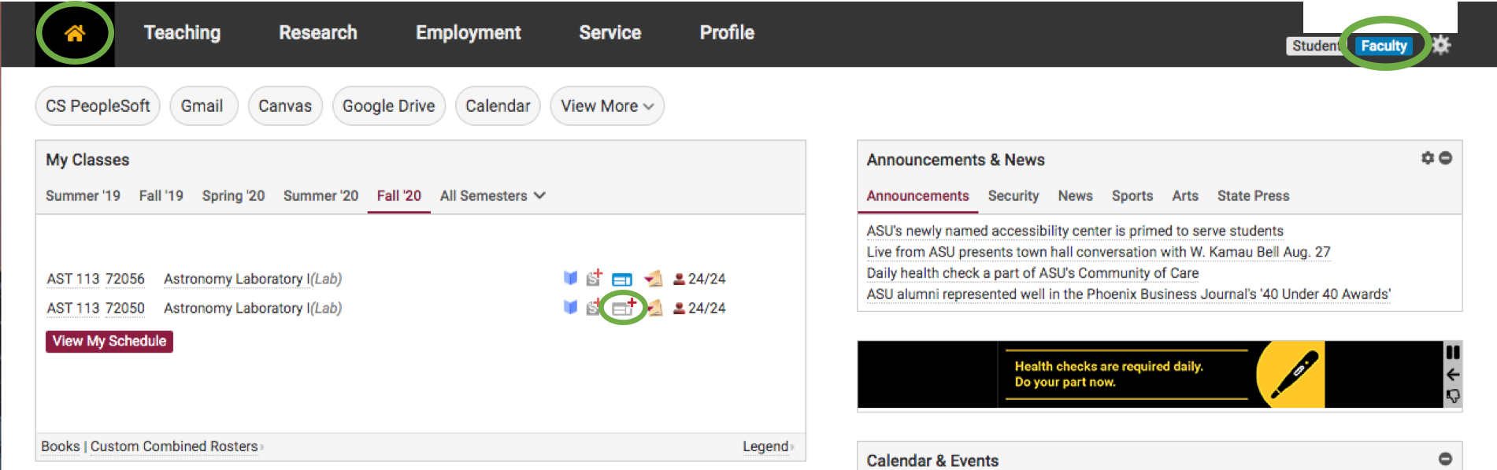

* This will take you to the next screen to set up your course. It is recommended to set up each section individually, as setting up multiple sections at the same time requires the creation of a .csv file with a specific format. Do not select “Request a Canvas training/development/organization course”.

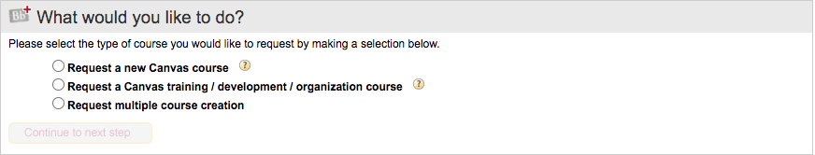

* Enter the information for your assigned section. The SLN is the Section Line Number listed for your specific section.

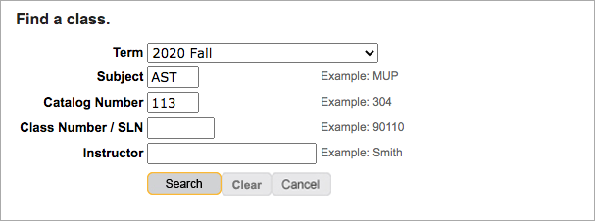

* Click search, then select the section. You may find more than one section listed, one with your name as the instructor, and one with the name of the faculty member in charge of the labs. It is recommended to click on the section with your name listed, though it’s unclear if this will affect anything.
* Continue to follow the instructions on the next few screens. Do not click “Add Sections”. Adding another section here will combine both Canvas pages into one so people from multiple sections will be combined. This is not recommended as different sections will have different schedules and due dates.
* If you have multiple sections it is recommended to add the day of the lab to the title of the course. For example: “AST 113: Astronomy Laboratory I (2020 Fall) Tuesday”.
* On the following screen it is recommended that if you have not taught the labs before to start a new Canvas class from scratch. All Canvas files will be provided. If you have taught the class before and used Canvas you can copy your previous Canvas page. There is also the option to copy a course from another instructor, however I’m not sure how this works. If possible you can copy the AST 113 Canvas pages from Kelley Liebst (although at the time of writing this document my pages are not fully set up).

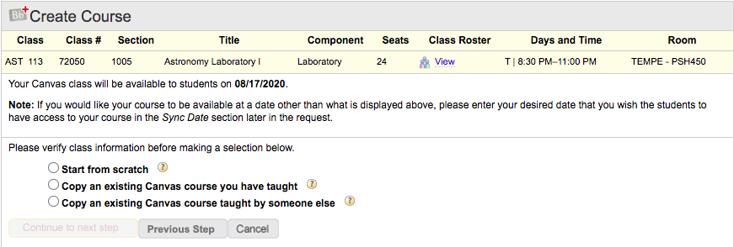

* When prompted to select instructors for the course delete Dr. Windhorst so that he doesn’t get emails and announcements from all sections (in the future be sure to ask the faculty member in charge of the labs what their preference is). Also be sure to set yourself as the instructor. The TA role in Canvas does not have as much functionality as the Instructor role.

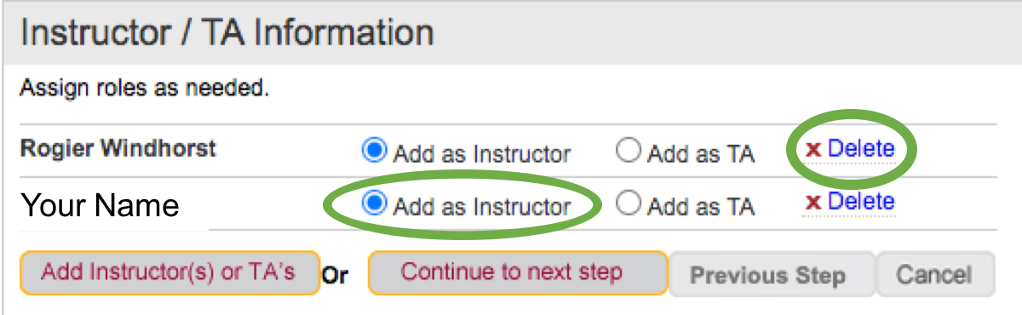

* No additional resources are needed.
* Double check the information you have entered is correct and select “Create Canvas Course” to submit your course request.
* Repeat for other sections.
* It can take a little while for your course to be created but you should receive an email when it’s ready.