**Hubble Expansion Quiz**

A figure below is the example of Hubble diagram for Type Ia Supernovae.

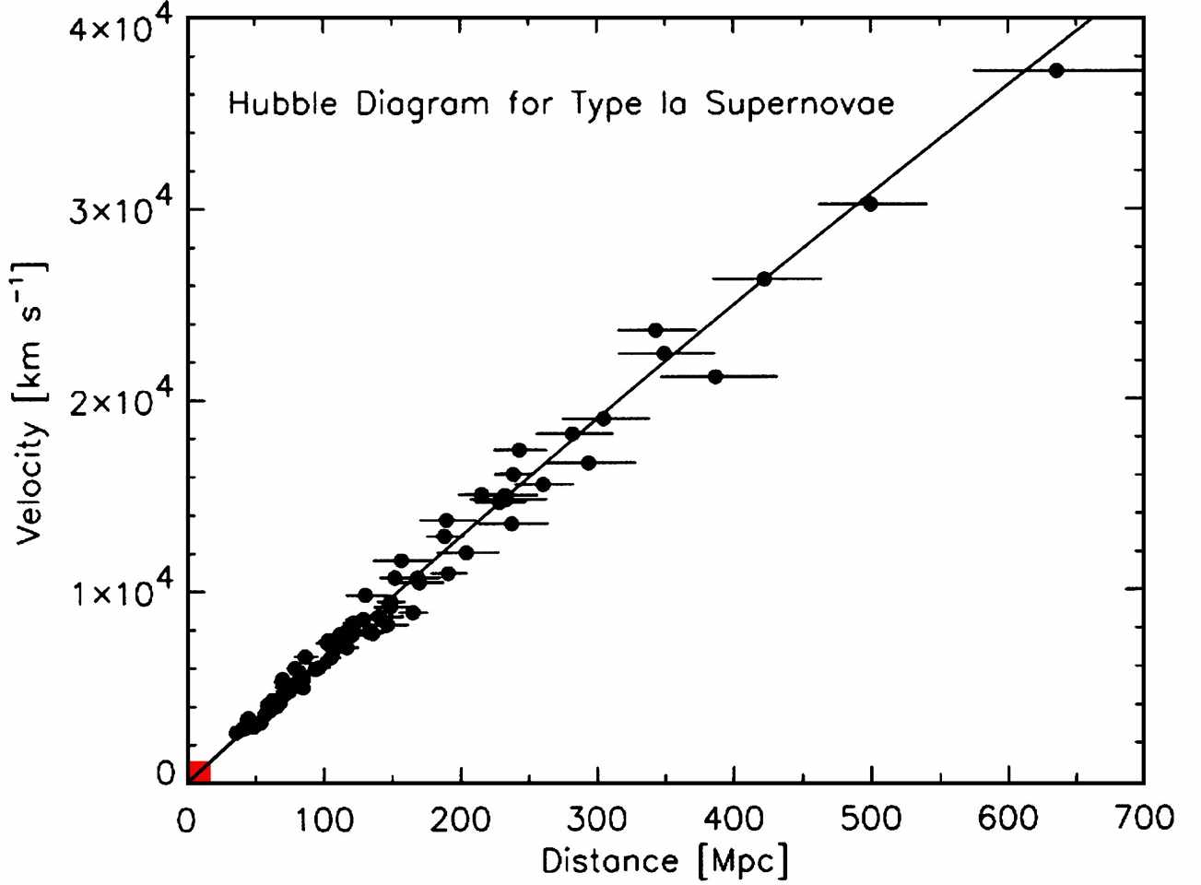

1. (10pts) Hubble’s expansion law is expressed by the equation *v = H0×D*, with the Hubble constant *H0*(slope of the diagram), the distance *D* to an object and its velocity *v*. Find the Hubble constant from the diagram. **Mark the data point you use** to calculate it on the diagram. Show your work.
2. (10pts) The true value of the Hubble constant is 73 km/sec/Mpc. What is the percentage error in your calculation from question 1? Show your work.
3. (15pts) What is the Age of the Universe? Use your Hubble constant from question 1. Follow the steps below.
   1. *H0* = ______________ km/sec/Mpc/(3*×*1019 km/Mpc) = _______________ sec-1
   2. T (sec) = 1/ *H0* = ________________seconds
   3. T (Gyr) = ________________ sec / 3.156*×*1016sec = __________________Gyr
4. (10pts) The currently adopted best value for the Age of the Universe is 13.7 Gyr. What is the percentage error in your age determination? Show your work.
5. (5pts) What is the name of the famous space telescope running for almost 20 years?