**NAME:**

**Prelab Questions for Hubble Expansion Lab**

1. Why does the pitch of a firetruck’s siren change as it speeds past you?

2. What color light has a longer wavelength – blue or red?

3. What are the typical values of observed redshift for objects in our own Galaxy?

**HUBBLE EXPANSION**

**What will you learn in this Lab?**

In this lab, you will reproduce the 20th century discovery by Edwin Hubble that the Universe is expanding. You will determine the rate of this expansion using the Hubble Ultra Deep Field.

**What do I need to bring to the Class with me to do this Lab?**

For this lab you will need:

• A copy of this lab script

• A pencil

• A calculator

**The Nature of Sound and Light**

An interesting property of sound waves is that the pitch of a sound emitted from a source moving with respect to the observer, varies as a function of the moving object's velocity. This is a phenomena you are all familiar with, if you have ever noted the change in the sound of a firetruck's or police car's siren that occurs as the sound sources moves away or towards you at a high velocity. Christian Doppler first derived the mathematical formalism to describe this effect, so in honor of its discoverer, we refer to this phenomena as the Doppler Shift of Sound.

Light waves are a different physical phenomenon than sound waves, light waves are manifestations of oscillations in electro-magnetic fields, whereas sound waves are pressures disturbances in a dense medium. *But* both phenomena can be described as waves. A light wave can be described, like a sound wave, by its wavelength or frequency. You interpret light of different wavelengths as different colors:

REDDER light has LONGER Wavelengths or LOWER Frequencies

BLUER light has SHORTER wavelengths or HIGHER Frequencies

Because the Doppler Shift effect applies to all wave phenomena, there exists a Doppler Shift of Light effect as well. Scientists quantify the amount by which that the light is shifted “blue” or “red” away from its rest-frame wavelength is given by a ratio referred to as a “redshift”, or simply “z”. Use the table to below to understand this terminology:

|  |  |  |
| --- | --- | --- |
| *If the light is …* | *…then the emitter is …* | *…and we call the effect a* |
| “Bluer” than expected | Moving towards you | Blueshift |
| “Redder” than expected | Moving away from you | Redshift |

In the above table, the “expected” wavelength of the light is measured in the “rest-frame”, usually in a laboratory on Earth. To see how this “expected” wavelength is useful consider the following. First, atoms and gases are the same here on Earth as they are anywhere in the Universe – Hydrogen in the Sun or here on Earth is the same Hydrogen that astronomers observe in galaxies hundreds of millions of lightyears away. So, if we know all of the transitions in a particular compound and the wavelength of light that each transition will produce, and we then measure any difference between the observed and expected wavelength from a distance object this indicates that the object has some relative velocity with respect to the observer.

The velocity of the object with respect to the rest-frame observer can be calculated with the following equation:

Where *z* equals the redshift of the object and *c* is the speed of light, 2.99x108 m/s.

When the redshift is small (much less than 1), then we can approximate the velocity of the moving object that is emitting light with the equation v = cz

For objects in the Milky Way, *z* is always much, much less than 1. This is because the velocity of the object is a true space velocity – the object is moving a distance *x* in a time *t,* and we all know that objects can’t travel faster than the speed of light.

But, things get interesting for distant galaxies where we commonly observe all objects with redshifts much greater than 1. But, this doesn’t mean that galaxies in the Universe are flying away from the observers at speeds greater than the speed of light. In fact, these galaxies are embedded in a Universe that is expanding! This discovery was made by Edwin Hubble in 1929, and is one of the primary arguments to support the “big bang theory.” In this lab, you will re-derive this expansion using a real scientific dataset.

**Introduction to AHaH**

In this lab you will use the Hubble Ultra Deep Field, a very long (~1 Million seconds) exposure of a “dark” part of the southern sky taken with the Hubble Space Telescope. In this image, thousands of galaxies were observed; some of these galaxies emitted their light more than 12 billion years ago. Arizona State researchers prepared this image so that a user of the “Appreciating Hubble at Hyperspeed” software could zoom through the image and inspect the images of the individual galaxies in the Field.

You will use this software to measure the redshifts and distances to a number of galaxies in the Field and derive the Hubble Law. The AHaH software is intuitive but the controls are provided in the graphic below.

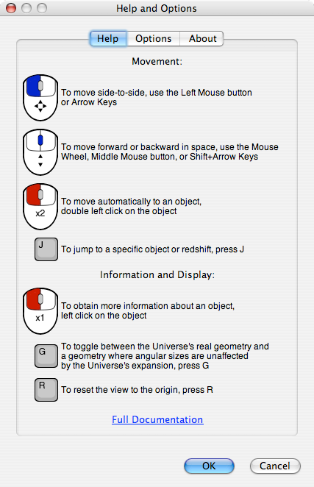

**Analysis**

When you understand how to obtain the redshift and distance for a galaxy in the Field, compile information for ~15 galaxies.

|  |  |  |
| --- | --- | --- |
| Galaxy ID | Distance (Mpc) | Redshift |
|  |  |  |
|  |  |  |
|  |  |  |
|  |  |  |
|  |  |  |
|  |  |  |
|  |  |  |
|  |  |  |
|  |  |  |
|  |  |  |
|  |  |  |
|  |  |  |
|  |  |  |
|  |  |  |
|  |  |  |

**GRAPH PAPER VERSION: Use this page if and only if you did your graph by hand on the graph paper provided.**

Now, using the graph paper at the end of the script, plot these objects. The “short” axis should be used as the Distance axis, and the “long” axis should be the galaxy’s redshift. When you are deciding on the range and spacing for this plot, remember to use the whole range of graph space available. You should also set the minimum Distance and Redshift value equals zero

Once you have plotted the data, draw a best-fit line to the distribution of data. This line does not need to go through all of the points, but should come close to each point. Remember to use a ruler or straight-edge. Your line should not “bend” or “jump”.

After plotting a best-fit line, perform the following:

1. Measure the slope of this line. To do this, remember that the slope is determined by measuring the change in the vertical direction divided by the change in the horizontal direction. The value of the slope should be small, much less than one, in the units you have plotted. You can show your calculations in the space below:

1. Convert the slope into the units of “km/s/Mpc” by multiplying the slope by value of the speed of light, which in km/s units, equals to 2.99x105

This constant is called “Hubble’s Constant.” Jump to page 7 and answer all the additional questions about this result.

**EXCEL VERSION: Use this page if and only if you did your graph on excel using the provided spreadsheet.**

Input your values for the Distance (Mpc) and the Redshift on the appropriate columns of the excel spreadsheet. When this is done correctly the Redshift is used to calculate the speed of the objects automatically. The graph created will have the Distance on the x-axis and the velocity in the y- axis.

Once the data has been plotted, a best-fit line will appear on the graph together with the equation of the line. The equation will have this form: y=mx where m is the slope of the line. This line does not need to go through all of the points, but should come close to each point.

1. What is the slope? Don’t forget to add the units of the slope. The units of the slope are the units of the y-axis divided by the units of the x-axis.

This constant is called “Hubble’s Constant.” Go to the next page and answer all the additional questions about this result.

**Additional Questions**

1. Think about what have you just measured about the Universe. On your graphs, as you move to larger and larger distances what happens to the velocity we measure for the velocity of galaxies? Are they moving away from us, or towards us? Think about direction – do you see the same thing independent of direction, or does it depend on which direction you look?
2. Based on your answer, what does that mean about the physical motion and evolution of the Universe? Given this discovery, wind the clock backwards and what does that tell you about the conditions and scale of the beginning of the Universe? What has happened in the intervening time?
3. If the accepted value of Hubble’s Constant is 73.8 km/s/Mpc, what is the percent error in your measurement?

Use the equation: % error = measured - accepted × 100%

accepted

1. Hubble’s Constant has the units for a “rate” – if the Universe has been expanding at the Hubble rate since its beginning, how long ago did the Universe begin expanding?
   1. To calculate this value, first divide Hubble’s Constant by the conversion factor between Mpc and km to cancel out these distance units and put the constant in 1/s units. Divide by 3.08x1019km/Mpc below:
   2. Now multiply by the number of seconds in one year (3.15x107 s/yr) to get your answer in inverse years.
   3. Now invert your answer (1 divided by your answer) to get the answer in years.
2. What are possible sources of error in the measurement of the Hubble Constant? “We could have messed up our measurements” is not a response. Think about the previous labs we have had in the semester – for example, Color-Magnitude Diagrams and Cepheids labs.

**Summarize what you have learned in tonight’s lab:**

