**NAME:___________________________**

**Exploring Impact cratering**

**What will you learn in this Lab?**

There are four major geologic processes that affect planetary surfaces – impact cratering, volcanism, tectonics, and erosion. Impact cratering is the most pervasive surface process on all planetary bodies. In this lab, you will:

* Become familiar with the relationship between crater size and crater morphology and the properties of projectiles.
* Determine the difference between a crater formed by an external impact (asteroid) and an internal explosion/eruption (volcano)
* Look at the relationship between kinetic energy of impact and the size/volume of the resulting crater.

**What do I need to bring to the Class with me to do this Lab?**

For this lab you will need:

* A copy of this lab script
* A pencil and eraser
* A scientific calculator

# I. Introduction

Impact cratering occurs when a planetesimal - usually debris from a comet, asteroid, or meteoroid - crashes into the surface of a terrestrial body (solid surfaced planets). Throughout the solar system's history, planetesimals have heavily bombarded all the terrestrial bodies. . On Earth, and even Venus and Mars, erosion, volcanic resurfacing, and tectonic activity continually erase craters, but the Moon and Mercury have not erased this bombardment because the other geologic processes on these bodies stopped millions of years ago. In this lab, we investigate the different type of craters, how they form, and what we can learn from them.

# II. Impact Craters

## Crater Basics

After a planetesimals impacts the surface of a terrestrial body, a crater is left behind. The original projectile vaporizes on impact due to tremendous pressures and temperatures involved with the impact. The typical speed at which a projectile hits a planetary body is 10 – 30 km/s. That’s 22,000 – 67,000 MPH! This produces a crater that is 10 to 20 times larger in diameter than the physical size of the impacting object. The shape of the crater is usually circular, but if the impact is at an oblique angle, the crater is asymmetric and usually oval.

Debris from the blast, called **ejecta**, is deposited in the area surrounding the crater. Close to the crater, the ejecta typically forms a thick, continuous layer, while at larger distances the ejecta may fall as discontinuous clumps of material. When large ejecta material falls back down to the surface, it is possible other craters will be made. These are termed secondary craters or secondary impacts. Ejecta that create long, bright streaks or lines that radiate from a crater are called rays.

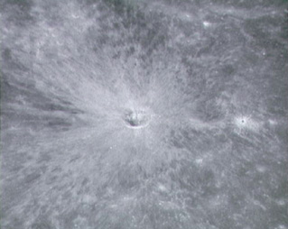

Figure 1 – Example of a lunar crater with rays (taken from orbit)

## Crater Types

There are three different kinds of craters: simple craters, complex craters, and rampart craters. Simple craters are usually less than 1km in diameter, have bowl shaped depressions, and are formed by projectiles travelling with low speed and low energy. Because the impact is created with a low-energy projectile, material will fall back into the crater and is known as Breccia fill.

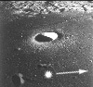

Figure 2 – Example of a simple crater (Moon)

Complex craters typically have shallow, relatively flat floors, central uplifts, and slump blocks and terraces on the inner wall of the crater rim. These craters are found in three classes of sizes. Low- to medium- energy impactors will result in craters that are 1 – 10 km in diameter with central peaks in the primary crater. Central peaks are formed from a rebound (uplift) of material, due to the larger speed and energy of the impactor, and a subsequent collapse back into the crater floor. When impactors have even more energy, the impact causes a more dramatic and extended uplift, creating the second class of complex crater – those with **peak rings**. These medium- to high- energy impactors are 100-300km in diameter and have a characteristic ring of mountains within the crater. Multi-ring basins are the third class of complex crater. These are approximately 1000km in diameter and are formed by large impactors travelling with high speed and energy.

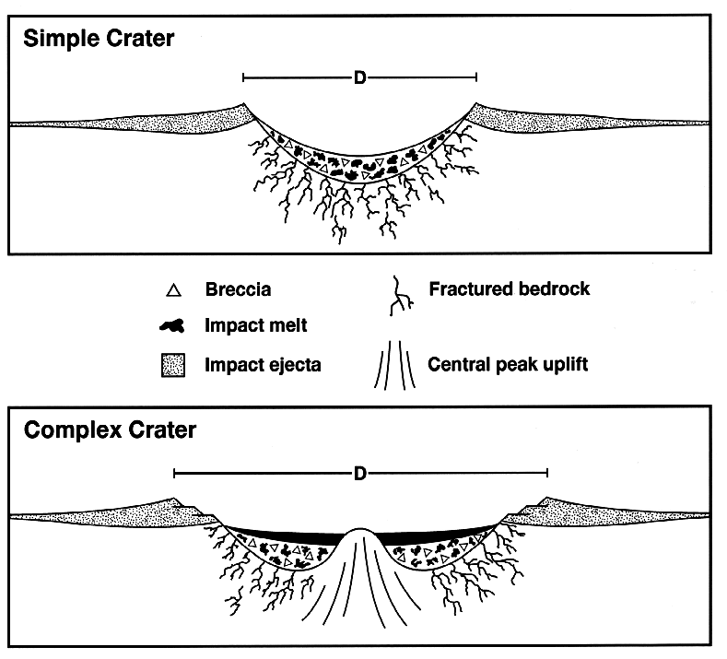

Figure 3 - Cross-section of a simple and complex crater

**a) 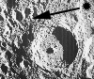 b) 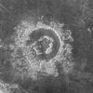 c)** 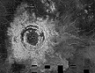

Figure 4 - Examples of Complex craters

(a) Central peak (moon); (b) Peak ring crater (Venus); (c) Multi-ring crater (Venus)

The third type of crater is a Rampart crater. They are characterized by teardrop shapes of material coming from the crater. These lobes are similar to those seen with volcanic and mud flows and are used as evidence that there was liquid or ice water (or some other volatile) at some time on the planetary surface.

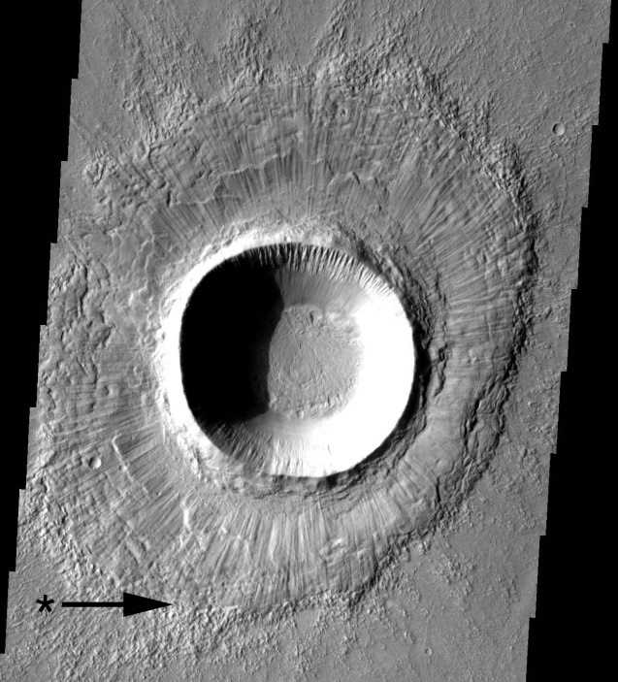

Figure 5 - Example of a rampart crater (Mars).

# IV. Volcanic Craters

Impact craters will have ejecta and crater floors at a lower elevation that the surrounding area. They can be simple or complex, but the environment will show signs of having been impacted. Volcanic craters, on the other hand, will be at a higher elevation than the nearby terrain, and though they may show signs of lava flows, the ejecta characteristic of impact craters does not appear near volcanic craters. A **caldera** is a volcanic crater formed by the collapse of an empty magma chamber.

# V. Relative Dating and Superposition

**Absolute time** refers to the exact time or date of an event (e.g. the dinosaurs died approximately 65 million years ago). For the Moon absolute time was determined by radioactive dating of lunar rocks brought back by the Apollo Moon missions.

However, we do not always have samples available to absolute date for terrestrial bodies. Instead, we use **relative dating** to determine the ages of events. Relative dating compares events against other events to determine the order in which they occurred. With relative dating, no exact date is identified (e.g., you might posit that WWI occurred before WWII without knowing the date for either event). Most often, relative dating is determined using the **law of superposition**. The law of superposition states that the top layer is *younger* than the bottom layer. When looking at craters, when we see one crater underneath another we know the bottom one was created first. This provides a relative timeline for when the impacts occurred.

# VI. The Experiment

## Exercise 1 – Qualitative Analysis

**Draw!** Choose a ball bearing and practice dropping it from various heights into the box of sand. Once you have perfected your aim, choose a height from which to drop your ball bearing, and in the boxes below, sketch the resulting crater (both from above the crater and looking through the side of the box). Below the sketch, indicate the crater diameter and an estimate of the measurement uncertainty.

**Sketch Top View of Impact Crater Sketch Side View of Impact Crater**

 

Drop Height: ____________ Drop Height: ____________

Diameter: _______________ Diameter: _______________

Error: ± _________________ Error: ± _________________

1. What limits the precision with which we can measure the crater diameter? In other words, what factors introduce uncertainty into the measured diameter of the crater?
2. Using full sentences, describe your crater. How would its appearance change if the ball hit the sand at an oblique angle rather than straight on?

## Exercise 2 – Impact Craters vs Volcanic Craters

This exercise will compare craters formed by external impacts (asteroids) to those from internal explosions/eruptions (for example from a volcanic explosion/eruption). You will use a balloon to simulate a volcanic explosion. Inflate the balloon to about fist-sized with the bicycle pump, attach the balloon to the tubing with a clamp or tie it off, and then place it into the center of the sandbox. Bury the balloon by piling up the sand in a mound over the balloon (about an inch or two deep), and pop the balloon with a sharp object (pencil or compass). Using the boxes below, sketch the crater from the side and top. Measure the diameter and estimate the error.

**Sketch Top View of Volcanic Crater Sketch Side View of Volcanic Crater**

 

Drop Height: ____________ Drop Height: ____________

Diameter: _______________ Diameter: _______________

Error: ± _________________ Error: ± _________________

1. How does the process for creating an impact crater differ from the process needed to create a volcanic crater?
2. Look at your sketches for the Impact Craters and Volcanic Craters. Compare and contrast their appearance.
   1. Are the raised rims different? If so, in what way?
   2. Which one has greater effect on the surrounding material? Explain.
   3. Which one might have used greater energy in excavating a crater? Explain.
3. Explain how you would be able to tell by looking at the surface of a planetary body whether an external impact (asteroid) or an internal explosion/eruption (volcano) made the crater.
4. Figures 6 and 7, below, show craters on planetary bodies in our own solar system. Examine these craters. Is there evidence that either planetary body may have some kind of liquid (perhaps water) in its history? Explain.

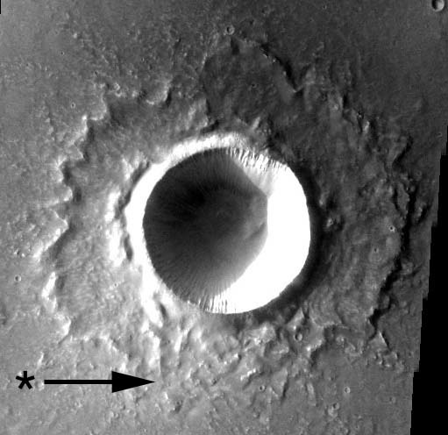 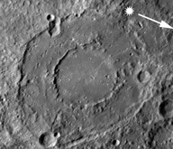

Figure 6 - Image from Mars Figure 7 - Image from Mercury

1. Theoretically, using the Law of Superposition with craters should provide the relative ages of the planetary bodies if we know when the first impacts began/ended. What geologic processes could confuse the relative age dating of planetary bodies?

## Exercise 3 – Mass, Velocity, and Crater Size

**Note:** Before starting this section, download the Impact Cratering spreadsheet.

The mass and velocity both play a role in determining the energy of the impactor when it hit the sand. The **free-fall velocity** is given by

$v= \sqrt{2gh}$ (Eq. 1)

where g = 9.81 m/s2 is the acceleration due to gravity and *h* is the height of the fall. This equation assumes the object starts at rest and gains speed as it falls toward the earth. **Kinetic energy** is the energy of a moving object, and depends on the object’s mass, *m*, and the object’s speed,

$KE= \frac{1}{2}mv^{2}$ (Eq. 2)

or

$KE= mgh$ (Eq. 3)

In this exercise you will investigate how crater diameters vary with the size, mass, and velocity of the impactor.

1. If the *mass* of the impactor doubles, will this increase or decrease the kinetic energy? By how much?
2. If the *mass* of the impactor doubles, will this affect the velocity? Explain.
3. If the *velocity* of the impactor doubles, will this increase or decrease the kinetic energy? By how much?

**Measure!** For this exercise, drop 5 ball bearings of various sizes into the box of sand. You will want to drop each ball vertically from the 4 heights indicated in the Excel spreadsheet. Measure the diameters of the craters produced, and record these values in the Excel table.

The spreadsheet will calculate the velocity and the kinetic energy of the impact for you. However, as scientists, you should always check a calculation or two by hand to ensure that your program is functioning properly.

1. Using the mass and height from your first impact, calculate the velocity and KE for this impact. **Show your work and don’t forget units!** Compare your calculated value to the appropriate columns in the spreadsheet to ensure it is functioning properly. (Hint: you may need to convert units. The final units for velocity should be m/s and KE should be g*m2/s2.)

Looking at the data in your spreadsheet, answer the following questions:

1. When you have two impactors of the same mass, but you double the height, does the KE increase or decrease? By how much (1x, 2x, ½, ¼, etc)?
2. Does doubling the ball mass affect the free-fall velocity? If so, by how much?
   1. Does the diameter of the ball affect its velocity? If so, by how much?
   2. Does doubling the height affect the velocity? By how much?

The Excel spreadsheet should provide 4 graphs

* Impactor mass vs. crater diameter
* Impactor diameter vs. crater diameter
* Impactor velocity vs. crater diameter
* log(crater diameter) vs. log(KE)

Look at these graphs and answer the following questions:

1. What general relationships do you see between the variables in each of your 3 graphs? As you increase the mass/diameter/velocity of the impactor, how does the diameter of the resulting crater change?
2. Which is the most important factor controlling the crater size - size, mass, or velocity of the projectile? Why?
3. As an asteroid falls toward Earth, it gains kinetic energy, as discussed above. That energy is released when the asteroid impacts the ground and excavates the material around the impact site. The volume of material excavated, and thus the diameter (*d*) of the crater, is proportional to the kinetic energy of the impactor and can be described by

or

* 1. If you were to plot log(crater diameter) vs. log(KE), what should the slope be?
  2. Does your data support this relationship between crater diameter and kinetic energy of the impact? (i.e., does it have the expected slope?)

# Conclusion

Summarize the concepts you learned about in tonight’s lab. What did you learn about each of these concept? Summarize the experiment. How did this experiment help you understanding of the concepts?