**NAME:___________________________**

**Introduction to the NIGHT sky**

**What will you learn in this Lab?**

This lab will introduce you to the layout of the night sky: constellations and stars, their names and the patterns they make, and the cardinal directions that allow you to orient yourself relative to the stars. You will be asked, probably for the first time, to critically look up and draw or chart what you see. In particular you should learn how to match the stars on a chart with what you see in the night sky.

**What do I need to bring to the Class with me to do this Lab?**

For this lab you will need:

* A copy of this lab script
* A pencil
* Audubon Sky Guide
* SC sky maps (both of them)
* Star wheel
* Red Flashlight

# I. Introduction:

In this lab, you will begin exploring the night sky. You will be introduced to constellations, asterisms, the magnitude system and stellar nomenclature. In addition, you will be introduced to the tools that you will use in upcoming night sky labs.

Even on the roof in the middle of the Phoenix metropolitan area, the primary thing you see when you look up in the sky are stars. It is very natural to see patterns in the stars. It is from this that the idea of constellations was developed.

# II. Constellations

**Constellations are areas of the sky where a group of stars form a recognizable pattern.** The entire sky has been broken up into 88 constellations. Most of the names of the constellations are based upon mythology from several thousand years ago. Some of the constellations look like the objects they are named for, many do not. However, many of the southern constellations (which can not be seen from Tempe) have more modern names indicative of the Industrial Revolution taking place at the time when they were first noticed by European explorers. Plates 69-211 in the Audubon Guide show maps and photographs of the 88 constellations. Pages 421-621 provide more information on the constellations.

When you consider the geography of the United States, every place in the U.S. is part of a state. Similarly, every point in the sky is part of a constellation. If an object (e.g. Moon or planet) appears in front of a constellation, it is referred to being within that constellation.

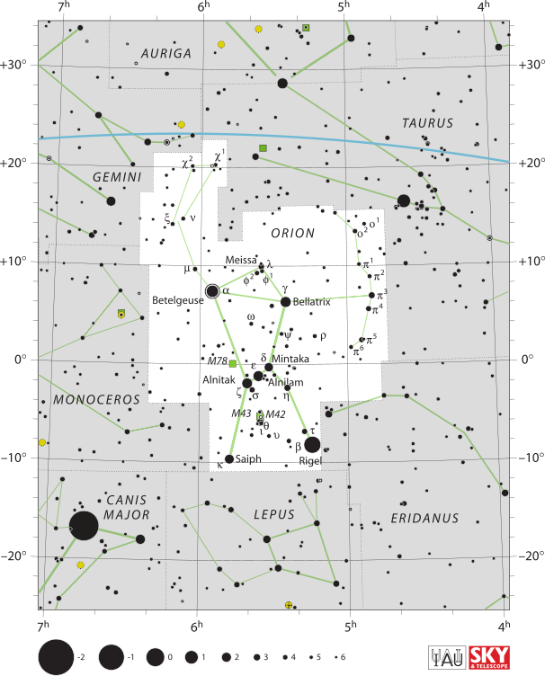

Fig 1. A chart of the constellation Orion.

# III. Special Constellations

For this class, we have two separate classes of special constellations: Circumpolar and Zodiacal.

## Circumpolar Constellations

Circumpolar constellations are those constellations that are close enough to the NCP (North Celestial Pole) that they never set below your horizon. It can easily be shown that for an object to be circumpolar it must be closer to the NCP than the observer's latitude. Here in Tempe, the latitude is 33º, so any object within 33º of the NCP is circumpolar in Tempe. The importance of these constellations is that they can be seen at any time of the night, although they do continue to appear to rotate around the NCP as the Earth rotates on its axis.

## Zodiacal Constellations

Most people know the names of these constellations. The reason for this is not that they are bright, but that they are placed in a very specific location. An observer on the Earth "sees" the Sun travel around the sky, passing through a variety of constellations, once a year. It is the motion of the Earth around the Sun that causes this apparent motion. There are 13 constellations in which the Sun appears throughout the year. These are the zodiacal constellations.

The twelve formal Zodiacal constellations are:

Aries, Taurus, Gemini, Cancer, Leo, Virgo, Libra, Scorpius, Sagittarius, Capricornus, Aquarius and Pisces.

The Sun also passes in front of Ophiuchus (the 13th mentioned above). The apparent path of the Sun defines the ecliptic and is shown on your SC charts as well as your star wheel.

## Asterisms

Constellations are often recognized by the pattern of stars that are located within them. There are also other prominent groups of stars that are not formal constellations. They can be larger than the constellations or subsets of the stars within a particular constellation. Some well-known examples visible from Tempe during the year are:

* The Big Dipper (part of Ursa Major)
* The Little Dipper (part of Ursa Minor)
* The Winter Hexagon
* The Summer Triangle (Altair, Deneb, and Vega)
* The Great Square of Pegasus
* The Sickle of Leo
* The Keystone of Hercules

# IV. Magnitudes

When one looks at the sky, or at the photos in the Audubon Guide, one quickly notices that all stars do not appear the same. There is a very wide range in brightness. Stars also appear in different colors. Astronomers occasionally use an archaic method of specifying the brightness of an object. This system is called the magnitude system. The brightness of a star as seen in the night sky is called its apparent magnitude. For a more detailed explanation of the magnitude system and how the numbers work, refer to p.24 of the Audubon Guide.

One will also notice, with some of the brightest stars, that one can see colors (binoculars may help for some students). Wien's Law (see your textbook) shows that the wavelength (or color) of peak brightness of a star depends upon the temperature of the star. You may have noticed this when looking a campfire or other fire sources. In general, they are red when at a lower temperature and as the temperature increases the color slowly changes from orange to yellow to white and finally to blue. However, there are exceptions to this rule based on what is being burned! In the sky, the color of a star indicates its surface temperature. Blue stars are hottest; red stars are coolest.

# V. Stellar Nomenclature

Many of the brightest stars in the sky have proper names. Your TA will introduce you to a dozen or so of these on the roof. You can also see that the brightest stars are named on your star wheel or in the Audubon Guide. One realizes that if all 6000 naked eye stars and the enormous number of fainter stars all had proper names, nobody would be able to figure out which star someone was talking about.

Astronomers developed a naming system for the brighter stars. The stars that are named within this system include nearly all of the stars visible from within the city. The name consists of two parts: the name of the constellation in which the star is and a Greek letter. See the lower case Greek alphabet below. The Greek letters generally correspond to the brightness of the star (i.e. the brightest star is , the second brightest  and so on through to ).

**The Lower-case Greek Alphabet**

|  |  |  |  |  |  |
| --- | --- | --- | --- | --- | --- |
|  | alpha |  | iota | ❒ | rho |
|  | beta |  | kappa | ⬧ | sigma |
|  | gamma | ● | lambda | ⧫ | tau |
|  | delta | ❍ | mu | ◆ | upsilon |
|  | epsilon | ■ | nu |  | phi |
|  | zeta |  | xi |  | chi |
|  | eta | □ | omicron |  | psi |
| ❑ | theta | ❐ | pi | ⬥ | omega |

*Since this system was done by estimating, there are many constellations where this simple rule is violated due to the presence of variable stars, or other contributing factors.

# VI. Equipment

## The Star Wheel

One of the most useful items that will be used this semester is your star wheel. Your TA will spend some time tonight explaining to you how to use this device.

## Red Flashlights

Another item that you will need to bring to every outdoor lab is a **red** **flashlight**. You will be out on the roof, but since we are in the city, it won't be really dark, but too dark to read your labs. Make sure you bring a red flashlight that just gives enough light that you can read the labs and see what you have written. Your eyes are less sensitive to red light than to white light, so your eyes will dilate less when using a red flashlight. Ask your TA for some red cellophane if you do not have a way of making your flashlight red.

# VII. The Experiment

## Exercise 1: Starwheel and Constellation Charts

1. Use your star wheel to determine which constellations should be visible at 8pm tonight. List the main ones.
2. Use your star wheel to determine which constellations are considered circumpolar from Tempe. List them.
3. If you were to travel to 50º N latitude, would the number of circumpolar constellations increase or decrease?
4. Use your star wheel to determine which zodiacal constellations should be visible at 8pm tonight. List them.

**You will need to use your Audbon Guide book or Fig. 1 on pg 2 to help answer the following questions.**

1. What is the famous three star asterism in Orion? ______________________

Hint: Men in Black. Still stumped, ask your TA for guidance.

1. Based on the apparent magnitude, what is the common and proper names of the brightest star in Orion?

Common name: ___________________ proper name: __________________

1. What is the apparent magnitude of this star? _________
2. What is the common name of  Orionis? What is the apparent magnitude of this star?

Common name: ___________________ apparent mag: ________

## Exercise 2 – Drawing a Constellation

Allow your eyes to get dark adapted (about 15 minutes). Your TA will give you a constellation tour to introduce you to the visible brighter stars and constellations.

**Draw!** Choose a bright constellation that you know is up tonight. Draw it on page 9. Identify N, S, E, and W on your diagram and the direction you think it will move at the night progresses.

1. Compare your drawing with the constellation sketch in the Audubon Guide. Did you see all the stars shown in the diagram? Why or why not (buildings blocking your view is not a valid argument)?
2. Make an estimate from the legend on the charts as to what was the faintest magnitude star you could see? Were you able to see all of the stars at this magnitude or only a select few?

## Exercise 3 – Specific Objects in the Night Sky

Using your star chart, find 5-10 bright stars (to be specified in class).

**Locate!** Locate the stars both in the sky and on your chart so you get used to reconciling the chart with what appears in the night sky.

**Record!** Record the stars’ proper names (this might require the use of your Audubon) in Table 1. Also record the constellation in which each star is found.

**Identify!** Identify the direction you had to look to observe the star.

**Table 1 – Bright Stars**

|  |  |  |  |
| --- | --- | --- | --- |
| **Star name** (common) | **Star name** (Proper) | **Constellation** | **Direction** |
|  |  |  |  |
|  |  |  |  |
|  |  |  |  |
|  |  |  |  |
|  |  |  |  |
|  |  |  |  |
|  |  |  |  |
|  |  |  |  |
|  |  |  |  |
|  |  |  |  |

Use Table 2 below to record information on the Moon and planets that can be seen tonight. Ask your TA to point out any such planets. Describe the color of the planets and which constellation the moon and planets are found in. Also identify which star from Table 1 is closest to each object.

**Table 2 – Moon and Planets**

|  |  |  |  |
| --- | --- | --- | --- |
| **Object name** | **Color** | **Constellation** | **Nearest star (Table 1)** |
|  |  |  |  |
|  |  |  |  |
|  |  |  |  |
|  |  |  |  |

# Exercise 4 – Sky Sketches

**Northern Sky Sketch**. Draw on page 10 an area of the sky about 70-80º high and wide.

1. Include all of the brighter stars – and try to draw to scale.
2. Label the constellations that you draw.
3. Include any bright objects like planets or the Moon.
4. Make sure you fill in the date and time of the observations.
5. Get instructor signature for each drawing.

**Southern Sky Sketch**. On page 11, do the same as for the Northern Sky Sketch.

1. Include all of the brighter stars – and try to draw to scale.
2. Label the constellations that you draw.
3. Include any bright objects like planets or the Moon.
4. Make sure you fill in the date and time of the observations.
5. Get instructor signature for each drawing.

# VIII. Conclusion:

## Part II Constellation Sketch

Choose a constellation, or two adjacent constellations, located **high** above the *horizon* consisting of at least **eight** or more stars visible to your eye.

1. Carefully draw this/these constellation(s) below

2. Indicate the brightness of the stars with different sized dots, using larger dots for brighter stars and smaller ones for the fainter stars.

3. Identify N, S, E, and W on your diagram.

4. Identify the direction you think it will move as the night progresses.

Constellation Name(s):

Date: Time:

Instructor verification:

## Part IV Northern sky sketch

Date: Time:

Instructor verification:



## Part IV Southern sky sketch

Date: Time:

Instructor verification:



South