**Name: _________________________**

**Introduction to the Telescope**

**What will you learn in this Lab?**

For a few of the labs this semester, you will be using an 8-inch Celestron telescope to take observations. This lab will introduce you to the telescope itself and some properties of a telescope. Observations will be made to illustrate the different telescope properties.

**What do I need to bring to the Class with me to do this Lab?**

For this lab you will need:

* A copy of this lab script
* A pencil
* Your flashlight
* Your star wheel
* Your Audubon field guide
* Scientific calculator

**If working from home using a personal telescope or binoculars, some parts may or may not be possible to complete. Discuss any questions with your TA. Some directions for binoculars or personal telescopes are provided.**

# I. Introduction:

In this lab exercise you will become familiar with the parts of a telescope and how to use one. You will also become familiar with some telescope properties and use observations to illustrate these properties. These properties include:

**Remember, telescopes are precision instruments; be careful using them. Ask your instructor for help when you are in doubt about what to do.**

## Lab Goals:

* Learn to set-up and operate the Celestron 8” telescope.
* Investigate how the focal length of the eyepiece affects the magnification and field of view of the telescope.
* Understand the terms (1) light gathering power, (2) resolving power, and (3) scale and know how they factor into the properties of a telescope.
* Make measurements with a telescope and understand how those measurements relate to the properties being explored.

# II. Parts of ASU’s CPC Series Telescope:

**Primary Mirror**: This is the large mirror at the telescope's lower end that 'collects' and focuses the light so that we can see fainter stars than with our 'naked' eyes. ASU astronomy labs currently use “8-inch” telescopes. This means the diameter of the primary mirror is 8 inches. These are called *reflecting* telescopes.

**Mounting**: The mounting supports the telescope and allows it to be moved in two directions (or axes): one in the same sense as the Earth rotates (*right ascension*) and the other in a north/south direction (*declination*).

**Optical Tube**: The optical tube holds the optical parts (eyepiece, primary, and secondary mirrors for *reflecting* telescopes) in the correct position.

**Clock Drive**: The clock drive turns the telescope at the same rate as the Earth turns, but in the opposite direction so that the telescope stays pointed at one particular location in the sky (*i.e.,* a star).

**Hand Control**: The hand control is the primary method used to interface with the Celestron telescopes. The four direction arrows allow you to slew the telescope in any desired direction or to better center an object in the eyepiece’s field of view.

**Star Diagonal**: The star diagonal diverts light at a right angle from the light path of the telescope. For astronomical observing, this allows you to observe in positions that are more comfortable than if you were to look along the axis of the optical tube.

**Finderscope**: The finderscope is a smaller telescope with *less* magnification and a *larger* field of view. It is attached to the side of the main telescope and points in the same direction as the main telescope. The larger field of view makes it easy to initially locate a star in the finder telescope, hence the name *finder*. After a star is centered on the cross hairs in the finder, it will also be visible in the eyepiece of the main telescope. DO NOT touch the finderscope for any reason. Do not use it as a handle to move the scope, or attempt to adjust it in any way.

**Eyepiece**: This is the part you look through! Each eyepiece is identified by its *focal length*, which is stamped in white letters on the casing (e.g., 18 mm, 25 mm, etc.)

**Focus Adjustment**: Once you have the star in the main eyepiece, focus on it sharply. It may help to remove your glasses. If you are observing faint objects, try using *averted vision*. That is, look at the object out of the corner of your eye. This works because the light detecting cells used by averted vision are more sensitive than those used by direct vision. It also will help to turn all the lights out and wait a few minutes for your eyes to become dark adapted.

**Tripod**: Each telescope rests on a tripod that has been carefully leveled for its location on the observation deck. A telescope’s ability to accurately track a desired target is best maintained by keeping the telescope on a level base. DO NOT move or adjust the tripod in any way during the duration of the outdoor labs.

**Fork Arms**: The Celestron telescopes are held in place by fork arms and are part of the slewing mechanism that allows proper tracking of celestial objects. NEVER grab the fork arms or body of the telescope to move/adjust the telescope.

**The different components of the Celestron 8-inch reflecting telescope is diagrammed in Fig. 1 on the next page.**

# III. Properties of a Telescope:

**Light Gathering Power**: The primary function of an astronomical telescope is to collect light. The *light gathering power* of a telescope is measured by the **area** of the light collector (either a lens or a mirror), though a telescope's size is always specified by the **diameter** of its primary mirror. The area of a circular mirror is

,

where *A* is the area of the mirror, and *D* is the diameter of the mirror. Thus, comparing the *light gathering power* of a 14-inch and 8-inch telescopes, we find the 14-inch has 3.06 times **greater** light gathering power.

**Focal Length**: For a simple mirror, the *focal length* is the distance between that mirror and the place where the image is formed. In a telescope with more than one optical element (or mirror), the *effective focal length* is often longer than the telescope tube itself. It is useful to know the focal length of the telescope or eyepiece that you are using. The focal lengths of the ASU telescopes are:

focal length = 2000mm, for the 8-inch Celestron telescopes

**Focal Length WILL differ if you are using your own telescope or Binoculars! Please find it for the model you own/purchased if possible.**

The focal lengths of the ASU eyepieces are stamped on the end of each eyepiece. Typical eyepiece focal lengths are 40mm (lowest power), 24mm, 18mm, etc.

**Magnification of a Telescope**: The *magnifying power* of a telescope is determined by the focal length of **both** the telescope and the eyepiece used. **An eyepiece with a shorter focal length gives a greater magnification.**

**Field of View of a Telescope**: The angular size of the piece of sky seen through a telescope is called its *field of view* (*i.e.,* FoV) and depends both on the telescope and the eyepiece used. Since the FoV is an angle, it is measured in *degrees* (º), *arcminutes* (‘), or *arcseconds* (“). For a given telescope, **the greater the focal length of the eyepiece, the greater the field of view**. If you double the focal length of the eyepiece, you also double the FoV. If you are using binoculars, it is more difficult to find field of view, and it will likely be quite large.

To calculate FoV with binoculars or a low magnification personal telescope, find an object of a known height or width such as a wall, and move so that it barely fits in your FoV. Then it is a simple calculation using a right triangle to find the angle subtended by the object of choice, and if placed right in your binoculars or eyepiece, this gives a good estimate for the size of your field of view.

For example, if in the triangle below, you are on the right, 50 feet away from the wall, which is five feet high, then the angle subtended by the wall is given by the inverse tangent function on a calculator.

5 feet

You are here

50 feet

tan^-1 ( 5 / 50 ) ~ 5.7 degrees

**If you are using this method to calculate your FoV, then reasonable estimates for height and distance are fine.** You can, but are by no means required to, measure the distance exactly, but it should be easy to measure the height of any object for this purpose. You can use your own height as a reference if using a wall for example, or use a piece of paper, which you can easily measure the size of with a ruler.

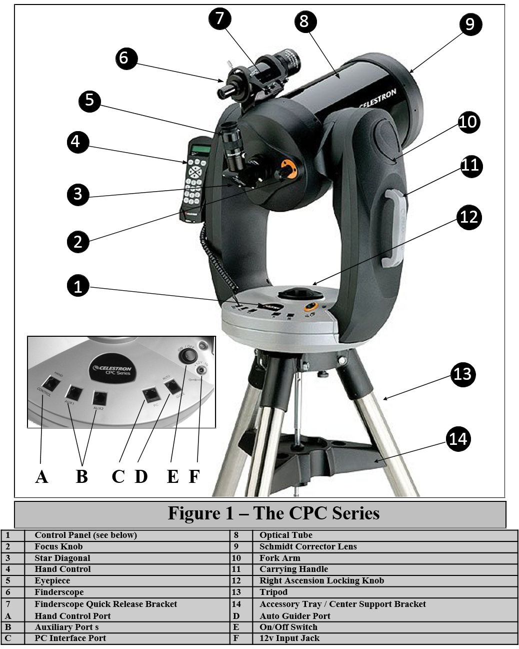

**Resolving Power**: The *resolving power* (also called *angular resolution)* is the ability of a telescope to separate two close images or to see fine detail in an image. Greater magnification WILL NOT resolve two images that are closer than the resolution of a telescope. The limit, called the Rayleigh criterion, depends on the diameter of the telescope's primary mirror (D) and the color (or wavelength) of the light observed. For **visible light**, the minimum separation of two objects which can just be resolved is:

,

where α is the angular separation of two stars (in arcseconds), and D is the diameter of the telescope's primary mirror (in inches). The diameter of the forward facing lenses is used if you are using binoculars.

For example, the resolving power for the 8-inch telescopes is α = 0.57”. However, you may not actually be able to see two images this close together because of atmospheric conditions ("seeing"), relative brightness of the objects, etc.

Scale of a Telescope: The scale at the focus of any astronomical telescope is the ratio of the angular size of an object in the sky to its image size with that telescope (e.g., how large the object would look if you were to photograph it with that telescope).

The scale is constant for a particular telescope and depends only on the focal length of the primary mirror. The scale is usually expressed in units of degrees per millimeter (º/mm) or arcseconds per millimeter (“/mm).

Examples:

1. If the scale is…

scale = 30” / mm

…an object which is 30 arcseconds in angular size in the sky will appear 1 mm in diameter when viewing that object through the telescope, an object 60 arcseconds in size will appear 2 mm in diameter when viewing through the telescope, etc.

1. If the scale is…

scale = 2°/mm

…an object which is 2 degrees in angular size in the sky will appear 1 mm in diameter when viewing that object through the telescope, an object 4 degrees in size will appear 2 mm in diameter when viewing through the telescope, etc.

# IV. The Experiment

## Exercise 1: Looking at Resolving Power and Light Gathering Power

In this exercise, you will estimate the resolving power of your eye and comparing it to the resolving power of a pair of the 8-inch Celestron, and a 2.25 set of Binoculars.

The angular separation between two stars can be calculated using trigonometry. Form a triangle with one length equal to the distance between you and the light box and the other length equal to the physical separation of the stars. The angular separation is

where  is the angular separation of the stars in arcseconds, s is the physical separation of the stars, d is the distance to the light box, and 3600 converts degrees to arcseconds. **To use this equation, your calculator should be in DEGREE mode!**

1. In bright light conditions, the pupil of the human eye is approximately 0.2 inches in diameter. What *should* the light gathering power of your eye be, if the human eye were perfect? Show your work. Hint: use the formula on page 6
2. What is the light gathering power of the 8-inch Celestron telescope? Show your work. Hint: use the formula on page 6
3. How much **greater** light gathering power does the 8-inch Celestron telescope have compared to the perfect human eye?
4. What *should* the resolving power of your eye be, if the human eye were perfect? Show your work. (Answer in arcseconds) Hint: use the formula on page 9
5. What is the resolving power of the 8-inch Celestron telescope? Show your work.( Answer in arcseconds) Hint: use the formula on page 9
6. If two objects are placed 1 ft apart at a distance of 5280 ft (1 mile) away from you, what will there angular separation be? Hint: use the formula on page 10
7. Using your answer from Q6, does the perfect human eye have the ability to resolve these two objects from one another? Can a 8-inch Celestron telescope resolve both objects from one another? Hint: use your answer for resolving power of the human eye and 8-inch Celestron telescope.
8. How does the resolving power of the perfect human eye compare to the resolving power of an 8-inch Celestron telescope? Why might these results be different? Hint: resolving power depends on the frequency of light
9. What is the resolving power of a pair of binoculars, if they have a 2.25 inch diameter? Show you work.
10. Compared to your eyes, how much better are the binoculars at resolving things?
11. Which observing instrument produces a larger scale, 2.25 inch Binoculars, or the 8-inch Celestron telescope? Explain why.

## Exercise 2: Looking at Magnification

For this part of the lab, you will examine how the magnification and light gathering power changes when you use eyepieces of differing focal lengths. You will observe an object with an 8-inch telescope, as viewed through the various eyepiece focal lengths

**Focal Length**: For a simple mirror, the *focal length* is the distance between that mirror and the place where the image is formed. In a telescope with more than one optical element (or mirror), the *effective focal length* is often longer than the telescope tube itself. It is useful to know the focal length of the telescope or eyepiece that you are using. The focal lengths of the ASU telescopes are:

focal length = 2000mm, for the 8-inch Celestron telescopes

The focal lengths of the ASU eyepieces are stamped on the end of each eyepiece. Typical eyepiece focal lengths are 40mm (lowest power), 24mm, 18mm, etc.

**Magnification of a Telescope**: The *magnifying power* of a telescope is determined by the focal length of **both** the telescope and the eyepiece used. **An eyepiece with a shorter focal length gives a greater magnification.**

Using the images below, you will compute the magnification of each image. Magnification changes depending on the focal length of the eyepiece you use.

Eyepiece: __________ mm Magnification: _______________

Eyepiece: __________ mm Magnification: _______________

Eyepiece: __________ mm Magnification: _______________

Eyepiece: __________ mm Magnification: _______________

40-mm eye-piece:

32-mm eye-piece:

15-mm eye-piece:

4-mm eye-piece:

1. When viewing the object through various telescope eye pieces,which instrument and eyepiece should stars/objects appear brightest? Why do you think this particular instrument/eyepiece should give the brightest view? Which one spreads out the light the *least*?

HINT: (compare the brightness of Jupiter in the 32mm and 40mm eye-piece)

1. Rank each eyepiece according to how bright that particular star/object should appear.

Eyepiece: __________ mm (Faintest)

Eyepiece: __________ mm

Eyepiece: __________ mm

Eyepiece: __________ mm (Brightest)

1. How does decreasing the focal length of the **eyepiece** (but not the **telescope**) change the magnification of the system? (Can be answered without a telescope)
2. Can you see fainter objects with a different (higher or lower) magnification? Why? (Can be answered without a telescope)

## Exercise 3: Field of View and Magnification

In this exercise, you will examine two photos of NGC 7635 (the Bubble Nebula) and answer questions regarding the field of view (FoV) and magnification below. Fig. 3 was taken using the Mt. Palomar 60 inch telescope using a CCD camera that rendered the image at a scale of 1.2 arcseconds/pixel. On the image you will see a bar that marks the length of 1 arcminute on the image at this scale.

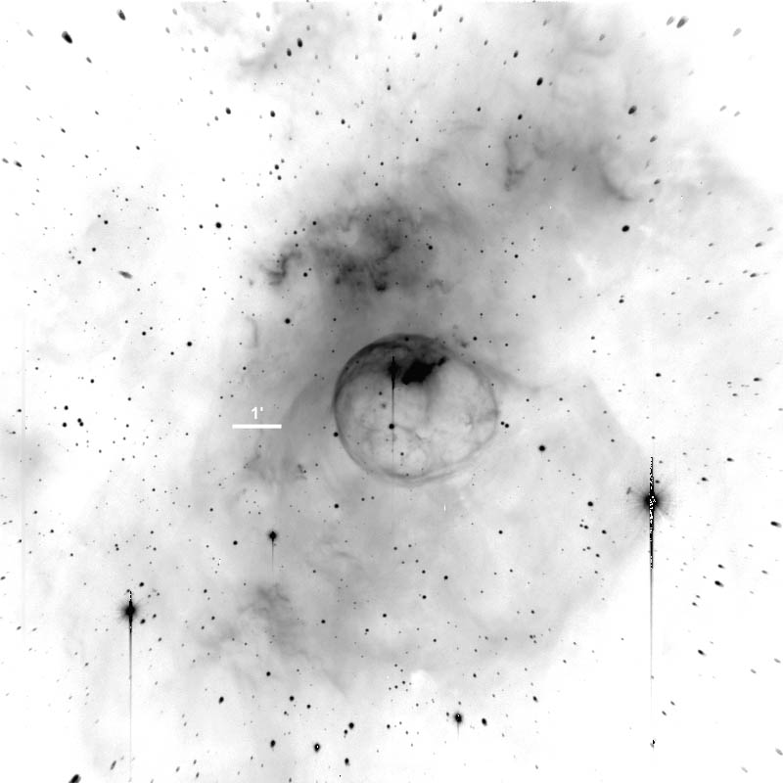

**Figure 3:** Mt. Palomar 60 inch telescope. The image above has a scale of 1.2 arcseconds/pixel. On the image you will see a bar that marks the length of 1 arcminute on the image at this scale.

Fig. 4 was taken using the Steward Observatory 90 inch telescope on Kitt Peak with a CCD camera that rendered the image at a scale of 0.3 arcseconds/pixel. On the image you will see a bar that marks the length of 1 arcminute on the image at this scale.

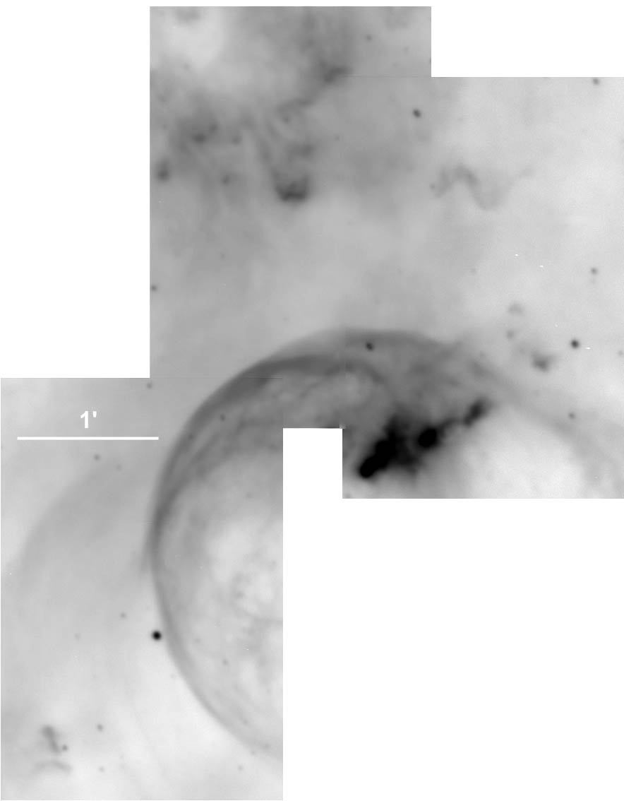

**Figure 4:** Steward Observatory 90 inch telescope on Kitt Peak. The image above has a scale of 0.3 arcseconds/pixel. On the image you will see a bar that marks the length of 1 arcminute on the image at this scale.

1. Which of the telescopes (Mt. Palomar or Steward) gives a higher apparent magnification? How do you know?
2. Which one gives the widest field of view? How do you know?
3. Use a ruler to measure the 1 arcminute scale for each of these photographs. Which image has the larger scale? By how much? HINT: Scale is given in units of angle per length (e.g., 3.4’/mm or 0.2deg/cm)
4. Which telescope would you use to take images of small structures inside a very large nebula? Justify your answer.
5. Which one would you use to image a dim, extremely distant galaxy? Explain.