**NAME:___________________________**

**MotionS of the NigHT Sky**

**What will you learn in this Lab?**

You will learn how the Earth’s rotation and revolution around the Sun combine to change our view of the night sky over time. You will also analyze movement of stars over a few hours to answer the seemingly obvious question – How long does it take the Earth to make one complete 360° rotation?

**What do I need to bring to the Class with me to do this Lab?**

For this lab you will need:

* A copy of this lab script
* A pencil
* A calculator
* Star Wheel
* Protractor or Protractor App

**Introduction:**

This lab looks at the motion of the night sky over time periods of a single day and over several months. The motion of the sky over a single day, also known as diurnal motion, is caused by the Earths rotation on its axis. The Earth rotates from West to East causing objects we see in the sky to appear to move in the opposite direction from East to West. As the Earth rotates your location on the Earth is pointed towards different areas of the sky, causing the view to change, much like how if you spin around, you will see different parts of the area around you. Figure 1 illustrates this diurnal motion. The first part of tonight’s lab will probe the question of how long it takes for the Earth to make one complete rotation on its axis using star movements over a period of hours, using your own observations and a photograph.

The stars will also appear to slowly change positions over the course of a year. This annual motion of the stars is due to the Earths revolution (orbit) around the Sun. As the Earth orbits the Sun throughout the year, our perspective from Earth also shifts. Figure 2 illustrates this annual motion. The second part of tonight’s lab includes sketching using *Stellarium* to observe how the night sky changes over many weeks.

Both the nightly motion and motion over several months will affect what objects are available to see on a given night at a given time. Thus, understanding this motion is critical for planning astronomical observations.

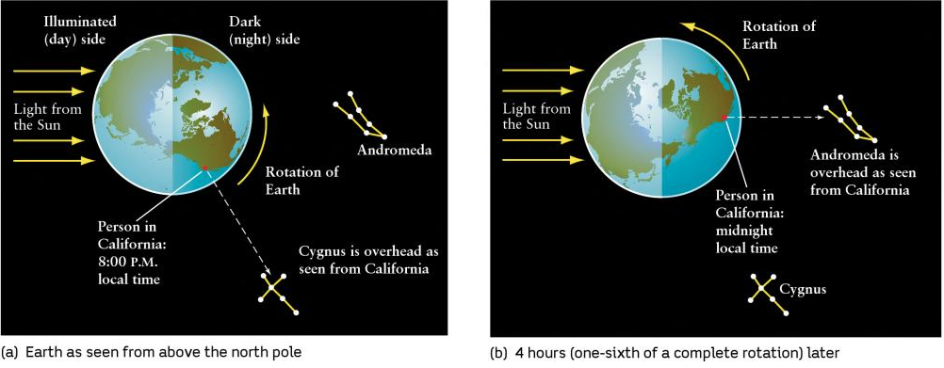

Figure 1[1]*: (a) Shows an observer in California at 8:00 PM local time with the constellation Cygnus overhead. (b) Shows the same observer 4 hours later at midnight local time, now with the constellation Andromeda overhead. The rotation of the Earth caused the apparent locations of the constellations to change over a few hours.

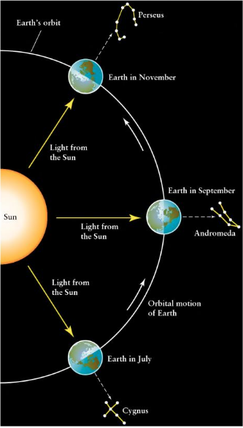

Figure 2[2]*: Shows an observer in California at midnight local time throughout the year. In July the constellation Cygnus is overhead. In September the constellation Andromeda is overhead. In November the constellation Perseus is overhead. The Earth’s revolution (orbit) around the Sun causes the apparent locations of constellations to change throughout the year.

Before we begin tonight’s lab, write down an answer to the following question:

**Q1.** How long do you think it takes for the Earth to make one complete rotation on its axis? In other words, what is the period of Earth’s rotation?

ANSWER _______________

**PART 1: Investigating Daily (Diurnal) Stellar Motion**

Sidereal time is time it takes the Earth to rotate once with respect to the “fixed” stars in the sky. From the perspective on Earth, a **sidereal day** is the time it takes the stars to appear to revolve around the Earth once. By analyzing how the position of the stars and constellations change as the Earth rotates, we can determine the length of a sidereal day. In this part you will observe this motion by sketching the position of a constellation at the beginning and end of the lab session, and you will calculate the length of a sidereal day using a photograph of star trails.

**SECTION 1: Observe and Sketch the Night Sky**

1. Near the beginning of the lab session go outside and face North. Alternatively set up *Stellarium* to your location, set the time to the start of the lab session, and pan around so you are facing North.
2. On the Observation Sheet for Part 1 provided on the next page, sketch the location of a bright constellation relative to the North Celestial Pole (Polaris). Label the time and date of your sketch.
3. Answer Question 2 below.
4. About two hours after your first sketch was made, go back outside and face North again. Alternatively set the time in *Stellarium* to two hours after the time the first observation was made.
5. On the same Observation Sheet, sketch the new location of the same constellation from your earlier sketch. Label the time and date of your new sketch.

Note: For the Southern Hemisphere face South, and change the Polaris label to South Celestial Pole, and the North label to South.

**Q2.** Which direction (clockwise or counterclockwise) do you think the constellation will move over the next few hours?

**Observation Sheet: Part 1 - Constellation Motion Over a Couple Hours**





**SECTION 2: Measuring the Sidereal Day Using a Photograph**

The photograph provided on the next page was taken by a camera mounted on a tripod with the shutter left open. The camera was pointed toward the North Celestial Pole, so the picture shows Polaris ( Ursa Minoris) and the surrounding stars. Because the Earth turned during the exposure, all the stars are seen as trails of starlight. The Earth rotates once in one sidereal day. By measuring the time it takes to complete part of a rotation, you can calculate how long it would take to complete a full rotation.

**Note: The total time elapsed from the beginning of the photograph until the end is 115 minutes.** The interruption in the star trails represents a brief period when the shutter was accidentally closed.

Part 1, Section 2: Analysis

1. Looking at the photograph, locate and mark the true North Celestial Pole.
2. Choose three bright star trails that do not run off the edges of the image. They do not have to be already labeled, but generally ones farther from the North Celestial Pole work better than ones closer in. Mark the starting and end points of your three star trails.
3. Now draw a pair of straight lines from these starting and ending marks to the North Celestial Pole.
4. Center your protractor on the North Celestial Pole and measure the angular distance from the starting and end mark for each star trail. Take the average for your three stars:

Star 1: ___________

Star 2: ___________

Star 3: ___________

Average: ___________

**Q3.** Using the total elapsed time for the photograph, along with your average angular distance, calculate the time it takes for the Earth to rotate so the stars make one complete circuit through the sky (one sidereal day). (*Hint: When the Earth rotates once, how many degrees through the sky should the stars move?)*

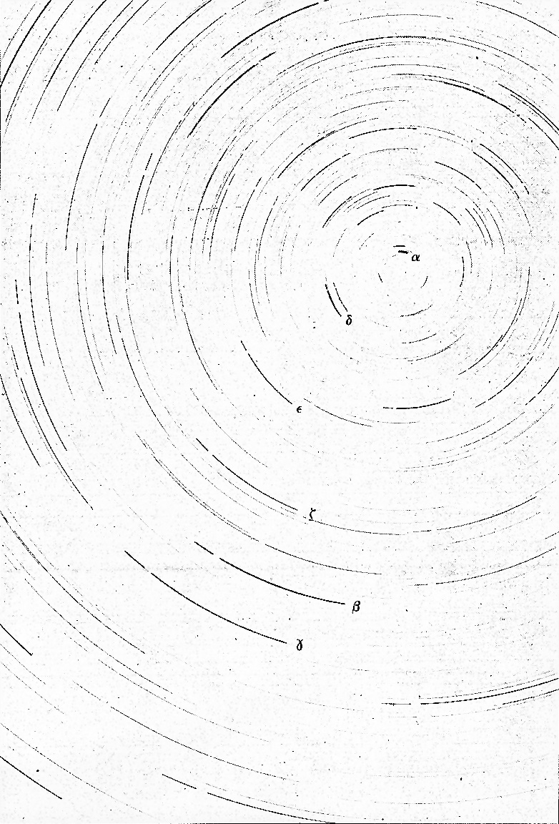

Part 1: Follow Up Questions

**Q4.** Does your calculation of the length of a sidereal day match the answer you gave to Q1 before lab began? If not, explain why you think they are different.

**Q5.** It takes approximately 23 hours, 56 minutes, and 4 seconds (23.9344 hours) for the Earth to make one complete rotation so that a star is seen in the exact same position from one night to the next (one sidereal day). Compare your calculation of the length of a sidereal day with the given sidereal day, and calculate the percent difference.

$$\% difference=\frac{|your value-known value|}{known value}*100\%$$

**PART 2: Investigating Long-Term (Annual) Stellar Motion**

In this part, you will use the *Stellarium* program to investigate how the stars move over a series of several weeks.

1. If you have not done so already set up *Stellarium* to your location, set the time to the start of the lab session, and pan around so you are facing North.
2. On the Observation Sheet for Part 2 provided on the next page, sketch the location of the same bright constellation from Part 1 relative to the North Celestial Pole (Polaris). Label the time and date of your sketch.
3. Now, move the date forward three months while keeping the time the same.
4. On the same Observation Sheet, sketch the new location of the same constellation. Label the time and date of your second sketch.

Note: For the Southern Hemisphere face South, and change the Polaris label to South Celestial Pole, and the North label to South.

**Observation Sheet: Part 2 - Constellation Motion Over Several Weeks**





Part 2: Analysis

It should be clear that objects in the sky have moved; you made two sketches at the same time but that are a few months apart, and the constellations are in different locations in each sketch. But how fast is the motion? You can calculate the rate at which the sky appears to change with the use of your sketch of the northern sky.

1. Choose three bright stars and draw a pair of straight lines from their location today and their location three months from now to Polaris.
2. Center your protractor on Polaris, and measure the angular distance from the stars location today and the location three months from now. Take the average for your three stars:

Star 1: ___________

Star 2: ___________

Star 3: ___________

Average: ___________

**Q6.** Make an estimate of the average rate of motion of the sky (in degrees per day) using the time elapsed between your observations from tonight and three months from now, and your average angular distance.

**Q7.** The position of stars in the sky moves by approximately 0.98 degrees per day (360 degrees in 365 days). Compare your calculation above with the given rate of motion, and calculate the percent difference.

$$\% difference=\frac{|your value-known value|}{known value}*100\%$$

Part 2 – Follow Up Questions

**Q8.** In *Stellarium*, pan around the sky and take note of the major constellations you see tonight at the start of your lab time. Then change the date to three months from now (still at your starting lab time) and answer the following questions.

1. Are there any bright constellations or stars that *are visible* tonight that will *no longer be visible* three months from now? Which ones?
2. Are there any new bright constellations or stars in the sky that *were not visible* tonight that *will be visible* three months from now? Which ones?

**Q9.** Referring to your sketches from Part 2 and considering the dates and times they were made, explain why the motion you see between your different sketches cannot be caused by the rotation of the Earth on its axis every ~24 hours.

**Summary Review Questions**:

Use your sketches or *Stellarium* to answer the following two questions.

**Q10.** If you face **North**, in which direction (circle one) does the sky appear to rotate

1. Over a few hours? Clockwise Counter-clockwise
2. Over multiple weeks? Clockwise Counter-clockwise

**Q11.** If you face **South**, in which direction (circle one) does the sky appear to rotate

1. Over a few hours? Clockwise Counter-clockwise
2. Over multiple weeks? Clockwise Counter-clockwise

**Q12.** What causes the constellations to move

1. During one night?
2. Over many nights?

**Q13.** Is Polaris directly at the North Celestial Pole? Explain how you can tell this from the star trails photograph.

**Q14.** We use the *solar day* (24h 00m) as our standard of time on clocks and watches. The length of the *solar day* differs from the *sidereal day* (23h 56m 4s) by three minutes and 56 seconds. Explain why the two are not equal and why the solar day is longer (a diagram may help in this explanation).

**Q15.** Calculate the number of *sidereal days* in a calendar year, and compare this value with the number of *solar days* in a calendar year.

**Q16.** Where will the stars you looked at tonight be found six months from now? Explain the reasoning that led to your answer.

**Summarize what you have learned in tonight’s lab:**

1. * Image credit: Freedman, R., Kaufmann, W. J., Geller, R. (2014). Universe. (n.p.): W. H. Freeman.
2.