**Motion of the Sky Prelab**

1. Explain the difference between a sidereal day and a solar day.

2. This lab will be using sketches from *Introduction to the Night Sky* lab to measure how much the sky moves from month to month. Bring those sketches with you to class tonight.

**MotionS of the NigHT Sky**

**What will you learn in this Lab?**

You will learn how the Earth’s rotation and orbiting around the Sun combine to change our view of the night sky over time. You will also use various methods to collect data to answer the seemingly obvious question – “How long does it take the Earth to make one complete 360 degree rotation?”

**What do I need to bring to the Class with me to do this Lab?**

For this lab you will need:

* A copy of this lab script
* A pencil
* A calculator
* Your Northern and Southern Sky Sketches from your previous Intro to the Night Sky lab exercise
* Audubon Sky Guide
* Red Flashlight

**Introduction:**

This lab is broken down into three parts. The first part will include sketching the night sky just like we did in the *Introduction to the Night Sky* lab for purpose of observing how the night sky changes over longer periods of time. We will also collect new information on certain stars’ positions to estimate how long it takes for stars to make one complete annual circuit of the sky. The second part will continue probing this same question with use of star trails captured in a time lapse photograph, and collection of additional data using the *Starry Night* astronomy program. The third part will have us outside again collecting a second set of observations of certain stars so we can make an estimate of how long it takes for the Earth to rotate 360 degrees. The last part summarizes all of our various measurements to make a final assessment of the why and how Earth’s rotation and orbiting of the Sun affect the where and when we see specific stars in the night sky.

Before we begin tonight’s lab, write down an answer to the following question:

1. ***How long do you think it takes for the Earth to make one complete rotation on its axis? In other words, what is the period of Earth’s rotation?***

ANSWER ________

**Part I – First Set of Rooftop Observations**

SECTION 1 – Changes in the Sky Over the Semester

At the beginning of the semester we made a set of North and South sky sketches during the *Introduction to the Night Sky* lab. If you have brought those with you, tear off the extra two copies of the Northern and Southern sky sketches (pages 15 and 16) and attach your original drawings in their place. Before going to the roof, make a note which constellations you included.

1. ***Now go to the roof and redo your North and South sky drawings (pages 17 and 18) to reflect the new positions of the constellations. Label the visible constellations and bright stars, including any new constellations that were not originally visible at the beginning of the semester.***

SECTION 2 – First Set of Observations Regarding Changes in the Sky Over a Single Day

We are going to take a new set of observations tonight about one hour apart. The purpose of collecting this data is to calculate how long it takes for the Earth to make one complete rotation so that each star would be at the same observed position as the previous night.

1. ***Your TA will give you a short list of bright stars. (Note to TAs: Preferably not stars that are setting in the west....) Use the sextants provided to measure the altitude and azimuth of the objects. Record these naked eye observations as Az(1) and Alt(1) in TABLE 1: OBSERVATIONS AND CALCULATIONS. Make sure to record the time of your observations on the table!***

**Part II – Indoor Analysis and Further Calculations**

SECTION 1 – Recreating Sky Sketches From Earlier This Semester

Skip this section if you brought your sketches from the *Introduction to the Night Sky* to tonight’s lab. If you did not bring these earlier sketches, complete this section. First, you will need to initiate the *Starry Night* program following the directions listed at the start of SECTION 3 below. Complete the two sketches using the following instructions:

1. ***In the Time Window, reset the date to Sept. 1 of this year. Make sure the time is still identical to the time of your first naked eye observation tonight. Use the "hand" tool to pan around until you are looking at the northern horizon (or click the "N" button). Draw the three or four of the major constellations surrounding Polaris on your extra Northern Sky sketch sheet. (page 16)***
2. ***Pan around to the southern horizon (or click the "S" button). Draw three or four of the constellations in the south, ideally bright ones that you recall your TA pointing out to you during the course of the semester. (page 15)***

SECTION 2 – Analyzing Two Sets of Sky Sketches For Changes Over The Semester

Compare your two sets of drawings and answer the following questions:

1. ***Are any of the constellations or bright stars you originally drew no longer visible? Which ones?***
2. ***Are there any new bright constellations in the sky that were not visible at the beginning of the semester?***
3. ***How does the motion of the stars in the northern sky differ from the motions of the stars in the southern sky. Why are they different?***
4. ***Looking at your southern sky sketches, which direction have the constellations appeared to have moved?***
5. ***Referring to your sketches and considering the dates they were made, explain why the motion you see between your different sketches cannot be caused by the rotation of the Earth on its axis every 24 hours.***
6. ***It should be clear that things in the sky have moved; you made your sketches at the same time each night, but the constellations are in different locations in each sketch. But how fast is the motion? You can calculate the rate at which the sky appears to rotate with the use of your sketches of the northern sky....***
   1. First, find and label the previously defined northern reference star on both of your North sky sketches. Find and label Polaris.
   2. On both sketches use a straight edge to draw a line straight up and down through Polaris. What is this line called?
   3. On both sketches draw another straight line from Polaris to the reference star. Use the protractor to measure the *position angle* (angle from north) between the two lines.

Position angle (Aug/Sept): _________ degrees

Position angle (Nov/Dec): _________ degrees

Change in position angle: _________ degrees

Days elapsed between: _________ days

* 1. Make an estimate of the average rate of motion of the sky in degrees per day using the time elapsed between when the two sketches were made.

1. ***At this point in the lab, provide a brief explanation of what you think is happening to cause this shift in our view of the stars. (Drawing diagrams are often helpful.)***

SECTION 3 – Using Photographic Observations to Measure How Long it Takes for Stars to Make One Complete Rotation Through the Night Sky.

In this section of the lab you will use a long-exposure photograph to determine the period of Earth’s rotation. The photograph provided in Figure 1 on page 7 was taken by a camera mounted on a tripod with the shutter left open. The camera was pointed toward the North Celestial Pole, so the picture shows Polaris ( Ursa Minoris) and the surrounding stars. Because the earth turned during the exposure, all of the stars are seen as trails of starlight.

The TOTAL TIME ELAPSED FROM THE BEGINNING OF THE PHOTOGRAPH UNTIL THE END = 115 MINUTES. The interruption in the star trails represents a brief period when the shutter was accidentally closed.

1. Looking at the photograph, locate the true North Celestial Pole. Place a dot at the NCP.
2. Choose three bright star trails that do not run off the edges of the image. They do not have to be already labeled, but generally ones farther from the North Celestial Pole work better than ones closer in. Mark the starting and end points of your three star trails with short lines. Like this:

|_____ ___________________________| 

(Except that the actual star trails will be curved, of course.)

1. Now draw a pair of straight lines from these starting and ending marks to Polaris.
2. Center your protractor on the North Pole. The center is the middle of the ruler portion of the protractor---if your protractor doubles as your sextant, this is the tiny hole where the string is tied.
3. ***Measure the angular distance from the starting and end mark for each star trail. Take the average for your three stars:***

1. ___________

2. ___________

3. ___________

AVERAGE: ____________

1. ***Using the starting and ending times for the photograph, along with your average angular distance, calculate the time it takes for the Earth to rotate so the stars make one complete circuit through the sky.***
2. ***Does your calculation in Question 14 above match the answer you gave in Question 1? If not, explain why you think they are different.***

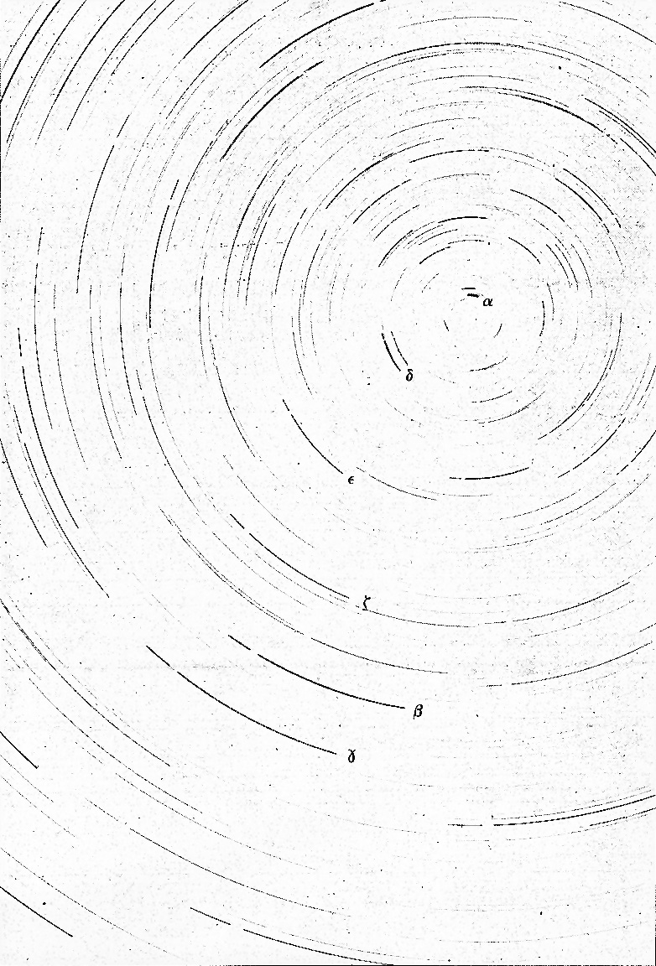

Figure 1. Time lapse photograph in the region of Ursa Minoris

SECTION 4 – Using the *Starry Night* Program to Calculate Changes Over Single Day

In the very upper-left corner is your tool selection tool. By default, SN opens in adaptive mode which allows you to click and drag around the scene, and brings up information when you hover over objects in the sky. You can play around with the other options. The most useful ones you’ll use in lab are:

**Angular Separation** – This tool lets you accurately measure the separation between two objects in the main window. Click on the first object, then drag to the second object. The angular separation between the two objects will be displayed, as well as the physical distance between them.

**Arrow** – Allows you to point at certain objects in the main window, and SN will tell you what it is, and information about the object.

**Constellation** – As you pan through the night sky, clicking will bring up the constellation label and art for the object you click on.

**Hand** – The hand tool lets you click and drag to pan around the main window.

**Magnification** – The magnification mode allows you to click anywhere in the main window and it will zoom in to that point. Alternatively, you can also click and drag a box, that you want to zoom to.

**The panel along the top functions as your information display.**

**Time and Date**

Starry Night opens up to the current date/time. By clicking on any of the date/time elements you can enter a new value. You can also always reset it to the current time, sunrise, or sunset today by clicking on the buttons below the display.



**Time Flow Rate**

By default SN advances at the same rate as real time, hence the 1x speed. Of course this is absurdly slow, so you can click on the arrow next to the rate to select a different speed. Or, you can even select a discrete time step so that SN plays forward 1 day at a time or other interval.

You can move one step at a time by using the buttons at either end of the button panel. The inner arrow buttons will change the display real time – i.e. one second per second. The stop button halts any display updates. This will be your most useful tool for this lab exercise!

**Viewing Location**

By default, this should be set to Phoenix, AZ. But you can also pick a different location to see what the sky looks anywhere in the world! If you’re lost, the Home button will always take you back to Phoenix at the current time. The two arrow buttons next to Home will allow you change your viewing altitude.

**Gaze**

This displays the altitude/azimuth coordinates of where you’re looking.

**Zoom**

This shows your angular field of view. In general, you can zoom in and out by using the scroll wheel on your mouse. Or you can use the (-) or (+) buttons.

Moreover, you also have a number of side panes that can allow you to pull up favorites, labels, or other information:



By default, SN launches with the adaptive cursor, so whenever you hover over an object it should provide information about the object, including Altitude, Azimuth as well as Right Ascension and Declination. If you have trouble, change the pointer to arrow. Now, when you point at an object with the Pointer, you will be shown Altitude and Azimuth as well as Right Ascension and Declination.

You can also turn on a "local" Altitude-Azimuth coordinate grid by choosing View > Alt/Az Guids > Grid in the toolbar at the top.

Turn on the constellations and labels from View > Constellations > Labels.

Turn on the Constellation stick figures by going to View > Constellations > Constellation Options… Check the Stick Figures box.

Turn on bright star labels by selecting the **Options** pane on the left, then expand Stars, and check the labels box next to Stars. Return to Guides, select Constellations again, and then Constellation Settings. In the Constellation Settings menu and click "Stick Figures".

You are now ready to do the computer portion of the exercise.

1. ***Measure the Altitude/Azimuth, and RA/Dec of select stars using the following steps:***
2. Make sure that the date in the Time Window is correct for tonight's date.
3. Set the time to match the time you recorded for your first naked eye observations on the roof.
4. Using the adaptive hand mode grab the sky and move it around until you find the stars in your list.
5. Hold the cursor over the star until its coordinates appear.
6. Record the Altitude/Azimuth and RA/Dec in the appropriate shaded columns in TABLE 1.
7. Repeat for all the stars on your list.

**Part III – Second Set of Outdoor Observations**

If at least an hour has elapsed since your first naked eye observations, you may return to the roof for the second set. Redo the measurements of Altitude and Azimuth, and enter the new values as Alt(2), Az(2) under the “Second Naked Eye Observations” column in TABLE 1. Again, make sure to record the time of your observations on the table!

**Part III – Final Analysis**

1. ***Make sure the Time Window in Starry Night is set to today's date and the time of the new set of naked eye observations. Use the hand tool and pointer tool to measure the coordinates of the same stars again in Starry Night. Record these values in Table 1 under the Second Starry Night Observations.***
2. ***What is the average level of error between your naked-eye measurements with the sextant and the "true" values from Starry Night? (You don't have to use the error formula a dozen times, just give a general estimate.)***
3. ***How did the RA and Dec change between the Time 1 measurements and the Time 2 measurements? Why?***
4. ***Now use the observations in TABLE 1, with the following formulas, to calculate the values in TABLE 2. Calculate $∆time$ in units of minutes. Then, when you calculate the period of Earth’s rotation in minutes, convert this answer into a more recognizable combination of hours and minutes.***
$$∆Alt=Alt\left(2\right)-Alt(1)$$

$$∆Az=Az\left(2\right)-Az(1)$$

$$∆Angle=\sqrt{{\left(∆Alt\right)}^{2}+{\left(∆Az\right)}^{2}}$$

$$∆time=Time of Second Obs. -Time of First Obs.$$

$$Period of Earth^{'}s Rotation= \frac{∆time}{∆Angle}×360°$$

5. ***The length of time for Earth to make one complete rotation so that a star is seen in the exact position from one night to the next is approximately 23 hours, 56 minutes and 4 seconds. Astronomers call this a “sidereal day”.***
   1. ***Compare your calculations from Table 2 with the given sidereal day of 23 hours, 56 minutes and 4 seconds long. Calculate your percentage error.***
   2. ***Calculate your percentage error between the value you obtained from Table 2 with the value you calculated in Question 14 using the star trails in the photograph.***
   3. ***Which method is more reliable, in your opinion? Why?***

**Summary Review Questions**:

1. If you face North, in which direction (clockwise or counterclockwise) did the sky appear to rotate during the night? What about during the semester?
2. What causes the constellations to move during the night? What causes the constellations to move over many nights?
3. Is Polaris directly at the North Celestial Pole? Explain how can you tell this from the photograph.
4. Which method of determining the *length of the sidereal day* gave an answer closer to the true value? Explain *why* you think that value was more accurate. How did this accuracy compare to that of measuring the rate of motion of the night sky during the semester?
5. We use the *solar day* (24h 00m) as our standard of time on clocks and watches. The length of the *solar day* differs from the *sidereal day* (23h 56m 4s) by three minutes and 56 seconds. Explain why the two are not equal and why the solar day is longer (a diagram may help in this explanation).
6. Calculate the number of *sidereal days* in a calendar year, and compare this value with the number of *solar days* in a calendar year.
7. Where will the stars you looked at tonight to complete Table 1 be found six months from now? Explain the reasoning that led to your answer.

**Summarize what you have learned in tonight’s lab:**

|  |  |  |  |  |  |  |  |
| --- | --- | --- | --- | --- | --- | --- | --- |
| **TABLE 1: OBSERVATIONS AND MEASUREMENTS** | **Time of Second**  **Observations:** | **Second**  **Starry Night Measurements** | **Az(2)** |  |  |  |  |
| **Alt(2)** |  |  |  |  |
| **Second**  **Naked Eye Observations** | **Az (2)** |  |  |  |  |
| **Alt (2)** |  |  |  |  |
| **Time of First Observations:** | **First Starry Night Measurements** | **Dec.** |  |  |  |  |
| **RA** |  |  |  |  |
| **Az (1)** |  |  |  |  |
| **Alt (1)** |  |  |  |  |
| **First Naked Eye Observations** | **Az (1)** |  |  |  |  |
| **Alt (1)** |  |  |  |  |
|  | | **Object** | 1. | 2. | 3. | 4. |

|  |  |  |  |  |  |  |  |
| --- | --- | --- | --- | --- | --- | --- | --- |
| **TABLE 2: CALCULATIONS** | **Starry Night Measurements:** | **Period of Earth’s Rotation** |  |  |  |  |  |
| $$∆Angle$$ |  |  |  |  |  |
| $$∆Az$$ |  |  |  |  |
| $$∆Alt$$ |  |  |  |  |
| **Naked Eye Observations:** | **Period of Earth’s Rotation** |  |  |  |  |  |
| $$∆Angle$$ |  |  |  |  |  |
| $$∆Az$$ |  |  |  |  |
| $$∆Alt$$ |  |  |  |  |
|  | **Object** | 1. | 2. | 3. | 4. |

**Southern sky sketch** Name:

Date: Time:

Instructor verification:



South

**Northern sky sketch**  Name:

Date: Time:

Instructor verification:





**Southern sky sketch** Name:

Date: Time:

Instructor verification:



South

**Northern sky sketch** Name:

Date: Time:

Instructor verification:



