**Motion of the Sky Prelab**

1. Explain the difference between a sidereal day and a solar day.

2. This lab will be using sketches from *Introduction to the Night Sky* lab to measure how much the sky moves from month to month. Bring those sketches with you to class tonight.

**MotionS of the NigHT Sky**

**What will you learn in this Lab?**

You will learn how the Earth’s rotation and orbiting around the Sun combine to change our view of the night sky over time. You will also analyze movement of stars over a few hours to answer the seemingly obvious question – “How long does it take the Earth to make one complete 360 degree rotation?”

**What do I need to bring to the Class with me to do this Lab?**

For this lab you will need:

* A copy of this lab script
* A pencil
* A calculator
* Your Northern and Southern Sky Sketches from your previous Intro to the Night Sky lab exercise
* Audubon Sky Guide
* Red Flashlight

**Introduction:**

This lab looks at the motion of the night sky over time periods of multiple weeks, and over a single day. One part of tonight’s lab will include sketching the night sky like we did in the *Introduction to the Night Sky* lab for purpose of observing how the night sky changes over multiple weeks of time. The second part will probe the question of how long it takes for the Earth to make one complete rotation on its axis using star movements over a period of hours. The last section summarizes our various measurements to make a final assessment of the why and how Earth’s rotation and orbiting of the Sun affect the where and when we see specific stars in the night sky.

Before we begin tonight’s lab, write down an answer to the following question:

1. ***How long do you think it takes for the Earth to make one complete rotation on its axis? In other words, what is the period of Earth’s rotation?***

ANSWER ________

**Part I - Motion of the Sky Over Multiple Weeks**

SECTION 1 – Recreating Sky Sketches From Earlier This Semester

Skip this section if you brought your sketches from the *Introduction to the Night Sky* to tonight’s lab. If you did not bring these earlier sketches, complete this section. First, you will need to initiate the *Starry Night* program following the directions found on the last pages of this lab script. Complete the two sketches using the following instructions:

1. ***In the Time Window, reset the date to September 1 of this year. Make sure the time is still identical to the time of your first naked eye observation tonight. Use the "hand" tool to pan around until you are looking at the southern horizon (or click the "S" button). Draw the three or four of the constellations in the south, ideally bright ones that you recall your TA pointing out to you during the course of the semester, on page 11.***
2. ***Pan around to the northern horizon (or click the "N" button). Draw three or four of the major constellations surrounding Polaris on your Northern Sky sketch sheet on page 12.***

SECTION 2 – Sketch Tonight’s Sky to See Motion Over Multiple Weeks

At the beginning of the semester we made a set of North and South sky sketches during the *Introduction to the Night Sky* lab. If you have brought those with you, tear off the extra two copies of the Northern and Southern sky sketches (pages 11 and 12) and attach your original drawings in their place. Before going to the roof, make a note which constellations you included.

1. ***Now go to the roof and redo your South and North sky drawings (pages 13 and 14) to reflect the new positions of the constellations. Label the visible constellations and bright stars, including any new constellations that were not originally visible at the beginning of the semester.***

SECTION 3 - Analyzing Two Sets of Sky Sketches For Changes Over Multiple Weeks

Compare your two sets of drawings and answer the following questions:

1. ***Are any of the constellations or bright stars you originally drew no longer visible? Which ones?***
2. ***Are there any new bright constellations in the sky that were not visible at the beginning of the semester?***
3. ***How does the motion of the stars in the northern sky differ from the motions of the stars in the southern sky. Why are they different?***
4. ***Looking at your southern sky sketches, which direction have the constellations appeared to have moved?***
5. ***Referring to your sketches and considering the dates they were made, explain why the motion you see between your different sketches cannot be caused by the rotation of the Earth on its axis every 24 hours.***
6. ***It should be clear that things in the sky have moved; you made your sketches at the same time each night, but the constellations are in different locations in each sketch. But how fast is the motion? You can calculate the rate at which the sky appears to rotate with the use of your sketches of the northern sky....***
   1. First, find and label the previously defined northern reference star on both of your North sky sketches. Find and label Polaris.
   2. On both sketches use a straight edge to draw a line straight up and down through Polaris. What is this line called?
   3. On both sketches draw another straight line from Polaris to the reference star. Use the protractor to measure the *position angle* (angle from north) between the two lines.

Position angle (Aug/Sept): _________ degrees

Position angle (Nov/Dec): _________ degrees

Change in position angle: _________ degrees

Days elapsed between: _________ days

* 1. Make an estimate of the average rate of motion of the sky in degrees per day using the time elapsed between when the two sketches were made.

1. ***At this point in the lab, provide a brief explanation of what you think is happening to cause this shift in our view of the stars. (Drawing diagrams are often helpful.)***

**Part II – Calculating a Sidereal Day**

In this section of the lab you will use both your own observations made tonight and a long-exposure photograph to determine the period of Earth’s rotation.

SECTION 1 – First Observation of the Night Sky

Go to the roof and using the template provided on page 15 to sketch where you see constellations and stars in the Northern sky. Find Polaris and make sure your drawing is centered on that location in the sky. Note the time the drawing was made.

SECTION 2 – Measuring the Sidereal Day Using a Photograph

The photograph provided in Figure 1 on page 7 was taken by a camera mounted on a tripod with the shutter left open. The camera was pointed toward the North Celestial Pole, so the picture shows Polaris ( Ursa Minoris) and the surrounding stars. Because the earth turned during the exposure, all of the stars are seen as trails of starlight.

The TOTAL TIME ELAPSED FROM THE BEGINNING OF THE PHOTOGRAPH UNTIL THE END = 115 MINUTES. The interruption in the star trails represents a brief period when the shutter was accidentally closed.

1. Looking at the photograph, locate the true North Celestial Pole. Place a dot at the NCP.
2. Choose three bright star trails that do not run off the edges of the image. They do not have to be already labeled, but generally ones farther from the North Celestial Pole work better than ones closer in. Mark the starting and end points of your three star trails with short lines. Like this:

|_____ ___________________________| 

(Except that the actual star trails will be curved, of course.)

1. Now draw a pair of straight lines from these starting and ending marks to Polaris.
2. Center your protractor on the North Pole. The center is the middle of the ruler portion of the protractor---if your protractor doubles as your sextant, this is the tiny hole where the string is tied.
3. ***Measure the angular distance from the starting and end mark for each star trail. Take the average for your three stars:***

1. ___________

2. ___________

3. ___________

AVERAGE: ____________

1. ***Using the starting and ending times for the photograph, along with your average angular distance, calculate the time it takes for the Earth to rotate so the stars make one complete circuit through the sky.***
2. ***Does your calculation in Question 13 above match the answer you gave in Question 1? If not, explain why you think they are different.***
3. ***The length of time for Earth to make one complete rotation so that a star is seen in the exact position from one night to the next is approximately 23 hours, 56 minutes and 4 seconds. Astronomers call this a “sidereal day”. Compare your calculations with the given sidereal day of 23 hours, 56 minutes and 4 seconds long. Calculate your percentage error.***

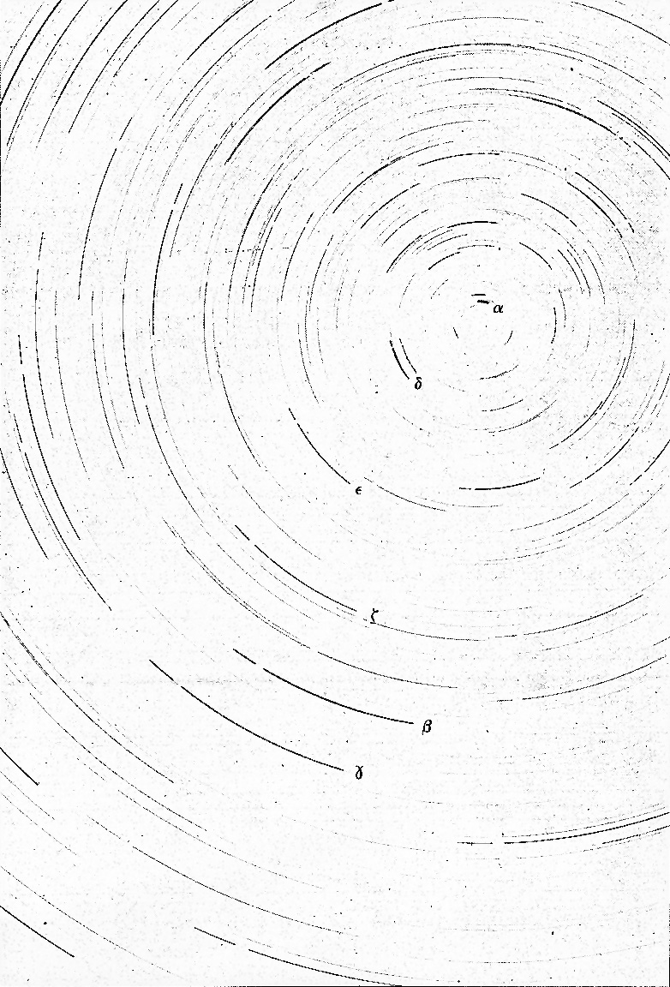

Figure 1. Time lapse photograph in the region of Ursa Minoris

SECTION 3 – Second Observation of the Night Sky

About 2 hours after you did the first observation, go back to the roof and using the template provided on page 16 sketch where you now see constellations and stars in the Northern sky. Again, find Polaris and make sure your drawing is centered on that location in the sky. Note the time the drawing was made.

Using your drawings on pages 15 and 16, perform the same analysis you did for the photograph.

1. One suggested method to accomplish this task is to place page 15 on top of page 16 and transfer the second set of bright star positions onto page 15.

1. Choose three sets of bright star trails that do not run off the edges of the sketch, preferably ones that are farther from the North Celestial Pole. Mark the starting and end points of your three star trails with short lines.
2. Now draw a pair of straight lines from these starting and ending marks to Polaris.
3. Center your protractor on the North Pole. The center is the middle of the ruler portion of the protractor---if your protractor doubles as your sextant, this is the tiny hole where the string is tied.
4. ***Measure the angular distance from the starting and end mark for each star trail. Take the average for your three stars:***

1. ___________

2. ___________

3. ___________

AVERAGE: ____________

1. ***Using the times you recorded for the first and second set of observations, and the change in time between, along with your average angular distance, calculate the time it takes for the Earth to rotate so the stars make one complete circuit through the sky.***
2. ***Does your calculation in Question 17 above match the answers you gave in Questions 1 and 13? If not, explain why you think they are different.***

**Summary Review Questions**:

1. If you face North, in which direction (clockwise or counterclockwise) did the sky appear to rotate over multiple weeks? What about over a few hours?
2. What causes the constellations to move during the night? What causes the constellations to move over many nights?
3. Is Polaris directly at the North Celestial Pole? Explain how you can tell this from the photograph.
4. We use the *solar day* (24h 00m) as our standard of time on clocks and watches. The length of the *solar day* differs from the *sidereal day* (23h 56m 4s) by three minutes and 56 seconds. Explain why the two are not equal and why the solar day is longer (a diagram may help in this explanation).
5. Calculate the number of *sidereal days* in a calendar year, and compare this value with the number of *solar days* in a calendar year.
6. Where will the stars you looked at tonight be found six months from now? Explain the reasoning that led to your answer.

**Summarize what you have learned in tonight’s lab:**

**Southern sky sketch** Name:

Date: Time:

Instructor verification:



South

**Northern sky sketch**  Name:

Date: Time:

Instructor verification:





**Southern sky sketch** Name:

Date: Time:

Instructor verification:



South

**Northern sky sketch** Name:

Date: Time:

Instructor verification:





**Northern sky sketch** Name:

Date: Time:

Instructor verification:





**Northern sky sketch** Name:

Date: Time:

Instructor verification:





Using the *Starry Night* Program

In the very upper-left corner is your tool selection tool. By default, SN opens in adaptive mode which allows you to click and drag around the scene, and brings up information when you hover over objects in the sky. You can play around with the other options. The most useful ones you’ll use in lab are:

**Angular Separation** – This tool lets you accurately measure the separation between two objects in the main window. Click on the first object, then drag to the second object. The angular separation between the two objects will be displayed, as well as the physical distance between them.

**Arrow** – Allows you to point at certain objects in the main window, and SN will tell you what it is, and information about the object.

**Constellation** – As you pan through the night sky, clicking will bring up the constellation label and art for the object you click on.

**Hand** – The hand tool lets you click and drag to pan around the main window.

**Magnification** – The magnification mode allows you to click anywhere in the main window and it will zoom in to that point. Alternatively, you can also click and drag a box, that you want to zoom to.

**The panel along the top functions as your information display.**

**Time and Date**

Starry Night opens up to the current date/time. By clicking on any of the date/time elements you can enter a new value. You can also always reset it to the current time, sunrise, or sunset today by clicking on the buttons below the display.



**Time Flow Rate**

By default SN advances at the same rate as real time, hence the 1x speed. Of course this is absurdly slow, so you can click on the arrow next to the rate to select a different speed. Or, you can even select a discrete time step so that SN plays forward 1 day at a time or other interval.

You can move one step at a time by using the buttons at either end of the button panel. The inner arrow buttons will change the display real time – i.e. one second per second. The stop button halts any display updates. This will be your most useful tool for this lab exercise!

**Viewing Location**

By default, this should be set to Phoenix, AZ. But you can also pick a different location to see what the sky looks anywhere in the world! If you’re lost, the Home button will always take you back to Phoenix at the current time. The two arrow buttons next to Home will allow you change your viewing altitude.

**Gaze**

This displays the altitude/azimuth coordinates of where you’re looking.

**Zoom**

This shows your angular field of view. In general, you can zoom in and out by using the scroll wheel on your mouse. Or you can use the (-) or (+) buttons.

Moreover, you also have a number of side panes that can allow you to pull up favorites, labels, or other information:



By default, SN launches with the adaptive cursor, so whenever you hover over an object it should provide information about the object, including Altitude, Azimuth as well as Right Ascension and Declination. If you have trouble, change the pointer to arrow. Now, when you point at an object with the Pointer, you will be shown Altitude and Azimuth as well as Right Ascension and Declination.

You can also turn on a "local" Altitude-Azimuth coordinate grid by choosing View > Alt/Az Guids > Grid in the toolbar at the top.

Turn on the constellations and labels from View > Constellations > Labels.

Turn on the Constellation stick figures by going to View > Constellations > Constellation Options… Check the Stick Figures box.

Turn on bright star labels by selecting the **Options** pane on the left, then expand Stars, and check the labels box next to Stars. Return to Guides, select Constellations again, and then Constellation Settings. In the Constellation Settings menu and click "Stick Figures".

You are now ready to do the computer portion of the exercise.