**Orbital Motion Prelab**

1. Review how and why planets orbit around the Sun. What is the physics involved in the process?
2. State Kepler’s First and Second Laws. What do they tell us about the way a planet orbits the Sun?
3. When we see planets in the sky, do they follow a particular path? Does this path have a special name

Orbital Motion

What will you learn in this Lab?

You will be using some special software to simulate the motion of planets in our Solar System and across the night sky. You will be asked to try and figure out Kepler’s Third Law using observations you make of the planets using this software. Having worked out the nature of the Law, you will be asked to make broader statements about how orbital motion is governed and about general properties of bodies in orbit around each other.

What do I need to bring to the Class with me to do this Lab? For this lab you need:

* A copy of this lab script
* A pencil
* Scientific Calculator
* 2 pages of graph paper

Introduction

The planets, and indeed all gravitationally bound objects, move in a very specific way as they orbit the object they are bound to. In the case of the planets, they are bound to the Sun through the force of gravity because of the Sun’s huge mass. Johannes Kepler worked out the details of this orbital motion from painstaking observation of the motion of the planets in the night sky. In this lab, we’ll be trying to do the same thing, but with the aid of the computer, we will have control of not only our viewing position but also the rate at which time passes.

Using the Computer – an Introduction to Starry Night

In this lab exercise you will be using a piece of software called Starry Night (SN) – be sure to use version Pro6. This is a very sophisticated planetarium package that can not only show us what the sky looks like at any time, from anywhere on Earth, but it can also transport us to other places in the solar system and even other stars!

Before you can conduct the exercise, we’ll go over the basic functionality of the software so you are more comfortable using it to obtain data for your experiment. The software is display-driven, i.e. the software’s main product is a picture of where you are and what you can see under the current conditions. This is not surprising given that astronomy is primarily a visual science. When you start the software, the display will show you what the current sky looks like, right now, facing towards the southern horizon. The scrollbars on the side of the window allow you to change your altitude and azimuth of where you’re looking. Play with it to get used to what your “world” looks like.

In the very upper-left corner is your tool selection tool. By default, SN opens in adaptive mode which allows you to click and drag around the scene, and brings up information when you hover over objects in the sky. You can play around with the other options. The most useful ones you’ll use in lab are:

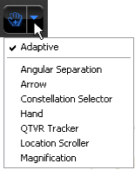Angular Separation – This tool lets you accurately measure the separation between two objects in the main window. Click on the first object, then drag to the second object. The angular separation between the two objects will be displayed, as well as the physical distance between them.

Arrow – Allows you to point at certain objects in the main window, and SN will tell you what it is, and information about the object.

Constellation – As you pan through the night sky, clicking will bring up the constellation label and art for the object you click on.

Hand – The hand tool lets you click and drag to pan around the main window.

Magnification – The magnification mode allows you to click anywhere in the main window and it will zoom in to that point. Alternatively, you can also click and drag a box, that you want to zoom to.

The panel along the top functions as your information display.

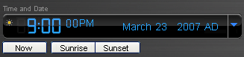Time and Date

Starry Night opens up to the current date/time. By clicking on any of the date/time elements you can enter a new value. You can also always reset it to the current time, sunrise, or sunset today by clicking on the buttons below the display.

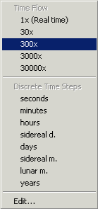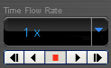Time Flow Rate

By default SN advances at the same rate as real time, hence the 1x speed. Of course this is absurdly slow, so you can click on the arrow next to the rate to select a different speed. Or, you can even select a discrete time step so that SN plays forward 1 day at a time or other interval.

You can move one step at a time by using the buttons at either end of the button panel. The inner arrow buttons will change the display real time – i.e. one second per second. The stop button halts any display updates. This will be your most useful tool for this lab exercise!

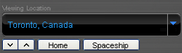Viewing Location

By default, this should be set to Phoenix, AZ. But you can also pick a different location to see what the sky looks anywhere in the world! If you’re lost, the Home button will always take you back to Phoenix at the current time. The two arrow buttons next to Home will allow you change your viewing altitude.

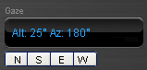Gaze

This displays the altitude/azimuth coordinates of where you’re looking.

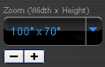

Zoom

This shows your angular field of view. In general, you can zoom in and out by using the scroll wheel on your mouse. Or you can use the (-) or (+) buttons.

Moreover, you also have a number of side panes that can allow you to pull up favorites, labels, or other information:



Clicking on a pane causes the pane to slide out, revealing a set of controls.

The most useful one for this lab, is under the Status pane. Click on the next to Time layer to expand it. Here, you will see a more detailed view of the Time and Date display. But the most useful for this lab is the Julian date!

If you have any questions at any time, please don’t hesitate to ask your TA. It is very important that you understand how to manipulate your environment before you move on to the exercise itself.

The Task – Verification of Kepler’s Third Law

One of Kepler’s Laws states that the period of a planet’s orbit is directly related to the size of that orbit through a simple relation. We are going to test that assertion and attempt to determine the simple relationship involved.

The first two laws state some simple properties of orbital motion.

Kepler’s First Law states that any body in orbit about another moves in an elliptical orbit with the central mass at one of the foci. In the case of the planets in our Solar System, these ellipses are very circular looking and are not very eccentric like the orbits of comets or asteroids.

Kepler’s Second Law goes one step further to point out that in moving around this elliptical orbit, when the orbiting body is close to the central mass, it moves faster, and when it is further away it moves slower. This produces the so-called law of equal areas, that an orbiting body sweeps out equal areas in equal times (see figure below).

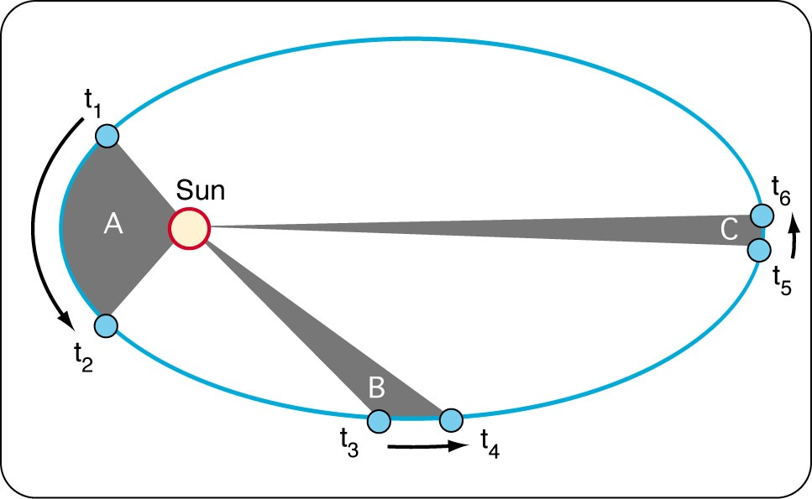

Kepler’s Third Law is related to both of these two laws but goes one step further. This is what we are intent on understanding better.

Observations

Using the Starry Night software, we are going to measure the orbital periods of the planets in our Solar System and attempt to derive the functional form of the relation that describes Kepler’s Third Law.

1. Use the software to present a view of the Inner Solar System (under Favourites > S~1 (the first one) > I~1 > IN~1). Using the time tools, and the various tools that change your view of the motion of the planets, measure the period of each inner planet and fill in the table at the end of this lab script with the following data: name of planet, period of orbit, average radius of the orbit. Perihelion is marked on each orbit, so your distance should be the average of perihelion and aphelion.
2. Next, repeat the process but with the Outer Solar System (under Favorites > S~1 (the first one) > O~1 > OU~1). Add these data to your table. An added complication is that the real-time distances are not displayed for the outer solar system – so you’ll need to use the measuring tool to estimate the distances between each of the planets and the Sun.

In what units did you measure your periods and orbital radii? It is typical to measure orbital periods in Earth years, and orbital radii in Astronomical Units (AU’s – which is the average radius of the Earth’s orbit). Make certain that you list the period in years and the average distance in AUs in your data table. In order to help with graphing the data, calculate the logarithm of the period and average radius and also include these in the data table.

We know that Kepler’s Third Law “simply” relates period and orbital radius. What one person refers to as simple may differ dramatically from what another person terms simple. In this case, simple means that the two quantities are related, but each term is raised to some power, ie. period cubed, or radius to the 5th power.

A very simple way to determine these power terms is to use the logarithm of the data. For example, if the following equation holds:

*ya = xb*

Then by taking the logarithm, the equation becomes a lot simpler to graph:



With your data, use a similar approach to determine the exponents used in Kepler’s Third Law.

1. Graph the logarithm of period versus the logarithm of orbital radius, and measure the slope of the resulting line.

The resulting slope will tell you the exponents needed in the simple relation between the two variables. Here are the decimal values of some common simple exponent ratios:

|  |  |
| --- | --- |
| Ratio | Decimal Value |
| 5/2 | 2.5 |
| 4/2 | 2.0 |
| 3/2 | 1.5 |
| 2/2 | 1.0 |
| 5/3 | 1.66 |
| 4/3 | 1.33 |
| 3/3 | 1.0 |
| 2/3 | 0.66 |
| 1/3 | 0.33 |
| 5/4 | 1.25 |
| 4/4 | 1.0 |
| 3/4 | 0.75 |
| 2/4 | 0.5 |
| 1/4 | 0.25 |

1. What expression do you get for Kepler’s Third Law?
2. What does it tell you about the period of a small orbit, versus the period of a large orbit? Does this make sense when you refer to Kepler’s Second Law?
3. Assume that the orbits are circular and calculate the average orbital speed (distance traveled divided by the time traveled) for each planet. Express the velocities in km/s (1 AU = 1.50x108 km) and include these in the data table at the end of the lab script.
4. Plot each planet’s velocity against its orbital radius. Draw a smooth curve through the data points. This curve is called a Keplerian rotation curve and is used to look for protoplanetary disks around other stars. If the material around a star is seen to move with the same distribution, then we know the material is bound to the star as the planets are bound to the Sun.
5. What fundamental force governs the motion of bodies in orbit about each other? In light of what you have calculated here, does this force get stronger or weaker when the two orbiting bodies get closer together? Why? Think about the analogy of whirling a ball on a string around your head and consider your orbital speeds from above. Explain your reasoning.
6. As a last exercise, move yourself back to the Earth’s surface and look at the sky. Turn off the sky so you can see the planets, and turn on their orbits so you can see their paths in the sky. You can now see how the plane of the Ecliptic is defined – it’s the plane of the orbits of the other bodies (and us) in a disk about the Sun. Move time forward to see how the planets’ motion changes with time. This is the way Kepler originally worked out his Laws of orbital motion.
7. Is this method harder or easier than the previous method you used? Why? What problems would you encounter with this method?
8. What are epicycles? Why are they seen to happen?
9. When you observed the motion of the planets in the inner and outer solar system, did the radius of the orbit stay the same as the planet moved? Why? Did the point of closest approach to the Sun (perihelion) occur at the same place in the orbit each time? If not, take a guess why not.
10. The planets’ orbits are very close to circular – did you perceive any change in orbital speed as the planets moved around their orbits?
11. The final form of Kepler’s Third Law is a remarkable formula and makes some very simple predictions. Do you expect this Law to be obeyed outside the Solar System? Why? Explain your reasoning.
12. In addressing epicycles (and retrograde motion) in your report, name the planets that perform epicycles in our night sky over the course of time, and which do not. Why?

Summarize what you have learned in tonight’s lab:

|  |  |  |  |  |  |
| --- | --- | --- | --- | --- | --- |
| Data Table | Period (years) | Ave orbital radius (AU) | Log (Period) | Log (orbital radius) | Orbital Speed (km/s) |
| Mercury |  |  |  |  |  |
| Venus |  |  |  |  |  |
| Earth |  |  |  |  |  |
| Mars |  |  |  |  |  |
| Jupiter |  |  |  |  |  |
| Saturn |  |  |  |  |  |
| Uranus |  |  |  |  |  |
| Neptune |  |  |  |  |  |

Please use space below for calculations.

