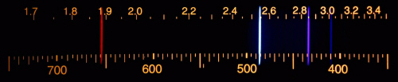EXAMPLE SPECTRA

Hydrogen

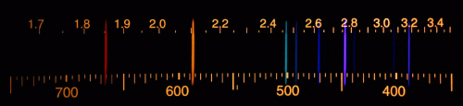

Helium

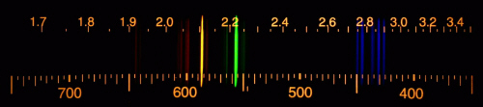Krypton

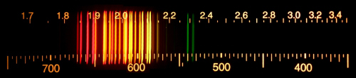

Neon

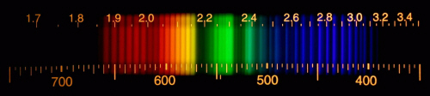

Nitrogen

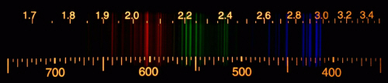

Argon

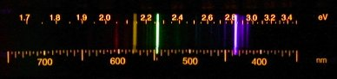

Mercury

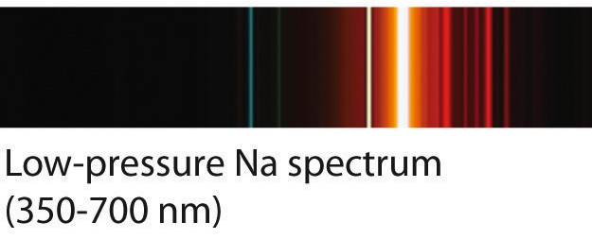Axis inverted! For Sodium Spectrum Below