NAME: \_\_\_\_\_\_\_\_\_\_\_\_\_\_\_\_\_\_\_\_\_\_\_\_\_\_\_\_\_\_\_\_\_

SPECTROSCOPY PRELAB

1. What is a spectrum?
2. Name the 3 types of spectra and, in 1 sentence each, describe them.
3. Use Wien’s law to calculate the surface temperature of the star Alnilam (ε Orionis). The peak wavelength (λpeak) of the star is 0.116 μm. How does this temperature compare to the surface temperature of the Sun?
4. Rank the energy of the following photons of light from highest to lowest.

FM Radio \_\_\_\_\_\_\_\_\_\_\_ (highest energy)

IR \_\_\_\_\_\_\_\_\_\_\_

X-Ray \_\_\_\_\_\_\_\_\_\_\_

Visible \_\_\_\_\_\_\_\_\_\_\_

UV \_\_\_\_\_\_\_\_\_\_\_

Long Radio \_\_\_\_\_\_\_\_\_\_\_

Microwave \_\_\_\_\_\_\_\_\_\_\_ (lowest energy)

SPECTROSCOPY

What will you learn in this Lab?

This lab is designed to introduce you to spectra and how they are related to light and atoms. It will teach you the different types of spectra and their origins. With this knowledge you will be able to identify different elements from the observed light of astronomical objects.

What do I need to bring to the Class with me to do this Lab?

For this lab you will need:

* A copy of this lab script
* A pencil
* Scientific calculator

Light

The electromagnetic phenomena that we call “light” can be adequately understood by its wave-like properties. If you are unfamiliar with the physical description of waves, consider the following figure.

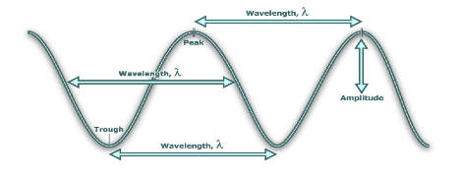

A wave can be fully defined by its wavelength and amplitude, which are outlined below.

A wave can similarly be described by its frequency.

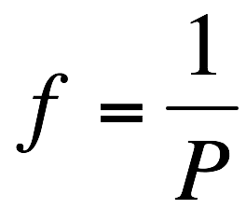

Where *f* is the frequency in Hertz and *P* is the period of the wave in seconds. The period is simply the time it takes for the wave to cycle between successive peaks (or troughs, or any corresponding point in the waveform).

Light waves are manifestations of oscillations in electro-magnetic fields. For light waves, the relationship between wavelength/frequency and “color” of a wave is:

REDDER light has LONGER Wavelengths and LOWER Frequencies

BLUER light has SHORTER wavelengths and HIGHER Frequencies

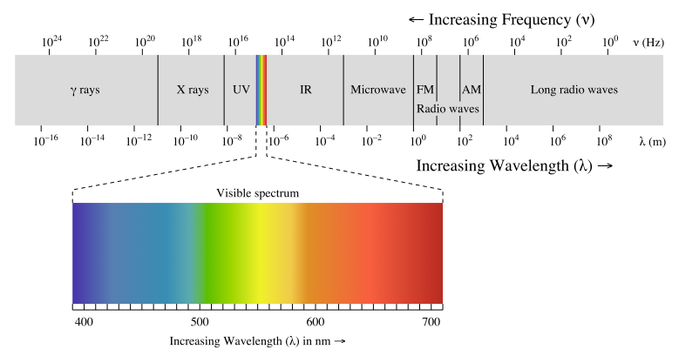

The spectrum of light

Look at the pictures below. When you pass white light through a prism the light gets divided into its constituent colors. This happens because the prism “bends” or refracts the light at an angle that is dependent on the wavelength of light. Shorter wavelengths (bluer) get refracted more (at a greater angle) than longer wavelengths (redder).

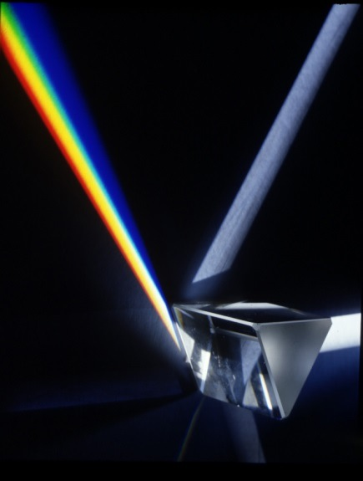 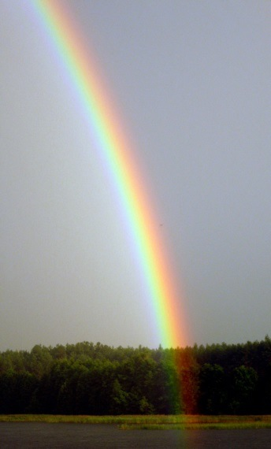

Note: Water droplets act like prisms forming rainbows

A spectrum is the outcome of separating light into its components according to wavelength.

To understand the spectra of astronomical objects we first need to understand how that light was produced. Atoms are made of protons and neutrons in their cores surrounded by electrons. These electrons can only exist in certain energy levels around the nucleus. The electrons can be excited into a higher energy level by collisions with other electrons, by absorbing photons or by the action of heat. The electrons can then jump back down to a lower energy level by emitting a photon releasing the extra energy they gained that took them up to the higher level. In other words, the energy released is equal to the difference in energy between the lower and the higher energy level.

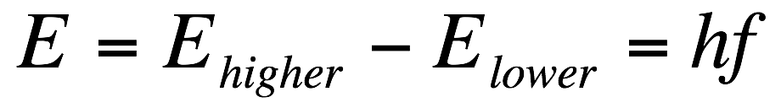

Since 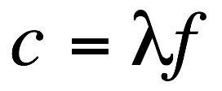

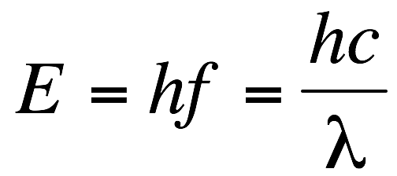

where h is the Planck constant (6.626 x 10-34 m2 kg/s), c is the speed of light in vacuum (3 x 108 m/s), λ is the wavelength of the emitted photon, and *f* its frequency.

Since electrons can only be in discrete energy levels they can only emit photons with specific energies, and by the relation above, of specific wavelengths. Different atoms have different numbers of electrons and different energy level distributions. Because of this, different types of atoms (i.e. different elements) emit or absorb photons that are specific to the element they represent just like your fingerprints are specific to you. By measuring the wavelengths of these photons it is possible to identify the element that emitted them.

In some cases the temperature of the environment surrounding the atom, or the energy of the photon absorbed by the atom, is too high. In these cases the electron can be ejected from the atom completely in a process called ionization. When an atom is fully ionized it has lost all its electrons, but it does not have to lose all its electrons to be called ionized. The resulting nuclear component of the atom (comprised of the neutrons and protons) is called an ion. The ejected electrons are now moving around the ions and can reattach if they lose energy. In cases when the temperature is too high the electrons can never lose enough energy to reattach and therefore the atoms stay fully ionized. When this happens the characteristic wavelengths of light for that element cannot be absorbed by the electrons since they’re missing, resulting in an absence of the strong absorption lines that would otherwise be observed.

1. Later in this lab we will use a representation of the atom in which a central nucleus containing protons and neutrons is surrounded by circles that represent the energy levels electrons can occupy. Draw such a diagram showing a nucleus, and five energy levels that electrons could occupy. Draw a dot to represent an electron at the lowest energy level.

Types of Spectra

Continuum Spectrum: These show emission over a wide range of wavelengths/frequencies, with the strength of emission at each wavelength and the wavelength of peak emission determined by the temperature of the object.

Emission Line Spectrum: Due to the discrete energy levels of electrons in the atoms of a hot gas, specific wavelengths of light can be emitted. These emission lines can be interpreted as a distinct "fingerprint" for that gas; astronomers use this fact to identify the chemical composition of clouds of gas in deep space. Each different type of atom (hydrogen, helium, lithium, etc.) has its own signature set of specific colors that it emits.

Absorption Line Spectrum: Similar to emission lines but in the reverse sense, these spectra are often due to cooler gas absorbing photons of the same specific energies as a hot gas emits. An absorption line spectrum appears to be a continuum spectrum with emission lines taken out. Imagine a cloud of cooler interstellar gas nearer to you than a hotter source of continuum radiation; you will see the more distant object's continuum minus those specific energies absorbed by the intervening gas cloud.

Wavelength

Intensity

Wavelength

Intensity

Wavelength

Intensity

|  |  |  |
| --- | --- | --- |
| SES103-Fa08_Week06_c-spectra_NTv0a | SES103-Fa08_Week06_e-spectra_NTv0a | SES103-Fa08_Week06_a-spectra_NTv0a |
| Continuum Spectrum | Emission Spectrum | Absorption Spectrum |

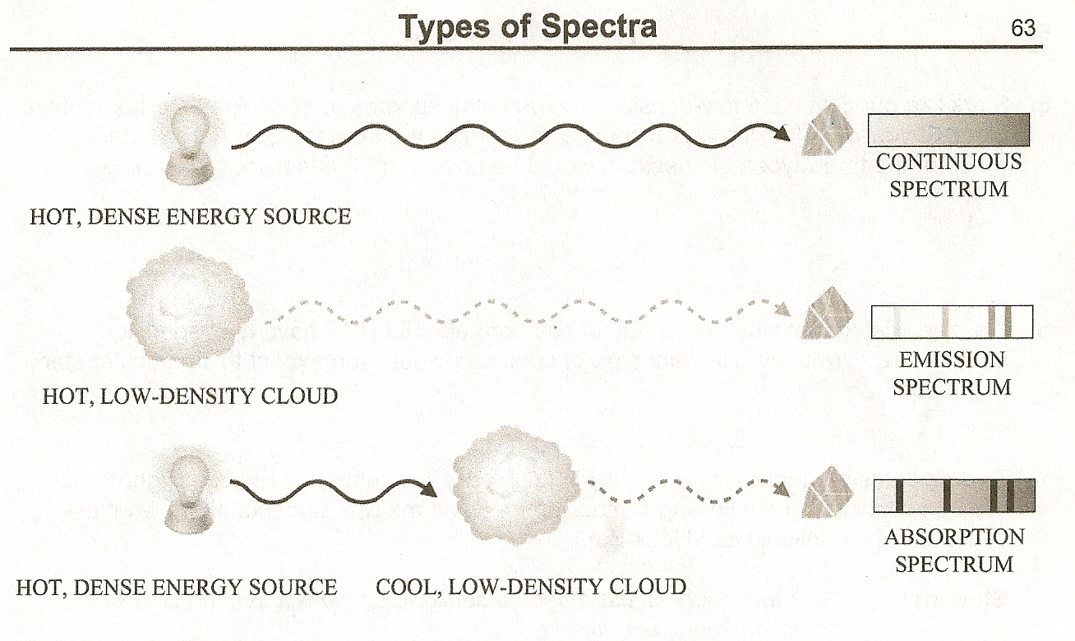

1. *What type of spectrum is produced when the light emitted directly from a hot, dense object passes through a prism?*
2. *What type of spectrum is produced when the light emitted directly from a hot, low-density cloud of gas passes through a prism?*
3. *Describe in detail the source of light and the path the light must take to produce an absorption spectrum.*
4. *There are dark lines in the absorption spectrum that represent missing light. What happened to this light that is missing in the absorption line spectrum?*
5. *Stars like our Sun have low-density, gaseous atmospheres surrounding their hot, dense cores. If you were looking at the spectra of light coming from the Sun (or any star), which of the three types of spectrum would be observed? Explain your reasoning.*
6. *If a star existed that was only a hot, dense core and did NOT have a low-density atmosphere surrounding it, what type of spectrum would you expect this particular star to give off?*
7. *Two students are looking at a brightly lit full Moon, illuminated by reflected light from the Sun. Consider the following discussion between the two students about what the spectrum of moonlight would look like.*

*Student 1: I think moonlight is just reflected sunlight, so we will see the Sun's*

*absorption line spectrum.*

*Student 2: I disagree. An absorption spectrum has to come from a hot, dense object. Since the Moon is not a hot, dense object, it can't give off an absorption*

*line spectrum.*

*Do you agree or disagree with either or both of the students? Explain your reasoning.*

1. *Imagine that you are looking at two different spectra of the Sun. Spectrum #1 is obtained using a telescope that is in a high orbit far above Earth's atmosphere. Spectrum #2 is obtained using a telescope located on the surface of Earth. Label each spectrum below as either Spectrum #1 or Spectrum #2.*

Spectrum # \_\_\_\_\_\_\_\_\_\_\_\_

**

Spectrum # \_\_\_\_\_\_\_\_\_\_\_\_

**

*Explain your reasoning behind your choices:*

One way an atom emits light (photons) occurs when an electron drops down from a high

energy level (also referred to as an excited state) to a lower energy level (the lowest energy level is referred to as the ground state.)

1. Will an atom emit light if all of the atom's electrons are in the ground state? Explain your reasoning.
2. In which case does an atom emit more energy (circle one)?

Case A: An electron drops down from the first excited state to the ground state.

Case B: An electron drops down from the third excited state to the ground state.

Explain your reasoning.

1. Redraw the initial drawing you made in Question 1. Describe what additions or changes you made on this new drawing so that it better conveys what you understand about the relationship between light and atoms.
2. Use the hypothetical atom drawings (A-F) below to answer the next five questions. Note there is only one correct choice for each question.

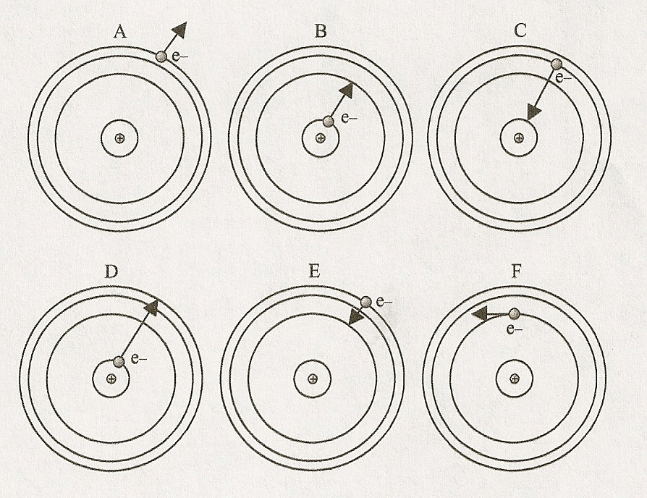

a) Which shows the absorption of violet light? Explain your reasoning.

b) Which shows the emission of blue light? Explain your reasoning.

c) Which shows the absorption of green light? Explain your reasoning.

d) Which shows the emission of orange light? Explain your reasoning.

e) Which shows an electron being ejected from the atom? (a.k.a. ionized)

\*\* Source: Questions 2-13 from *Lecture-Tutorials for Introductory Astronomy*, 3rd Ed., E.E. Prather, T.F. Slater, J.P. Adams, G. Brissenden.

Lab Exercise

We will be studying light through a spectroscope. A spectroscope (or spectrometer) separates light into its different color components. When you look through the spectroscope, you should notice several colored lines.

As we have already discussed, each element in the periodic table has a distinct atomic structure. Energy levels of the electrons in each kind of atom are a signature; we can use spectra to identify the source atoms.

Look at the figures below. The correct orientation of the spectrometer is shown in the left image. To see the spectrum point the film transparency slit toward the light source and look through the diffraction grating. The spectrum will appear to the left on the calibrated scale.

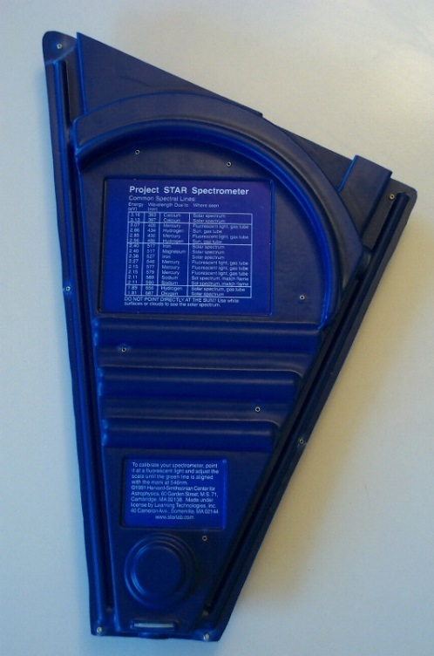 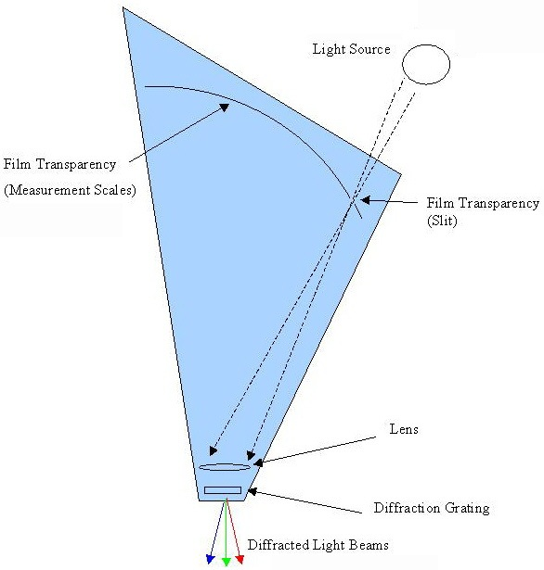

Part I: Absorption Spectrum

The image below is the visible portion of the spectrum of the Sun. Answer the following questions using this image.

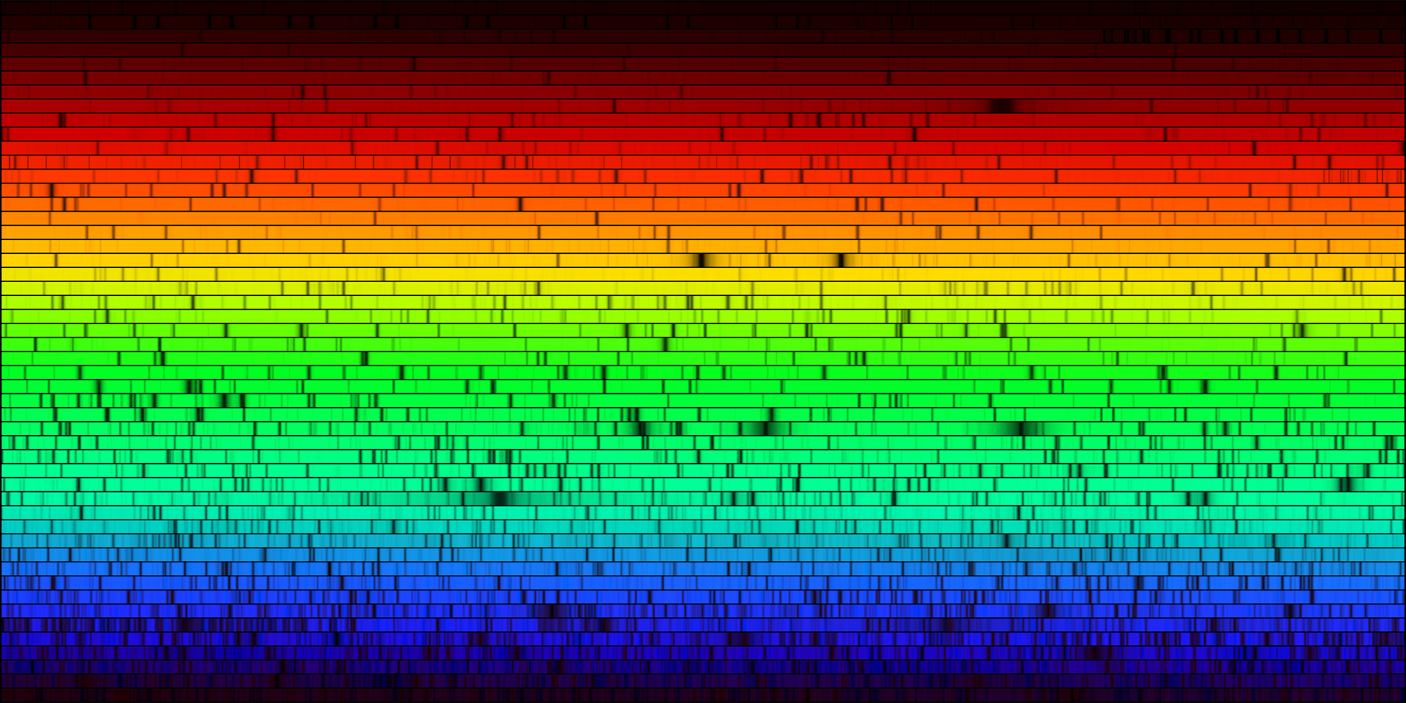

1. What kind of spectrum is this?
2. How would you explain the origin of the dark lines in this spectrum? Recall that the Sun is a giant ball of hot gas and that the further you go into the Sun, the hotter it gets.

There is a relationship between color and the temperature of the surface of the star. This is defined by Wien’s Law:

or

Where is in units of and is in units of Kelvin.

1. The Sun’s surface temperature is 5780 K. What is the peak wavelength emitted by the Sun? SHOW YOUR WORK.

Here are approximate wavelengths associated with colors in the visible light region of the electromagnetic spectrum:

violet ≈ 0.35 - 0.39 μm indigo ≈ 0.39 - 0.42 μm blue ≈ 0.42 - 0.46 μm

aqua ≈ 0.46 - 0.50 μm green ≈ 0.50 - 0.56 μm yellow ≈ 0.56 - 0.60 μm

orange ≈ 0.60 – 0.65 μm red ≈ 0.65 - 0.75μm

1. What color does your answer for the previous question correspond to?

PART II: Emission Spectrum

Obviously, light can be made up of a variety of different colors, both discrete and continuous. For instance, the white-light bulbs that you have at home and use everyday do not put out "white light" as is commonly believed; instead, light of many colors is emitted and the different colors combine to look like white light.

In the next part of this lab you will look at the emission line spectrum of several different gas lamps — please do not touch the bulbs! By recording the emission lines you see and comparing them to a list of known emission spectra, you will identify four different gases seen in emission.

Fill in the emission lines you see on the charts below (make your best guess based on the number and general placement of the emission lines, according to the colors and wavelengths that have been given). Identify what element you have in each tube, based on the key of reference spectra provided. Use the provided color pencils.

|  |  |  |
| --- | --- | --- |
| Tube # | Sketch of emission lines | Element |
| 1 | : : : : | : : : : | : : : : | : : : : | : : : :    700 nm 600 nm 500 nm 400 nm  red yellow green indigo |  |
| 2 | : : : : | : : : : | : : : : | : : : : | : : : :    700 nm 600 nm 500 nm 400 nm  red yellow green indigo |  |
| 3 | : : : : | : : : : | : : : : | : : : : | : : : :    700 nm 600 nm 500 nm 400 nm  red yellow green indigo |  |
| 4 | : : : : | : : : : | : : : : | : : : : | : : : :    700 nm 600 nm 500 nm 400 nm  red yellow green indigo |  |
| 5 | : : : : | : : : : | : : : : | : : : : | : : : :    700 nm 600 nm 500 nm 400 nm  red yellow green indigo |  |
| 6 | : : : : | : : : : | : : : : | : : : : | : : : :    700 nm 600 nm 500 nm 400 nm  red yellow green indigo |  |

PART III: Everyday applications

Look through the spectrometer at any fluorescent bulb (try the lights out in the hallway if the ones in the classroom are off). Make sure you can adequately see the component colors separated. Notice the colors that combine to make up the “white” light you see.

1. Describe, generally, what you observe through the spectrometer. What are the component colors of the fluorescent bulb?

|  |
| --- |
| : : : : | : : : : | : : : : | : : : : | : : : :    700 nm 600 nm 500 nm 400 nm  red yellow green indigo |

1. What kind of spectrum do you observe when looking through the spectrometer at a fluorescent bulb?
2. What elements that make up the fluorescent bulb can you identify from the spectrum?
3. What kind of spectrum do you observe when looking through the spectrometer at the provided incandescent bulb?

Summarize what you have learned in this lab: