Intro to the Telescope

-before you go out on the roof, take them into the telescope room and show them a telescope in the light

-take the red cellophane and tape to class with you

-show them how to move the telescopes so they can do some of the exercises by themselves

-they will be using the older telescopes, but they won’t know what RA and dec are yet, so just say “up and down” and “side to side”

-I usually start this lab by drawing a diagram of how reflectors and refractors work, explain why there aren’t any big refractors, then get into the properties of a telescope and show them the equations (skip scale because that only applies when you take an image)

-you HAVE to draw a picture for resolving power

Star 1 Star 2

α1: can resolve both stars

α2: see both stars as one object

-“α is the minimum angle/distance that 2 objects can be apart and you can still see them as separate objects”

-they will be in 3 big groups for this lab, and they will just work their way around to each exercise

-try to have the exercises spread out over the roof

-once they’re done with their observations, take them back to the classroom so they can finish the questions

Procedure

-split them up into 3 big groups

-Exercise 1: Determining the Size of the Field of View

-need two telescopes (9 and 11 usually work well for this) facing south with different eyepieces. I would recommend a 12 mm and 25 mm focal length (don’t use a 40 mm because it will take too long)

-do NOT plug the telescopes in for this exercise!

-have them split up further and one half of the group will only time one eyepiece, then they will share the information with the other half of their group later

-stopwatches are in the cabinet in the front of the telescope room with the eyepieces

-question 6 might be a little difficult for them to figure out, especially if this is the first actually lab that they’re doing, so you can have them skip it if you want

-Exercise 2: Magnification and Light Gathering Power

-use 2 telescopes (different than the ones for exercise 2) and two different eyepieces

-planets and the moon are good to look at for this exercise

-they only need to sketch the view from the finder scope and 2 eyepieces, so one circle will be blank

-Exercise 3: Resolving Power

-need 1 telescope with a 12 mm eyepiece, and binoculars

-use Alberio in the fall, and Castor in the spring

-question 16: diameter of binocs = 2.25 inches

Intro to the Night Sky

-go over all the terms

-stellar nomenclature: bright stars will often have 2 names: one cultural name, and one with information about the star: eg. Vega = α Lyra

-greek letters indicate the brightness (α is brightest), but this ordering can be broken due to variable stars

-bring the red cellophane and tape to class

-go over how to use the star charts and star wheel

-you’ll probably want to finish of the roof instead of the classroom, so make sure they take their stuff and you lock the door

Procedure

-once you’re outside, give a brief constellation tour to help them get oriented with the sky

-Part 1: Drawing a Constellation

-they pretty much just need to draw one constellation (Cassiopeia and Orion are usually pretty good for this) and compare their drawing to the Audubon Guide

-they need to label N, S, E, W and the time. This can be tricky if they choose a constellation in the south (north on the sky is always up)

N N

W E E W

S S

North South

-Part 2: Specific Objects in the Night Sky

-they just observe a list of stars and fill out the table

-Polaris, Caph, Deneb, Altair, Vega, Arcturus, and Anteres are good for the fall, Betelgeuse, Sirius, Capella, Aldebaran, and Procyon are good for the spring. Feel free to add more.

-have them find the other name for these stars too

-you can use a planet or the moon for table 2, but just have them fill out the color and figure out what constellation it’s in

-Part 3: Sky Sketches

-they just draw the northern and southern sky

-they need to label constellations, directions, date, and time

Impact Cratering

-don’t put out the sand boxes until you’re ready to use them. Even though your students are adults they won’t be able to resist the urge to play in the sand.

-go over the types of craters, both impact and volcanic. I would recommend showing the pictures from the lab on the projector

-go over the equations in the beginning, even though they’re presented in the middle of the lab

-be sure to emphasize what units have to be used with the equations

Procedure

-you will need to have rulers and meter sticks

-you should bring some extra graph paper in case someone doesn’t have the lab script or it didn’t print very well

-Exercise 1:

-in this part they will be dropping various sized ball bearings into the sand from different heights

-all of the equipment is in tubs in H458

-I have them drop the balls from .5m, 1m, and 2m above the sand

-they need to drop each ball from each height at least once (normally when taking scientific data you would take several measurements and average them together. You’re not going to have time to do that in this lab)

-ball bearing masses and diameters (you will need to give this to your students):

Mass (g) | Diameter (inches)
7.7 | 0.5
15.9 | 0.625
27.3 | 0.75
44.3 | 0.875
66.7 | 1

-to make the crater, you hold the meter stick in the sand box and hold the ball bearing at the right height, then just let go (do not throw it), then take the ruler and measure the diameter of the crater

-it doesn’t matter if they line up the top, middle, or bottom of the ball bearing with the meter stick, or if they measure to the inside or the outside of the rim of the crater, just as long as they make the measurements the same way every time

-after each crater is made, smooth the sand over with the ruler

-they also need to sketch a top view and side view of one of the craters (I would recommend they sketch the crater from the biggest ball from the tallest height as it will be the biggest crater)

-Exercise 2:

-you may or may not have time for this (if you run out of time you can do one yourself as a demonstration rather than have each group do it themselves)

-this part is to compare an impact crater with a volcanic crater

-the easiest way to do this is to use the pumps: clamp a balloon to the end of the tube and pump it up, then bury it in the sand with the tube still attached, and pop it with a pencil or something sharp

-they then need to sketch a top view and side view of the crater

-Exercise 3:

-this is just filling out the rest of the table

-they need to calculate log(crater diameter), velocity, kinetic energy, and log(KE)

-be careful with units!

Analysis/Questions

-basically they just go through and answer the questions

-Exercise 1:

-this is where they do all the graphing. This is the most confusing part of the lab

-you’ll have to show them how to do this (see the excel spreadsheet I made)

-(i) will have 3 lines, one for each height
(ii) will have 3 lines, one for each height
(iii) will have 5 lines, one for each mass

-Exercise 2:

-questions on the differences between the impact and volcanic craters

-Exercise 3:

-only do this if they’ve done everything else and you still have at least 30 minutes left (odds are you’re not going to have time for this)

-this is very confusing for them

-they plot log(crater diameter) vs. log(KE)

-you’ll have to tell them how to find the slope

-you’ll have to explain how the slope will give the relation in question 2

Spectroscopy

-allow a little extra time to set up for this lab

-all of the equipment is in H470

-each spectroscopy class will need :1 sodium lamp (the big one with it’s own power supply), 1 mercury or hydrogen lamp (the blue box (not a tardis =P), or the tall lamps), 2 carousels with 4 lamps each, 24 spectrographs, and 12 to 15 boxes of colored pencils

-I usually set up all the lamps at the back of the room, or off to the sides and set up chairs by them so that the students can move to the workstation to look at the lamps

-leave the lamps off until you’re ready to use them

-I use a powerpoint to go over the background material that I will also e-mail

Procedure

-show them how to use the spectrographs and the carousels

-I always ask if anyone is color blind, but I tell them that they don’t have to tell me if they don’t want to, but if someone is it will be good for you to know, because this lab will be really hard for them

-you’ll want two groups using the lamps at the same time, everyone else will need to work on the other parts

-Part 1: Absorption Spectrum

-use the picture to answer the questions

-Part 2: Emission Spectrum

-they will be using the lamps in this part

-you’ll need to have the lights dimmed, but not completely off for this

-the easiest way for the students to do this is to have one person look at the lamp through the spectrograph and read off where there are emission lines, and the other person to record them in the lab script, then switch

-they basically just need to copy the spectrum that they see into their lab scripts using the colored pencils and try to identify which number is which element from the sample spectra (at the end of the notes and e-mailed as a pdf)

-if you are in a computer room, you can post the sample spectra on BB and have the students download it and look at on their individual computers, if not you can display the samples on the projector

-as of 8/28/12 the lamps are labeled as follows:

1: Nitrogen
2: Helium
3: Neon
4: Argon
5: Mercury
6: Sodium

-they need to get right up next to the lamps to be able to see them well

-Part 3: Everyday Applications

-they will need to look at a fluorescent and incandescent light bulbs either in the classroom or in the hallway

-Part 4: Astronomical Applications

-they answer a bunch of questions based on the provided stellar spectra

-the students in AST 113 will not be able to answer several of these questions because we do not cover stars in that class: skip questions 10, 13, 14, 15, and 16

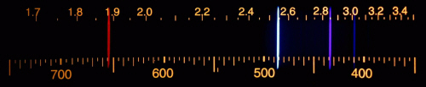
EXAMPLE SPECTRA
Hydrogen

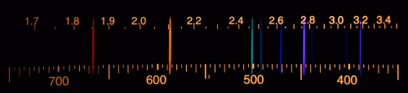
Helium
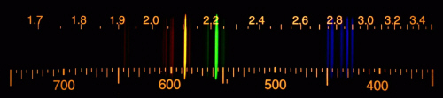
Krypton

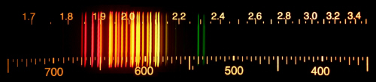
Neon
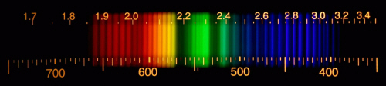
Nitrogen

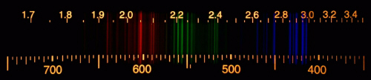
Argon

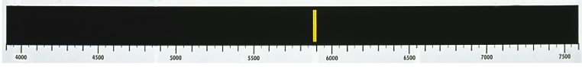
*Note the axis is inverted for the following 3 spectra
Sodium
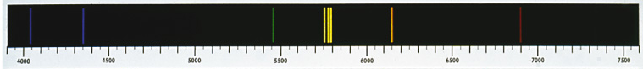
Mercury

Calcium

