Braeside Observing – Extrasolar planets

What will you learn in this lab?

We have developed models of the solar system based on the mass, motions, locations, and compositions of the planets and the Sun. Do other solar systems exist? In this lab you will:
- Categorize the properties of terrestrial and Jovian planets in our solar system
- Become familiar with methods for looking for extrasolar planets
- Use the Braeside Observatory to look for an extrasolar planet
- Determine whether other solar systems resemble our own

What do I need to bring to the Class with me to do this Lab?

- A copy of this lab script
- Pencil and eraser
- Scientific Calculator

Introduction:

In class, you have been studying properties of our own solar system, learning about the Earth and Moon, other planets, asteroids, comets, and meteorites, and the Sun. From your studies, you have probably come to some conclusions as to how our solar system works. Astronomers have developed models of how our solar system formed based on our knowledge of the solar system.

Are there other solar systems? Do they look like ours? These are just a few of the questions that astronomers are trying to answer. To do so, we must scan the skies for other solar systems. To date, over 100 promising candidates for planets in orbit around other Sun-like stars have been observed. These planets are called extrasolar planets – implying that they orbit a star other than our own Sun. There are two primary methods that astronomers have been using on their search for extrasolar planets:

Method 1: Doppler method

In your lecture course, you were introduced to the concept of Doppler shifts – the perceived change in the frequency of light being emitted by an object due to the relative motion between the object and the observer. If the object is moving towards us, we see a blueshift in the lines of the object's spectrum. Similarly, if the object is moving away from us, we observe a redshift in the object's spectrum.

Figure 1:
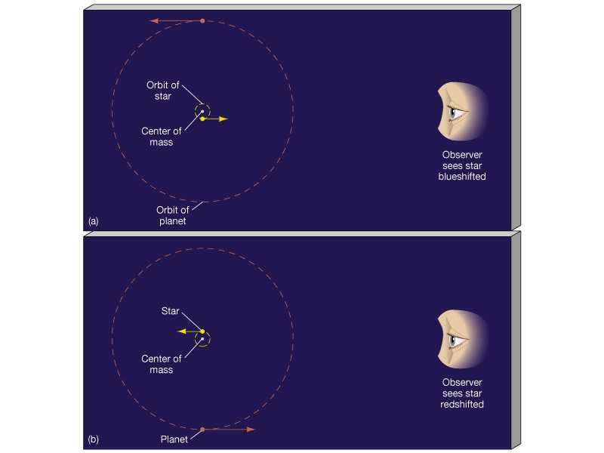
Because a star and its planets orbit a common center of mass, we should observe Doppler shifts in the spectrum of the star. Figure 1 illustrates this process. The amount that a frequency of light is shifted is proportional to the velocity of the planet in its orbit around the star and mass of the planet tugging on the star. Astronomers who are looking for extrasolar planets measure this "wobble" by obtaining Doppler velocity curves. By using this method, the mass and orbital semi-major axis for an extrasolar planet may be obtained.

Method 2: Transit method

In your lecture course, you were introduced to solar eclipses, where the Moon moves in front of the Sun and blocks the sunlight from our perspective. The dimming light from the Sun while being eclipsed can be plotted versus time, resulting in a light curve.

Figure 2:
If an extrasolar planet orbits its star such that it passes between the star and Earth, we observe an "eclipse" or transit. See Figure 2 for an illustration of the transit and resulting light curve. Astronomers are scanning the sky for stars that show evidence of transits due to having planets in orbit. From a transit, the radius of the planet may be calculated.

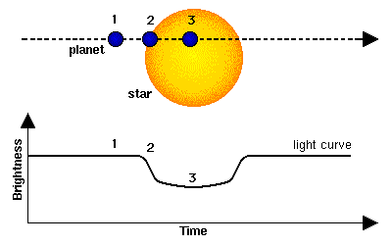

In this lab exercise, you will use both methods to investigate an extrasolar planet in orbit around a star very similar to our own Sun. There will be no formal written lab report for this exercise. (Please hold down the applause.) Write your answers to questions directly on the lab script and turn the lab script into your TA when due.

Exercise 1: Properties of our own solar system

The following table contains physical data for the nine planets in our solar system.

Table 1 | Mercury | Venus | Earth | Mars | Jupiter | Saturn | Uranus | Neptune | Pluto
Semi-major axis (AU) | 0.39 | 0.72 | 1.00 | 1.52 | 5.20 | 9.54 | 19.2 | 30.1 | 39.4
Mass (Earth masses – M_{Earth}) | 0.055 | 0.82 | 1.00 | 0.11 | 318 | 95.0 | 14.5 | 16.7 | 0.002
Radius (Earth radii - R_{Earth}) | 0.38 | 0.95 | 1.00 | 0.53 | 11.2 | 9.5 | 4.0 | 3.7 | 0.19
Atmosphere | none | CO₂/N | N/O | CO₂/N | H/He | H/He | H/He | H/He | N/CH₄(?)
Density (Earth densities) | 0.98 | 0.95 | 1.0 | 0.71 | 0.24 | 0.13 | 0.24 | 0.29 | 0.38

We divide the planets in the solar system into two major classifications – Terrestrial (Earth-like) and Jovian (Jupiter-like). By inspecting the values in Table 1, answer the following questions.

- Which four planets are terrestrial?

- Which four planets are Jovian?

- Which planet does not fit either category well?

- Which type (terrestrial or Jovian) is more massive?

- Which type (terrestrial or Jovian) has smaller radii?

- Which type (terrestrial or Jovian) has higher densities?

- Are the terrestrial planets located close to the Sun, far from the Sun, or spread evenly throughout the entire solar system?

- Are the Jovian planets located close to the Sun, far from the Sun, or spread evenly throughout the entire solar system?

Exercise 2: Doppler Method

In this section, we will use real data from Doppler measurements of spectral lines in two stars to discover a planet orbiting the star and compare the results of the discovery with planets in our solar system. Here is the Doppler velocity curve for the star HD 209458. If the star did not have a planet in orbit, the velocity would be constant (no red- or blueshift).
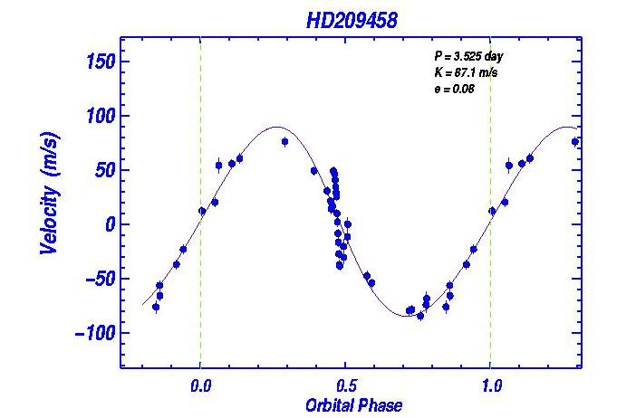

Here is the Doppler velocity curve for the parent star of TrES-1:
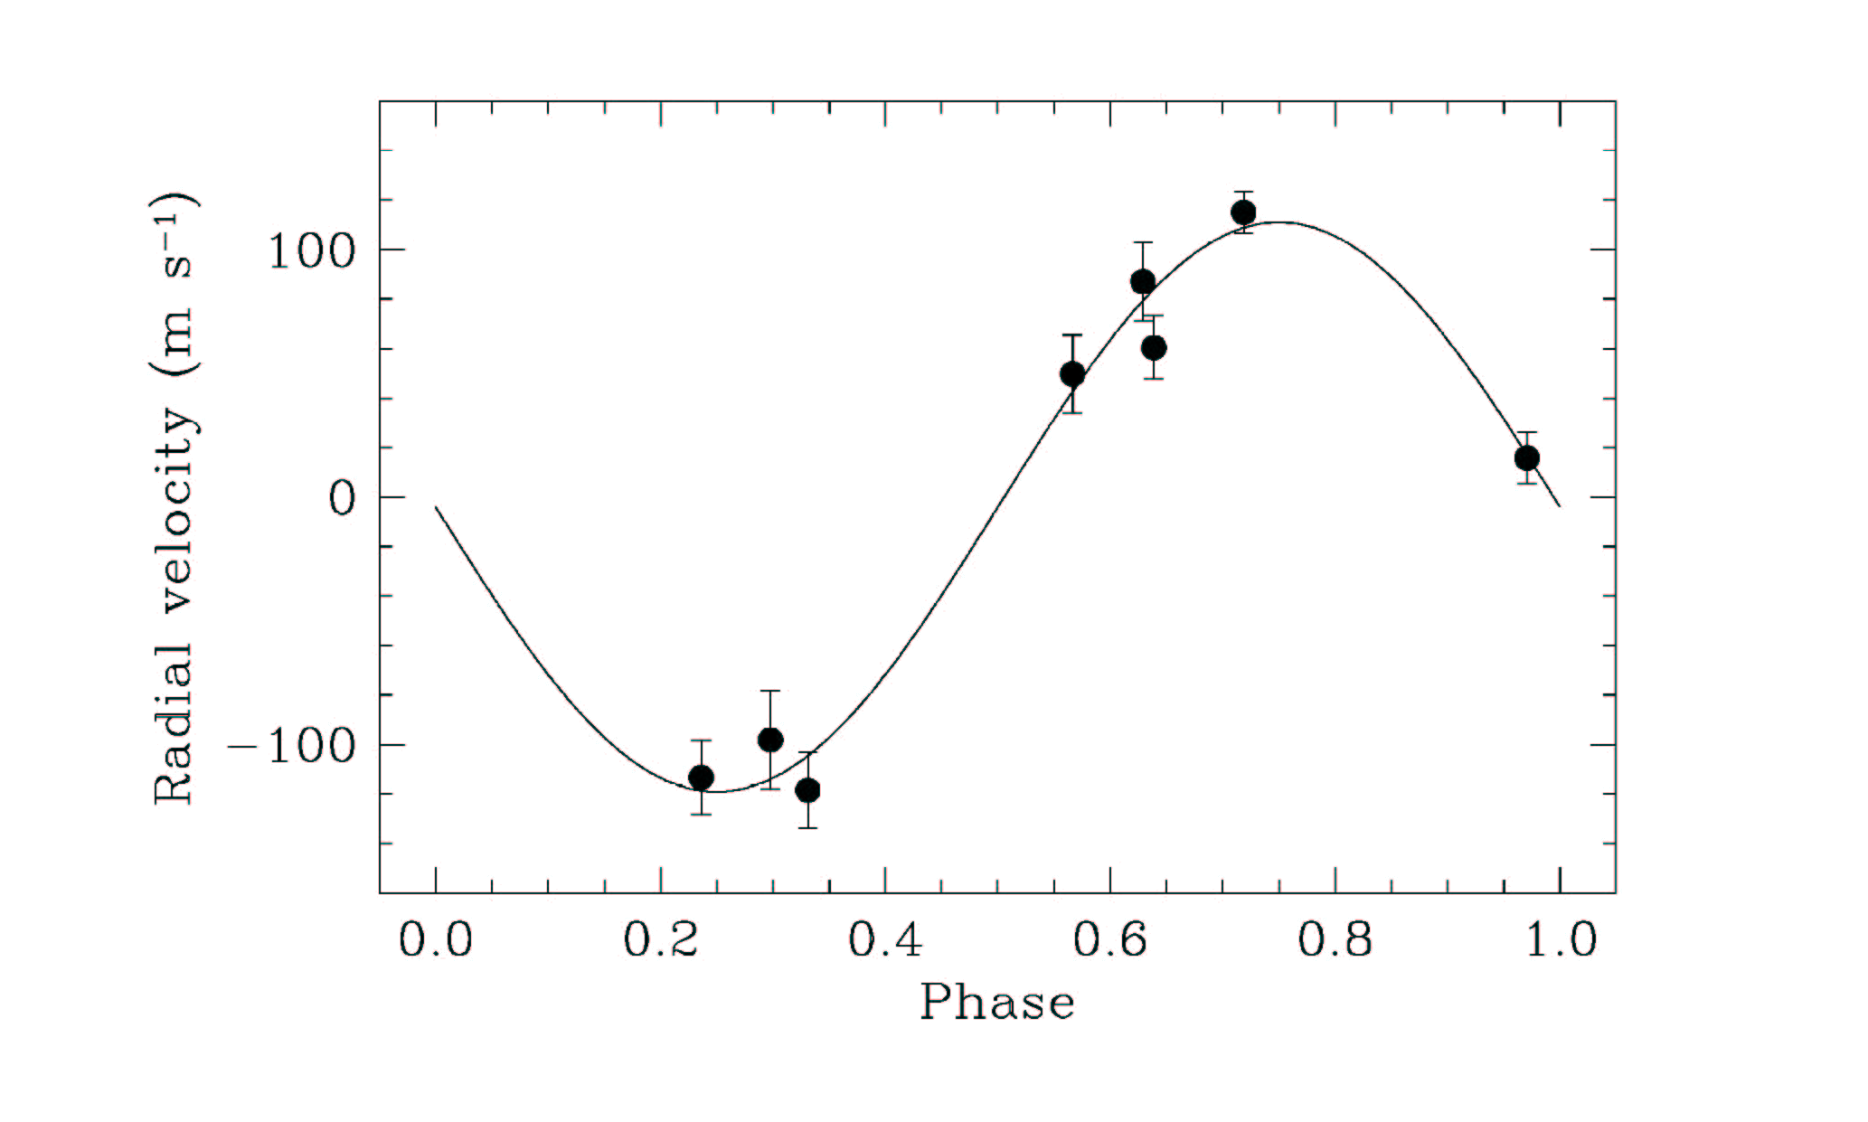
P = 3.03 d
- Use information given on the graph to determine the period of the planet's orbit, P, in days.

P = _______________ days (HD 209458)

P = _______________ days (TrES-1)

- What is P in years?

P = _______________ years (HD 209458)

P = _______________ years (TrES-1)

- What is the amplitude of the curve (orbital velocity), K, in m/s? (Take 1/2 of the full range of velocities.)

K = _______________ m/s (HD 209458)

K = _______________ m/s (TrES-1)

- We will make some simplifying assumptions for this new planetary system:
  - The orbit of the planet is circular (e = 0).
  - The mass of the star is 1 solar mass.
  - The mass of the planet is much, much less than that of the star.
  - We are viewing the system nearly edge on
  - We express everything in terms of the mass and period of Jupiter.

We make these assumptions to simplify the equations we have to use for determining the mass of the planet. The equation we use is:

M_{planet} = (P/12)^{1/3} × (K/13) × M_{Jupiter}

P should be expressed in years and K in m/s. To compare to our solar system, twelve years is the approximate orbital period for Jupiter and 13 m/s is the magnitude of the "wobble" of the Sun due to Jupiter's gravitational pull. Use your values for P and K and calculate the mass of this new planet in terms of the mass of Jupiter.

M_{planet} = ________________ M_{Jupiter} (HD 209458)

M_{planet} = ________________ M_{Jupiter} (TrES-1)

Recall that M_{Jupiter} = 318 M_{Earth}

M_{planet} = ________________ M_{Earth} (HD 209458)

M_{planet} = ________________ M_{Earth} (TrES-1)

- From our assumptions above, we can calculate the distance (in AU) this planet is away from its star using Kepler's 3rd law:

a³/P² = 1

using P in years. Solve for a, the semi-major axis, in AU.

a = ____________________ AU (HD 209458)

a = ____________________ AU (TrES-1)

- Compare these planets to those in our solar system. Where are their orbits located? (For example, if in our solar system, would this planet lie between Mars and Jupiter?)

Exercise 3: Transit Method

This is the light curve for HD 209458:
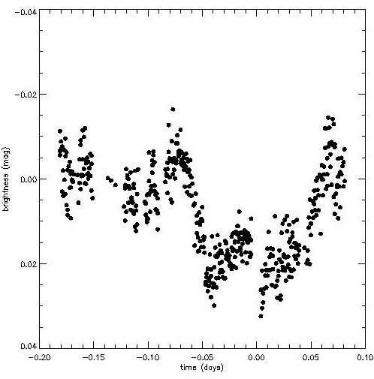

Here is the light curve for TrES-1:
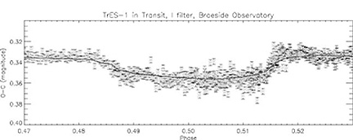

- What is the change in brightness, Δm, of each star while the planet is transiting?

(HD 209458)

(TrES-1)

The change in brightness may be used to calculate the radius of the planet. Specifically,

You will use the change in brightness that you calculated for question 15 and assume that the radius of HD 209458 is similar to our Sun's (radius of the Sun = 6.96 x 10⁸ m). It would also be useful to express the radius in terms of Jupiter radii (R_{Jupiter}) to help give us a sense of size of the planet compared to planets in our solar system. Accounting for these factors,

- What is the radius of the planet, r_{p} (expressed in R_{Jupiter})?

(HD 209458)

(TrES-1)

- What is the radius of the planet, r_{p} (expressed in R_{Earth})?

(HD 209458)

(TrES-1)

Questions:

- Based on the distance from its parent star (calculated in Exercise 2), would you call these planets to be terrestrial or a Jovian planets?

(HD 209458)

(TrES-1)

- Based on the mass that you calculated for the planet in Exercise 2, would you call these terrestrial or Jovian planets?

(HD 209458)

(TrES-1)

- Based on the radius that you calculated for these planet s(in Exercise 3), would you call them terrestrial or Jovian planets?

(HD 209458)

(TrES-1)

- Spectroscopic observations of the planet around HD 209458 have noted that it is surrounded by a layer of hydrogen (H). Based on this observation, would you call this planet a terrestrial or Jovian planet?

- Would the planets (HD 209458 and TrES-1) conform to observations based on our solar system alone? Why or why not?

- Will the unusual characteristics of some of the extrasolar planets (like those above) affect our models of how solar systems form? Why or why not?

Exercise 4: Transit Method – In-class observations

Now you will go to the Braeside control room and make observations of the star that may have a transiting planet and see if you can verify the presence of a planet around this star using the transit method. The Braeside telescope is a 16-inch telescope located in Flagstaff, Arizona. With the help of a telescope operator, you will remotely use the Braeside observatory to observe the star. (If it is cloudy in Flagstaff, you may use the telescope interface to plot data from previous observations.)

The following are instructions for using the telescope GUI – please ask the telescope operator for assistance:

- Type file name or browse for file.
- Click the button "Star flux".
  - Click on the center of the target star.
  - Click just beyond the diffraction spikes.
  - Click a bit farther out from the target star, but stay close enough so as not to reach any other stars in the field.
- Click the button "Comp flux".
  - Click on the center of a comparison star.
  - Click just on the edge of that star.
  - Click a little farther out from the comparison star, but stay close enough so as not to reach any other stars in the field.
- Click "Plot" to display your data. The large star designates your data point from this evening.
- Type your name in the space provided.
- Click "Print Files" to print the graph to be handed in with your lab report.

Your plot displays change in brightness of the star, Δm and phase. Looking at your plot, answer the following questions.

- During your observation of ____________ (write in name of star), was a planet transiting the star? How can you tell?

Conclusion:

References:

- Figure 1 - Astronomy Today, 4th edition, Chaisson and McMillan, Prentice Hall, 2002
- Figure 2 – Brown and Charbonneau, http://www.hao.ucar.edu/public/research/stare/hd209458.html
- The Doppler velocity curve for HD 209458 was obtained from the website: http://exoplanets.org
- The Doppler velocity curve for TrES-1 was obtained from Alonso, et.al. at http://www.hao.ucar.edu
- The equation for the radius of the planet from the photometry data is from Santoretti & Schneider, A&AS, 134, 553.

