Exploring Impact Cratering

What will you learn in this lab?

There are four major geologic processes that affect planetary surfaces – impact cratering, volcanism, tectonics, and erosion. Impact cratering is the most pervasive surface process on all planetary bodies. In this lab you will:
- Become familiar with the relationship between crater size and crater morphology and the properties of the projectiles
- Determine the difference between a crater formed by an external impact and an internal explosion/eruption
- Look at the relationship between the kinetic energy of an impact and the size/volume of the crater.

What do I need to bring to the Class with me to do this Lab?

- A copy of this lab script
- Pencil and eraser
- Scientific Calculator

Introduction:

Impact cratering occurs when a planetesimal - usually debris from a comet, asteroid, or meteoroid - crashes into the surface of a terrestrial body (solid surfaced planets). Throughout the solar system's history, planetesimals have heavily bombarded all the terrestrial bodies. The Moon and Mercury have not erased this bombardment because the other geologic processes on these bodies stopped millions of years ago. On Earth, and even Venus and Mars, erosion and redeposition, volcanic resurfacing, and tectonic activity continually erase craters.

After the impact, a crater is left behind, with the original projectile vaporizing on impact due to tremendous pressures and temperatures. The typical speed at which a projectile hits a planetary body is 10-30 km/s. This produces a crater that is 10 to 20 times larger in diameter than the physical size of the impacting object. The shape of the crater is usually circular, but if the impact is at an oblique angle, the crater is asymmetric and usually oval.

Debris from the blast is deposited in the area surrounding the crater. This material is usually called ejecta. Close to the crater, the ejecta typically forms a thick, continuous layer, while at larger distances the ejecta may fall as discontinuous clumps of material. When large ejecta material falls back down to the surface, it is possible other craters will be made. These are termed secondary craters or impacts. Ejecta that create long, bright streaks or lines that radiate from a crater are called rays.

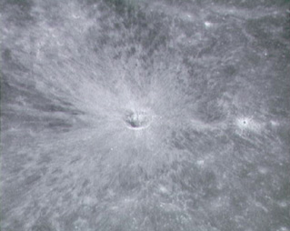
Figure 1 – Example of a lunar crater with rays taken from orbit

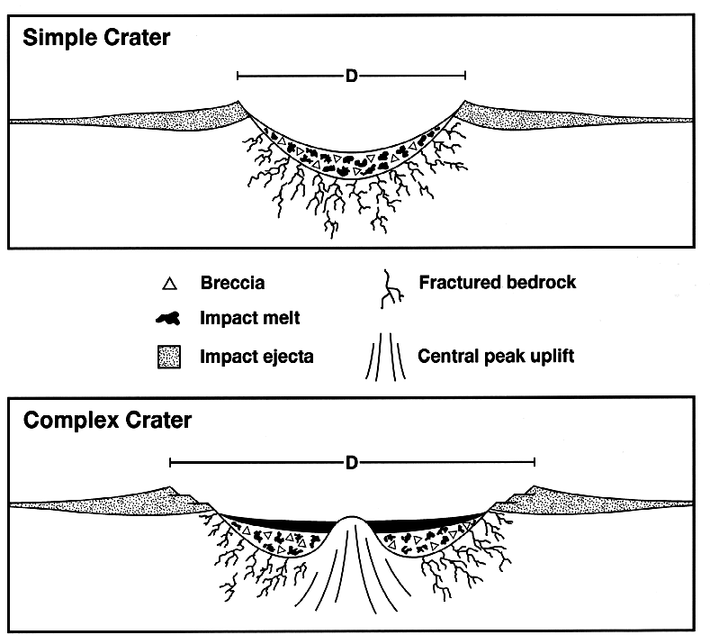
Figure 2 - Cross-section of a simple and complex crater

There are three different kinds of craters. Simple craters are usually less than 1km in diameter and have bowl shaped depressions. The depth-to-diameter ratio of a simple crater can range from about 1:5 to 1:7. They are formed by projectiles travelling with low speed and energy. The initial crater formed by this kind of impactor is named a transient cavity. Because the impact is created with a low energy projectile, material will fall back into the crater and is called Breccia fill.

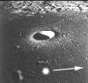
Figure 3 - Example of a simple crater (Moon)

Complex craters typically have shallow (the depth-to-diameter ratio usually ranges from 1:10 to 1:20), relatively flat floors, central uplifts, and slump blocks and terraces on the inner wall of the crater rim. These craters are found in three classes of sizes. Those that are 1-10km in diameter have central peaks in the primary crater. These are formed from a rebound (uplift) of material, due to the larger speed and energy of the impactor, and a subsequent collapse back into the crater floor. Complex craters with peak rings are 100-300km in diameter. These have a characteristic ring of mountains within the crater. Multi-ring basins are the third class of complex crater. These are approximately 1000km in diameter and are formed by large impactors travelling with high speed and energy.

a)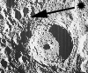 b) 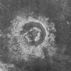 c) 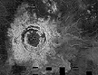
Figure 4 - Examples of Complex craters: a) Central peak (moon);
b) Peak ring crater (Venus); c) Multi-ring crater (Venus)

The third type of crater is a Rampart crater. These craters have lobate forms associated with the crater where the lobes are similar to those seen with volcanic and mud flows. They are characterized by teardrop shapes of material coming from the crater. These craters are used as evidence that there was water (or some other volatile), liquid or ice, at some time on the planetary surface.

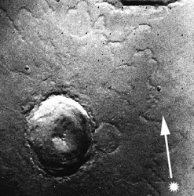
Figure 5 - Example of a rampart crater (Mars)

Exercise 1:
This exercise will show how crater diameters vary with the size, mass, and velocity of the impactor.

For this exercise you will need to drop balls of various sizes into sand. You will need to choose 3 heights from which to drop the balls to create craters. The heights should be at least 50cm apart from each other and start at 50 cm above the sandbox. The balls need to be dropped vertically into the box of sand. After the impact you will need to figure out how to measure the diameters of the craters produced. Don’t forget to include an error estimate of your diameter measurement. Also draw one characteristic sketch of the craters made (both from above the crater and looking through the side of the box). Your data table (given here on the last page of this lab script) should include the impactor height, mass, diameter, and the measured crater diameter with estimated measurement error.

Be sure to repeat the cratering and measuring processes a few times for each size of impactor. Don’t forget to smooth over the sand with the ruler before each new impact.

Remember to look over the questions for this section at the end of the lab to be sure you have taken enough data before moving on to Exercise 2.

Exercise 2:
This exercise will compare craters formed by external impacts to those from internal explosions or eruptions (for example from a volcanic explosion/eruption).

For the internal explosion you will be using a bicycle pump apparatus that will cause a balloon to simulate an explosion from inside the sand. A balloon should be attached to the tubing with a rubber band and put on the bottom of the tub. Place the cover onto the tub and pump up the balloon until it pops. Examine the crater formed.

For the internal eruption you will use the same apparatus but with a balloon flush up against the end of the tubing and attached with a rubber band. Put the tubing an inch under the sand and replace the cover of the tub. Pump up the balloon until it pops and examine the crater.

Your data for this exercise should be characteristic sketches of each type of crater along with measured diameter information and measurement error for each.

Remember to look over the questions for this section at the end of the lab to be sure you have taken enough data before moving on to Exercise 3.

Exercise 3:
This exercise will look at the general relationships between the kinetic energy of the impact and the crater size. First, let's define a few terms: kinetic energy is the energy of a moving object, and free-fall velocity is the speed an object attains due to gravity when released from a given height.

For this exercise you will need your data table from Exercise 1. You will need to calculate the kinetic energy of impact for each set of data. Use the following equations:

Free-fall velocity:
,
where v = free-fall velocity, g = gravitational acceleration=9.8m/s,
h = height ball was dropped from

Kinetic Energy:
,
where KE= kinetic energy, m = mass of ball, v = free-fall velocity

Put your final calculations into a data table. (You will also want to include the logarithm of the kinetic energy in your table for use in your analysis.

The data from your table will be used to answer the questions for this exercise in the analysis/questions section.

Be sure to have your data table signed by the TA before you move on to the next section. Your work area will need to be clean and picked up before a signature is given.

Analysis/Questions:

Exercise 1:

- Plot your data on graph paper (provided).
- Impactor mass vs. crater diameter
- Impactor diameter vs. crater diameter
- Impactor velocity vs. crater diameter

- What general relationships do you see between the variables in each of your 3 graphs?

Exercise 2:

- Look at your sketches for the external and internal craters. Compare and contrast the different processes.
- Are the raised rims different?

- Which one has greater effect on the surrounding material?

- Which one might have used greater energy in excavating a crater?

- Explain how you would be able to tell by looking at the surface of a planetary body whether an external impact or an internal explosion/eruption made the crater.

- Examine the figures from planetary bodies in our own solar system, figures 6 and 7.
- Which feature is probably volcanic in origin? Which is from an impact? If it is from an impact is the crater simple or complex? Explain your reasoning and the evidence you used to reach your hypothesis.

- Do any of these craters show evidence that the planetary body may have had water or some kind of liquid in its history? Why or why not?

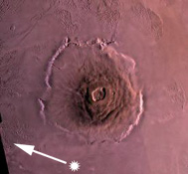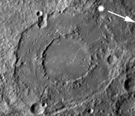
Figure 6 - Image from Mars Figure 7 - Image from Mercury

Exercise 3:

- Plot a graph of log (crater diameter) vs. log (Kinetic Energy) from this exercise and draw a line or curve that best fits the data points.

- Does your experiment qualitatively support the relationship between crater diameter and kinetic energy of the impact, ? Explain. [HINT: look at the slope of your plot of log(d) versus log(KE)].

Wrap-up questions:

- Which is the most important factor controlling the crater size - size, mass, or velocity of the projectile? Why?

- Theoretically we should be able to use craters to give relative ages to planetary bodies if we know when the first impacts began/ended – younger craters cover the older craters. What geologic processes could confuse this relative age dating of planetary bodies?

- What were the major sources of error in this laboratory exercise?

Conclusion:

Data Table
Impactor | Mass | Diameter | Height | Crater diameter | log(crater diameter) | Velocity | Kinetic Energy | Log(KE)

